­Clem Daria-Ștefana

Grupa 234

Proiect – Baze de date

Gestiunea unei școli

1. Prezentați pe scurt baza de date (utilitatea ei).

Acest proiect are ca temă gestiunea unei școli. Astfel, elevii școlii sunt înscriși în clase, care fac parte dintr-o încadrare. La fiecară clasă sunt anumite materii și anumiți profesori care predau. Profesorii pot preda mai multe materii (de exemplu, un profesor poate preda fizică și chimie sau limba română și limba latină). Elevii primesc note la materiile de la clasă. De asemenea, elevii au posibilitatea de a lua bursă în timpul anului școlar. Aceasta poate fi de 3 tipuri: bursă de merit, de performanță și socială.

În funcție de bugetul alocat școlii, bursele se acordă elevilor după anumite criterii. Bursa de merit este oferită elevilor care au rezultate bune la ore sau care strâng un anumit punctaj la proiectele organizate de școală. Rezultatele de la ore se calculează în funcție de importanța notelor luate de elevi (examen, teză, test, etc). Bursa de performanță este acordată elevilor care obțin premii la olimpiadele naționale și nu sunt corigenți la nicio materie (media ≥ 5). În final, bursa socială este destinată celor care suferă de o condiție medicală sau a căror părinți au veniturile jumătate din salariul minim pe economie.

Elevii școlii care se încadrează să ia una sau mai multe burse pot primi banii cash, de la contabilitate, sau într-un cont care aparține unei bănci. O bancă poate avea mai multe conturi deschise. Aceștia pot partipa în timpul anului la olimpiade (acestea se actualizează anual, în funcție de programa stabilită) și pot realiza proiecte.

2. Realizați diagrama entitate-relație (ERD).

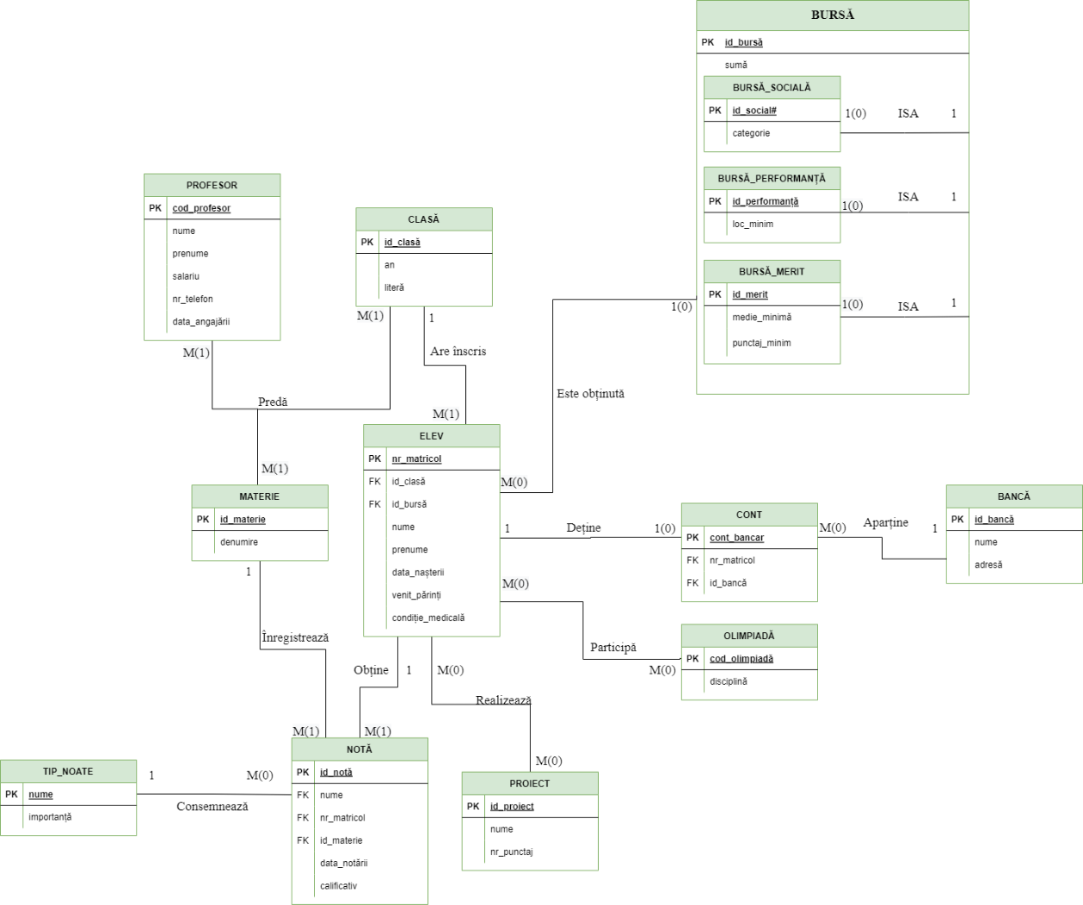

1. Pornind de la diagrama entitate-relație realizați diagrama conceptuală a modelului propus, integrând toate atributele necesare.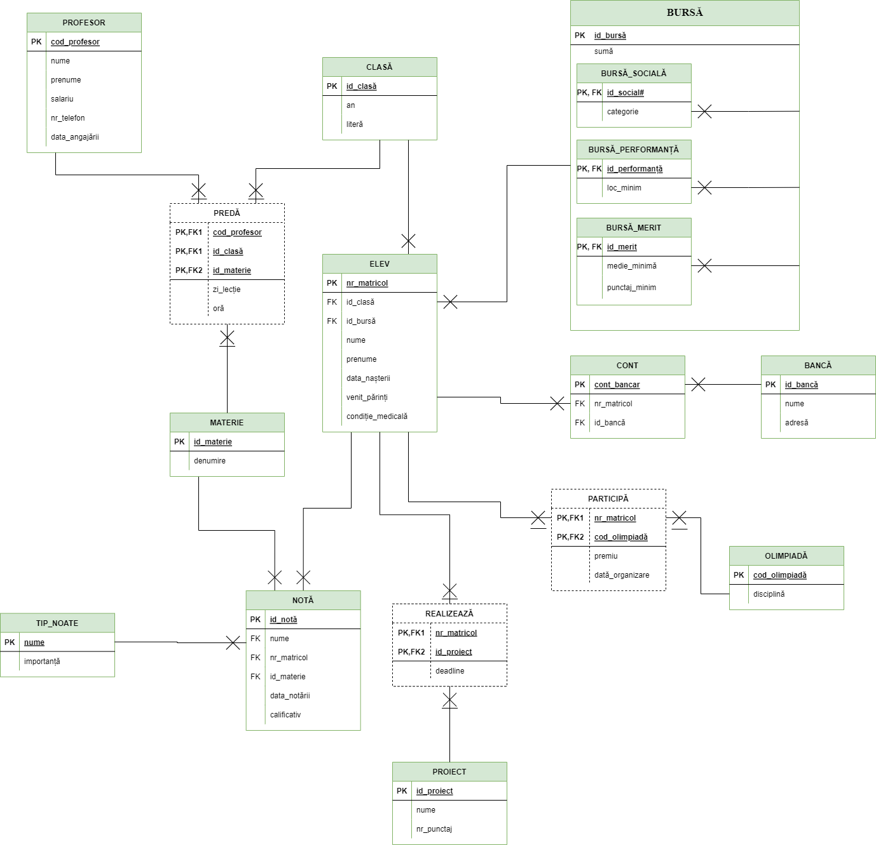
2. Implementați în Oracle diagrama conceptuală realizată: definiți toate tabelele, implementând toate constrângerile de integritate necesare (chei primare, cheile externe etc).

create table MATERIE (

id_materie number(2, 0) not null primary key,

denumire varchar2(20) not null

);

create table PROFESOR (

cod_profesor number(4, 0) not null primary key,

nume varchar2(20) not null,

prenume varchar2(20) not null,

salariu number(4, 0) not null,

nr_telefon varchar2(10) not null,

data_angajarii date not null

);

create table CLASA (

id_clasa number(3, 0) not null primary key,

an number(2, 0) not null,

litera char(1) not null

);

create table ELEV (

nr_matricol number(5, 0) not null primary key,

id_clasa number(3, 0) not null,

id_bursa number(2, 0),

nume varchar2(20) not null,

prenume varchar2(20) not null,

data_nasterii date not null,

venit_parinti number(5, 0) not null,

conditie_medicala number(1, 0) not null,

foreign key(id_clasa) references CLASA(id_clasa),

foreign key(id_bursa) references BURSA(id_bursa)

);

create table CONT (

cont_bancar varchar2(24) not null primary key,

nr_matricol number(5, 0) not null,

id_banca varchar2(20) not null,

foreign key(nr_matricol) references ELEV(nr_matricol),

foreign key(id_banca) references BANCA(id_banca)

);

create table BANCA (

id_banca varchar2(20) not null primary key,

nume varchar2(35) not null,

adresa varchar2(40)

);

create sequence generare_cod_olimpiada

Start with 10000

Increment by 1;

create table OLIMPIADA (

cod_olimpiada number(5, 0) not null primary key,

disciplina varchar2(30) not null

);

create table PROIECT (

id_proiect number(4, 0) not null primary key,

nume varchar2(25) not null,

nr_punctaj number(3, 1) not null

);

create table BURSA (

id_bursa number(2, 0) not null primary key,

suma number(3, 0) not null

);

create table BURSA_SOCIALA (

id_social number(2, 0) not null primary key,

categorie varchar2(10) not null,

foreign key(id_social) references BURSA(id_bursa)

);

create table BURSA_MERIT (

id_merit number(2, 0) not null primary key,

medie_minima number(2, 1) not null,

punctaj_minim number(2, 0) not null,

foreign key(id_merit) references BURSA(id_bursa)

);

create table BURSA_PERFORMANTA (

id_performanta number(2, 0) not null primary key,

loc_minim number(1, 0) not null,

foreign key(id_performanta) references BURSA(id_bursa)

);

create table PREDA (

cod_profesor number(4, 0) not null,

id_clasa number(3, 0) not null,

id_materie number(2, 0) not null,

zi_lectie number(1, 0) not null,

ora number(2, 0) not null,

constraint pk_preda primary key(cod_profesor, id_clasa, id_materie)

);

create table REALIZEAZA (

nr_matricol number(5, 0) not null,

id_proiect number(4, 0) not null,

deadline date not null,

constraint pk_realizeaza primary key(nr_matricol, id_proiect, deadline)

);

create table PARTICIPA (

nr_matricol number(5, 0) not null,

cod_olimpiada number(5, 0) not null,

premiu number(2, 0) not null,

data_organizare date not null,

constraint pk_participa primary key(nr_matricol, cod_olimpiada)

);

create table TIP_NOTA (

nume varchar2(25) not null primary key,

importanta number(1, 0) not null

);

create table NOTA (

id_nota number(6, 0) not null primary key,

nume varchar2(25) not null,

nr_matricol number(5, 0) not null,

id_materie number(2, 0) not null,

data_notarii date not null,

calificativ number(3, 1) not null,

foreign key(nume) references TIP_NOTA(nume),

foreign key(nr_matricol) references ELEV(nr_matricol),

foreign key(id_materie) references MATERIE(id_materie)

);

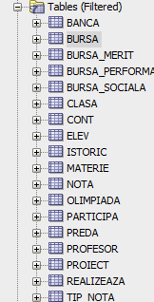

1. Adăugați informații coerente în tabelele create (minim 5 înregistrări pentru fiecare entitate independentă; minim 10 înregistrări pentru tabela asociativă).

insert into MATERIE values (1, 'matematica');

insert into MATERIE values (2, 'chimie');

insert into MATERIE values (3, 'fizica');

insert into MATERIE values (4, 'sport');

insert into MATERIE values (5, 'informatica');

insert into MATERIE values (6, 'biologie');

insert into MATERIE values (7, 'psihologie');

insert into MATERIE values (8, 'limba romana');

insert into MATERIE values (9, 'limba franceza');

insert into MATERIE values (10, 'educatie civica');

insert into MATERIE values (11, 'muzica');

insert into MATERIE values (12, 'desen');

insert into MATERIE values (13, 'limba engleza');

insert into MATERIE values (14, 'TIC');

insert into MATERIE values (15, 'istorie');

insert into MATERIE values (16, 'geografie');

insert into MATERIE values (17, 'filozofie');

insert into MATERIE values (18, 'limba spaniola');

insert into MATERIE values (19, 'educatie tehnologica');

insert into MATERIE values (20, 'Optional PopCulture');

insert into MATERIE values (21, 'limba latina');

insert into PROFESOR values (200, 'dima', 'cezar', 3179, '0782446817', '25-03-2003');

insert into PROFESOR values (138, 'apostol', 'daria', 4800, '0797783548', '24-04-2008');

insert into PROFESOR values (5, 'amoraritei', 'cezar', 4567, '0717474711', '01-11-1984');

insert into PROFESOR values (161, 'penescu', 'cezar', 3413, '0711761768', '10-06-1998');

insert into PROFESOR values (124, 'apostol', 'cezar', 5681, '0769904924', '19-09-2007');

insert into PROFESOR values (22, 'scutaru', 'amalia', 4313, '0736818377', '15-02-1982');

insert into PROFESOR values (194, 'cojocaru', 'delia', 3482, '0734043134', '07-04-1994');

insert into PROFESOR values (48, 'scutaru', 'stefan', 3068, '0731248667', '11-08-2012');

insert into PROFESOR values (117, 'popovici', 'matei', 6193, '0761888769', '28-02-1998');

insert into PROFESOR values (191, 'apetrei', 'calin', 5112, '0759779287', '06-08-1980');

insert into PROFESOR values (23, 'amoraritei', 'delia', 4396, '0780343570', '17-03-2018');

insert into PROFESOR values (118, 'onciuleanu', 'calin', 3131, '0715530331', '08-01-2015');

insert into PROFESOR values (137, 'cuzic', 'cezar', 4166, '0736351626', '18-08-1993');

insert into PROFESOR values (90, 'alexa', 'elias', 4939, '0714248130', '04-06-2018');

insert into PROFESOR values (61, 'apetrei', 'daria', 6181, '0752436786', '15-07-2015');

insert into PROFESOR values (173, 'popovici', 'stefana', 4691, '0738737343', '01-03-2017');

insert into PROFESOR values (129, 'amoraritei', 'robert', 5647, '0762800380', '27-11-2008');

insert into PROFESOR values (199, 'amoraritei', 'daria', 6121, '0760141077', '02-07-1995');

insert into PROFESOR values (27, 'popescu', 'delia', 4337, '0740240855', '21-03-2012');

insert into PROFESOR values (152, 'popescu', 'valentin', 5252, '0763332056', '04-12-1985');

insert into PROFESOR values (136, 'cuzic', 'elias', 5716, '0774357097', '07-08-2019');

insert into PROFESOR values (128, 'amoraritei', 'matei', 3673, '0751863354', '02-02-1987');

insert into PROFESOR values (164, 'alexa', 'valentin', 5449, '0760084349', '16-02-2010');

insert into PROFESOR values (213, 'mutu', 'ciprian', 3068, '0750000010', '17-02-2011');

insert into PROFESOR values (219, 'dita', 'constantin', 3479, '0702400817', sysdate);

insert into PROFESOR values (230, 'drelciuc', 'cristian', 3000, '0723009001', sysdate);

insert into PROFESOR values (231, 'ambrozie', 'vasile', 3240, '0760112004', sysdate);

insert into CLASA values (80, 12, 'A');

insert into CLASA values (81, 12, 'B');

insert into CLASA values (82, 12, 'C');

insert into CLASA values (83, 12, 'D');

insert into CLASA values (100, 10, 'A');

insert into CLASA values (101, 10, 'B');

insert into CLASA values (102, 10, 'C');

insert into CLASA values (103, 10, 'D');

insert into CLASA values (104, 11, 'A');

insert into CLASA values (105, 11, 'B');

insert into CLASA values (106, 11, 'C');

insert into CLASA values (107, 11, 'D');

insert into CLASA values (210, 9, 'A');

insert into CLASA values (211, 9, 'B');

insert into CLASA values (212, 9, 'C');

insert into CLASA values (213, 9, 'D');

insert into CLASA values (206, 8, 'A');

insert into CLASA values (207, 8, 'B');

insert into CLASA values (208, 8, 'C');

insert into CLASA values (209, 8, 'D');

insert into CLASA values (467, 3, 'A');

insert into CLASA values (468, 3, 'B');

insert into CLASA values (469, 3, 'C');

insert into CLASA values (470, 3, 'D');

insert into CLASA values (300, 2, 'A');

insert into CLASA values (301, 2, 'B');

insert into CLASA values (302, 2, 'C');

insert into CLASA values (303, 2, 'D');

insert into CLASA values (405, 0, 'A');

insert into CLASA values (406, 0, 'B');

insert into CLASA values (407, 0, 'C');

insert into CLASA values (408, 0, 'D');

insert into CLASA values (327, 1, 'A');

insert into CLASA values (328, 1, 'B');

insert into CLASA values (329, 1, 'C');

insert into CLASA values (330, 1, 'D');

insert into CLASA values (560, 4, 'A');

insert into CLASA values (561, 4, 'B');

insert into CLASA values (562, 4, 'C');

insert into CLASA values (563, 4, 'D');

insert into CLASA values (565, 5, 'A');

insert into CLASA values (566, 5, 'B');

insert into CLASA values (567, 5, 'C');

insert into CLASA values (568, 5, 'D');

insert into CLASA values (580, 6, 'A');

insert into CLASA values (581, 6, 'B');

insert into CLASA values (582, 6, 'C');

insert into CLASA values (583, 6, 'D');

insert into CLASA values (901, 7, 'A');

insert into CLASA values (902, 7, 'B');

insert into CLASA values (903, 7, 'C');

insert into CLASA values (904, 7, 'D');

insert into ELEV(nr_matricol, id_clasa, id_bursa, nume, prenume, data_nasterii, venit_parinti, conditie_medicala)

values (84753, 565, 72, 'pinzaru', 'claudia', '21-12-2011', 21140, 0);

insert into ELEV(nr_matricol, id_clasa, id_bursa, nume, prenume, data_nasterii, venit_parinti, conditie_medicala)

values (68559, 208, 10, 'birleanu', 'matei', '14-12-2008', 93395, 0);

insert into ELEV(nr_matricol, id_clasa, id_bursa, nume, prenume, data_nasterii, venit_parinti, conditie_medicala)

values (82323, 565, 57, 'berbecariu', 'irina', '29-07-2011', 50193, 0);

insert into ELEV(nr_matricol, id_clasa, id_bursa, nume, prenume, data_nasterii, venit_parinti, conditie_medicala)

values (51001, 406, 11, 'onciuleanu', 'andrei', '29-03-2016', 34350, 0);

insert into ELEV(nr_matricol, id_clasa, id_bursa, nume, prenume, data_nasterii, venit_parinti, conditie_medicala)

values (75503, 206, 56, 'boamba', 'stefana', '15-08-2008', 9245, 1);

insert into ELEV(nr_matricol, id_clasa, id_bursa, nume, prenume, data_nasterii, venit_parinti, conditie_medicala)

values (91860, 105, 70, 'meran', 'andreea', '05-04-2005', 15562, 0);

insert into ELEV(nr_matricol, id_clasa, id_bursa, nume, prenume, data_nasterii, venit_parinti, conditie_medicala)

values (26880, 581, 74, 'apostol', 'alexandru', '16-07-2010', 8367, 0);

insert into ELEV(nr_matricol, id_clasa, id_bursa, nume, prenume, data_nasterii, venit_parinti, conditie_medicala)

values (29056, 107, 10, 'boca', 'denis', '23-11-2005', 28143, 0);

insert into ELEV(nr_matricol, id_clasa, id_bursa, nume, prenume, data_nasterii, venit_parinti, conditie_medicala)

values (96444, 904, 83, 'stratu', 'denis', '15-08-2009', 81516, 0);

insert into ELEV(nr_matricol, id_clasa, id_bursa, nume, prenume, data_nasterii, venit_parinti, conditie_medicala)

values (79329, 565, 14, 'radu', 'teodor', '23-04-2011', 81248, 1);

insert into ELEV(nr_matricol, id_clasa, id_bursa, nume, prenume, data_nasterii, venit_parinti, conditie_medicala)

values (86076, 82, 70, 'jitareanu', 'matei', '18-11-2004', 71240, 0);

insert into ELEV(nr_matricol, id_clasa, id_bursa, nume, prenume, data_nasterii, venit_parinti, conditie_medicala)

values (70844, 582, 81, 'ursaciuc', 'valentina', '26-02-2010', 79813, 1);

insert into ELEV(nr_matricol, id_clasa, id_bursa, nume, prenume, data_nasterii, venit_parinti, conditie_medicala)

values (24372, 469, 12, 'scutaru', 'claudia', '05-03-2013', 54934, 1);

insert into ELEV(nr_matricol, id_clasa, id_bursa, nume, prenume, data_nasterii, venit_parinti, conditie_medicala)

values (64827, 106, 71, 'alexa', 'narcisa', '25-10-2005', 82845, 1);

insert into ELEV(nr_matricol, id_clasa, id_bursa, nume, prenume, data_nasterii, venit_parinti, conditie_medicala)

values (37363, 206, 13, 'ursaciuc', 'denis', '11-09-2008', 13476, 0);

insert into ELEV(nr_matricol, id_clasa, id_bursa, nume, prenume, data_nasterii, venit_parinti, conditie_medicala)

values (94748, 107, 74, 'mocanu', 'matei', '22-03-2005', 47514, 0);

insert into ELEV(nr_matricol, id_clasa, id_bursa, nume, prenume, data_nasterii, venit_parinti, conditie_medicala)

values (76040, 103, 56, 'popescu', 'daria', '01-08-2006', 81567, 1);

insert into ELEV(nr_matricol, id_clasa, id_bursa, nume, prenume, data_nasterii, venit_parinti, conditie_medicala)

values (92152, 329, 71, 'mindrescu', 'ionela', '01-04-2015', 9403, 1);

insert into ELEV(nr_matricol, id_clasa, id_bursa, nume, prenume, data_nasterii, venit_parinti, conditie_medicala)

values (76010, 100, 83, 'onciuleanu', 'bianca', '01-11-2006', 5090, 0);

insert into ELEV(nr_matricol, id_clasa, id_bursa, nume, prenume, data_nasterii, venit_parinti, conditie_medicala)

values (54140, 567, 11, 'dima', 'adrian', '25-07-2011', 23831, 0);

insert into ELEV(nr_matricol, id_clasa, id_bursa, nume, prenume, data_nasterii, venit_parinti, conditie_medicala)

values (80441, 102, 12, 'apostol', 'constantin', '17-11-2006', 59087, 0);

insert into ELEV(nr_matricol, id_clasa, id_bursa, nume, prenume, data_nasterii, venit_parinti, conditie_medicala)

values (87296, 904, 71, 'boamba', 'andrei', '16-09-2009', 24657, 0);

insert into ELEV(nr_matricol, id_clasa, nume, prenume, data_nasterii, venit_parinti, conditie_medicala)

values (22259, 406, 'cujba', 'miruna', '22-07-2016', 58934, 0);

insert into ELEV(nr_matricol, id_clasa, id_bursa, nume, prenume, data_nasterii, venit_parinti, conditie_medicala)

values (96820, 562, 10, 'tibulca', 'vasile', '15-08-2012', 31928, 1);

insert into ELEV(nr_matricol, id_clasa, id_bursa, nume, prenume, data_nasterii, venit_parinti, conditie_medicala)

values (52645, 407, 82, 'ursaciuc', 'constantin', '01-08-2016', 67114, 1);

insert into ELEV(nr_matricol, id_clasa, id_bursa, nume, prenume, data_nasterii, venit_parinti, conditie_medicala)

values (38923, 904, 10, 'boamba', 'daria', '07-05-2009', 81830, 0);

insert into ELEV(nr_matricol, id_clasa, id_bursa, nume, prenume, data_nasterii, venit_parinti, conditie_medicala)

values (68815, 563, 70, 'boca', 'constantin', '29-01-2012', 78509, 1);

insert into ELEV(nr_matricol, id_clasa, id_bursa, nume, prenume, data_nasterii, venit_parinti, conditie_medicala)

values (28349, 213, 12, 'alexa', 'andreea', '11-10-2007', 34271, 0);

insert into ELEV(nr_matricol, id_clasa, id_bursa, nume, prenume, data_nasterii, venit_parinti, conditie_medicala)

values (96433, 327, 12, 'basarab', 'eduard', '13-01-2015', 57721, 0);

insert into ELEV(nr_matricol, id_clasa, id_bursa, nume, prenume, data_nasterii, venit_parinti, conditie_medicala)

values (42545, 212, 13, 'cujba', 'irina', '27-12-2007', 93687, 1);

insert into ELEV(nr_matricol, id_clasa, id_bursa, nume, prenume, data_nasterii, venit_parinti, conditie_medicala)

values (32529, 566, 73, 'apetrei', 'antonia', '16-10-2011', 52561, 0);

insert into ELEV(nr_matricol, id_clasa, id_bursa, nume, prenume, data_nasterii, venit_parinti, conditie_medicala)

values (92092, 408, 14, 'onciuleanu', 'antonia', '17-05-2016', 48859, 0);

insert into ELEV(nr_matricol, id_clasa, id_bursa, nume, prenume, data_nasterii, venit_parinti, conditie_medicala)

values (34698, 566, 10, 'popescu', 'isabela', '23-01-2011', 84109, 0);

insert into ELEV(nr_matricol, id_clasa, id_bursa, nume, prenume, data_nasterii, venit_parinti, conditie_medicala)

values (27639, 210, 71, 'basarab', 'bianca', '03-12-2007', 48427, 0);

insert into ELEV(nr_matricol, id_clasa, id_bursa, nume, prenume, data_nasterii, venit_parinti, conditie_medicala)

values (68754, 902, 70, 'budeanu', 'vasile', '08-07-2009', 51124, 1);

insert into ELEV(nr_matricol, id_clasa, id_bursa, nume, prenume, data_nasterii, venit_parinti, conditie_medicala)

values (86863, 102, 81, 'cuzic', 'ionela', '11-06-2006', 29117, 0);

insert into ELEV(nr_matricol, id_clasa, id_bursa, nume, prenume, data_nasterii, venit_parinti, conditie_medicala)

values (83253, 406, 57, 'cojocaru', 'valentin', '17-05-2016', 34534, 0);

insert into ELEV(nr_matricol, id_clasa, id_bursa, nume, prenume, data_nasterii, venit_parinti, conditie_medicala)

values (76878, 563, 57, 'pinzaru', 'robert', '01-01-2012', 42879, 0);

insert into ELEV(nr_matricol, id_clasa, id_bursa, nume, prenume, data_nasterii, venit_parinti, conditie_medicala)

values (44926, 107, 12, 'berbecariu', 'ionela', '04-07-2005', 92036, 0);

insert into ELEV(nr_matricol, id_clasa, id_bursa, nume, prenume, data_nasterii, venit_parinti, conditie_medicala)

values (20632, 100, 11, 'boca', 'miruna', '06-02-2006', 86761, 0);

insert into ELEV(nr_matricol, id_clasa, id_bursa, nume, prenume, data_nasterii, venit_parinti, conditie_medicala)

values (10724, 582, 80, 'minecan', 'vasile', '18-01-2010', 52126, 0);

insert into ELEV(nr_matricol, id_clasa, nume, prenume, data_nasterii, venit_parinti, conditie_medicala)

values (62155, 105, 'minecan', 'irina', '07-01-2005', 83006, 0);

insert into ELEV(nr_matricol, id_clasa, id_bursa, nume, prenume, data_nasterii, venit_parinti, conditie_medicala)

values (91508, 208, 82, 'cojocaru', 'adrian', '19-04-2008', 1503, 1);

insert into ELEV(nr_matricol, id_clasa, id_bursa, nume, prenume, data_nasterii, venit_parinti, conditie_medicala)

values (41026, 566, 83, 'pinzaru', 'viviana', '29-10-2011', 10295, 1);

insert into ELEV(nr_matricol, id_clasa, id_bursa, nume, prenume, data_nasterii, venit_parinti, conditie_medicala)

values (23340, 104, 10, 'tibulca', 'valentin', '22-06-2005', 12211, 1);

insert into ELEV(nr_matricol, id_clasa, nume, prenume, data_nasterii, venit_parinti, conditie_medicala)

values (34835, 407, 'mocanu', 'bianca', '03-07-2016', 1323, 1);

insert into ELEV(nr_matricol, id_clasa, id_bursa, nume, prenume, data_nasterii, venit_parinti, conditie_medicala)

values (18071, 406, 74, 'penescu', 'sorin', '01-10-2016', 6111, 1);

insert into ELEV(nr_matricol, id_clasa, id_bursa, nume, prenume, data_nasterii, venit_parinti, conditie_medicala)

values (27592, 568, 73, 'scutaru', 'ionela', '15-02-2011', 27546, 1);

insert into ELEV(nr_matricol, id_clasa, id_bursa, nume, prenume, data_nasterii, venit_parinti, conditie_medicala)

values (43700, 563, 13, 'berbecariu', 'daria', '13-07-2012', 28864, 0);

insert into ELEV(nr_matricol, id_clasa, id_bursa, nume, prenume, data_nasterii, venit_parinti, conditie_medicala)

values (59547, 209, 74, 'stratu', 'mihai', '01-10-2008', 40105, 0);

insert into ELEV(nr_matricol, id_clasa, id_bursa, nume, prenume, data_nasterii, venit_parinti, conditie_medicala)

values (62599, 100, 70, 'berbecariu', 'ioana', '12-03-2006', 38916, 0);

insert into ELEV(nr_matricol, id_clasa, id_bursa, nume, prenume, data_nasterii, venit_parinti, conditie_medicala)

values (50404, 562, 56, 'cujba', 'dan', '16-09-2012', 6555, 0);

insert into ELEV(nr_matricol, id_clasa, id_bursa, nume, prenume, data_nasterii, venit_parinti, conditie_medicala)

values (18428, 405, 83, 'boca', 'matei', '07-08-2016', 10764, 0);

insert into ELEV(nr_matricol, id_clasa, nume, prenume, data_nasterii, venit_parinti, conditie_medicala)

values (56266, 80, 'mocanu', 'constantin', '04-05-2004', 96381, 1);

insert into ELEV(nr_matricol, id_clasa, id_bursa, nume, prenume, data_nasterii, venit_parinti, conditie_medicala)

values (12918, 583, 11, 'brinzac', 'mihaela', '10-02-2010', 57208, 0);

insert into ELEV(nr_matricol, id_clasa, id_bursa, nume, prenume, data_nasterii, venit_parinti, conditie_medicala)

values (96225, 567, 56, 'lungu', 'vasile', '10-05-2011', 94392, 0);

insert into ELEV(nr_matricol, id_clasa, id_bursa, nume, prenume, data_nasterii, venit_parinti, conditie_medicala)

values (74896, 83, 83, 'alexa', 'cosmin', '04-04-2004', 43837, 1);

insert into ELEV(nr_matricol, id_clasa, id_bursa, nume, prenume, data_nasterii, venit_parinti, conditie_medicala)

values (32993, 208, 13, 'cuzic', 'vasile', '05-10-2008', 13521, 1);

insert into ELEV(nr_matricol, id_clasa, id_bursa, nume, prenume, data_nasterii, venit_parinti, conditie_medicala)

values (33193, 104, 13, 'basarab', 'viviana', '11-07-2005', 85315, 0);

insert into ELEV(nr_matricol, id_clasa, id_bursa, nume, prenume, data_nasterii, venit_parinti, conditie_medicala)

values (71442, 903, 80, 'cujba', 'sorin', '19-10-2009', 59179, 0);

insert into ELEV(nr_matricol, id_clasa, id_bursa, nume, prenume, data_nasterii, venit_parinti, conditie_medicala)

values (50088, 210, 81, 'boamba', 'ionela', '07-02-2007', 79285, 0);

insert into ELEV(nr_matricol, id_clasa, id_bursa, nume, prenume, data_nasterii, venit_parinti, conditie_medicala)

values (46117, 207, 82, 'brinzac', 'irina', '15-09-2008', 14825, 1);

insert into ELEV(nr_matricol, id_clasa, id_bursa, nume, prenume, data_nasterii, venit_parinti, conditie_medicala)

values (83409, 211, 81, 'dima', 'dan', '25-05-2007', 16609, 1);

insert into ELEV(nr_matricol, id_clasa, id_bursa, nume, prenume, data_nasterii, venit_parinti, conditie_medicala)

values (53141, 583, 74, 'apostol', 'valentin', '13-10-2010', 70666, 1);

insert into ELEV(nr_matricol, id_clasa, id_bursa, nume, prenume, data_nasterii, venit_parinti, conditie_medicala)

values (89636, 330, 10, 'apostol', 'eduard', '19-12-2015', 16377, 1);

insert into ELEV(nr_matricol, id_clasa, id_bursa, nume, prenume, data_nasterii, venit_parinti, conditie_medicala)

values (61529, 300, 10, 'popovici', 'narcisa', '21-11-2014', 50049, 0);

insert into ELEV(nr_matricol, id_clasa, id_bursa, nume, prenume, data_nasterii, venit_parinti, conditie_medicala)

values (78503, 405, 14, 'onciuleanu', 'gabriela', '22-03-2016', 57973, 1);

insert into ELEV(nr_matricol, id_clasa, id_bursa, nume, prenume, data_nasterii, venit_parinti, conditie_medicala)

values (38732, 210, 14, 'onciuleanu', 'mihai', '06-08-2007', 10901, 0);

insert into ELEV(nr_matricol, id_clasa, nume, prenume, data_nasterii, venit_parinti, conditie_medicala)

values (56992, 100, 'clem', 'roland', '01-02-2006', 93052, 0);

insert into ELEV(nr_matricol, id_clasa, id_bursa, nume, prenume, data_nasterii, venit_parinti, conditie_medicala)

values (19081, 207, 71, 'maftei', 'vlad', '28-04-2008', 7156, 1);

insert into ELEV(nr_matricol, id_clasa, id_bursa, nume, prenume, data_nasterii, venit_parinti, conditie_medicala)

values (56592, 328, 57, 'jitareanu', 'irina', '12-06-2015', 21457, 0);

insert into ELEV(nr_matricol, id_clasa, id_bursa, nume, prenume, data_nasterii, venit_parinti, conditie_medicala)

values (42496, 211, 82, 'bistriceanu', 'cosmin', '13-08-2007', 86702, 1);

insert into ELEV(nr_matricol, id_clasa, id_bursa, nume, prenume, data_nasterii, venit_parinti, conditie_medicala)

values (57624, 560, 13, 'basarab', 'constantin', '21-09-2012', 15697, 1);

insert into ELEV(nr_matricol, id_clasa, id_bursa, nume, prenume, data_nasterii, venit_parinti, conditie_medicala)

values (11921, 211, 13, 'stefanoaia', 'cosmin', '15-02-2007', 87366, 1);

insert into ELEV(nr_matricol, id_clasa, id_bursa, nume, prenume, data_nasterii, venit_parinti, conditie_medicala)

values (65749, 83, 71, 'mindrescu', 'narcisa', '23-03-2004', 72473, 1);

insert into ELEV(nr_matricol, id_clasa, id_bursa, nume, prenume, data_nasterii, venit_parinti, conditie_medicala)

values (34754, 210, 73, 'meran', 'mihaela', '17-05-2007', 53392, 1);

insert into ELEV(nr_matricol, id_clasa, id_bursa, nume, prenume, data_nasterii, venit_parinti, conditie_medicala)

values (47791, 583, 81, 'boamba', 'valentina', '13-05-2010', 34099, 0);

insert into ELEV(nr_matricol, id_clasa, id_bursa, nume, prenume, data_nasterii, venit_parinti, conditie_medicala)

values (90522, 105, 56, 'cujba', 'valentina', '29-01-2005', 29652, 0);

insert into ELEV(nr_matricol, id_clasa, id_bursa, nume, prenume, data_nasterii, venit_parinti, conditie_medicala)

values (25531, 210, 74, 'ursaciuc', 'gabriela', '01-08-2007', 81731, 1);

insert into ELEV(nr_matricol, id_clasa, id_bursa, nume, prenume, data_nasterii, venit_parinti, conditie_medicala)

values (93405, 904, 56, 'jitareanu', 'dan', '23-12-2009', 76985, 0);

insert into ELEV(nr_matricol, id_clasa, id_bursa, nume, prenume, data_nasterii, venit_parinti, conditie_medicala)

values (47700, 904, 56, 'boca', 'sorin', '01-09-2009', 49921, 0);

insert into ELEV(nr_matricol, id_clasa, id_bursa, nume, prenume, data_nasterii, venit_parinti, conditie_medicala)

values (14071, 213, 13, 'pinzaru', 'miruna', '01-03-2007', 86294, 0);

insert into ELEV(nr_matricol, id_clasa, id_bursa, nume, prenume, data_nasterii, venit_parinti, conditie_medicala)

values (30562, 106, 74, 'radu', 'constantin', '16-04-2005', 83356, 0);

insert into ELEV(nr_matricol, id_clasa, id_bursa, nume, prenume, data_nasterii, venit_parinti, conditie_medicala)

values (68919, 581, 56, 'amoraritei', 'viviana', '10-04-2010', 86339, 0);

insert into ELEV(nr_matricol, id_clasa, id_bursa, nume, prenume, data_nasterii, venit_parinti, conditie_medicala)

values (28871, 208, 57, 'lungu', 'miruna', '28-09-2008', 11985, 0);

insert into ELEV(nr_matricol, id_clasa, id_bursa, nume, prenume, data_nasterii, venit_parinti, conditie_medicala)

values (74618, 211, 11, 'jitareanu', 'denis', '27-06-2007', 43302, 1);

insert into ELEV(nr_matricol, id_clasa, id_bursa, nume, prenume, data_nasterii, venit_parinti, conditie_medicala)

values (60640, 213, 56, 'mindrescu', 'isabela', '29-02-2007', 70861, 0);

insert into ELEV(nr_matricol, id_clasa, id_bursa, nume, prenume, data_nasterii, venit_parinti, conditie_medicala)

values (62879, 407, 70, 'budeanu', 'cosmin', '01-01-2016', 31788, 0);

insert into ELEV(nr_matricol, id_clasa, id_bursa, nume, prenume, data_nasterii, venit_parinti, conditie_medicala)

values (88042, 209, 74, 'apetrei', 'alexandru', '09-02-2008', 51972, 0);

insert into ELEV(nr_matricol, id_clasa, id_bursa, nume, prenume, data_nasterii, venit_parinti, conditie_medicala)

values (51136, 566, 71, 'dima', 'antonia', '22-04-2011', 8992, 0);

insert into ELEV(nr_matricol, id_clasa, id_bursa, nume, prenume, data_nasterii, venit_parinti, conditie_medicala)

values (19950, 561, 71, 'maftei', 'andrei', '22-06-2012', 27370, 0);

insert into ELEV(nr_matricol, id_clasa, id_bursa, nume, prenume, data_nasterii, venit_parinti, conditie_medicala)

values (97600, 101, 10, 'tibulca', 'narcisa', '28-06-2006', 70069, 1);

insert into ELEV(nr_matricol, id_clasa, id_bursa, nume, prenume, data_nasterii, venit_parinti, conditie_medicala)

values (73076, 562, 56, 'mindrescu', 'andreea', '18-07-2012', 46719, 0);

insert into ELEV(nr_matricol, id_clasa, id_bursa, nume, prenume, data_nasterii, venit_parinti, conditie_medicala)

values (87819, 408, 72, 'scutaru', 'mihaela', '08-02-2016', 53578, 0);

insert into ELEV(nr_matricol, id_clasa, id_bursa, nume, prenume, data_nasterii, venit_parinti, conditie_medicala)

values (22438, 104, 12, 'brinzac', 'narcisa', '23-04-2005', 36394, 0);

insert into ELEV(nr_matricol, id_clasa, id_bursa, nume, prenume, data_nasterii, venit_parinti, conditie_medicala)

values (48660, 329, 13, 'meran', 'vasile', '15-12-2015', 65436, 0);

insert into ELEV(nr_matricol, id_clasa, id_bursa, nume, prenume, data_nasterii, venit_parinti, conditie_medicala)

values (50343, 902, 12, 'scutaru', 'robert', '17-01-2009', 79454, 1);

insert into ELEV(nr_matricol, id_clasa, id_bursa, nume, prenume, data_nasterii, venit_parinti, conditie_medicala)

values (60053, 102, 83, 'boca', 'vasile', '04-05-2006', 41620, 1);

insert into ELEV(nr_matricol, id_clasa, id_bursa, nume, prenume, data_nasterii, venit_parinti, conditie_medicala)

values (55839, 103, 56, 'tibulca', 'andreea', '07-03-2006', 12510, 0);

insert into ELEV(nr_matricol, id_clasa, id_bursa, nume, prenume, data_nasterii, venit_parinti, conditie_medicala)

values (31643, 211, 56, 'munteanu', 'vasile', '12-08-2007', 27000, 1);

insert into ELEV(nr_matricol, id_clasa, id_bursa, nume, prenume, data_nasterii, venit_parinti, conditie_medicala)

values (10851, 902, 56, 'cuzic', 'valentin', '25-06-2009', 30006, 0);

insert into ELEV(nr_matricol, id_clasa, id_bursa, nume, prenume, data_nasterii, venit_parinti, conditie_medicala)

values (47221, 902, 10, 'popescu', 'denis', '14-02-2009', 12758, 1);

insert into ELEV(nr_matricol, id_clasa, id_bursa, nume, prenume, data_nasterii, venit_parinti, conditie_medicala)

values (58021, 212, 14, 'apetrei', 'viviana', '24-03-2007', 35876, 1);

insert into ELEV(nr_matricol, id_clasa, id_bursa, nume, prenume, data_nasterii, venit_parinti, conditie_medicala)

values (70746, 302, 73, 'birleanu', 'dan', '06-08-2014', 42424, 1);

insert into ELEV(nr_matricol, id_clasa, id_bursa, nume, prenume, data_nasterii, venit_parinti, conditie_medicala)

values (65572, 303, 81, 'cuzic', 'cosmin', '24-02-2014', 11425, 0);

insert into ELEV(nr_matricol, id_clasa, id_bursa, nume, prenume, data_nasterii, venit_parinti, conditie_medicala)

values (43241, 329, 57, 'cujba', 'andreea', '13-02-2015', 41773, 0);

insert into ELEV(nr_matricol, id_clasa, id_bursa, nume, prenume, data_nasterii, venit_parinti, conditie_medicala)

values (18140, 562, 10, 'mindrescu', 'denis', '09-09-2012', 89376, 0);

insert into ELEV(nr_matricol, id_clasa, id_bursa, nume, prenume, data_nasterii, venit_parinti, conditie_medicala)

values (35746, 213, 70, 'popovici', 'mihaela', '23-07-2007', 63865, 0);

insert into ELEV(nr_matricol, id_clasa, id_bursa, nume, prenume, data_nasterii, venit_parinti, conditie_medicala)

values (74002, 100, 80, 'meran', 'ioana', '20-09-2006', 43900, 0);

insert into ELEV(nr_matricol, id_clasa, nume, prenume, data_nasterii, venit_parinti, conditie_medicala)

values (19527, 300, 'cojocaru', 'valentina', '06-01-2014', 67533, 1);

insert into ELEV(nr_matricol, id_clasa, id_bursa, nume, prenume, data_nasterii, venit_parinti, conditie_medicala)

values (49626, 901, 12, 'cojocaru', 'viviana', '01-11-2009', 74727, 1);

insert into ELEV(nr_matricol, id_clasa, id_bursa, nume, prenume, data_nasterii, venit_parinti, conditie_medicala)

values (80436, 100, 10, 'scutaru', 'daria', '24-01-2006', 62862, 0);

insert into ELEV(nr_matricol, id_clasa, id_bursa, nume, prenume, data_nasterii, venit_parinti, conditie_medicala)

values (68934, 101, 11, 'clem', 'cosmin', '07-04-2006', 59948, 1);

insert into ELEV(nr_matricol, id_clasa, id_bursa, nume, prenume, data_nasterii, venit_parinti, conditie_medicala)

values (62768, 100, 14, 'munteanu', 'andreea', '17-06-2006', 19497, 1);

insert into ELEV(nr_matricol, id_clasa, id_bursa, nume, prenume, data_nasterii, venit_parinti, conditie_medicala)

values (16246, 903, 70, 'basarab', 'teodor', '05-05-2009', 11873, 1);

insert into ELEV(nr_matricol, id_clasa, id_bursa, nume, prenume, data_nasterii, venit_parinti, conditie_medicala)

values (33594, 568, 72, 'brinzac', 'bianca', '02-03-2011', 31613, 0);

insert into ELEV(nr_matricol, id_clasa, id_bursa, nume, prenume, data_nasterii, venit_parinti, conditie_medicala)

values (35941, 565, 10, 'dima', 'constantin', '02-10-2011', 24115, 1);

insert into ELEV(nr_matricol, id_clasa, id_bursa, nume, prenume, data_nasterii, venit_parinti, conditie_medicala)

values (51850, 901, 73, 'cuzic', 'miruna', '11-12-2009', 72071, 0);

insert into ELEV(nr_matricol, id_clasa, id_bursa, nume, prenume, data_nasterii, venit_parinti, conditie_medicala)

values (32114, 303, 13, 'radu', 'andrei', '20-05-2014', 64871, 1);

insert into ELEV(nr_matricol, id_clasa, id_bursa, nume, prenume, data_nasterii, venit_parinti, conditie_medicala)

values (43582, 207, 70, 'apetrei', 'gabriela', '18-10-2008', 97489, 0);

insert into ELEV(nr_matricol, id_clasa, id_bursa, nume, prenume, data_nasterii, venit_parinti, conditie_medicala)

values (50328, 212, 82, 'minecan', 'dan', '28-02-2007', 63560, 0);

insert into ELEV(nr_matricol, id_clasa, id_bursa, nume, prenume, data_nasterii, venit_parinti, conditie_medicala)

values (74919, 82, 70, 'ursaciuc', 'adrian', '06-09-2004', 69176, 1);

insert into ELEV(nr_matricol, id_clasa, id_bursa, nume, prenume, data_nasterii, venit_parinti, conditie_medicala)

values (77523, 300, 14, 'popovici', 'dan', '04-12-2014', 30642, 0);

insert into ELEV(nr_matricol, id_clasa, id_bursa, nume, prenume, data_nasterii, venit_parinti, conditie_medicala)

values (96507, 563, 10, 'apostol', 'narcisa', '11-08-2012', 39865, 1);

insert into ELEV(nr_matricol, id_clasa, id_bursa, nume, prenume, data_nasterii, venit_parinti, conditie_medicala)

values (13841, 103, 56, 'minecan', 'denis', '27-12-2006', 20402, 1);

insert into ELEV(nr_matricol, id_clasa, id_bursa, nume, prenume, data_nasterii, venit_parinti, conditie_medicala)

values (57659, 583, 13, 'lungu', 'dan', '06-11-2010', 10544, 0);

insert into ELEV(nr_matricol, id_clasa, id_bursa, nume, prenume, data_nasterii, venit_parinti, conditie_medicala)

values (52026, 328, 71, 'stratu', 'miruna', '21-10-2015', 68889, 0);

insert into ELEV(nr_matricol, id_clasa, id_bursa, nume, prenume, data_nasterii, venit_parinti, conditie_medicala)

values (21259, 582, 80, 'maftei', 'ioana', '10-09-2010', 56839, 0);

insert into ELEV(nr_matricol, id_clasa, id_bursa, nume, prenume, data_nasterii, venit_parinti, conditie_medicala)

values (48445, 408, 10, 'maftei', 'adrian', '27-12-2016', 83459, 0);

insert into ELEV(nr_matricol, id_clasa, nume, prenume, data_nasterii, venit_parinti, conditie_medicala)

values (37064, 583, 'tibulca', 'alexandru', '07-07-2010', 12412, 0);

insert into ELEV(nr_matricol, id_clasa, id_bursa, nume, prenume, data_nasterii, venit_parinti, conditie_medicala)

values (44230, 566, 57, 'stratu', 'viviana', '19-05-2011', 31175, 0);

insert into ELEV(nr_matricol, id_clasa, id_bursa, nume, prenume, data_nasterii, venit_parinti, conditie_medicala)

values (18418, 209, 83, 'birleanu', 'teodor', '04-07-2008', 6899, 0);

insert into ELEV(nr_matricol, id_clasa, id_bursa, nume, prenume, data_nasterii, venit_parinti, conditie_medicala)

values (69131, 901, 80, 'stefanoaia', 'stefana', '02-05-2009', 31738, 0);

insert into ELEV(nr_matricol, id_clasa, id_bursa, nume, prenume, data_nasterii, venit_parinti, conditie_medicala)

values (36613, 102, 10, 'clem', 'miruna', '25-07-2006', 46812, 0);

insert into ELEV(nr_matricol, id_clasa, id_bursa, nume, prenume, data_nasterii, venit_parinti, conditie_medicala)

values (79654, 904, 82, 'stefanoaia', 'miruna', '13-09-2009', 69657, 0);

insert into ELEV(nr_matricol, id_clasa, id_bursa, nume, prenume, data_nasterii, venit_parinti, conditie_medicala)

values (75937, 107, 82, 'apetrei', 'miruna', '27-07-2005', 10080, 1);

insert into ELEV(nr_matricol, id_clasa, nume, prenume, data_nasterii, venit_parinti, conditie_medicala)

values (12310, 563, 'maftei', 'mihaela', '25-04-2012', 97318, 1);

insert into ELEV(nr_matricol, id_clasa, id_bursa, nume, prenume, data_nasterii, venit_parinti, conditie_medicala)

values (59946, 565, 10, 'popescu', 'mihai', '05-05-2011', 61619, 1);

insert into ELEV(nr_matricol, id_clasa, id_bursa, nume, prenume, data_nasterii, venit_parinti, conditie_medicala)

values (37068, 468, 80, 'stefanoaia', 'teodor', '07-08-2013', 5355, 0);

insert into ELEV(nr_matricol, id_clasa, id_bursa, nume, prenume, data_nasterii, venit_parinti, conditie_medicala)

values (93311, 104, 74, 'cozorici', 'vasile', '11-01-2005', 75595, 0);

insert into ELEV(nr_matricol, id_clasa, id_bursa, nume, prenume, data_nasterii, venit_parinti, conditie_medicala)

values (69484, 328, 74, 'lungu', 'claudia', '04-11-2015', 21220, 1);

insert into ELEV(nr_matricol, id_clasa, id_bursa, nume, prenume, data_nasterii, venit_parinti, conditie_medicala)

values (65663, 470, 73, 'mocanu', 'ionela', '14-02-2013', 65508, 1);

insert into ELEV(nr_matricol, id_clasa, id_bursa, nume, prenume, data_nasterii, venit_parinti, conditie_medicala)

values (44668, 212, 10, 'lungu', 'teodor', '14-11-2007', 94806, 0);

insert into ELEV(nr_matricol, id_clasa, id_bursa, nume, prenume, data_nasterii, venit_parinti, conditie_medicala)

values (92362, 330, 71, 'meran', 'constantin', '05-04-2015', 60766, 0);

insert into ELEV(nr_matricol, id_clasa, id_bursa, nume, prenume, data_nasterii, venit_parinti, conditie_medicala)

values (48514, 106, 56, 'minecan', 'teodor', '15-12-2005', 56606, 1);

insert into ELEV(nr_matricol, id_clasa, id_bursa, nume, prenume, data_nasterii, venit_parinti, conditie_medicala)

values (21499, 469, 11, 'amoraritei', 'antonia', '19-08-2013', 1024, 1);

insert into ELEV(nr_matricol, id_clasa, id_bursa, nume, prenume, data_nasterii, venit_parinti, conditie_medicala)

values (19024, 561, 81, 'onciuleanu', 'petruta', '11-04-2012', 16921, 0);

insert into ELEV(nr_matricol, id_clasa, id_bursa, nume, prenume, data_nasterii, venit_parinti, conditie_medicala)

values (53849, 903, 80, 'brinzac', 'matei', '17-07-2009', 66063, 0);

insert into ELEV(nr_matricol, id_clasa, id_bursa, nume, prenume, data_nasterii, venit_parinti, conditie_medicala)

values (13483, 567, 83, 'popescu', 'mihaela', '29-06-2011', 65037, 1);

insert into ELEV(nr_matricol, id_clasa, id_bursa, nume, prenume, data_nasterii, venit_parinti, conditie_medicala)

values (39894, 563, 70, 'cozorici', 'sorin', '01-01-2012', 73329, 1);

insert into ELEV(nr_matricol, id_clasa, id_bursa, nume, prenume, data_nasterii, venit_parinti, conditie_medicala)

values (93563, 102, 83, 'boca', 'antonia', '20-07-2006', 41812, 1);

insert into ELEV(nr_matricol, id_clasa, id_bursa, nume, prenume, data_nasterii, venit_parinti, conditie_medicala)

values (64500, 302, 10, 'onciuleanu', 'denis', '20-09-2014', 60715, 1);

insert into ELEV(nr_matricol, id_clasa, id_bursa, nume, prenume, data_nasterii, venit_parinti, conditie_medicala)

values (85915, 567, 10, 'apostol', 'adrian', '01-03-2011', 64095, 1);

insert into ELEV(nr_matricol, id_clasa, id_bursa, nume, prenume, data_nasterii, venit_parinti, conditie_medicala)

values (29203, 562, 74, 'cojocaru', 'gabriela', '13-07-2012', 73390, 1);

insert into ELEV(nr_matricol, id_clasa, id_bursa, nume, prenume, data_nasterii, venit_parinti, conditie_medicala)

values (49485, 902, 57, 'mindrescu', 'stefana', '03-05-2009', 67308, 0);

insert into ELEV(nr_matricol, id_clasa, id_bursa, nume, prenume, data_nasterii, venit_parinti, conditie_medicala)

values (27284, 207, 70, 'radu', 'eduard', '09-10-2008', 27980, 1);

insert into ELEV(nr_matricol, id_clasa, id_bursa, nume, prenume, data_nasterii, venit_parinti, conditie_medicala)

values (71488, 562, 70, 'ursaciuc', 'andrei', '26-07-2012', 94251, 0);

insert into ELEV(nr_matricol, id_clasa, id_bursa, nume, prenume, data_nasterii, venit_parinti, conditie_medicala)

values (93017, 405, 83, 'dima', 'andrei', '16-09-2016', 34653, 0);

insert into ELEV(nr_matricol, id_clasa, id_bursa, nume, prenume, data_nasterii, venit_parinti, conditie_medicala)

values (46134, 101, 12, 'pinzaru', 'vlad', '25-11-2006', 59800, 1);

insert into ELEV(nr_matricol, id_clasa, id_bursa, nume, prenume, data_nasterii, venit_parinti, conditie_medicala)

values (53820, 301, 83, 'popescu', 'alexandru', '05-02-2014', 70621, 1);

insert into ELEV(nr_matricol, id_clasa, id_bursa, nume, prenume, data_nasterii, venit_parinti, conditie_medicala)

values (24807, 408, 81, 'stefanoaia', 'daria', '04-01-2016', 18850, 0);

insert into ELEV(nr_matricol, id_clasa, id_bursa, nume, prenume, data_nasterii, venit_parinti, conditie_medicala)

values (28147, 206, 12, 'apostol', 'matei', '26-11-2008', 74455, 0);

insert into ELEV(nr_matricol, id_clasa, id_bursa, nume, prenume, data_nasterii, venit_parinti, conditie_medicala)

values (23302, 207, 70, 'berbecariu', 'denis', '18-06-2008', 63866, 0);

insert into ELEV(nr_matricol, id_clasa, id_bursa, nume, prenume, data_nasterii, venit_parinti, conditie_medicala)

values (29375, 583, 12, 'jitareanu', 'vasile', '17-06-2010', 22209, 0);

insert into ELEV(nr_matricol, id_clasa, id_bursa, nume, prenume, data_nasterii, venit_parinti, conditie_medicala)

values (27410, 83, 11, 'cozorici', 'robert', '21-09-2004', 41066, 0);

insert into ELEV(nr_matricol, id_clasa, id_bursa, nume, prenume, data_nasterii, venit_parinti, conditie_medicala)

values (34006, 583, 56, 'minecan', 'roland', '25-11-2010', 20999, 0);

insert into ELEV(nr_matricol, id_clasa, id_bursa, nume, prenume, data_nasterii, venit_parinti, conditie_medicala)

values (35031, 904, 70, 'budeanu', 'dan', '04-10-2009', 83534, 1);

insert into ELEV(nr_matricol, id_clasa, id_bursa, nume, prenume, data_nasterii, venit_parinti, conditie_medicala)

values (28313, 80, 13, 'lungu', 'miruna', '17-06-2004', 15221, 1);

insert into ELEV(nr_matricol, id_clasa, id_bursa, nume, prenume, data_nasterii, venit_parinti, conditie_medicala)

values (37724, 107, 13, 'bistriceanu', 'matei', '04-02-2005', 33533, 1);

insert into ELEV(nr_matricol, id_clasa, id_bursa, nume, prenume, data_nasterii, venit_parinti, conditie_medicala)

values (13134, 562, 10, 'boca', 'andreea', '12-11-2012', 32062, 1);

insert into ELEV(nr_matricol, id_clasa, id_bursa, nume, prenume, data_nasterii, venit_parinti, conditie_medicala)

values (99281, 901, 74, 'boamba', 'gabriela', '06-08-2009', 32086, 0);

insert into ELEV(nr_matricol, id_clasa, id_bursa, nume, prenume, data_nasterii, venit_parinti, conditie_medicala)

values (34123, 206, 72, 'amoraritei', 'vlad', '11-07-2008', 46861, 1);

insert into ELEV(nr_matricol, id_clasa, id_bursa, nume, prenume, data_nasterii, venit_parinti, conditie_medicala)

values (43924, 303, 11, 'meran', 'narcisa', '10-12-2014', 46222, 0);

insert into ELEV(nr_matricol, id_clasa, id_bursa, nume, prenume, data_nasterii, venit_parinti, conditie_medicala)

values (44843, 210, 13, 'cuzic', 'andrei', '11-10-2007', 25036, 1);

insert into ELEV(nr_matricol, id_clasa, id_bursa, nume, prenume, data_nasterii, venit_parinti, conditie_medicala)

values (51360, 567, 80, 'apetrei', 'mihaela', '10-11-2011', 20732, 0);

insert into ELEV(nr_matricol, id_clasa, id_bursa, nume, prenume, data_nasterii, venit_parinti, conditie_medicala)

values (55082, 470, 13, 'cojocaru', 'constantin', '07-07-2013', 50471, 1);

insert into ELEV(nr_matricol, id_clasa, id_bursa, nume, prenume, data_nasterii, venit_parinti, conditie_medicala)

values (10478, 102, 14, 'penescu', 'stefana', '13-12-2006', 12907, 0);

insert into ELEV(nr_matricol, id_clasa, id_bursa, nume, prenume, data_nasterii, venit_parinti, conditie_medicala)

values (98527, 468, 72, 'mindrescu', 'petruta', '26-07-2013', 79903, 1);

insert into ELEV(nr_matricol, id_clasa, id_bursa, nume, prenume, data_nasterii, venit_parinti, conditie_medicala)

values (57082, 566, 11, 'pinzaru', 'irina', '22-02-2011', 99716, 1);

insert into ELEV(nr_matricol, id_clasa, id_bursa, nume, prenume, data_nasterii, venit_parinti, conditie_medicala)

values (41827, 207, 82, 'clem', 'andreea', '19-06-2008', 38662, 0);

insert into ELEV(nr_matricol, id_clasa, id_bursa, nume, prenume, data_nasterii, venit_parinti, conditie_medicala)

values (18974, 467, 81, 'penescu', 'petruta', '20-09-2013', 20291, 0);

insert into ELEV(nr_matricol, id_clasa, id_bursa, nume, prenume, data_nasterii, venit_parinti, conditie_medicala)

values (79905, 209, 82, 'boamba', 'sorin', '14-09-2008', 52046, 0);

insert into ELEV(nr_matricol, id_clasa, id_bursa, nume, prenume, data_nasterii, venit_parinti, conditie_medicala)

values (65016, 566, 14, 'popovici', 'valentin', '08-02-2011', 98161, 0);

insert into ELEV(nr_matricol, id_clasa, id_bursa, nume, prenume, data_nasterii, venit_parinti, conditie_medicala)

values (16576, 211, 83, 'onciuleanu', 'adrian', '12-03-2007', 54253, 0);

insert into ELEV(nr_matricol, id_clasa, id_bursa, nume, prenume, data_nasterii, venit_parinti, conditie_medicala)

values (88151, 330, 74, 'jitareanu', 'roland', '01-10-2015', 60951, 0);

insert into ELEV(nr_matricol, id_clasa, id_bursa, nume, prenume, data_nasterii, venit_parinti, conditie_medicala)

values (74287, 470, 80, 'scutaru', 'valentin', '13-01-2013', 35101, 1);

insert into ELEV(nr_matricol, id_clasa, id_bursa, nume, prenume, data_nasterii, venit_parinti, conditie_medicala)

values (47413, 105, 74, 'mindrescu', 'ioana', '20-03-2005', 75058, 1);

insert into ELEV(nr_matricol, id_clasa, id_bursa, nume, prenume, data_nasterii, venit_parinti, conditie_medicala)

values (80664, 208, 13, 'cujba', 'adrian', '07-11-2008', 55165, 1);

insert into ELEV(nr_matricol, id_clasa, id_bursa, nume, prenume, data_nasterii, venit_parinti, conditie_medicala)

values (38325, 328, 12, 'birleanu', 'miruna', '28-05-2015', 98858, 0);

insert into ELEV(nr_matricol, id_clasa, id_bursa, nume, prenume, data_nasterii, venit_parinti, conditie_medicala)

values (95282, 303, 12, 'amoraritei', 'claudia', '11-12-2014', 16833, 1);

insert into ELEV(nr_matricol, id_clasa, id_bursa, nume, prenume, data_nasterii, venit_parinti, conditie_medicala)

values (46288, 567, 72, 'berbecariu', 'miruna', '01-12-2011', 87543, 0);

insert into ELEV(nr_matricol, id_clasa, id_bursa, nume, prenume, data_nasterii, venit_parinti, conditie_medicala)

values (68183, 107, 73, 'scutaru', 'andreea', '24-05-2005', 89541, 0);

insert into ELEV(nr_matricol, id_clasa, id_bursa, nume, prenume, data_nasterii, venit_parinti, conditie_medicala)

values (39027, 213, 71, 'jitareanu', 'constantin', '15-01-2007', 69353, 1);

insert into ELEV(nr_matricol, id_clasa, id_bursa, nume, prenume, data_nasterii, venit_parinti, conditie_medicala)

values (85050, 903, 57, 'apostol', 'viviana', '09-10-2009', 60662, 0);

insert into ELEV(nr_matricol, id_clasa, id_bursa, nume, prenume, data_nasterii, venit_parinti, conditie_medicala)

values (82470, 580, 73, 'munteanu', 'cosmin', '20-09-2010', 36909, 1);

insert into ELEV(nr_matricol, id_clasa, id_bursa, nume, prenume, data_nasterii, venit_parinti, conditie_medicala)

values (49431, 327, 11, 'basarab', 'denis', '29-08-2015', 22518, 0);

insert into ELEV(nr_matricol, id_clasa, id_bursa, nume, prenume, data_nasterii, venit_parinti, conditie_medicala)

values (69139, 82, 80, 'stratu', 'petruta', '15-04-2004', 95164, 1);

insert into ELEV(nr_matricol, id_clasa, id_bursa, nume, prenume, data_nasterii, venit_parinti, conditie_medicala)

values (47852, 302, 72, 'minecan', 'miruna', '13-11-2014', 21985, 1);

insert into ELEV(nr_matricol, id_clasa, id_bursa, nume, prenume, data_nasterii, venit_parinti, conditie_medicala)

values (11451, 562, 71, 'apostol', 'dan', '22-07-2012', 74803, 0);

insert into ELEV(nr_matricol, id_clasa, nume, prenume, data_nasterii, venit_parinti, conditie_medicala)

values (27738, 580, 'radu', 'bianca', '18-05-2010', 57526, 0);

insert into ELEV(nr_matricol, id_clasa, id_bursa, nume, prenume, data_nasterii, venit_parinti, conditie_medicala)

values (33509, 103, 83, 'stratu', 'alexandru', '01-05-2006', 37463, 1);

insert into ELEV(nr_matricol, id_clasa, id_bursa, nume, prenume, data_nasterii, venit_parinti, conditie_medicala)

values (72133, 566, 72, 'jitareanu', 'cosmin', '05-10-2011', 72909, 0);

insert into ELEV(nr_matricol, id_clasa, id_bursa, nume, prenume, data_nasterii, venit_parinti, conditie_medicala)

values (45942, 327, 80, 'berbecariu', 'mihai', '20-05-2015', 67204, 1);

insert into ELEV(nr_matricol, id_clasa, id_bursa, nume, prenume, data_nasterii, venit_parinti, conditie_medicala)

values (36047, 329, 72, 'mindrescu', 'alexandru', '06-07-2015', 95941, 1);

insert into ELEV(nr_matricol, id_clasa, id_bursa, nume, prenume, data_nasterii, venit_parinti, conditie_medicala)

values (55561, 561, 82, 'popovici', 'miruna', '04-06-2012', 11332, 0);

insert into ELEV(nr_matricol, id_clasa, id_bursa, nume, prenume, data_nasterii, venit_parinti, conditie_medicala)

values (98152, 300, 83, 'apetrei', 'valentina', '01-11-2014', 75247, 0);

insert into ELEV(nr_matricol, id_clasa, id_bursa, nume, prenume, data_nasterii, venit_parinti, conditie_medicala)

values (42407, 80, 82, 'dima', 'miruna', '01-06-2004', 56929, 0);

insert into ELEV(nr_matricol, id_clasa, nume, prenume, data_nasterii, venit_parinti, conditie_medicala)

values (43488, 208, 'mocanu', 'miruna', '25-03-2008', 80524, 0);

insert into ELEV(nr_matricol, id_clasa, id_bursa, nume, prenume, data_nasterii, venit_parinti, conditie_medicala)

values (74775, 901, 70, 'cojocaru', 'eduard', '09-02-2009', 69914, 1);

insert into ELEV(nr_matricol, id_clasa, id_bursa, nume, prenume, data_nasterii, venit_parinti, conditie_medicala)

values (83301, 83, 11, 'basarab', 'sorin', '22-04-2004', 62261, 0);

insert into ELEV(nr_matricol, id_clasa, id_bursa, nume, prenume, data_nasterii, venit_parinti, conditie_medicala)

values (80462, 80, 12, 'dima', 'irina', '07-02-2004', 9494, 0);

insert into ELEV(nr_matricol, id_clasa, id_bursa, nume, prenume, data_nasterii, venit_parinti, conditie_medicala)

values (97936, 106, 13, 'bistriceanu', 'sorin', '04-01-2005', 27484, 0);

insert into ELEV(nr_matricol, id_clasa, id_bursa, nume, prenume, data_nasterii, venit_parinti, conditie_medicala)

values (26067, 560, 73, 'ursaciuc', 'dan', '16-12-2012', 8584, 0);

insert into ELEV(nr_matricol, id_clasa, id_bursa, nume, prenume, data_nasterii, venit_parinti, conditie_medicala)

values (10406, 467, 14, 'onciuleanu', 'isabela', '16-07-2013', 24375, 1);

insert into ELEV(nr_matricol, id_clasa, id_bursa, nume, prenume, data_nasterii, venit_parinti, conditie_medicala)

values (60304, 83, 80, 'bistriceanu', 'stefana', '04-03-2004', 35092, 0);

insert into ELEV(nr_matricol, id_clasa, id_bursa, nume, prenume, data_nasterii, venit_parinti, conditie_medicala)

values (47264, 327, 10, 'cuzic', 'viviana', '29-12-2015', 67133, 1);

insert into ELEV(nr_matricol, id_clasa, id_bursa, nume, prenume, data_nasterii, venit_parinti, conditie_medicala)

values (36477, 328, 10, 'birleanu', 'cosmin', '15-06-2015', 29529, 1);

insert into ELEV(nr_matricol, id_clasa, nume, prenume, data_nasterii, venit_parinti, conditie_medicala)

values (35920, 469, 'cuzic', 'narcisa', '23-08-2013', 84771, 1);

insert into ELEV(nr_matricol, id_clasa, id_bursa, nume, prenume, data_nasterii, venit_parinti, conditie_medicala)

values (68294, 470, 57, 'cozorici', 'miruna', '14-12-2013', 97186, 1);

insert into ELEV(nr_matricol, id_clasa, id_bursa, nume, prenume, data_nasterii, venit_parinti, conditie_medicala)

values (44835, 102, 57, 'apostol', 'valentina', '01-05-2006', 85849, 1);

insert into ELEV(nr_matricol, id_clasa, id_bursa, nume, prenume, data_nasterii, venit_parinti, conditie_medicala)

values (69065, 83, 70, 'boca', 'irina', '01-12-2004', 16890, 0);

insert into ELEV(nr_matricol, id_clasa, id_bursa, nume, prenume, data_nasterii, venit_parinti, conditie_medicala)

values (38500, 103, 82, 'lungu', 'valentin', '27-08-2006', 87308, 0);

insert into ELEV(nr_matricol, id_clasa, id_bursa, nume, prenume, data_nasterii, venit_parinti, conditie_medicala)

values (60814, 206, 56, 'meran', 'gabriela', '04-03-2008', 29954, 0);

insert into ELEV(nr_matricol, id_clasa, id_bursa, nume, prenume, data_nasterii, venit_parinti, conditie_medicala)

values (35090, 560, 10, 'penescu', 'gabriela', '14-08-2012', 2796, 0);

insert into ELEV(nr_matricol, id_clasa, id_bursa, nume, prenume, data_nasterii, venit_parinti, conditie_medicala)

values (96888, 100, 80, 'pinzaru', 'daria', '10-09-2006', 76275, 1);

insert into ELEV(nr_matricol, id_clasa, id_bursa, nume, prenume, data_nasterii, venit_parinti, conditie_medicala)

values (21483, 468, 83, 'mocanu', 'dan', '02-04-2013', 87648, 1);

insert into ELEV(nr_matricol, id_clasa, id_bursa, nume, prenume, data_nasterii, venit_parinti, conditie_medicala)

values (62770, 102, 57, 'cuzic', 'petruta', '17-12-2006', 59052, 1);

insert into ELEV(nr_matricol, id_clasa, id_bursa, nume, prenume, data_nasterii, venit_parinti, conditie_medicala)

values (50680, 562, 70, 'dima', 'viviana', '29-08-2012', 41238, 1);

insert into ELEV(nr_matricol, id_clasa, id_bursa, nume, prenume, data_nasterii, venit_parinti, conditie_medicala)

values (35939, 468, 57, 'stefanoaia', 'mihai', '20-07-2013', 42776, 0);

insert into ELEV(nr_matricol, id_clasa, id_bursa, nume, prenume, data_nasterii, venit_parinti, conditie_medicala)

values (84573, 583, 13, 'popovici', 'alexandru', '19-06-2010', 71758, 0);

insert into ELEV(nr_matricol, id_clasa, id_bursa, nume, prenume, data_nasterii, venit_parinti, conditie_medicala)

values (25160, 210, 81, 'clem', 'miruna', '25-02-2007', 78879, 1);

insert into ELEV(nr_matricol, id_clasa, nume, prenume, data_nasterii, venit_parinti, conditie_medicala)

values (83692, 104, 'apetrei', 'eduard', '28-06-2005', 86727, 1);

insert into ELEV(nr_matricol, id_clasa, id_bursa, nume, prenume, data_nasterii, venit_parinti, conditie_medicala)

values (99021, 567, 11, 'ursaciuc', 'ioana', '04-09-2011', 50902, 0);

insert into ELEV(nr_matricol, id_clasa, id_bursa, nume, prenume, data_nasterii, venit_parinti, conditie_medicala)

values (90249, 408, 13, 'dima', 'robert', '09-05-2016', 44256, 0);

insert into ELEV(nr_matricol, id_clasa, nume, prenume, data_nasterii, venit_parinti, conditie_medicala)

values (36904, 470, 'brinzac', 'claudia', '06-08-2013', 48654, 1);

insert into ELEV(nr_matricol, id_clasa, id_bursa, nume, prenume, data_nasterii, venit_parinti, conditie_medicala)

values (14948, 330, 72, 'cozorici', 'eduard', '27-02-2015', 65686, 0);

insert into ELEV(nr_matricol, id_clasa, id_bursa, nume, prenume, data_nasterii, venit_parinti, conditie_medicala)

values (11799, 106, 71, 'mindrescu', 'cosmin', '28-06-2005', 19116, 1);

insert into ELEV(nr_matricol, id_clasa, id_bursa, nume, prenume, data_nasterii, venit_parinti, conditie_medicala)

values (96041, 211, 13, 'cozorici', 'stefana', '01-10-2007', 6145, 0);

insert into ELEV(nr_matricol, id_clasa, id_bursa, nume, prenume, data_nasterii, venit_parinti, conditie_medicala)

values (76140, 302, 11, 'berbecariu', 'teodor', '26-04-2014', 29883, 0);

insert into ELEV(nr_matricol, id_clasa, id_bursa, nume, prenume, data_nasterii, venit_parinti, conditie_medicala)

values (97175, 567, 82, 'stefanoaia', 'narcisa', '09-08-2011', 86116, 0);

insert into ELEV(nr_matricol, id_clasa, id_bursa, nume, prenume, data_nasterii, venit_parinti, conditie_medicala)

values (32803, 83, 81, 'cujba', 'antonia', '13-09-2004', 22665, 1);

insert into ELEV(nr_matricol, id_clasa, id_bursa, nume, prenume, data_nasterii, venit_parinti, conditie_medicala)

values (72494, 82, 57, 'lungu', 'valentina', '07-10-2004', 50488, 1);

insert into ELEV(nr_matricol, id_clasa, id_bursa, nume, prenume, data_nasterii, venit_parinti, conditie_medicala)

values (70808, 560, 72, 'penescu', 'teodor', '14-04-2012', 12973, 1);

insert into ELEV(nr_matricol, id_clasa, id_bursa, nume, prenume, data_nasterii, venit_parinti, conditie_medicala)

values (95801, 901, 81, 'amoraritei', 'adrian', '03-05-2009', 77126, 1);

insert into ELEV(nr_matricol, id_clasa, id_bursa, nume, prenume, data_nasterii, venit_parinti, conditie_medicala)

values (57072, 301, 70, 'apostol', 'andreea', '01-04-2014', 76815, 0);

insert into ELEV(nr_matricol, id_clasa, id_bursa, nume, prenume, data_nasterii, venit_parinti, conditie_medicala)

values (57849, 213, 72, 'bistriceanu', 'roland', '20-04-2007', 7059, 1);

insert into ELEV(nr_matricol, id_clasa, id_bursa, nume, prenume, data_nasterii, venit_parinti, conditie_medicala)

values (98256, 563, 72, 'alexa', 'petruta', '21-03-2012', 30736, 0);

insert into ELEV(nr_matricol, id_clasa, id_bursa, nume, prenume, data_nasterii, venit_parinti, conditie_medicala)

values (18208, 106, 14, 'dima', 'alexandru', '10-07-2005', 55174, 1);

insert into ELEV(nr_matricol, id_clasa, id_bursa, nume, prenume, data_nasterii, venit_parinti, conditie_medicala)

values (12071, 209, 71, 'jitareanu', 'adrian', '01-02-2008', 54950, 0);

insert into ELEV(nr_matricol, id_clasa, id_bursa, nume, prenume, data_nasterii, venit_parinti, conditie_medicala)

values (25591, 560, 81, 'mindrescu', 'bianca', '25-09-2012', 63279, 0);

insert into ELEV(nr_matricol, id_clasa, id_bursa, nume, prenume, data_nasterii, venit_parinti, conditie_medicala)

values (31170, 209, 56, 'meran', 'alexandru', '18-11-2008', 39348, 0);

insert into ELEV(nr_matricol, id_clasa, id_bursa, nume, prenume, data_nasterii, venit_parinti, conditie_medicala)

values (92212, 207, 11, 'apetrei', 'valentin', '22-11-2008', 33105, 1);

insert into ELEV(nr_matricol, id_clasa, id_bursa, nume, prenume, data_nasterii, venit_parinti, conditie_medicala)

values (26071, 407, 10, 'boca', 'alexandru', '10-01-2016', 86163, 1);

insert into ELEV(nr_matricol, id_clasa, id_bursa, nume, prenume, data_nasterii, venit_parinti, conditie_medicala)

values (67746, 301, 83, 'budeanu', 'stefana', '09-07-2014', 78977, 1);

insert into ELEV(nr_matricol, id_clasa, id_bursa, nume, prenume, data_nasterii, venit_parinti, conditie_medicala)

values (63384, 904, 11, 'clem', 'robert', '02-06-2009', 43058, 0);

insert into ELEV(nr_matricol, id_clasa, id_bursa, nume, prenume, data_nasterii, venit_parinti, conditie_medicala)

values (78095, 901, 81, 'cojocaru', 'vlad', '01-06-2009', 78162, 1);

insert into ELEV(nr_matricol, id_clasa, id_bursa, nume, prenume, data_nasterii, venit_parinti, conditie_medicala)

values (93466, 208, 81, 'onciuleanu', 'narcisa', '08-04-2008', 50315, 0);

insert into ELEV(nr_matricol, id_clasa, id_bursa, nume, prenume, data_nasterii, venit_parinti, conditie_medicala)

values (97259, 330, 82, 'tibulca', 'miruna', '11-02-2015', 83424, 0);

insert into ELEV(nr_matricol, id_clasa, id_bursa, nume, prenume, data_nasterii, venit_parinti, conditie_medicala)

values (78349, 470, 56, 'bistriceanu', 'valentin', '04-04-2013', 61134, 1);

insert into ELEV(nr_matricol, id_clasa, id_bursa, nume, prenume, data_nasterii, venit_parinti, conditie_medicala)

values (85502, 470, 10, 'apostol', 'irina', '18-01-2013', 72747, 0);

insert into ELEV(nr_matricol, id_clasa, id_bursa, nume, prenume, data_nasterii, venit_parinti, conditie_medicala)

values (70721, 467, 11, 'meran', 'andrei', '18-08-2013', 23557, 1);

insert into ELEV(nr_matricol, id_clasa, id_bursa, nume, prenume, data_nasterii, venit_parinti, conditie_medicala)

values (78019, 903, 81, 'scutaru', 'irina', '17-01-2009', 96436, 0);

insert into ELEV(nr_matricol, id_clasa, id_bursa, nume, prenume, data_nasterii, venit_parinti, conditie_medicala)

values (17113, 407, 57, 'cozorici', 'adrian', '02-11-2016', 82909, 0);

insert into ELEV(nr_matricol, id_clasa, id_bursa, nume, prenume, data_nasterii, venit_parinti, conditie_medicala)

values (90147, 104, 81, 'tibulca', 'stefana', '10-07-2005', 74209, 1);

insert into ELEV(nr_matricol, id_clasa, id_bursa, nume, prenume, data_nasterii, venit_parinti, conditie_medicala)

values (77866, 82, 13, 'pinzaru', 'andrei', '08-01-2004', 74580, 0);

insert into ELEV(nr_matricol, id_clasa, id_bursa, nume, prenume, data_nasterii, venit_parinti, conditie_medicala)

values (95377, 212, 12, 'clem', 'claudia', '11-11-2007', 62747, 1);

insert into ELEV(nr_matricol, id_clasa, id_bursa, nume, prenume, data_nasterii, venit_parinti, conditie_medicala)

values (36208, 211, 73, 'popovici', 'cosmin', '01-09-2007', 33127, 0);

insert into ELEV(nr_matricol, id_clasa, id_bursa, nume, prenume, data_nasterii, venit_parinti, conditie_medicala)

values (60653, 212, 13, 'basarab', 'dan', '23-08-2007', 60237, 0);

insert into ELEV(nr_matricol, id_clasa, nume, prenume, data_nasterii, venit_parinti, conditie_medicala)

values (85080, 560, 'scutaru', 'vasile', '14-02-2012', 80663, 1);

insert into ELEV(nr_matricol, id_clasa, id_bursa, nume, prenume, data_nasterii, venit_parinti, conditie_medicala)

values (15868, 82, 11, 'jitareanu', 'daria', '25-03-2004', 84943, 0);

insert into ELEV(nr_matricol, id_clasa, nume, prenume, data_nasterii, venit_parinti, conditie_medicala)

values (34760, 302, 'radu', 'daria', '24-04-2014', 54351, 1);

insert into ELEV(nr_matricol, id_clasa, id_bursa, nume, prenume, data_nasterii, venit_parinti, conditie_medicala)

values (16740, 467, 10, 'boamba', 'alexandru', '05-03-2013', 70687, 1);

insert into ELEV(nr_matricol, id_clasa, id_bursa, nume, prenume, data_nasterii, venit_parinti, conditie_medicala)

values (54855, 901, 72, 'pinzaru', 'antonia', '24-05-2009', 75269, 0);

insert into ELEV(nr_matricol, id_clasa, id_bursa, nume, prenume, data_nasterii, venit_parinti, conditie_medicala)

values (22208, 327, 74, 'alexa', 'vasile', '22-04-2015', 52543, 1);

insert into ELEV(nr_matricol, id_clasa, id_bursa, nume, prenume, data_nasterii, venit_parinti, conditie_medicala)

values (21313, 301, 11, 'bistriceanu', 'vasile', '26-06-2014', 25361, 1);

insert into ELEV(nr_matricol, id_clasa, id_bursa, nume, prenume, data_nasterii, venit_parinti, conditie_medicala)

values (19178, 581, 70, 'basarab', 'valentina', '07-08-2010', 63804, 0);

insert into ELEV(nr_matricol, id_clasa, id_bursa, nume, prenume, data_nasterii, venit_parinti, conditie_medicala)

values (65535, 212, 73, 'pinzaru', 'andreea', '19-08-2007', 40316, 1);

insert into ELEV(nr_matricol, id_clasa, id_bursa, nume, prenume, data_nasterii, venit_parinti, conditie_medicala)

values (10751, 562, 81, 'meran', 'adrian', '28-06-2012', 5271, 1);

insert into ELEV(nr_matricol, id_clasa, id_bursa, nume, prenume, data_nasterii, venit_parinti, conditie_medicala)

values (86540, 406, 56, 'tibulca', 'constantin', '20-10-2016', 98897, 1);

insert into ELEV(nr_matricol, id_clasa, id_bursa, nume, prenume, data_nasterii, venit_parinti, conditie_medicala)

values (76326, 104, 72, 'radu', 'alexandru', '06-01-2005', 82975, 1);

insert into ELEV(nr_matricol, id_clasa, id_bursa, nume, prenume, data_nasterii, venit_parinti, conditie_medicala)

values (56957, 213, 12, 'birleanu', 'adrian', '26-09-2007', 92138, 1);

insert into ELEV(nr_matricol, id_clasa, id_bursa, nume, prenume, data_nasterii, venit_parinti, conditie_medicala)

values (43366, 302, 12, 'apostol', 'gabriela', '11-02-2014', 6420, 1);

insert into ELEV(nr_matricol, id_clasa, id_bursa, nume, prenume, data_nasterii, venit_parinti, conditie_medicala)

values (82314, 903, 74, 'minecan', 'ioana', '19-06-2009', 74766, 0);

insert into ELEV(nr_matricol, id_clasa, id_bursa, nume, prenume, data_nasterii, venit_parinti, conditie_medicala)

values (89124, 469, 82, 'minecan', 'isabela', '19-10-2013', 67191, 1);

insert into ELEV(nr_matricol, id_clasa, id_bursa, nume, prenume, data_nasterii, venit_parinti, conditie_medicala)

values (36024, 580, 73, 'lungu', 'bianca', '16-06-2010', 6372, 1);

insert into ELEV(nr_matricol, id_clasa, id_bursa, nume, prenume, data_nasterii, venit_parinti, conditie_medicala)

values (24758, 567, 70, 'ursaciuc', 'viviana', '04-04-2011', 46445, 0);

insert into ELEV(nr_matricol, id_clasa, id_bursa, nume, prenume, data_nasterii, venit_parinti, conditie_medicala)

values (13915, 582, 83, 'radu', 'denis', '22-04-2010', 48723, 0);

insert into ELEV(nr_matricol, id_clasa, id_bursa, nume, prenume, data_nasterii, venit_parinti, conditie_medicala)

values (26683, 213, 73, 'meran', 'denis', '11-07-2007', 35256, 1);

insert into ELEV(nr_matricol, id_clasa, nume, prenume, data_nasterii, venit_parinti, conditie_medicala)

values (98711, 208, 'cujba', 'miruna', '12-11-2008', 75438, 0);

insert into ELEV(nr_matricol, id_clasa, id_bursa, nume, prenume, data_nasterii, venit_parinti, conditie_medicala)

values (81565, 901, 74, 'dima', 'miruna', '27-06-2009', 26901, 0);

insert into ELEV(nr_matricol, id_clasa, id_bursa, nume, prenume, data_nasterii, venit_parinti, conditie_medicala)

values (51586, 583, 72, 'dima', 'valentin', '17-09-2010', 77886, 0);

insert into ELEV(nr_matricol, id_clasa, id_bursa, nume, prenume, data_nasterii, venit_parinti, conditie_medicala)

values (50025, 100, 73, 'boamba', 'adrian', '01-05-2006', 59609, 1);

insert into ELEV(nr_matricol, id_clasa, id_bursa, nume, prenume, data_nasterii, venit_parinti, conditie_medicala)

values (41810, 327, 82, 'apetrei', 'constantin', '02-05-2015', 54402, 0);

insert into ELEV(nr_matricol, id_clasa, id_bursa, nume, prenume, data_nasterii, venit_parinti, conditie_medicala)

values (92127, 83, 71, 'cozorici', 'antonia', '05-09-2004', 27585, 0);

insert into ELEV(nr_matricol, id_clasa, id_bursa, nume, prenume, data_nasterii, venit_parinti, conditie_medicala)

values (78915, 212, 57, 'jitareanu', 'claudia', '04-12-2007', 91120, 1);

insert into ELEV(nr_matricol, id_clasa, id_bursa, nume, prenume, data_nasterii, venit_parinti, conditie_medicala)

values (93371, 904, 71, 'amoraritei', 'petruta', '02-10-2009', 5999, 1);

insert into ELEV(nr_matricol, id_clasa, id_bursa, nume, prenume, data_nasterii, venit_parinti, conditie_medicala)

values (92243, 302, 13, 'penescu', 'eduard', '03-12-2014', 10144, 1);

insert into ELEV(nr_matricol, id_clasa, id_bursa, nume, prenume, data_nasterii, venit_parinti, conditie_medicala)

values (12057, 212, 74, 'tibulca', 'roland', '20-08-2007', 65263, 1);

insert into ELEV(nr_matricol, id_clasa, id_bursa, nume, prenume, data_nasterii, venit_parinti, conditie_medicala)

values (15743, 327, 13, 'apostol', 'vasile', '29-06-2015', 41389, 0);

insert into ELEV(nr_matricol, id_clasa, nume, prenume, data_nasterii, venit_parinti, conditie_medicala)

values (97190, 102, 'cozorici', 'valentin', '24-08-2006', 37320, 0);

insert into ELEV(nr_matricol, id_clasa, id_bursa, nume, prenume, data_nasterii, venit_parinti, conditie_medicala)

values (69299, 580, 14, 'penescu', 'adrian', '01-08-2010', 46102, 0);

insert into ELEV(nr_matricol, id_clasa, id_bursa, nume, prenume, data_nasterii, venit_parinti, conditie_medicala)

values (64106, 303, 80, 'cujba', 'mihaela', '07-09-2014', 10315, 0);

insert into ELEV(nr_matricol, id_clasa, id_bursa, nume, prenume, data_nasterii, venit_parinti, conditie_medicala)

values (30852, 302, 82, 'popovici', 'andrei', '15-12-2014', 20331, 1);

insert into ELEV(nr_matricol, id_clasa, id_bursa, nume, prenume, data_nasterii, venit_parinti, conditie_medicala)

values (23655, 213, 74, 'brinzac', 'miruna', '26-07-2007', 37995, 0);

insert into ELEV(nr_matricol, id_clasa, id_bursa, nume, prenume, data_nasterii, venit_parinti, conditie_medicala)

values (55046, 83, 83, 'stefanoaia', 'valentina', '25-06-2004', 34743, 0);

insert into ELEV(nr_matricol, id_clasa, nume, prenume, data_nasterii, venit_parinti, conditie_medicala)

values (20469, 301, 'amoraritei', 'dan', '23-10-2014', 22194, 0);

insert into ELEV(nr_matricol, id_clasa, id_bursa, nume, prenume, data_nasterii, venit_parinti, conditie_medicala)

values (30324, 581, 12, 'radu', 'roland', '04-10-2010', 38301, 1);

insert into ELEV(nr_matricol, id_clasa, id_bursa, nume, prenume, data_nasterii, venit_parinti, conditie_medicala)

values (48261, 568, 13, 'popescu', 'stefana', '01-06-2011', 78457, 1);

insert into ELEV(nr_matricol, id_clasa, id_bursa, nume, prenume, data_nasterii, venit_parinti, conditie_medicala)

values (50868, 568, 83, 'radu', 'viviana', '15-04-2011', 50625, 1);

insert into ELEV(nr_matricol, id_clasa, nume, prenume, data_nasterii, venit_parinti, conditie_medicala)

values (83780, 300, 'jitareanu', 'miruna', '25-07-2014', 88530, 1);

insert into ELEV(nr_matricol, id_clasa, id_bursa, nume, prenume, data_nasterii, venit_parinti, conditie_medicala)

values (89612, 405, 71, 'radu', 'miruna', '13-07-2016', 79497, 0);

insert into ELEV(nr_matricol, id_clasa, id_bursa, nume, prenume, data_nasterii, venit_parinti, conditie_medicala)

values (48308, 302, 74, 'dima', 'valentina', '29-03-2014', 19798, 0);

insert into ELEV(nr_matricol, id_clasa, id_bursa, nume, prenume, data_nasterii, venit_parinti, conditie_medicala)

values (60692, 565, 70, 'cozorici', 'teodor', '11-08-2011', 24821, 1);

insert into ELEV(nr_matricol, id_clasa, id_bursa, nume, prenume, data_nasterii, venit_parinti, conditie_medicala)

values (70734, 82, 82, 'mindrescu', 'andrei', '24-02-2004', 4091, 1);

insert into ELEV(nr_matricol, id_clasa, id_bursa, nume, prenume, data_nasterii, venit_parinti, conditie_medicala)

values (87886, 107, 57, 'bistriceanu', 'narcisa', '11-04-2005', 53658, 0);

insert into ELEV(nr_matricol, id_clasa, id_bursa, nume, prenume, data_nasterii, venit_parinti, conditie_medicala)

values (84963, 213, 56, 'popovici', 'roland', '17-04-2007', 30991, 0);

insert into ELEV(nr_matricol, id_clasa, id_bursa, nume, prenume, data_nasterii, venit_parinti, conditie_medicala)

values (44118, 83, 81, 'ursaciuc', 'robert', '05-02-2004', 68233, 0);

insert into ELEV(nr_matricol, id_clasa, id_bursa, nume, prenume, data_nasterii, venit_parinti, conditie_medicala)

values (13044, 100, 73, 'alexa', 'sorin', '10-12-2006', 64553, 1);

insert into ELEV(nr_matricol, id_clasa, id_bursa, nume, prenume, data_nasterii, venit_parinti, conditie_medicala)

values (48881, 107, 12, 'apetrei', 'andrei', '05-04-2005', 71641, 0);

insert into ELEV(nr_matricol, id_clasa, id_bursa, nume, prenume, data_nasterii, venit_parinti, conditie_medicala)

values (86676, 561, 71, 'scutaru', 'valentina', '12-11-2012', 84374, 1);

insert into ELEV(nr_matricol, id_clasa, id_bursa, nume, prenume, data_nasterii, venit_parinti, conditie_medicala)

values (39158, 100, 13, 'munteanu', 'narcisa', '29-04-2006', 70958, 1);

insert into ELEV(nr_matricol, id_clasa, id_bursa, nume, prenume, data_nasterii, venit_parinti, conditie_medicala)

values (15023, 210, 14, 'budeanu', 'sorin', '22-12-2007', 47956, 0);

insert into ELEV(nr_matricol, id_clasa, id_bursa, nume, prenume, data_nasterii, venit_parinti, conditie_medicala)

values (98716, 583, 70, 'stratu', 'narcisa', '01-09-2010', 50449, 1);

insert into ELEV(nr_matricol, id_clasa, id_bursa, nume, prenume, data_nasterii, venit_parinti, conditie_medicala)

values (79291, 302, 83, 'onciuleanu', 'teodor', '17-12-2014', 80618, 0);

insert into ELEV(nr_matricol, id_clasa, id_bursa, nume, prenume, data_nasterii, venit_parinti, conditie_medicala)

values (58955, 329, 83, 'cozorici', 'andreea', '19-03-2015', 43940, 0);

insert into ELEV(nr_matricol, id_clasa, id_bursa, nume, prenume, data_nasterii, venit_parinti, conditie_medicala)

values (13126, 568, 12, 'apostol', 'ioana', '14-10-2011', 29209, 1);

insert into ELEV(nr_matricol, id_clasa, nume, prenume, data_nasterii, venit_parinti, conditie_medicala)

values (65141, 101, 'onciuleanu', 'constantin', '13-10-2006', 10234, 1);

insert into ELEV(nr_matricol, id_clasa, id_bursa, nume, prenume, data_nasterii, venit_parinti, conditie_medicala)

values (18763, 328, 71, 'birleanu', 'mihai', '02-10-2015', 7423, 1);

insert into ELEV(nr_matricol, id_clasa, id_bursa, nume, prenume, data_nasterii, venit_parinti, conditie_medicala)

values (28337, 567, 12, 'alexa', 'constantin', '16-09-2011', 38821, 1);

insert into ELEV(nr_matricol, id_clasa, id_bursa, nume, prenume, data_nasterii, venit_parinti, conditie_medicala)

values (75643, 566, 56, 'meran', 'eduard', '29-12-2011', 54580, 1);

insert into ELEV(nr_matricol, id_clasa, id_bursa, nume, prenume, data_nasterii, venit_parinti, conditie_medicala)

values (13081, 582, 72, 'cuzic', 'gabriela', '10-06-2010', 92612, 1);

insert into ELEV(nr_matricol, id_clasa, id_bursa, nume, prenume, data_nasterii, venit_parinti, conditie_medicala)

values (87754, 301, 10, 'cuzic', 'alexandru', '24-06-2014', 41579, 0);

insert into ELEV(nr_matricol, id_clasa, id_bursa, nume, prenume, data_nasterii, venit_parinti, conditie_medicala)

values (13818, 469, 80, 'bistriceanu', 'miruna', '03-09-2013', 53288, 1);

insert into ELEV(nr_matricol, id_clasa, id_bursa, nume, prenume, data_nasterii, venit_parinti, conditie_medicala)

values (22837, 209, 81, 'radu', 'narcisa', '04-07-2008', 25899, 0);

insert into ELEV(nr_matricol, id_clasa, id_bursa, nume, prenume, data_nasterii, venit_parinti, conditie_medicala)

values (21492, 568, 70, 'alexa', 'adrian', '27-07-2011', 58102, 0);

insert into ELEV(nr_matricol, id_clasa, id_bursa, nume, prenume, data_nasterii, venit_parinti, conditie_medicala)

values (36581, 100, 12, 'minecan', 'miruna', '17-11-2006', 97443, 0);

insert into ELEV(nr_matricol, id_clasa, id_bursa, nume, prenume, data_nasterii, venit_parinti, conditie_medicala)

values (81061, 100, 82, 'scutaru', 'eduard', '29-10-2006', 26030, 0);

insert into ELEV(nr_matricol, id_clasa, id_bursa, nume, prenume, data_nasterii, venit_parinti, conditie_medicala)

values (18728, 300, 11, 'mindrescu', 'daria', '21-02-2014', 8218, 0);

insert into ELEV(nr_matricol, id_clasa, id_bursa, nume, prenume, data_nasterii, venit_parinti, conditie_medicala)

values (61132, 560, 56, 'bistriceanu', 'isabela', '21-03-2012', 37882, 1);

insert into ELEV(nr_matricol, id_clasa, id_bursa, nume, prenume, data_nasterii, venit_parinti, conditie_medicala)

values (58870, 103, 83, 'mindrescu', 'valentin', '21-06-2006', 48415, 0);

insert into ELEV(nr_matricol, id_clasa, id_bursa, nume, prenume, data_nasterii, venit_parinti, conditie_medicala)

values (90937, 562, 71, 'pinzaru', 'mihai', '14-05-2012', 13637, 1);

insert into ELEV(nr_matricol, id_clasa, id_bursa, nume, prenume, data_nasterii, venit_parinti, conditie_medicala)

values (97604, 567, 13, 'apetrei', 'bianca', '02-01-2011', 72013, 1);

insert into ELEV(nr_matricol, id_clasa, id_bursa, nume, prenume, data_nasterii, venit_parinti, conditie_medicala)

values (90479, 561, 80, 'popovici', 'robert', '28-12-2012', 63163, 0);

insert into ELEV(nr_matricol, id_clasa, id_bursa, nume, prenume, data_nasterii, venit_parinti, conditie_medicala)

values (88104, 407, 74, 'clem', 'daria', '28-02-2016', 31457, 1);

insert into ELEV(nr_matricol, id_clasa, id_bursa, nume, prenume, data_nasterii, venit_parinti, conditie_medicala)

values (15065, 82, 10, 'munteanu', 'mihai', '14-12-2004', 5805, 1);

insert into ELEV(nr_matricol, id_clasa, id_bursa, nume, prenume, data_nasterii, venit_parinti, conditie_medicala)

values (53078, 469, 74, 'basarab', 'vasile', '24-11-2013', 31014, 1);

insert into ELEV(nr_matricol, id_clasa, id_bursa, nume, prenume, data_nasterii, venit_parinti, conditie_medicala)

values (80901, 565, 11, 'clem', 'mihai', '27-01-2011', 17135, 1);

insert into ELEV(nr_matricol, id_clasa, id_bursa, nume, prenume, data_nasterii, venit_parinti, conditie_medicala)

values (24097, 405, 10, 'clem', 'stefana', '06-11-2016', 26392, 0);

insert into ELEV(nr_matricol, id_clasa, id_bursa, nume, prenume, data_nasterii, venit_parinti, conditie_medicala)

values (69281, 302, 12, 'penescu', 'daria', '01-06-2014', 11718, 0);

insert into ELEV(nr_matricol, id_clasa, id_bursa, nume, prenume, data_nasterii, venit_parinti, conditie_medicala)

values (52042, 562, 82, 'birleanu', 'miruna', '16-08-2012', 90373, 1);

insert into ELEV(nr_matricol, id_clasa, nume, prenume, data_nasterii, venit_parinti, conditie_medicala)

values (99113, 583, 'amoraritei', 'roland', '20-08-2010', 88099, 1);

insert into ELEV(nr_matricol, id_clasa, id_bursa, nume, prenume, data_nasterii, venit_parinti, conditie_medicala)

values (54668, 562, 80, 'boca', 'eduard', '15-01-2012', 8587, 1);

insert into ELEV(nr_matricol, id_clasa, id_bursa, nume, prenume, data_nasterii, venit_parinti, conditie_medicala)

values (58047, 106, 74, 'berbecariu', 'mihaela', '23-08-2005', 90125, 0);

insert into ELEV(nr_matricol, id_clasa, id_bursa, nume, prenume, data_nasterii, venit_parinti, conditie_medicala)

values (42254, 581, 83, 'lungu', 'matei', '06-08-2010', 85664, 0);

insert into ELEV(nr_matricol, id_clasa, id_bursa, nume, prenume, data_nasterii, venit_parinti, conditie_medicala)

values (39462, 300, 14, 'budeanu', 'petruta', '09-09-2014', 84258, 0);

insert into ELEV(nr_matricol, id_clasa, id_bursa, nume, prenume, data_nasterii, venit_parinti, conditie_medicala)

values (96002, 903, 13, 'basarab', 'stefana', '24-01-2009', 36077, 0);

insert into ELEV(nr_matricol, id_clasa, id_bursa, nume, prenume, data_nasterii, venit_parinti, conditie_medicala)

values (31475, 904, 81, 'cujba', 'mihai', '18-09-2009', 18042, 1);

insert into ELEV(nr_matricol, id_clasa, id_bursa, nume, prenume, data_nasterii, venit_parinti, conditie_medicala)

values (77943, 583, 56, 'munteanu', 'sorin', '29-12-2010', 98581, 1);

insert into ELEV(nr_matricol, id_clasa, id_bursa, nume, prenume, data_nasterii, venit_parinti, conditie_medicala)

values (25984, 105, 71, 'budeanu', 'miruna', '16-11-2005', 39213, 0);

insert into ELEV(nr_matricol, id_clasa, id_bursa, nume, prenume, data_nasterii, venit_parinti, conditie_medicala)

values (54634, 208, 70, 'penescu', 'vlad', '26-01-2008', 40204, 0);

insert into ELEV(nr_matricol, id_clasa, id_bursa, nume, prenume, data_nasterii, venit_parinti, conditie_medicala)

values (99707, 211, 57, 'stefanoaia', 'miruna', '13-06-2007', 94976, 1);

insert into ELEV(nr_matricol, id_clasa, id_bursa, nume, prenume, data_nasterii, venit_parinti, conditie_medicala)

values (81066, 329, 56, 'minecan', 'narcisa', '13-06-2015', 74770, 1);

insert into ELEV(nr_matricol, id_clasa, nume, prenume, data_nasterii, venit_parinti, conditie_medicala)

values (79691, 83, 'maftei', 'andreea', '20-08-2004', 14273, 0);

insert into ELEV(nr_matricol, id_clasa, id_bursa, nume, prenume, data_nasterii, venit_parinti, conditie_medicala)

values (87361, 566, 72, 'onciuleanu', 'miruna', '05-04-2011', 12441, 0);

insert into ELEV(nr_matricol, id_clasa, id_bursa, nume, prenume, data_nasterii, venit_parinti, conditie_medicala)

values (60879, 211, 10, 'clem', 'petruta', '08-11-2007', 8534, 0);

insert into ELEV(nr_matricol, id_clasa, id_bursa, nume, prenume, data_nasterii, venit_parinti, conditie_medicala)

values (15409, 301, 13, 'birleanu', 'constantin', '03-11-2014', 68664, 1);

insert into ELEV(nr_matricol, id_clasa, id_bursa, nume, prenume, data_nasterii, venit_parinti, conditie_medicala)

values (29636, 300, 14, 'ursaciuc', 'sorin', '14-05-2014', 71471, 1);

insert into ELEV(nr_matricol, id_clasa, id_bursa, nume, prenume, data_nasterii, venit_parinti, conditie_medicala)

values (88521, 565, 83, 'cujba', 'alexandru', '18-02-2011', 55259, 0);

insert into ELEV(nr_matricol, id_clasa, id_bursa, nume, prenume, data_nasterii, venit_parinti, conditie_medicala)

values (35211, 106, 13, 'munteanu', 'mihaela', '04-05-2005', 62143, 0);

insert into ELEV(nr_matricol, id_clasa, id_bursa, nume, prenume, data_nasterii, venit_parinti, conditie_medicala)

values (79118, 300, 12, 'cojocaru', 'dan', '02-06-2014', 44767, 1);

insert into ELEV(nr_matricol, id_clasa, id_bursa, nume, prenume, data_nasterii, venit_parinti, conditie_medicala)

values (94467, 407, 80, 'cozorici', 'dan', '13-01-2016', 49045, 0);

insert into ELEV(nr_matricol, id_clasa, id_bursa, nume, prenume, data_nasterii, venit_parinti, conditie_medicala)

values (57183, 212, 74, 'minecan', 'sorin', '06-11-2007', 22276, 0);

insert into ELEV(nr_matricol, id_clasa, id_bursa, nume, prenume, data_nasterii, venit_parinti, conditie_medicala)

values (46878, 901, 56, 'clem', 'narcisa', '13-06-2009', 24564, 1);

insert into ELEV(nr_matricol, id_clasa, id_bursa, nume, prenume, data_nasterii, venit_parinti, conditie_medicala)

values (90610, 301, 10, 'popovici', 'mihai', '12-07-2014', 73181, 1);

insert into ELEV(nr_matricol, id_clasa, id_bursa, nume, prenume, data_nasterii, venit_parinti, conditie_medicala)

values (38719, 107, 80, 'onciuleanu', 'roland', '28-04-2005', 17979, 0);

insert into ELEV(nr_matricol, id_clasa, id_bursa, nume, prenume, data_nasterii, venit_parinti, conditie_medicala)

values (91543, 300, 11, 'boca', 'bianca', '01-05-2014', 55279, 0);

insert into ELEV(nr_matricol, id_clasa, id_bursa, nume, prenume, data_nasterii, venit_parinti, conditie_medicala)

values (43399, 100, 80, 'popovici', 'eduard', '02-07-2006', 34503, 0);

insert into ELEV(nr_matricol, id_clasa, id_bursa, nume, prenume, data_nasterii, venit_parinti, conditie_medicala)

values (61449, 467, 71, 'munteanu', 'irina', '11-12-2013', 22641, 1);

insert into ELEV(nr_matricol, id_clasa, id_bursa, nume, prenume, data_nasterii, venit_parinti, conditie_medicala)

values (85932, 301, 81, 'berbecariu', 'andreea', '28-09-2014', 58253, 0);

insert into ELEV(nr_matricol, id_clasa, id_bursa, nume, prenume, data_nasterii, venit_parinti, conditie_medicala)

values (28930, 567, 10, 'stefanoaia', 'alexandru', '29-11-2011', 31623, 0);

insert into ELEV(nr_matricol, id_clasa, id_bursa, nume, prenume, data_nasterii, venit_parinti, conditie_medicala)

values (46605, 469, 82, 'jitareanu', 'antonia', '12-05-2013', 7675, 1);

insert into ELEV(nr_matricol, id_clasa, id_bursa, nume, prenume, data_nasterii, venit_parinti, conditie_medicala)

values (61238, 468, 71, 'lungu', 'stefana', '02-08-2013', 22925, 1);

insert into ELEV(nr_matricol, id_clasa, id_bursa, nume, prenume, data_nasterii, venit_parinti, conditie_medicala)

values (73252, 328, 72, 'scutaru', 'alexandru', '01-02-2015', 54797, 1);

insert into ELEV(nr_matricol, id_clasa, id_bursa, nume, prenume, data_nasterii, venit_parinti, conditie_medicala)

values (85316, 83, 74, 'popescu', 'narcisa', '20-01-2004', 75232, 1);

insert into ELEV(nr_matricol, id_clasa, id_bursa, nume, prenume, data_nasterii, venit_parinti, conditie_medicala)

values (82159, 106, 74, 'popovici', 'adrian', '24-08-2005', 1694, 1);

insert into ELEV(nr_matricol, id_clasa, id_bursa, nume, prenume, data_nasterii, venit_parinti, conditie_medicala)

values (86609, 405, 72, 'boca', 'andrei', '09-04-2016', 13525, 1);

insert into ELEV(nr_matricol, id_clasa, id_bursa, nume, prenume, data_nasterii, venit_parinti, conditie_medicala)

values (48037, 80, 80, 'boamba', 'andreea', '02-01-2004', 82209, 0);

insert into ELEV(nr_matricol, id_clasa, id_bursa, nume, prenume, data_nasterii, venit_parinti, conditie_medicala)

values (64075, 105, 71, 'apostol', 'bianca', '12-12-2005', 48969, 0);

insert into ELEV(nr_matricol, id_clasa, id_bursa, nume, prenume, data_nasterii, venit_parinti, conditie_medicala)

values (46301, 467, 56, 'apostol', 'cosmin', '05-04-2013', 69726, 0);

insert into ELEV(nr_matricol, id_clasa, id_bursa, nume, prenume, data_nasterii, venit_parinti, conditie_medicala)

values (30912, 470, 57, 'mocanu', 'mihaela', '04-09-2013', 86859, 1);

insert into ELEV(nr_matricol, id_clasa, id_bursa, nume, prenume, data_nasterii, venit_parinti, conditie_medicala)

values (24216, 207, 56, 'clem', 'denis', '13-11-2008', 68670, 1);

insert into ELEV(nr_matricol, id_clasa, id_bursa, nume, prenume, data_nasterii, venit_parinti, conditie_medicala)

values (17228, 330, 56, 'boamba', 'miruna', '09-02-2015', 86906, 1);

insert into ELEV(nr_matricol, id_clasa, nume, prenume, data_nasterii, venit_parinti, conditie_medicala)

values (71903, 469, 'onciuleanu', 'claudia', '13-04-2013', 60671, 1);

insert into ELEV(nr_matricol, id_clasa, id_bursa, nume, prenume, data_nasterii, venit_parinti, conditie_medicala)

values (38339, 83, 74, 'bistriceanu', 'miruna', '01-12-2004', 46827, 1);

insert into ELEV(nr_matricol, id_clasa, id_bursa, nume, prenume, data_nasterii, venit_parinti, conditie_medicala)

values (50593, 560, 56, 'radu', 'isabela', '27-04-2012', 52206, 0);

insert into ELEV(nr_matricol, id_clasa, id_bursa, nume, prenume, data_nasterii, venit_parinti, conditie_medicala)

values (24150, 901, 83, 'minecan', 'daria', '19-07-2009', 88295, 1);

insert into ELEV(nr_matricol, id_clasa, id_bursa, nume, prenume, data_nasterii, venit_parinti, conditie_medicala)

values (80869, 470, 83, 'stefanoaia', 'matei', '22-03-2013', 1046, 1);

insert into ELEV(nr_matricol, id_clasa, id_bursa, nume, prenume, data_nasterii, venit_parinti, conditie_medicala)

values (90613, 210, 13, 'amoraritei', 'irina', '04-04-2007', 32803, 1);

insert into ELEV(nr_matricol, id_clasa, id_bursa, nume, prenume, data_nasterii, venit_parinti, conditie_medicala)

values (76830, 212, 80, 'penescu', 'roland', '12-05-2007', 68734, 1);

insert into ELEV(nr_matricol, id_clasa, id_bursa, nume, prenume, data_nasterii, venit_parinti, conditie_medicala)

values (46582, 208, 12, 'berbecariu', 'roland', '16-10-2008', 2933, 0);

insert into ELEV(nr_matricol, id_clasa, id_bursa, nume, prenume, data_nasterii, venit_parinti, conditie_medicala)

values (81017, 561, 56, 'cojocaru', 'antonia', '22-10-2012', 70201, 0);

insert into ELEV(nr_matricol, id_clasa, id_bursa, nume, prenume, data_nasterii, venit_parinti, conditie_medicala)

values (39727, 210, 80, 'tibulca', 'sorin', '12-07-2007', 17992, 0);

insert into ELEV(nr_matricol, id_clasa, id_bursa, nume, prenume, data_nasterii, venit_parinti, conditie_medicala)

values (34284, 562, 74, 'munteanu', 'dan', '29-01-2012', 94687, 1);

insert into ELEV(nr_matricol, id_clasa, id_bursa, nume, prenume, data_nasterii, venit_parinti, conditie_medicala)

values (95887, 105, 82, 'ursaciuc', 'andreea', '29-01-2005', 24312, 1);

insert into ELEV(nr_matricol, id_clasa, id_bursa, nume, prenume, data_nasterii, venit_parinti, conditie_medicala)

values (62358, 582, 72, 'tibulca', 'gabriela', '14-11-2010', 2922, 1);

insert into ELEV(nr_matricol, id_clasa, id_bursa, nume, prenume, data_nasterii, venit_parinti, conditie_medicala)

values (39900, 581, 11, 'alexa', 'andrei', '21-01-2010', 10265, 0);

insert into ELEV(nr_matricol, id_clasa, id_bursa, nume, prenume, data_nasterii, venit_parinti, conditie_medicala)

values (70154, 207, 10, 'budeanu', 'ionela', '01-04-2008', 25066, 0);

insert into ELEV(nr_matricol, id_clasa, id_bursa, nume, prenume, data_nasterii, venit_parinti, conditie_medicala)

values (59804, 330, 73, 'munteanu', 'vlad', '28-06-2015', 41148, 1);

insert into ELEV(nr_matricol, id_clasa, id_bursa, nume, prenume, data_nasterii, venit_parinti, conditie_medicala)

values (82926, 102, 83, 'ursaciuc', 'mihaela', '28-03-2006', 91498, 1);

insert into ELEV(nr_matricol, id_clasa, id_bursa, nume, prenume, data_nasterii, venit_parinti, conditie_medicala)

values (81253, 328, 81, 'berbecariu', 'alexandru', '27-02-2015', 89899, 0);

insert into ELEV(nr_matricol, id_clasa, id_bursa, nume, prenume, data_nasterii, venit_parinti, conditie_medicala)

values (25937, 470, 56, 'cuzic', 'daria', '23-06-2013', 74470, 0);

insert into ELEV(nr_matricol, id_clasa, id_bursa, nume, prenume, data_nasterii, venit_parinti, conditie_medicala)

values (95695, 468, 13, 'stratu', 'stefana', '15-01-2013', 34469, 0);

insert into ELEV(nr_matricol, id_clasa, id_bursa, nume, prenume, data_nasterii, venit_parinti, conditie_medicala)

values (20341, 470, 14, 'stefanoaia', 'isabela', '23-12-2013', 62152, 1);

insert into ELEV(nr_matricol, id_clasa, nume, prenume, data_nasterii, venit_parinti, conditie_medicala)

values (88787, 80, 'apetrei', 'ioana', '07-07-2004', 27208, 0);

insert into ELEV(nr_matricol, id_clasa, id_bursa, nume, prenume, data_nasterii, venit_parinti, conditie_medicala)

values (90232, 408, 10, 'popescu', 'constantin', '04-10-2016', 32430, 0);

insert into ELEV(nr_matricol, id_clasa, id_bursa, nume, prenume, data_nasterii, venit_parinti, conditie_medicala)

values (85638, 105, 12, 'meran', 'sorin', '17-06-2005', 78158, 0);

insert into ELEV(nr_matricol, id_clasa, id_bursa, nume, prenume, data_nasterii, venit_parinti, conditie_medicala)

values (10498, 102, 73, 'meran', 'viviana', '14-02-2006', 4542, 0);

insert into ELEV(nr_matricol, id_clasa, id_bursa, nume, prenume, data_nasterii, venit_parinti, conditie_medicala)

values (97679, 560, 70, 'penescu', 'isabela', '10-01-2012', 36494, 1);

insert into ELEV(nr_matricol, id_clasa, id_bursa, nume, prenume, data_nasterii, venit_parinti, conditie_medicala)

values (59017, 206, 12, 'minecan', 'adrian', '10-10-2008', 94158, 1);

insert into ELEV(nr_matricol, id_clasa, id_bursa, nume, prenume, data_nasterii, venit_parinti, conditie_medicala)

values (13864, 80, 71, 'popescu', 'vlad', '17-08-2004', 45198, 0);

insert into ELEV(nr_matricol, id_clasa, id_bursa, nume, prenume, data_nasterii, venit_parinti, conditie_medicala)

values (17021, 565, 73, 'boamba', 'valentin', '24-07-2011', 36903, 0);

insert into ELEV(nr_matricol, id_clasa, id_bursa, nume, prenume, data_nasterii, venit_parinti, conditie_medicala)

values (98765, 211, 74, 'jitareanu', 'andreea', '22-12-2007', 90241, 0);

insert into ELEV(nr_matricol, id_clasa, id_bursa, nume, prenume, data_nasterii, venit_parinti, conditie_medicala)

values (48741, 408, 82, 'boamba', 'bianca', '28-04-2016', 82579, 0);

insert into ELEV(nr_matricol, id_clasa, id_bursa, nume, prenume, data_nasterii, venit_parinti, conditie_medicala)

values (75662, 405, 11, 'apetrei', 'vlad', '20-10-2016', 19700, 0);

insert into ELEV(nr_matricol, id_clasa, id_bursa, nume, prenume, data_nasterii, venit_parinti, conditie_medicala)

values (15399, 103, 12, 'mindrescu', 'dan', '25-11-2006', 63516, 1);

insert into ELEV(nr_matricol, id_clasa, id_bursa, nume, prenume, data_nasterii, venit_parinti, conditie_medicala)

values (20920, 901, 57, 'amoraritei', 'denis', '21-12-2009', 20439, 0);

insert into ELEV(nr_matricol, id_clasa, id_bursa, nume, prenume, data_nasterii, venit_parinti, conditie_medicala)

values (87479, 103, 71, 'dima', 'isabela', '01-08-2006', 18326, 1);

insert into ELEV(nr_matricol, id_clasa, id_bursa, nume, prenume, data_nasterii, venit_parinti, conditie_medicala)

values (24678, 468, 56, 'minecan', 'mihaela', '19-01-2013', 50481, 0);

insert into ELEV(nr_matricol, id_clasa, id_bursa, nume, prenume, data_nasterii, venit_parinti, conditie_medicala)

values (91087, 300, 11, 'onciuleanu', 'viviana', '14-04-2014', 3691, 1);

insert into ELEV(nr_matricol, id_clasa, id_bursa, nume, prenume, data_nasterii, venit_parinti, conditie_medicala)

values (73548, 330, 11, 'bistriceanu', 'dan', '23-12-2015', 89859, 1);

insert into ELEV(nr_matricol, id_clasa, nume, prenume, data_nasterii, venit_parinti, conditie_medicala)

values (49164, 103, 'pinzaru', 'petruta', '18-05-2006', 85346, 0);

insert into ELEV(nr_matricol, id_clasa, nume, prenume, data_nasterii, venit_parinti, conditie_medicala)

values (56497, 467, 'apostol', 'daria', '23-12-2013', 86253, 0);

insert into ELEV(nr_matricol, id_clasa, id_bursa, nume, prenume, data_nasterii, venit_parinti, conditie_medicala)

values (56401, 104, 12, 'penescu', 'irina', '10-12-2005', 8774, 1);

insert into ELEV(nr_matricol, id_clasa, id_bursa, nume, prenume, data_nasterii, venit_parinti, conditie_medicala)

values (24465, 103, 83, 'penescu', 'matei', '11-02-2006', 25884, 1);

insert into ELEV(nr_matricol, id_clasa, id_bursa, nume, prenume, data_nasterii, venit_parinti, conditie_medicala)

values (35077, 405, 57, 'stefanoaia', 'petruta', '25-07-2016', 25529, 0);

insert into ELEV(nr_matricol, id_clasa, id_bursa, nume, prenume, data_nasterii, venit_parinti, conditie_medicala)

values (97141, 904, 13, 'cujba', 'vasile', '21-12-2009', 12128, 0);

insert into ELEV(nr_matricol, id_clasa, id_bursa, nume, prenume, data_nasterii, venit_parinti, conditie_medicala)

values (99029, 406, 71, 'penescu', 'ioana', '05-02-2016', 87267, 0);

insert into ELEV(nr_matricol, id_clasa, id_bursa, nume, prenume, data_nasterii, venit_parinti, conditie_medicala)

values (48861, 563, 13, 'lungu', 'vlad', '28-11-2012', 84097, 1);

insert into ELEV(nr_matricol, id_clasa, id_bursa, nume, prenume, data_nasterii, venit_parinti, conditie_medicala)

values (61987, 568, 11, 'maftei', 'viviana', '01-11-2011', 21857, 0);

insert into ELEV(nr_matricol, id_clasa, id_bursa, nume, prenume, data_nasterii, venit_parinti, conditie_medicala)

values (67460, 82, 57, 'jitareanu', 'valentina', '09-03-2004', 6749, 1);

insert into ELEV(nr_matricol, id_clasa, id_bursa, nume, prenume, data_nasterii, venit_parinti, conditie_medicala)

values (25452, 207, 71, 'stefanoaia', 'ioana', '17-02-2008', 76119, 1);

insert into ELEV(nr_matricol, id_clasa, id_bursa, nume, prenume, data_nasterii, venit_parinti, conditie_medicala)

values (40223, 209, 71, 'clem', 'alexandru', '26-12-2008', 37642, 0);

insert into ELEV(nr_matricol, id_clasa, nume, prenume, data_nasterii, venit_parinti, conditie_medicala)

values (73668, 903, 'boamba', 'vlad', '01-07-2009', 13206, 0);

insert into ELEV(nr_matricol, id_clasa, id_bursa, nume, prenume, data_nasterii, venit_parinti, conditie_medicala)

values (59818, 563, 71, 'radu', 'valentin', '28-03-2012', 61716, 0);

insert into ELEV(nr_matricol, id_clasa, id_bursa, nume, prenume, data_nasterii, venit_parinti, conditie_medicala)

values (82047, 583, 57, 'tibulca', 'ioana', '07-08-2010', 86549, 1);

insert into ELEV(nr_matricol, id_clasa, id_bursa, nume, prenume, data_nasterii, venit_parinti, conditie_medicala)

values (37738, 408, 80, 'stefanoaia', 'roland', '28-05-2016', 57425, 0);

insert into ELEV(nr_matricol, id_clasa, id_bursa, nume, prenume, data_nasterii, venit_parinti, conditie_medicala)

values (90754, 301, 83, 'cojocaru', 'roland', '01-01-2014', 75409, 1);

insert into ELEV(nr_matricol, id_clasa, id_bursa, nume, prenume, data_nasterii, venit_parinti, conditie_medicala)

values (97830, 211, 74, 'cujba', 'ionela', '12-06-2007', 82627, 1);

insert into ELEV(nr_matricol, id_clasa, id_bursa, nume, prenume, data_nasterii, venit_parinti, conditie_medicala)

values (22402, 81, 11, 'popovici', 'teodor', '16-04-2004', 64764, 0);

insert into ELEV(nr_matricol, id_clasa, nume, prenume, data_nasterii, venit_parinti, conditie_medicala)

values (54031, 106, 'scutaru', 'adrian', '15-01-2005', 45527, 0);

insert into ELEV(nr_matricol, id_clasa, id_bursa, nume, prenume, data_nasterii, venit_parinti, conditie_medicala)

values (92383, 901, 70, 'birleanu', 'andreea', '11-03-2009', 74032, 1);

insert into ELEV(nr_matricol, id_clasa, id_bursa, nume, prenume, data_nasterii, venit_parinti, conditie_medicala)

values (11660, 903, 56, 'cujba', 'robert', '02-08-2009', 53639, 1);

insert into ELEV(nr_matricol, id_clasa, id_bursa, nume, prenume, data_nasterii, venit_parinti, conditie_medicala)

values (99635, 102, 83, 'munteanu', 'ioana', '05-12-2006', 82518, 0);

insert into ELEV(nr_matricol, id_clasa, id_bursa, nume, prenume, data_nasterii, venit_parinti, conditie_medicala)

values (18599, 101, 83, 'apetrei', 'matei', '22-02-2006', 95073, 1);

insert into ELEV(nr_matricol, id_clasa, id_bursa, nume, prenume, data_nasterii, venit_parinti, conditie_medicala)

values (13872, 406, 74, 'apostol', 'roland', '27-09-2016', 71992, 1);

insert into ELEV(nr_matricol, id_clasa, id_bursa, nume, prenume, data_nasterii, venit_parinti, conditie_medicala)

values (49757, 207, 56, 'scutaru', 'constantin', '18-02-2008', 47082, 1);

insert into ELEV(nr_matricol, id_clasa, id_bursa, nume, prenume, data_nasterii, venit_parinti, conditie_medicala)

values (55893, 206, 81, 'brinzac', 'gabriela', '01-10-2008', 69732, 1);

insert into ELEV(nr_matricol, id_clasa, id_bursa, nume, prenume, data_nasterii, venit_parinti, conditie_medicala)

values (16011, 327, 80, 'cozorici', 'denis', '10-04-2015', 87550, 1);

insert into ELEV(nr_matricol, id_clasa, id_bursa, nume, prenume, data_nasterii, venit_parinti, conditie_medicala)

values (97410, 213, 70, 'maftei', 'gabriela', '06-08-2007', 96561, 0);

insert into ELEV(nr_matricol, id_clasa, id_bursa, nume, prenume, data_nasterii, venit_parinti, conditie_medicala)

values (68498, 563, 82, 'onciuleanu', 'irina', '14-12-2012', 77953, 1);

insert into ELEV(nr_matricol, id_clasa, id_bursa, nume, prenume, data_nasterii, venit_parinti, conditie_medicala)

values (19150, 327, 71, 'basarab', 'narcisa', '01-08-2015', 61647, 0);

insert into ELEV(nr_matricol, id_clasa, id_bursa, nume, prenume, data_nasterii, venit_parinti, conditie_medicala)

values (86036, 468, 80, 'popescu', 'eduard', '27-09-2013', 6141, 1);

insert into ELEV(nr_matricol, id_clasa, id_bursa, nume, prenume, data_nasterii, venit_parinti, conditie_medicala)

values (95802, 565, 83, 'dima', 'claudia', '08-11-2011', 47358, 0);

insert into ELEV(nr_matricol, id_clasa, id_bursa, nume, prenume, data_nasterii, venit_parinti, conditie_medicala)

values (16372, 302, 81, 'popovici', 'valentina', '11-08-2014', 66273, 1);

insert into ELEV(nr_matricol, id_clasa, id_bursa, nume, prenume, data_nasterii, venit_parinti, conditie_medicala)

values (62421, 104, 14, 'pinzaru', 'dan', '27-07-2005', 38528, 1);

insert into ELEV(nr_matricol, id_clasa, id_bursa, nume, prenume, data_nasterii, venit_parinti, conditie_medicala)

values (82200, 583, 80, 'munteanu', 'gabriela', '28-02-2010', 95597, 0);

insert into ELEV(nr_matricol, id_clasa, id_bursa, nume, prenume, data_nasterii, venit_parinti, conditie_medicala)

values (37289, 212, 12, 'munteanu', 'alexandru', '15-11-2007', 92740, 0);

insert into ELEV(nr_matricol, id_clasa, id_bursa, nume, prenume, data_nasterii, venit_parinti, conditie_medicala)

values (77170, 104, 57, 'pinzaru', 'stefana', '19-12-2005', 38491, 0);

insert into ELEV(nr_matricol, id_clasa, id_bursa, nume, prenume, data_nasterii, venit_parinti, conditie_medicala)

values (82881, 81, 12, 'minecan', 'robert', '15-02-2004', 19458, 1);

insert into ELEV(nr_matricol, id_clasa, id_bursa, nume, prenume, data_nasterii, venit_parinti, conditie_medicala)

values (51688, 408, 80, 'lungu', 'petruta', '21-01-2016', 42495, 0);

insert into ELEV(nr_matricol, id_clasa, id_bursa, nume, prenume, data_nasterii, venit_parinti, conditie_medicala)

values (46404, 209, 81, 'munteanu', 'andrei', '14-10-2008', 3296, 1);

insert into ELEV(nr_matricol, id_clasa, id_bursa, nume, prenume, data_nasterii, venit_parinti, conditie_medicala)

values (50139, 100, 14, 'apostol', 'sorin', '21-05-2006', 68535, 0);

insert into ELEV(nr_matricol, id_clasa, id_bursa, nume, prenume, data_nasterii, venit_parinti, conditie_medicala)

values (77554, 328, 56, 'lungu', 'andrei', '16-11-2015', 56555, 1);

insert into ELEV(nr_matricol, id_clasa, id_bursa, nume, prenume, data_nasterii, venit_parinti, conditie_medicala)

values (53557, 405, 13, 'clem', 'matei', '05-07-2016', 98864, 1);

insert into ELEV(nr_matricol, id_clasa, id_bursa, nume, prenume, data_nasterii, venit_parinti, conditie_medicala)

values (29629, 560, 83, 'stefanoaia', 'denis', '02-02-2012', 27074, 1);

insert into ELEV(nr_matricol, id_clasa, id_bursa, nume, prenume, data_nasterii, venit_parinti, conditie_medicala)

values (72669, 565, 82, 'stratu', 'antonia', '15-04-2011', 92003, 1);

insert into ELEV(nr_matricol, id_clasa, id_bursa, nume, prenume, data_nasterii, venit_parinti, conditie_medicala)

values (44608, 81, 82, 'mocanu', 'robert', '04-02-2004', 16273, 1);

insert into ELEV(nr_matricol, id_clasa, id_bursa, nume, prenume, data_nasterii, venit_parinti, conditie_medicala)

values (91642, 563, 72, 'meran', 'valentin', '21-03-2012', 88146, 1);

insert into ELEV(nr_matricol, id_clasa, id_bursa, nume, prenume, data_nasterii, venit_parinti, conditie_medicala)

values (43717, 302, 80, 'bistriceanu', 'viviana', '05-12-2014', 36648, 0);

insert into ELEV(nr_matricol, id_clasa, id_bursa, nume, prenume, data_nasterii, venit_parinti, conditie_medicala)

values (32683, 209, 70, 'birleanu', 'vasile', '23-05-2008', 96551, 0);

insert into ELEV(nr_matricol, id_clasa, id_bursa, nume, prenume, data_nasterii, venit_parinti, conditie_medicala)

values (63586, 469, 14, 'apetrei', 'petruta', '28-07-2013', 69297, 1);

insert into ELEV(nr_matricol, id_clasa, id_bursa, nume, prenume, data_nasterii, venit_parinti, conditie_medicala)

values (32523, 328, 71, 'mocanu', 'daria', '26-09-2015', 95623, 1);

insert into ELEV(nr_matricol, id_clasa, id_bursa, nume, prenume, data_nasterii, venit_parinti, conditie_medicala)

values (45618, 210, 11, 'pinzaru', 'alexandru', '26-10-2007', 85887, 0);

insert into ELEV(nr_matricol, id_clasa, nume, prenume, data_nasterii, venit_parinti, conditie_medicala)

values (90741, 406, 'meran', 'miruna', '15-06-2016', 31821, 1);

insert into ELEV(nr_matricol, id_clasa, id_bursa, nume, prenume, data_nasterii, venit_parinti, conditie_medicala)

values (77730, 83, 81, 'cujba', 'denis', '19-12-2004', 14621, 0);

insert into ELEV(nr_matricol, id_clasa, id_bursa, nume, prenume, data_nasterii, venit_parinti, conditie_medicala)

values (47397, 209, 73, 'berbecariu', 'miruna', '03-08-2008', 7999, 0);

insert into ELEV(nr_matricol, id_clasa, id_bursa, nume, prenume, data_nasterii, venit_parinti, conditie_medicala)

values (81752, 567, 81, 'meran', 'teodor', '05-03-2011', 7743, 1);

insert into ELEV(nr_matricol, id_clasa, id_bursa, nume, prenume, data_nasterii, venit_parinti, conditie_medicala)

values (38160, 581, 10, 'popescu', 'cosmin', '19-04-2010', 13917, 0);

insert into ELEV(nr_matricol, id_clasa, id_bursa, nume, prenume, data_nasterii, venit_parinti, conditie_medicala)

values (27776, 103, 80, 'mindrescu', 'viviana', '24-05-2006', 14483, 0);

insert into ELEV(nr_matricol, id_clasa, id_bursa, nume, prenume, data_nasterii, venit_parinti, conditie_medicala)

values (26007, 563, 74, 'penescu', 'denis', '13-06-2012', 67139, 1);

insert into ELEV(nr_matricol, id_clasa, id_bursa, nume, prenume, data_nasterii, venit_parinti, conditie_medicala)

values (16982, 105, 13, 'popovici', 'daria', '23-03-2005', 4117, 1);

insert into ELEV(nr_matricol, id_clasa, id_bursa, nume, prenume, data_nasterii, venit_parinti, conditie_medicala)

values (10171, 560, 11, 'alexa', 'valentina', '01-07-2012', 95517, 0);

insert into ELEV(nr_matricol, id_clasa, id_bursa, nume, prenume, data_nasterii, venit_parinti, conditie_medicala)

values (16157, 470, 83, 'radu', 'petruta', '14-01-2013', 4813, 0);

insert into ELEV(nr_matricol, id_clasa, id_bursa, nume, prenume, data_nasterii, venit_parinti, conditie_medicala)

values (24494, 208, 14, 'meran', 'isabela', '14-11-2008', 77167, 0);

insert into ELEV(nr_matricol, id_clasa, id_bursa, nume, prenume, data_nasterii, venit_parinti, conditie_medicala)

values (60943, 563, 70, 'dima', 'mihaela', '11-12-2012', 54777, 1);

insert into ELEV(nr_matricol, id_clasa, id_bursa, nume, prenume, data_nasterii, venit_parinti, conditie_medicala)

values (49470, 582, 82, 'popescu', 'bianca', '25-03-2010', 12044, 0);

insert into ELEV(nr_matricol, id_clasa, id_bursa, nume, prenume, data_nasterii, venit_parinti, conditie_medicala)

values (92603, 300, 80, 'mindrescu', 'mihaela', '05-04-2014', 56116, 0);

insert into ELEV(nr_matricol, id_clasa, id_bursa, nume, prenume, data_nasterii, venit_parinti, conditie_medicala)

values (84467, 468, 70, 'bistriceanu', 'daria', '20-11-2013', 39147, 1);

insert into ELEV(nr_matricol, id_clasa, id_bursa, nume, prenume, data_nasterii, venit_parinti, conditie_medicala)

values (67786, 902, 73, 'meran', 'claudia', '10-11-2009', 47608, 0);

insert into ELEV(nr_matricol, id_clasa, id_bursa, nume, prenume, data_nasterii, venit_parinti, conditie_medicala)

values (90063, 103, 73, 'lungu', 'ionela', '05-11-2006', 66808, 1);

insert into ELEV(nr_matricol, id_clasa, id_bursa, nume, prenume, data_nasterii, venit_parinti, conditie_medicala)

values (78276, 208, 70, 'cuzic', 'irina', '25-11-2008', 39032, 1);

insert into ELEV(nr_matricol, id_clasa, id_bursa, nume, prenume, data_nasterii, venit_parinti, conditie_medicala)

values (16638, 301, 56, 'budeanu', 'alexandru', '13-07-2014', 34538, 1);

insert into ELEV(nr_matricol, id_clasa, nume, prenume, data_nasterii, venit_parinti, conditie_medicala)

values (90006, 107, 'stefanoaia', 'andrei', '11-06-2005', 21182, 0);

insert into ELEV(nr_matricol, id_clasa, nume, prenume, data_nasterii, venit_parinti, conditie_medicala)

values (63399, 100, 'stratu', 'sorin', '10-11-2006', 81962, 0);

insert into ELEV(nr_matricol, id_clasa, id_bursa, nume, prenume, data_nasterii, venit_parinti, conditie_medicala)

values (14115, 405, 72, 'brinzac', 'constantin', '01-12-2016', 53988, 0);

insert into ELEV(nr_matricol, id_clasa, id_bursa, nume, prenume, data_nasterii, venit_parinti, conditie_medicala)

values (16442, 83, 70, 'amoraritei', 'cosmin', '11-05-2004', 70157, 0);

insert into ELEV(nr_matricol, id_clasa, id_bursa, nume, prenume, data_nasterii, venit_parinti, conditie_medicala)

values (76262, 104, 14, 'amoraritei', 'eduard', '22-06-2005', 75031, 0);

insert into ELEV(nr_matricol, id_clasa, id_bursa, nume, prenume, data_nasterii, venit_parinti, conditie_medicala)

values (79734, 470, 73, 'stratu', 'ioana', '01-11-2013', 4749, 1);

insert into ELEV(nr_matricol, id_clasa, id_bursa, nume, prenume, data_nasterii, venit_parinti, conditie_medicala)

values (43593, 406, 13, 'birleanu', 'isabela', '07-01-2016', 49133, 0);

insert into ELEV(nr_matricol, id_clasa, id_bursa, nume, prenume, data_nasterii, venit_parinti, conditie_medicala)

values (20573, 561, 82, 'alexa', 'teodor', '25-05-2012', 58425, 0);

insert into ELEV(nr_matricol, id_clasa, id_bursa, nume, prenume, data_nasterii, venit_parinti, conditie_medicala)

values (79817, 567, 83, 'meran', 'vlad', '03-09-2011', 66716, 0);

insert into ELEV(nr_matricol, id_clasa, id_bursa, nume, prenume, data_nasterii, venit_parinti, conditie_medicala)

values (61673, 83, 12, 'popescu', 'matei', '29-12-2004', 20766, 0);

insert into ELEV(nr_matricol, id_clasa, id_bursa, nume, prenume, data_nasterii, venit_parinti, conditie_medicala)

values (20906, 106, 14, 'cozorici', 'valentina', '19-02-2005', 12378, 1);

insert into ELEV(nr_matricol, id_clasa, id_bursa, nume, prenume, data_nasterii, venit_parinti, conditie_medicala)

values (72908, 328, 12, 'budeanu', 'robert', '11-10-2015', 22883, 0);

insert into ELEV(nr_matricol, id_clasa, id_bursa, nume, prenume, data_nasterii, venit_parinti, conditie_medicala)

values (10619, 406, 57, 'onciuleanu', 'robert', '24-04-2016', 50568, 0);

insert into ELEV(nr_matricol, id_clasa, id_bursa, nume, prenume, data_nasterii, venit_parinti, conditie_medicala)

values (99623, 100, 57, 'dima', 'daria', '05-06-2006', 72090, 1);

insert into ELEV(nr_matricol, id_clasa, id_bursa, nume, prenume, data_nasterii, venit_parinti, conditie_medicala)

values (31831, 206, 11, 'brinzac', 'eduard', '26-11-2008', 56255, 0);

insert into ELEV(nr_matricol, id_clasa, id_bursa, nume, prenume, data_nasterii, venit_parinti, conditie_medicala)

values (67203, 563, 13, 'stefanoaia', 'valentin', '18-08-2012', 69491, 1);

insert into ELEV(nr_matricol, id_clasa, id_bursa, nume, prenume, data_nasterii, venit_parinti, conditie_medicala)

values (33406, 83, 71, 'basarab', 'vlad', '17-09-2004', 68749, 0);

insert into ELEV(nr_matricol, id_clasa, id_bursa, nume, prenume, data_nasterii, venit_parinti, conditie_medicala)

values (52953, 206, 74, 'mocanu', 'andreea', '07-11-2008', 60890, 0);

insert into ELEV(nr_matricol, id_clasa, id_bursa, nume, prenume, data_nasterii, venit_parinti, conditie_medicala)

values (49163, 213, 12, 'cozorici', 'ioana', '02-05-2007', 75744, 1);

insert into ELEV(nr_matricol, id_clasa, id_bursa, nume, prenume, data_nasterii, venit_parinti, conditie_medicala)

values (32715, 405, 73, 'maftei', 'claudia', '11-08-2016', 7515, 0);

insert into ELEV(nr_matricol, id_clasa, id_bursa, nume, prenume, data_nasterii, venit_parinti, conditie_medicala)

values (82379, 327, 10, 'alexa', 'mihaela', '25-04-2015', 98059, 0);

insert into ELEV(nr_matricol, id_clasa, id_bursa, nume, prenume, data_nasterii, venit_parinti, conditie_medicala)

values (45555, 101, 56, 'amoraritei', 'mihaela', '08-02-2006', 33741, 0);

insert into ELEV(nr_matricol, id_clasa, id_bursa, nume, prenume, data_nasterii, venit_parinti, conditie_medicala)

values (31265, 329, 14, 'pinzaru', 'mihaela', '26-09-2015', 77210, 1);

insert into ELEV(nr_matricol, id_clasa, id_bursa, nume, prenume, data_nasterii, venit_parinti, conditie_medicala)

values (91969, 206, 72, 'alexa', 'mihai', '08-11-2008', 12514, 0);

insert into ELEV(nr_matricol, id_clasa, id_bursa, nume, prenume, data_nasterii, venit_parinti, conditie_medicala)

values (83162, 80, 72, 'clem', 'vlad', '09-06-2004', 30646, 1);

insert into ELEV(nr_matricol, id_clasa, id_bursa, nume, prenume, data_nasterii, venit_parinti, conditie_medicala)

values (33391, 82, 80, 'maftei', 'denis', '25-12-2004', 54306, 1);

insert into ELEV(nr_matricol, id_clasa, id_bursa, nume, prenume, data_nasterii, venit_parinti, conditie_medicala)

values (62666, 106, 11, 'budeanu', 'mihaela', '24-02-2005', 71863, 1);

insert into ELEV(nr_matricol, id_clasa, id_bursa, nume, prenume, data_nasterii, venit_parinti, conditie_medicala)

values (88848, 561, 56, 'lungu', 'mihaela', '17-10-2012', 16195, 0);

insert into ELEV(nr_matricol, id_clasa, id_bursa, nume, prenume, data_nasterii, venit_parinti, conditie_medicala)

values (42640, 106, 56, 'berbecariu', 'sorin', '16-12-2005', 97678, 1);

insert into ELEV(nr_matricol, id_clasa, id_bursa, nume, prenume, data_nasterii, venit_parinti, conditie_medicala)

values (70046, 470, 82, 'bistriceanu', 'ionela', '29-04-2013', 93657, 1);

insert into ELEV(nr_matricol, id_clasa, id_bursa, nume, prenume, data_nasterii, venit_parinti, conditie_medicala)

values (90351, 902, 80, 'basarab', 'matei', '05-02-2009', 58082, 1);

insert into ELEV(nr_matricol, id_clasa, id_bursa, nume, prenume, data_nasterii, venit_parinti, conditie_medicala)

values (31681, 583, 83, 'minecan', 'vlad', '02-08-2010', 57571, 1);

insert into ELEV(nr_matricol, id_clasa, id_bursa, nume, prenume, data_nasterii, venit_parinti, conditie_medicala)

values (99550, 82, 12, 'dima', 'ionela', '01-08-2004', 33248, 1);

insert into ELEV(nr_matricol, id_clasa, id_bursa, nume, prenume, data_nasterii, venit_parinti, conditie_medicala)

values (51117, 106, 80, 'basarab', 'adrian', '02-09-2005', 16581, 0);

insert into ELEV(nr_matricol, id_clasa, nume, prenume, data_nasterii, venit_parinti, conditie_medicala)

values (27337, 470, 'mindrescu', 'claudia', '28-10-2013', 79482, 1);

insert into ELEV(nr_matricol, id_clasa, id_bursa, nume, prenume, data_nasterii, venit_parinti, conditie_medicala)

values (63300, 100, 83, 'cojocaru', 'claudia', '23-10-2006', 37951, 0);

insert into ELEV(nr_matricol, id_clasa, id_bursa, nume, prenume, data_nasterii, venit_parinti, conditie_medicala)

values (46128, 903, 56, 'cozorici', 'miruna', '21-11-2009', 54975, 1);

insert into ELEV(nr_matricol, id_clasa, id_bursa, nume, prenume, data_nasterii, venit_parinti, conditie_medicala)

values (97730, 107, 71, 'minecan', 'petruta', '09-10-2005', 28333, 1);

insert into ELEV(nr_matricol, id_clasa, id_bursa, nume, prenume, data_nasterii, venit_parinti, conditie_medicala)

values (54620, 328, 57, 'cojocaru', 'andreea', '04-08-2015', 37548, 0);

insert into ELEV(nr_matricol, id_clasa, id_bursa, nume, prenume, data_nasterii, venit_parinti, conditie_medicala)

values (20083, 469, 57, 'apostol', 'claudia', '13-03-2013', 4735, 0);

insert into ELEV(nr_matricol, id_clasa, id_bursa, nume, prenume, data_nasterii, venit_parinti, conditie_medicala)

values (17765, 468, 13, 'berbecariu', 'vlad', '11-10-2013', 42220, 0);

insert into ELEV(nr_matricol, id_clasa, id_bursa, nume, prenume, data_nasterii, venit_parinti, conditie_medicala)

values (64907, 328, 56, 'lungu', 'denis', '10-06-2015', 47495, 0);

insert into ELEV(nr_matricol, id_clasa, id_bursa, nume, prenume, data_nasterii, venit_parinti, conditie_medicala)

values (19925, 101, 14, 'jitareanu', 'mihaela', '27-05-2006', 14091, 1);

insert into ELEV(nr_matricol, id_clasa, id_bursa, nume, prenume, data_nasterii, venit_parinti, conditie_medicala)

values (61233, 568, 82, 'popovici', 'vlad', '12-01-2011', 15075, 1);

insert into ELEV(nr_matricol, id_clasa, id_bursa, nume, prenume, data_nasterii, venit_parinti, conditie_medicala)

values (82060, 467, 10, 'dima', 'cosmin', '23-12-2013', 34746, 1);

insert into ELEV(nr_matricol, id_clasa, id_bursa, nume, prenume, data_nasterii, venit_parinti, conditie_medicala)

values (49612, 470, 14, 'radu', 'robert', '01-09-2013', 33381, 0);

insert into ELEV(nr_matricol, id_clasa, id_bursa, nume, prenume, data_nasterii, venit_parinti, conditie_medicala)

values (24141, 80, 12, 'amoraritei', 'isabela', '22-05-2004', 90675, 1);

insert into ELEV(nr_matricol, id_clasa, id_bursa, nume, prenume, data_nasterii, venit_parinti, conditie_medicala)

values (79747, 101, 10, 'brinzac', 'alexandru', '06-10-2006', 34270, 1);

insert into ELEV(nr_matricol, id_clasa, id_bursa, nume, prenume, data_nasterii, venit_parinti, conditie_medicala)

values (38274, 82, 14, 'bistriceanu', 'claudia', '23-10-2004', 16193, 1);

insert into ELEV(nr_matricol, id_clasa, id_bursa, nume, prenume, data_nasterii, venit_parinti, conditie_medicala)

values (80562, 102, 11, 'basarab', 'miruna', '20-05-2006', 22384, 0);

insert into ELEV(nr_matricol, id_clasa, id_bursa, nume, prenume, data_nasterii, venit_parinti, conditie_medicala)

values (34676, 301, 74, 'popovici', 'ionela', '14-11-2014', 27927, 0);

insert into ELEV(nr_matricol, id_clasa, id_bursa, nume, prenume, data_nasterii, venit_parinti, conditie_medicala)

values (51196, 80, 73, 'jitareanu', 'viviana', '06-05-2004', 98960, 0);

insert into ELEV(nr_matricol, id_clasa, id_bursa, nume, prenume, data_nasterii, venit_parinti, conditie_medicala)

values (55455, 329, 74, 'clem', 'bianca', '08-01-2015', 21804, 1);

insert into ELEV(nr_matricol, id_clasa, id_bursa, nume, prenume, data_nasterii, venit_parinti, conditie_medicala)

values (89224, 101, 10, 'brinzac', 'vasile', '07-03-2006', 66986, 0);

insert into ELEV(nr_matricol, id_clasa, id_bursa, nume, prenume, data_nasterii, venit_parinti, conditie_medicala)

values (60939, 904, 83, 'ursaciuc', 'daria', '21-02-2009', 5857, 0);

insert into ELEV(nr_matricol, id_clasa, id_bursa, nume, prenume, data_nasterii, venit_parinti, conditie_medicala)

values (60823, 566, 71, 'maftei', 'antonia', '28-09-2011', 38795, 0);

insert into ELEV(nr_matricol, id_clasa, id_bursa, nume, prenume, data_nasterii, venit_parinti, conditie_medicala)

values (36717, 103, 12, 'mocanu', 'vasile', '08-07-2006', 19204, 0);

insert into ELEV(nr_matricol, id_clasa, id_bursa, nume, prenume, data_nasterii, venit_parinti, conditie_medicala)

values (35753, 303, 13, 'scutaru', 'bianca', '29-04-2014', 97066, 1);

insert into ELEV(nr_matricol, id_clasa, id_bursa, nume, prenume, data_nasterii, venit_parinti, conditie_medicala)

values (75127, 303, 72, 'brinzac', 'daria', '08-12-2014', 52137, 1);

insert into ELEV(nr_matricol, id_clasa, id_bursa, nume, prenume, data_nasterii, venit_parinti, conditie_medicala)

values (49855, 329, 81, 'apetrei', 'daria', '27-02-2015', 21211, 1);

insert into ELEV(nr_matricol, id_clasa, id_bursa, nume, prenume, data_nasterii, venit_parinti, conditie_medicala)

values (31442, 208, 56, 'stratu', 'mihaela', '02-04-2008', 13773, 0);

insert into ELEV(nr_matricol, id_clasa, id_bursa, nume, prenume, data_nasterii, venit_parinti, conditie_medicala)

values (61173, 102, 71, 'amoraritei', 'constantin', '24-09-2006', 67796, 0);

insert into ELEV(nr_matricol, id_clasa, id_bursa, nume, prenume, data_nasterii, venit_parinti, conditie_medicala)

values (18350, 405, 82, 'budeanu', 'ioana', '05-03-2016', 7053, 0);

insert into ELEV(nr_matricol, id_clasa, id_bursa, nume, prenume, data_nasterii, venit_parinti, conditie_medicala)

values (93299, 211, 74, 'popescu', 'andreea', '01-01-2007', 78259, 1);

insert into ELEV(nr_matricol, id_clasa, id_bursa, nume, prenume, data_nasterii, venit_parinti, conditie_medicala)

values (68335, 562, 81, 'cujba', 'isabela', '15-08-2012', 37440, 1);

insert into ELEV(nr_matricol, id_clasa, id_bursa, nume, prenume, data_nasterii, venit_parinti, conditie_medicala)

values (28736, 81, 81, 'budeanu', 'constantin', '18-06-2004', 41287, 1);

insert into ELEV(nr_matricol, id_clasa, id_bursa, nume, prenume, data_nasterii, venit_parinti, conditie_medicala)

values (64657, 327, 72, 'meran', 'valentina', '01-08-2015', 83148, 0);

insert into ELEV(nr_matricol, id_clasa, nume, prenume, data_nasterii, venit_parinti, conditie_medicala)

values (80712, 467, 'berbecariu', 'robert', '03-01-2013', 64936, 0);

insert into ELEV(nr_matricol, id_clasa, id_bursa, nume, prenume, data_nasterii, venit_parinti, conditie_medicala)

values (23222, 82, 71, 'maftei', 'stefana', '22-12-2004', 97533, 0);

insert into ELEV(nr_matricol, id_clasa, id_bursa, nume, prenume, data_nasterii, venit_parinti, conditie_medicala)

values (85610, 301, 80, 'cozorici', 'gabriela', '22-12-2014', 19295, 0);

insert into ELEV(nr_matricol, id_clasa, id_bursa, nume, prenume, data_nasterii, venit_parinti, conditie_medicala)

values (98656, 329, 71, 'tibulca', 'bianca', '03-05-2015', 7554, 0);

insert into ELEV(nr_matricol, id_clasa, id_bursa, nume, prenume, data_nasterii, venit_parinti, conditie_medicala)

values (68646, 107, 11, 'ursaciuc', 'vasile', '03-10-2005', 49958, 1);

insert into ELEV(nr_matricol, id_clasa, id_bursa, nume, prenume, data_nasterii, venit_parinti, conditie_medicala)

values (13528, 301, 10, 'lungu', 'sorin', '16-07-2014', 18155, 1);

insert into ELEV(nr_matricol, id_clasa, id_bursa, nume, prenume, data_nasterii, venit_parinti, conditie_medicala)

values (89086, 212, 74, 'tibulca', 'isabela', '02-05-2007', 57642, 0);

insert into ELEV(nr_matricol, id_clasa, id_bursa, nume, prenume, data_nasterii, venit_parinti, conditie_medicala)

values (11576, 901, 74, 'apostol', 'mihai', '22-01-2009', 61927, 0);

insert into ELEV(nr_matricol, id_clasa, id_bursa, nume, prenume, data_nasterii, venit_parinti, conditie_medicala)

values (41363, 300, 13, 'popovici', 'ioana', '08-07-2014', 31483, 0);

insert into ELEV(nr_matricol, id_clasa, id_bursa, nume, prenume, data_nasterii, venit_parinti, conditie_medicala)

values (44962, 467, 14, 'maftei', 'narcisa', '17-08-2013', 89009, 1);

insert into ELEV(nr_matricol, id_clasa, id_bursa, nume, prenume, data_nasterii, venit_parinti, conditie_medicala)

values (66045, 83, 57, 'munteanu', 'ionela', '29-03-2004', 99329, 0);

insert into ELEV(nr_matricol, id_clasa, id_bursa, nume, prenume, data_nasterii, venit_parinti, conditie_medicala)

values (36864, 566, 82, 'minecan', 'mihai', '26-10-2011', 56664, 1);

insert into ELEV(nr_matricol, id_clasa, id_bursa, nume, prenume, data_nasterii, venit_parinti, conditie_medicala)

values (70575, 566, 80, 'radu', 'stefana', '19-05-2011', 33795, 0);

insert into ELEV(nr_matricol, id_clasa, id_bursa, nume, prenume, data_nasterii, venit_parinti, conditie_medicala)

values (83338, 406, 57, 'apetrei', 'irina', '01-06-2016', 30987, 1);

insert into ELEV(nr_matricol, id_clasa, id_bursa, nume, prenume, data_nasterii, venit_parinti, conditie_medicala)

values (23399, 210, 74, 'alexa', 'antonia', '21-05-2007', 51950, 0);

insert into ELEV(nr_matricol, id_clasa, id_bursa, nume, prenume, data_nasterii, venit_parinti, conditie_medicala)

values (17642, 302, 11, 'cojocaru', 'ionela', '27-06-2014', 27955, 1);

insert into ELEV(nr_matricol, id_clasa, id_bursa, nume, prenume, data_nasterii, venit_parinti, conditie_medicala)

values (52078, 581, 81, 'birleanu', 'gabriela', '14-09-2010', 45558, 0);

insert into ELEV(nr_matricol, id_clasa, id_bursa, nume, prenume, data_nasterii, venit_parinti, conditie_medicala)

values (56178, 213, 72, 'budeanu', 'mihai', '29-10-2007', 58894, 0);

insert into ELEV(nr_matricol, id_clasa, id_bursa, nume, prenume, data_nasterii, venit_parinti, conditie_medicala)

values (36870, 560, 82, 'stratu', 'valentin', '22-10-2012', 41915, 1);

insert into ELEV(nr_matricol, id_clasa, id_bursa, nume, prenume, data_nasterii, venit_parinti, conditie_medicala)

values (76530, 80, 73, 'basarab', 'andrei', '26-12-2004', 91923, 0);

insert into ELEV(nr_matricol, id_clasa, id_bursa, nume, prenume, data_nasterii, venit_parinti, conditie_medicala)

values (60853, 902, 13, 'stratu', 'claudia', '19-10-2009', 8368, 1);

insert into ELEV(nr_matricol, id_clasa, id_bursa, nume, prenume, data_nasterii, venit_parinti, conditie_medicala)

values (34167, 470, 83, 'amoraritei', 'teodor', '23-02-2013', 83177, 0);

insert into ELEV(nr_matricol, id_clasa, id_bursa, nume, prenume, data_nasterii, venit_parinti, conditie_medicala)

values (50171, 469, 10, 'dima', 'bianca', '20-05-2013', 68834, 0);

insert into ELEV(nr_matricol, id_clasa, id_bursa, nume, prenume, data_nasterii, venit_parinti, conditie_medicala)

values (72960, 904, 73, 'minecan', 'ionela', '05-01-2009', 98869, 1);

insert into ELEV(nr_matricol, id_clasa, id_bursa, nume, prenume, data_nasterii, venit_parinti, conditie_medicala)

values (99345, 207, 74, 'alexa', 'ionela', '01-05-2008', 35549, 1);

insert into ELEV(nr_matricol, id_clasa, nume, prenume, data_nasterii, venit_parinti, conditie_medicala)

values (94699, 208, 'bistriceanu', 'vlad', '25-09-2008', 83502, 1);

insert into ELEV(nr_matricol, id_clasa, id_bursa, nume, prenume, data_nasterii, venit_parinti, conditie_medicala)

values (65127, 107, 81, 'bistriceanu', 'ioana', '27-10-2005', 66606, 0);

insert into ELEV(nr_matricol, id_clasa, nume, prenume, data_nasterii, venit_parinti, conditie_medicala)

values (67296, 582, 'berbecariu', 'narcisa', '23-03-2010', 99356, 1);

insert into ELEV(nr_matricol, id_clasa, id_bursa, nume, prenume, data_nasterii, venit_parinti, conditie_medicala)

values (98357, 207, 13, 'bistriceanu', 'andrei', '13-07-2008', 55192, 1);

insert into ELEV(nr_matricol, id_clasa, id_bursa, nume, prenume, data_nasterii, venit_parinti, conditie_medicala)

values (11678, 405, 12, 'popovici', 'vasile', '26-05-2016', 32467, 0);

insert into ELEV(nr_matricol, id_clasa, id_bursa, nume, prenume, data_nasterii, venit_parinti, conditie_medicala)

values (77520, 302, 74, 'tibulca', 'eduard', '27-11-2014', 55058, 1);

insert into ELEV(nr_matricol, id_clasa, id_bursa, nume, prenume, data_nasterii, venit_parinti, conditie_medicala)

values (90097, 102, 80, 'bistriceanu', 'constantin', '26-08-2006', 4593, 1);

insert into ELEV(nr_matricol, id_clasa, id_bursa, nume, prenume, data_nasterii, venit_parinti, conditie_medicala)

values (61988, 563, 13, 'apetrei', 'teodor', '24-10-2012', 13894, 0);

insert into ELEV(nr_matricol, id_clasa, id_bursa, nume, prenume, data_nasterii, venit_parinti, conditie_medicala)

values (23215, 562, 73, 'berbecariu', 'gabriela', '22-09-2012', 76161, 1);

insert into ELEV(nr_matricol, id_clasa, id_bursa, nume, prenume, data_nasterii, venit_parinti, conditie_medicala)

values (45705, 407, 10, 'minecan', 'antonia', '22-10-2016', 46943, 1);

insert into ELEV(nr_matricol, id_clasa, id_bursa, nume, prenume, data_nasterii, venit_parinti, conditie_medicala)

values (94560, 582, 57, 'boamba', 'viviana', '11-12-2010', 18169, 1);

insert into ELEV(nr_matricol, id_clasa, id_bursa, nume, prenume, data_nasterii, venit_parinti, conditie_medicala)

values (30743, 904, 14, 'popovici', 'irina', '21-05-2009', 63986, 0);

insert into ELEV(nr_matricol, id_clasa, id_bursa, nume, prenume, data_nasterii, venit_parinti, conditie_medicala)

values (11419, 565, 57, 'mindrescu', 'miruna', '26-11-2011', 75034, 1);

insert into ELEV(nr_matricol, id_clasa, id_bursa, nume, prenume, data_nasterii, venit_parinti, conditie_medicala)

values (62744, 562, 83, 'budeanu', 'miruna', '04-05-2012', 72657, 1);

insert into ELEV(nr_matricol, id_clasa, id_bursa, nume, prenume, data_nasterii, venit_parinti, conditie_medicala)

values (39482, 470, 81, 'cozorici', 'cosmin', '26-12-2013', 97614, 0);

insert into ELEV(nr_matricol, id_clasa, nume, prenume, data_nasterii, venit_parinti, conditie_medicala)

values (58631, 561, 'budeanu', 'irina', '11-12-2012', 7870, 1);

insert into ELEV(nr_matricol, id_clasa, nume, prenume, data_nasterii, venit_parinti, conditie_medicala)

values (39192, 303, 'apetrei', 'isabela', '22-03-2014', 3011, 0);

insert into ELEV(nr_matricol, id_clasa, id_bursa, nume, prenume, data_nasterii, venit_parinti, conditie_medicala)

values (85393, 208, 74, 'penescu', 'cosmin', '02-12-2008', 35065, 1);

insert into ELEV(nr_matricol, id_clasa, id_bursa, nume, prenume, data_nasterii, venit_parinti, conditie_medicala)

values (18617, 568, 56, 'brinzac', 'andrei', '23-07-2011', 87303, 1);

insert into ELEV(nr_matricol, id_clasa, id_bursa, nume, prenume, data_nasterii, venit_parinti, conditie_medicala)

values (44729, 568, 83, 'minecan', 'viviana', '07-05-2011', 81802, 1);

insert into ELEV(nr_matricol, id_clasa, id_bursa, nume, prenume, data_nasterii, venit_parinti, conditie_medicala)

values (44833, 408, 70, 'ursaciuc', 'petruta', '29-10-2016', 7793, 0);

insert into ELEV(nr_matricol, id_clasa, id_bursa, nume, prenume, data_nasterii, venit_parinti, conditie_medicala)

values (32632, 213, 14, 'scutaru', 'isabela', '20-04-2007', 44823, 0);

insert into ELEV(nr_matricol, id_clasa, id_bursa, nume, prenume, data_nasterii, venit_parinti, conditie_medicala)

values (57975, 406, 73, 'popovici', 'isabela', '02-07-2016', 6458, 1);

insert into ELEV(nr_matricol, id_clasa, id_bursa, nume, prenume, data_nasterii, venit_parinti, conditie_medicala)

values (22592, 328, 12, 'apetrei', 'narcisa', '23-03-2015', 86794, 1);

insert into ELEV(nr_matricol, id_clasa, id_bursa, nume, prenume, data_nasterii, venit_parinti, conditie_medicala)

values (67849, 106, 74, 'brinzac', 'ionela', '24-07-2005', 38927, 1);

insert into ELEV(nr_matricol, id_clasa, id_bursa, nume, prenume, data_nasterii, venit_parinti, conditie_medicala)

values (67477, 566, 13, 'cojocaru', 'vasile', '25-03-2011', 56919, 1);

insert into ELEV(nr_matricol, id_clasa, id_bursa, nume, prenume, data_nasterii, venit_parinti, conditie_medicala)

values (99666, 329, 57, 'berbecariu', 'cosmin', '29-02-2015', 38491, 1);

insert into ELEV(nr_matricol, id_clasa, id_bursa, nume, prenume, data_nasterii, venit_parinti, conditie_medicala)

values (61905, 211, 74, 'cuzic', 'teodor', '12-09-2007', 51485, 1);

insert into ELEV(nr_matricol, id_clasa, id_bursa, nume, prenume, data_nasterii, venit_parinti, conditie_medicala)

values (19536, 211, 10, 'basarab', 'irina', '08-05-2007', 89519, 1);

insert into ELEV(nr_matricol, id_clasa, id_bursa, nume, prenume, data_nasterii, venit_parinti, conditie_medicala)

values (78329, 206, 72, 'budeanu', 'isabela', '18-03-2008', 22460, 1);

insert into ELEV(nr_matricol, id_clasa, id_bursa, nume, prenume, data_nasterii, venit_parinti, conditie_medicala)

values (95385, 408, 10, 'budeanu', 'vlad', '19-03-2016', 7395, 1);

insert into ELEV(nr_matricol, id_clasa, id_bursa, nume, prenume, data_nasterii, venit_parinti, conditie_medicala)

values (87506, 467, 74, 'jitareanu', 'robert', '14-10-2013', 18577, 1);

insert into ELEV(nr_matricol, id_clasa, id_bursa, nume, prenume, data_nasterii, venit_parinti, conditie_medicala)

values (10222, 213, 14, 'birleanu', 'ionela', '09-06-2007', 15129, 0);

insert into ELEV(nr_matricol, id_clasa, id_bursa, nume, prenume, data_nasterii, venit_parinti, conditie_medicala)

values (83193, 560, 82, 'jitareanu', 'ioana', '24-10-2012', 96123, 0);

insert into ELEV(nr_matricol, id_clasa, id_bursa, nume, prenume, data_nasterii, venit_parinti, conditie_medicala)

values (25868, 82, 72, 'budeanu', 'andrei', '15-04-2004', 55245, 1);

insert into ELEV(nr_matricol, id_clasa, id_bursa, nume, prenume, data_nasterii, venit_parinti, conditie_medicala)

values (39598, 581, 11, 'ursaciuc', 'miruna', '07-03-2010', 52067, 1);

insert into ELEV(nr_matricol, id_clasa, id_bursa, nume, prenume, data_nasterii, venit_parinti, conditie_medicala)

values (92025, 583, 80, 'clem', 'sorin', '12-10-2010', 52128, 0);

insert into ELEV(nr_matricol, id_clasa, id_bursa, nume, prenume, data_nasterii, venit_parinti, conditie_medicala)

values (30327, 561, 80, 'cuzic', 'valentina', '17-03-2012', 71592, 0);

insert into ELEV(nr_matricol, id_clasa, id_bursa, nume, prenume, data_nasterii, venit_parinti, conditie_medicala)

values (52029, 904, 74, 'pinzaru', 'ionela', '01-08-2009', 43178, 0);

insert into ELEV(nr_matricol, id_clasa, id_bursa, nume, prenume, data_nasterii, venit_parinti, conditie_medicala)

values (23626, 565, 82, 'stratu', 'vasile', '26-12-2011', 69566, 0);

insert into ELEV(nr_matricol, id_clasa, id_bursa, nume, prenume, data_nasterii, venit_parinti, conditie_medicala)

values (88198, 330, 12, 'mocanu', 'valentin', '17-11-2015', 45210, 1);

insert into ELEV(nr_matricol, id_clasa, id_bursa, nume, prenume, data_nasterii, venit_parinti, conditie_medicala)

values (62639, 561, 73, 'pinzaru', 'teodor', '13-01-2012', 48649, 0);

insert into ELEV(nr_matricol, id_clasa, nume, prenume, data_nasterii, venit_parinti, conditie_medicala)

values (37957, 327, 'minecan', 'alexandru', '21-04-2015', 24492, 0);

insert into ELEV(nr_matricol, id_clasa, id_bursa, nume, prenume, data_nasterii, venit_parinti, conditie_medicala)

values (78228, 80, 81, 'apetrei', 'dan', '04-03-2004', 14279, 0);

insert into ELEV(nr_matricol, id_clasa, id_bursa, nume, prenume, data_nasterii, venit_parinti, conditie_medicala)

values (83718, 560, 71, 'brinzac', 'denis', '14-06-2012', 45569, 0);

insert into ELEV(nr_matricol, id_clasa, nume, prenume, data_nasterii, venit_parinti, conditie_medicala)

values (41996, 567, 'cuzic', 'mihai', '11-12-2011', 76421, 1);

insert into ELEV(nr_matricol, id_clasa, id_bursa, nume, prenume, data_nasterii, venit_parinti, conditie_medicala)

values (47349, 213, 81, 'clem', 'constantin', '05-08-2007', 43164, 1);

insert into ELEV(nr_matricol, id_clasa, id_bursa, nume, prenume, data_nasterii, venit_parinti, conditie_medicala)

values (95853, 560, 10, 'brinzac', 'antonia', '05-07-2012', 98441, 0);

insert into ELEV(nr_matricol, id_clasa, id_bursa, nume, prenume, data_nasterii, venit_parinti, conditie_medicala)

values (47549, 213, 10, 'cujba', 'bianca', '01-07-2007', 96616, 1);

insert into ELEV(nr_matricol, id_clasa, id_bursa, nume, prenume, data_nasterii, venit_parinti, conditie_medicala)

values (31274, 583, 71, 'minecan', 'eduard', '16-04-2010', 70003, 0);

insert into ELEV(nr_matricol, id_clasa, id_bursa, nume, prenume, data_nasterii, venit_parinti, conditie_medicala)

values (35923, 904, 80, 'penescu', 'viviana', '08-03-2009', 90931, 0);

insert into ELEV(nr_matricol, id_clasa, id_bursa, nume, prenume, data_nasterii, venit_parinti, conditie_medicala)

values (16498, 107, 12, 'lungu', 'irina', '29-11-2005', 13526, 1);

insert into ELEV(nr_matricol, id_clasa, id_bursa, nume, prenume, data_nasterii, venit_parinti, conditie_medicala)

values (21545, 903, 12, 'amoraritei', 'andrei', '24-01-2009', 85812, 1);

insert into ELEV(nr_matricol, id_clasa, id_bursa, nume, prenume, data_nasterii, venit_parinti, conditie_medicala)

values (41976, 328, 72, 'scutaru', 'vlad', '08-02-2015', 11413, 1);

insert into ELEV(nr_matricol, id_clasa, nume, prenume, data_nasterii, venit_parinti, conditie_medicala)

values (50511, 561, 'cojocaru', 'matei', '25-07-2012', 21373, 1);

insert into ELEV(nr_matricol, id_clasa, id_bursa, nume, prenume, data_nasterii, venit_parinti, conditie_medicala)

values (21991, 81, 81, 'amoraritei', 'bianca', '15-05-2004', 87494, 1);

insert into ELEV(nr_matricol, id_clasa, id_bursa, nume, prenume, data_nasterii, venit_parinti, conditie_medicala)

values (62797, 563, 74, 'birleanu', 'alexandru', '09-09-2012', 43723, 0);

insert into ELEV(nr_matricol, id_clasa, id_bursa, nume, prenume, data_nasterii, venit_parinti, conditie_medicala)

values (49733, 329, 73, 'boamba', 'claudia', '21-06-2015', 41983, 1);

insert into ELEV(nr_matricol, id_clasa, id_bursa, nume, prenume, data_nasterii, venit_parinti, conditie_medicala)

values (99275, 469, 74, 'popescu', 'claudia', '07-11-2013', 62644, 0);

insert into ELEV(nr_matricol, id_clasa, id_bursa, nume, prenume, data_nasterii, venit_parinti, conditie_medicala)

values (16904, 568, 14, 'budeanu', 'bianca', '01-01-2011', 17618, 0);

insert into ELEV(nr_matricol, id_clasa, id_bursa, nume, prenume, data_nasterii, venit_parinti, conditie_medicala)

values (62210, 82, 74, 'alexa', 'ioana', '17-01-2004', 44158, 1);

insert into ELEV(nr_matricol, id_clasa, id_bursa, nume, prenume, data_nasterii, venit_parinti, conditie_medicala)

values (29639, 103, 81, 'cojocaru', 'robert', '19-12-2006', 76425, 1);

insert into ELEV(nr_matricol, id_clasa, id_bursa, nume, prenume, data_nasterii, venit_parinti, conditie_medicala)

values (18839, 582, 14, 'stratu', 'adrian', '17-12-2010', 6267, 0);

insert into ELEV(nr_matricol, id_clasa, id_bursa, nume, prenume, data_nasterii, venit_parinti, conditie_medicala)

values (19212, 405, 14, 'stratu', 'dan', '26-09-2016', 35628, 1);

insert into ELEV(nr_matricol, id_clasa, id_bursa, nume, prenume, data_nasterii, venit_parinti, conditie_medicala)

values (91728, 302, 74, 'stefanoaia', 'andreea', '25-08-2014', 10579, 1);

insert into ELEV(nr_matricol, id_clasa, id_bursa, nume, prenume, data_nasterii, venit_parinti, conditie_medicala)

values (97444, 80, 56, 'bistriceanu', 'mihaela', '04-07-2004', 92295, 1);

insert into ELEV(nr_matricol, id_clasa, id_bursa, nume, prenume, data_nasterii, venit_parinti, conditie_medicala)

values (10352, 903, 57, 'onciuleanu', 'cosmin', '14-06-2009', 86899, 1);

insert into ELEV(nr_matricol, id_clasa, id_bursa, nume, prenume, data_nasterii, venit_parinti, conditie_medicala)

values (77041, 210, 10, 'cojocaru', 'petruta', '12-10-2007', 29565, 0);

insert into ELEV(nr_matricol, id_clasa, id_bursa, nume, prenume, data_nasterii, venit_parinti, conditie_medicala)

values (12607, 327, 71, 'onciuleanu', 'ionela', '15-08-2015', 75693, 0);

insert into ELEV(nr_matricol, id_clasa, id_bursa, nume, prenume, data_nasterii, venit_parinti, conditie_medicala)

values (65816, 903, 57, 'alexa', 'stefana', '20-09-2009', 51536, 1);

insert into ELEV(nr_matricol, id_clasa, id_bursa, nume, prenume, data_nasterii, venit_parinti, conditie_medicala)

values (81845, 561, 14, 'minecan', 'andreea', '12-04-2012', 69839, 1);

insert into ELEV(nr_matricol, id_clasa, id_bursa, nume, prenume, data_nasterii, venit_parinti, conditie_medicala)

values (99308, 566, 11, 'dima', 'andreea', '09-06-2011', 72879, 0);

insert into ELEV(nr_matricol, id_clasa, id_bursa, nume, prenume, data_nasterii, venit_parinti, conditie_medicala)

values (80236, 107, 80, 'popescu', 'petruta', '09-10-2005', 7260, 0);

insert into ELEV(nr_matricol, id_clasa, id_bursa, nume, prenume, data_nasterii, venit_parinti, conditie_medicala)

values (35393, 209, 74, 'cuzic', 'mihaela', '26-10-2008', 31829, 0);

insert into ELEV(nr_matricol, id_clasa, id_bursa, nume, prenume, data_nasterii, venit_parinti, conditie_medicala)

values (81212, 302, 72, 'scutaru', 'stefana', '06-10-2014', 77957, 0);

insert into ELEV(nr_matricol, id_clasa, id_bursa, nume, prenume, data_nasterii, venit_parinti, conditie_medicala)

values (46935, 101, 71, 'munteanu', 'miruna', '12-11-2006', 58324, 1);

insert into ELEV(nr_matricol, id_clasa, id_bursa, nume, prenume, data_nasterii, venit_parinti, conditie_medicala)

values (64077, 101, 13, 'alexa', 'vlad', '21-02-2006', 21325, 1);

insert into ELEV(nr_matricol, id_clasa, nume, prenume, data_nasterii, venit_parinti, conditie_medicala)

values (75204, 560, 'birleanu', 'viviana', '07-12-2012', 14237, 1);

insert into ELEV(nr_matricol, id_clasa, id_bursa, nume, prenume, data_nasterii, venit_parinti, conditie_medicala)

values (68896, 329, 14, 'boca', 'mihai', '22-01-2015', 50047, 0);

insert into ELEV(nr_matricol, id_clasa, id_bursa, nume, prenume, data_nasterii, venit_parinti, conditie_medicala)

values (88703, 104, 56, 'brinzac', 'sorin', '17-06-2005', 24152, 0);

insert into ELEV(nr_matricol, id_clasa, id_bursa, nume, prenume, data_nasterii, venit_parinti, conditie_medicala)

values (94396, 583, 72, 'alexa', 'denis', '22-04-2010', 57229, 1);

insert into ELEV(nr_matricol, id_clasa, id_bursa, nume, prenume, data_nasterii, venit_parinti, conditie_medicala)

values (57131, 103, 83, 'alexa', 'alexandru', '26-04-2006', 84455, 0);

insert into ELEV(nr_matricol, id_clasa, id_bursa, nume, prenume, data_nasterii, venit_parinti, conditie_medicala)

values (63459, 302, 72, 'cujba', 'narcisa', '23-03-2014', 53424, 1);

insert into ELEV(nr_matricol, id_clasa, id_bursa, nume, prenume, data_nasterii, venit_parinti, conditie_medicala)

values (77977, 567, 73, 'apostol', 'petruta', '01-11-2011', 44948, 0);

insert into ELEV(nr_matricol, id_clasa, id_bursa, nume, prenume, data_nasterii, venit_parinti, conditie_medicala)

values (39445, 208, 71, 'apostol', 'vlad', '18-01-2008', 70320, 1);

insert into ELEV(nr_matricol, id_clasa, id_bursa, nume, prenume, data_nasterii, venit_parinti, conditie_medicala)

values (98612, 567, 11, 'mindrescu', 'eduard', '11-06-2011', 60995, 1);

insert into ELEV(nr_matricol, id_clasa, id_bursa, nume, prenume, data_nasterii, venit_parinti, conditie_medicala)

values (65646, 82, 81, 'onciuleanu', 'vlad', '18-10-2004', 80576, 0);

insert into ELEV(nr_matricol, id_clasa, id_bursa, nume, prenume, data_nasterii, venit_parinti, conditie_medicala)

values (50116, 81, 80, 'cuzic', 'bianca', '10-06-2004', 49790, 0);

insert into ELEV(nr_matricol, id_clasa, id_bursa, nume, prenume, data_nasterii, venit_parinti, conditie_medicala)

values (19176, 562, 74, 'tibulca', 'adrian', '10-07-2012', 78141, 1);

insert into ELEV(nr_matricol, id_clasa, id_bursa, nume, prenume, data_nasterii, venit_parinti, conditie_medicala)

values (17895, 902, 70, 'pinzaru', 'isabela', '01-08-2009', 74953, 1);

insert into ELEV(nr_matricol, id_clasa, id_bursa, nume, prenume, data_nasterii, venit_parinti, conditie_medicala)

values (36080, 80, 72, 'cozorici', 'isabela', '27-01-2004', 9989, 1);

insert into ELEV(nr_matricol, id_clasa, id_bursa, nume, prenume, data_nasterii, venit_parinti, conditie_medicala)

values (45200, 566, 82, 'clem', 'mihaela', '11-07-2011', 83877, 0);

insert into ELEV(nr_matricol, id_clasa, id_bursa, nume, prenume, data_nasterii, venit_parinti, conditie_medicala)

values (35929, 582, 57, 'mocanu', 'viviana', '23-06-2010', 81081, 0);

insert into ELEV(nr_matricol, id_clasa, id_bursa, nume, prenume, data_nasterii, venit_parinti, conditie_medicala)

values (76841, 407, 12, 'basarab', 'roland', '29-03-2016', 2458, 1);

insert into ELEV(nr_matricol, id_clasa, id_bursa, nume, prenume, data_nasterii, venit_parinti, conditie_medicala)

values (57206, 327, 57, 'birleanu', 'vlad', '21-04-2015', 64433, 0);

insert into ELEV(nr_matricol, id_clasa, id_bursa, nume, prenume, data_nasterii, venit_parinti, conditie_medicala)

values (21530, 209, 14, 'brinzac', 'cosmin', '25-01-2008', 44500, 1);

insert into ELEV(nr_matricol, id_clasa, id_bursa, nume, prenume, data_nasterii, venit_parinti, conditie_medicala)

values (70728, 407, 83, 'penescu', 'mihai', '01-08-2016', 15898, 0);

insert into ELEV(nr_matricol, id_clasa, id_bursa, nume, prenume, data_nasterii, venit_parinti, conditie_medicala)

values (59204, 406, 13, 'berbecariu', 'andrei', '27-06-2016', 94881, 1);

insert into ELEV(nr_matricol, id_clasa, id_bursa, nume, prenume, data_nasterii, venit_parinti, conditie_medicala)

values (88150, 903, 14, 'mocanu', 'petruta', '09-10-2009', 47585, 0);

insert into ELEV(nr_matricol, id_clasa, id_bursa, nume, prenume, data_nasterii, venit_parinti, conditie_medicala)

values (39931, 467, 10, 'berbecariu', 'vasile', '22-01-2013', 54822, 1);

insert into ELEV(nr_matricol, id_clasa, id_bursa, nume, prenume, data_nasterii, venit_parinti, conditie_medicala)

values (46742, 581, 13, 'apetrei', 'adrian', '01-02-2010', 28481, 1);

insert into ELEV(nr_matricol, id_clasa, id_bursa, nume, prenume, data_nasterii, venit_parinti, conditie_medicala)

values (22182, 208, 73, 'stefanoaia', 'adrian', '08-03-2008', 73513, 0);

insert into ELEV(nr_matricol, id_clasa, id_bursa, nume, prenume, data_nasterii, venit_parinti, conditie_medicala)

values (34443, 468, 81, 'radu', 'miruna', '29-03-2013', 21988, 1);

insert into ELEV(nr_matricol, id_clasa, id_bursa, nume, prenume, data_nasterii, venit_parinti, conditie_medicala)

values (39001, 301, 70, 'clem', 'irina', '25-01-2014', 67085, 1);

insert into ELEV(nr_matricol, id_clasa, id_bursa, nume, prenume, data_nasterii, venit_parinti, conditie_medicala)

values (22675, 328, 13, 'minecan', 'bianca', '25-02-2015', 74145, 0);

insert into ELEV(nr_matricol, id_clasa, id_bursa, nume, prenume, data_nasterii, venit_parinti, conditie_medicala)

values (81428, 468, 13, 'apetrei', 'denis', '27-10-2013', 9888, 0);

insert into ELEV(nr_matricol, id_clasa, id_bursa, nume, prenume, data_nasterii, venit_parinti, conditie_medicala)

values (23249, 582, 72, 'meran', 'matei', '26-03-2010', 25406, 0);

insert into ELEV(nr_matricol, id_clasa, id_bursa, nume, prenume, data_nasterii, venit_parinti, conditie_medicala)

values (65103, 206, 10, 'stefanoaia', 'claudia', '24-02-2008', 90275, 1);

insert into ELEV(nr_matricol, id_clasa, id_bursa, nume, prenume, data_nasterii, venit_parinti, conditie_medicala)

values (54852, 300, 10, 'apostol', 'ionela', '02-12-2014', 29427, 0);

insert into ELEV(nr_matricol, id_clasa, id_bursa, nume, prenume, data_nasterii, venit_parinti, conditie_medicala)

values (66431, 104, 70, 'scutaru', 'mihai', '18-06-2005', 97112, 1);

insert into ELEV(nr_matricol, id_clasa, id_bursa, nume, prenume, data_nasterii, venit_parinti, conditie_medicala)

values (56840, 467, 80, 'alexa', 'claudia', '05-12-2013', 48991, 1);

insert into ELEV(nr_matricol, id_clasa, id_bursa, nume, prenume, data_nasterii, venit_parinti, conditie_medicala)

values (71996, 406, 13, 'budeanu', 'matei', '10-05-2016', 49637, 0);

insert into ELEV(nr_matricol, id_clasa, nume, prenume, data_nasterii, venit_parinti, conditie_medicala)

values (98444, 103, 'cojocaru', 'denis', '02-12-2006', 5696, 0);

insert into ELEV(nr_matricol, id_clasa, id_bursa, nume, prenume, data_nasterii, venit_parinti, conditie_medicala)

values (51144, 328, 70, 'popescu', 'miruna', '27-08-2015', 56804, 0);

insert into ELEV(nr_matricol, id_clasa, id_bursa, nume, prenume, data_nasterii, venit_parinti, conditie_medicala)

values (33466, 300, 10, 'ursaciuc', 'cosmin', '07-07-2014', 45311, 1);

insert into ELEV(nr_matricol, id_clasa, nume, prenume, data_nasterii, venit_parinti, conditie_medicala)

values (93071, 469, 'maftei', 'valentina', '14-05-2013', 72526, 1);

insert into ELEV(nr_matricol, id_clasa, id_bursa, nume, prenume, data_nasterii, venit_parinti, conditie_medicala)

values (98313, 80, 83, 'popescu', 'valentina', '21-09-2004', 1253, 0);

insert into ELEV(nr_matricol, id_clasa, id_bursa, nume, prenume, data_nasterii, venit_parinti, conditie_medicala)

values (19274, 581, 82, 'stefanoaia', 'gabriela', '23-08-2010', 3764, 0);

insert into ELEV(nr_matricol, id_clasa, id_bursa, nume, prenume, data_nasterii, venit_parinti, conditie_medicala)

values (91463, 405, 11, 'stefanoaia', 'sorin', '24-04-2016', 43663, 0);

insert into ELEV(nr_matricol, id_clasa, id_bursa, nume, prenume, data_nasterii, venit_parinti, conditie_medicala)

values (52700, 82, 82, 'boamba', 'mihai', '25-02-2004', 38700, 0);

insert into ELEV(nr_matricol, id_clasa, id_bursa, nume, prenume, data_nasterii, venit_parinti, conditie_medicala)

values (69300, 902, 12, 'cojocaru', 'teodor', '15-02-2009', 97501, 1);

insert into ELEV(nr_matricol, id_clasa, id_bursa, nume, prenume, data_nasterii, venit_parinti, conditie_medicala)

values (12930, 901, 81, 'ursaciuc', 'bianca', '13-02-2009', 82127, 1);

insert into ELEV(nr_matricol, id_clasa, id_bursa, nume, prenume, data_nasterii, venit_parinti, conditie_medicala)

values (71447, 329, 72, 'clem', 'teodor', '26-09-2015', 66953, 1);

insert into ELEV(nr_matricol, id_clasa, id_bursa, nume, prenume, data_nasterii, venit_parinti, conditie_medicala)

values (70839, 206, 12, 'boca', 'miruna', '23-06-2008', 54365, 1);

insert into ELEV(nr_matricol, id_clasa, id_bursa, nume, prenume, data_nasterii, venit_parinti, conditie_medicala)

values (44638, 81, 83, 'radu', 'claudia', '26-02-2004', 2345, 1);

insert into ELEV(nr_matricol, id_clasa, nume, prenume, data_nasterii, venit_parinti, conditie_medicala)

values (32932, 107, 'boamba', 'miruna', '10-09-2005', 92389, 1);

insert into ELEV(nr_matricol, id_clasa, id_bursa, nume, prenume, data_nasterii, venit_parinti, conditie_medicala)

values (36123, 408, 12, 'popovici', 'bianca', '17-10-2016', 69341, 1);

insert into ELEV(nr_matricol, id_clasa, id_bursa, nume, prenume, data_nasterii, venit_parinti, conditie_medicala)

values (94765, 106, 57, 'radu', 'sorin', '08-09-2005', 2682, 1);

insert into ELEV(nr_matricol, id_clasa, id_bursa, nume, prenume, data_nasterii, venit_parinti, conditie_medicala)

values (87892, 300, 71, 'popovici', 'gabriela', '13-06-2014', 65496, 1);

insert into ELEV(nr_matricol, id_clasa, id_bursa, nume, prenume, data_nasterii, venit_parinti, conditie_medicala)

values (90430, 561, 80, 'munteanu', 'robert', '18-10-2012', 66816, 1);

insert into ELEV(nr_matricol, id_clasa, id_bursa, nume, prenume, data_nasterii, venit_parinti, conditie_medicala)

values (69298, 567, 10, 'cojocaru', 'cosmin', '04-12-2011', 26495, 1);

insert into ELEV(nr_matricol, id_clasa, id_bursa, nume, prenume, data_nasterii, venit_parinti, conditie_medicala)

values (39499, 329, 56, 'apetrei', 'mihai', '08-02-2015', 78383, 1);

insert into ELEV(nr_matricol, id_clasa, id_bursa, nume, prenume, data_nasterii, venit_parinti, conditie_medicala)

values (45754, 212, 81, 'brinzac', 'miruna', '09-06-2007', 24467, 0);

insert into ELEV(nr_matricol, id_clasa, id_bursa, nume, prenume, data_nasterii, venit_parinti, conditie_medicala)

values (18580, 561, 80, 'cuzic', 'miruna', '09-11-2012', 39892, 0);

insert into ELEV(nr_matricol, id_clasa, id_bursa, nume, prenume, data_nasterii, venit_parinti, conditie_medicala)

values (52047, 566, 83, 'ursaciuc', 'miruna', '15-03-2011', 93443, 0);

insert into ELEV(nr_matricol, id_clasa, id_bursa, nume, prenume, data_nasterii, venit_parinti, conditie_medicala)

values (92384, 107, 82, 'apetrei', 'ionela', '02-03-2005', 11574, 0);

insert into ELEV(nr_matricol, id_clasa, id_bursa, nume, prenume, data_nasterii, venit_parinti, conditie_medicala)

values (54270, 405, 11, 'mocanu', 'adrian', '27-07-2016', 27218, 1);

insert into ELEV(nr_matricol, id_clasa, nume, prenume, data_nasterii, venit_parinti, conditie_medicala)

values (42980, 566, 'basarab', 'andreea', '16-08-2011', 74483, 1);

insert into ELEV(nr_matricol, id_clasa, id_bursa, nume, prenume, data_nasterii, venit_parinti, conditie_medicala)

values (58540, 330, 73, 'scutaru', 'denis', '11-01-2015', 8022, 1);

insert into ELEV(nr_matricol, id_clasa, id_bursa, nume, prenume, data_nasterii, venit_parinti, conditie_medicala)

values (15269, 212, 80, 'cujba', 'claudia', '17-05-2007', 97573, 0);

insert into ELEV(nr_matricol, id_clasa, id_bursa, nume, prenume, data_nasterii, venit_parinti, conditie_medicala)

values (50210, 211, 72, 'penescu', 'robert', '09-04-2007', 76557, 1);

insert into ELEV(nr_matricol, id_clasa, id_bursa, nume, prenume, data_nasterii, venit_parinti, conditie_medicala)

values (91566, 80, 57, 'jitareanu', 'miruna', '18-04-2004', 49281, 0);

insert into ELEV(nr_matricol, id_clasa, id_bursa, nume, prenume, data_nasterii, venit_parinti, conditie_medicala)

values (39639, 328, 11, 'tibulca', 'claudia', '17-08-2015', 832, 1);

insert into ELEV(nr_matricol, id_clasa, id_bursa, nume, prenume, data_nasterii, venit_parinti, conditie_medicala)

values (37156, 582, 14, 'apostol', 'miruna', '29-03-2010', 83031, 0);

insert into ELEV(nr_matricol, id_clasa, id_bursa, nume, prenume, data_nasterii, venit_parinti, conditie_medicala)

values (93378, 904, 74, 'popescu', 'vasile', '26-06-2009', 31781, 0);

insert into ELEV(nr_matricol, id_clasa, nume, prenume, data_nasterii, venit_parinti, conditie_medicala)

values (46821, 407, 'lungu', 'adrian', '03-07-2016', 87521, 1);

insert into ELEV(nr_matricol, id_clasa, id_bursa, nume, prenume, data_nasterii, venit_parinti, conditie_medicala)

values (34008, 902, 71, 'cozorici', 'vlad', '17-05-2009', 9822, 0);

insert into ELEV(nr_matricol, id_clasa, id_bursa, nume, prenume, data_nasterii, venit_parinti, conditie_medicala)

values (65744, 469, 13, 'amoraritei', 'alexandru', '20-06-2013', 82016, 0);

insert into ELEV(nr_matricol, id_clasa, nume, prenume, data_nasterii, venit_parinti, conditie_medicala)

values (59755, 81, 'stratu', 'valentina', '24-10-2004', 20600, 0);

insert into ELEV(nr_matricol, id_clasa, id_bursa, nume, prenume, data_nasterii, venit_parinti, conditie_medicala)

values (37725, 406, 57, 'stefanoaia', 'irina', '10-03-2016', 47322, 0);

insert into ELEV(nr_matricol, id_clasa, id_bursa, nume, prenume, data_nasterii, venit_parinti, conditie_medicala)

values (12019, 212, 57, 'dima', 'ioana', '03-07-2007', 77137, 1);

insert into ELEV(nr_matricol, id_clasa, id_bursa, nume, prenume, data_nasterii, venit_parinti, conditie_medicala)

values (89489, 300, 83, 'cujba', 'roland', '09-03-2014', 28867, 0);

insert into ELEV(nr_matricol, id_clasa, id_bursa, nume, prenume, data_nasterii, venit_parinti, conditie_medicala)

values (80557, 105, 83, 'penescu', 'valentin', '01-06-2005', 16392, 1);

insert into ELEV(nr_matricol, id_clasa, id_bursa, nume, prenume, data_nasterii, venit_parinti, conditie_medicala)

values (58914, 329, 73, 'popescu', 'ionela', '27-08-2015', 3489, 0);

insert into ELEV(nr_matricol, id_clasa, id_bursa, nume, prenume, data_nasterii, venit_parinti, conditie_medicala)

values (13200, 303, 12, 'tibulca', 'petruta', '26-01-2014', 51279, 1);

insert into ELEV(nr_matricol, id_clasa, id_bursa, nume, prenume, data_nasterii, venit_parinti, conditie_medicala)

values (27022, 303, 10, 'apetrei', 'robert', '19-11-2014', 13264, 1);

insert into ELEV(nr_matricol, id_clasa, id_bursa, nume, prenume, data_nasterii, venit_parinti, conditie_medicala)

values (26989, 406, 14, 'maftei', 'matei', '28-11-2016', 57782, 0);

insert into ELEV(nr_matricol, id_clasa, id_bursa, nume, prenume, data_nasterii, venit_parinti, conditie_medicala)

values (24496, 469, 14, 'radu', 'ionela', '07-07-2013', 26785, 0);

insert into ELEV(nr_matricol, id_clasa, id_bursa, nume, prenume, data_nasterii, venit_parinti, conditie_medicala)

values (53992, 901, 81, 'clem', 'valentin', '06-02-2009', 78558, 0);

insert into ELEV(nr_matricol, id_clasa, id_bursa, nume, prenume, data_nasterii, venit_parinti, conditie_medicala)

values (68054, 210, 81, 'cuzic', 'matei', '04-12-2007', 96514, 0);

insert into ELEV(nr_matricol, id_clasa, nume, prenume, data_nasterii, venit_parinti, conditie_medicala)

values (31898, 102, 'maftei', 'robert', '02-07-2006', 89429, 1);

insert into ELEV(nr_matricol, id_clasa, id_bursa, nume, prenume, data_nasterii, venit_parinti, conditie_medicala)

values (58035, 565, 83, 'radu', 'irina', '01-01-2011', 45374, 0);

insert into ELEV(nr_matricol, id_clasa, id_bursa, nume, prenume, data_nasterii, venit_parinti, conditie_medicala)

values (30549, 467, 74, 'dima', 'stefana', '08-03-2013', 95036, 0);

insert into ELEV(nr_matricol, id_clasa, id_bursa, nume, prenume, data_nasterii, venit_parinti, conditie_medicala)

values (61371, 106, 57, 'cuzic', 'adrian', '01-02-2005', 16403, 0);

insert into ELEV(nr_matricol, id_clasa, id_bursa, nume, prenume, data_nasterii, venit_parinti, conditie_medicala)

values (96996, 82, 14, 'pinzaru', 'matei', '03-03-2004', 67328, 0);

insert into ELEV(nr_matricol, id_clasa, nume, prenume, data_nasterii, venit_parinti, conditie_medicala)

values (24529, 209, 'mindrescu', 'vlad', '28-11-2008', 2490, 1);

insert into ELEV(nr_matricol, id_clasa, id_bursa, nume, prenume, data_nasterii, venit_parinti, conditie_medicala)

values (48418, 902, 56, 'birleanu', 'andrei', '19-06-2009', 88289, 1);

insert into ELEV(nr_matricol, id_clasa, id_bursa, nume, prenume, data_nasterii, venit_parinti, conditie_medicala)

values (50327, 580, 14, 'birleanu', 'mihaela', '09-12-2010', 60545, 1);

insert into ELEV(nr_matricol, id_clasa, id_bursa, nume, prenume, data_nasterii, venit_parinti, conditie_medicala)

values (68716, 405, 83, 'apetrei', 'andreea', '01-07-2016', 53716, 1);

insert into ELEV(nr_matricol, id_clasa, id_bursa, nume, prenume, data_nasterii, venit_parinti, conditie_medicala)

values (74535, 81, 57, 'mocanu', 'andrei', '06-11-2004', 83657, 0);

insert into ELEV(nr_matricol, id_clasa, id_bursa, nume, prenume, data_nasterii, venit_parinti, conditie_medicala)

values (79243, 407, 56, 'boamba', 'ioana', '12-09-2016', 75411, 0);

insert into ELEV(nr_matricol, id_clasa, id_bursa, nume, prenume, data_nasterii, venit_parinti, conditie_medicala)

values (63531, 561, 70, 'stratu', 'vlad', '03-05-2012', 43029, 0);

insert into ELEV(nr_matricol, id_clasa, id_bursa, nume, prenume, data_nasterii, venit_parinti, conditie_medicala)

values (27720, 407, 72, 'tibulca', 'cosmin', '09-09-2016', 90032, 1);

insert into ELEV(nr_matricol, id_clasa, id_bursa, nume, prenume, data_nasterii, venit_parinti, conditie_medicala)

values (85447, 209, 82, 'apostol', 'robert', '27-12-2008', 24659, 0);

insert into ELEV(nr_matricol, id_clasa, id_bursa, nume, prenume, data_nasterii, venit_parinti, conditie_medicala)

values (30497, 329, 14, 'scutaru', 'viviana', '20-10-2015', 39598, 1);

insert into ELEV(nr_matricol, id_clasa, id_bursa, nume, prenume, data_nasterii, venit_parinti, conditie_medicala)

values (52379, 405, 72, 'brinzac', 'stefana', '16-08-2016', 68997, 0);

insert into ELEV(nr_matricol, id_clasa, id_bursa, nume, prenume, data_nasterii, venit_parinti, conditie_medicala)

values (70793, 103, 57, 'brinzac', 'vlad', '07-11-2006', 40588, 1);

insert into ELEV(nr_matricol, id_clasa, id_bursa, nume, prenume, data_nasterii, venit_parinti, conditie_medicala)

values (87780, 207, 56, 'cojocaru', 'bianca', '14-06-2008', 81759, 1);

insert into ELEV(nr_matricol, id_clasa, id_bursa, nume, prenume, data_nasterii, venit_parinti, conditie_medicala)

values (68069, 469, 70, 'meran', 'mihai', '01-02-2013', 27448, 1);

insert into ELEV(nr_matricol, id_clasa, id_bursa, nume, prenume, data_nasterii, venit_parinti, conditie_medicala)

values (76959, 106, 11, 'penescu', 'valentina', '13-06-2005', 76491, 1);

insert into ELEV(nr_matricol, id_clasa, id_bursa, nume, prenume, data_nasterii, venit_parinti, conditie_medicala)

values (41050, 103, 11, 'cujba', 'gabriela', '01-01-2006', 43422, 1);

insert into ELEV(nr_matricol, id_clasa, id_bursa, nume, prenume, data_nasterii, venit_parinti, conditie_medicala)

values (78878, 468, 80, 'pinzaru', 'ioana', '03-07-2013', 44412, 1);

insert into ELEV(nr_matricol, id_clasa, id_bursa, nume, prenume, data_nasterii, venit_parinti, conditie_medicala)

values (59321, 105, 81, 'bistriceanu', 'alexandru', '01-05-2005', 72251, 0);

insert into ELEV(nr_matricol, id_clasa, id_bursa, nume, prenume, data_nasterii, venit_parinti, conditie_medicala)

values (73805, 207, 83, 'munteanu', 'valentina', '11-03-2008', 48851, 1);

insert into ELEV(nr_matricol, id_clasa, id_bursa, nume, prenume, data_nasterii, venit_parinti, conditie_medicala)

values (11702, 209, 56, 'berbecariu', 'antonia', '28-01-2008', 94120, 1);

insert into ELEV(nr_matricol, id_clasa, id_bursa, nume, prenume, data_nasterii, venit_parinti, conditie_medicala)

values (64514, 408, 13, 'maftei', 'irina', '11-12-2016', 52556, 0);

insert into ELEV(nr_matricol, id_clasa, id_bursa, nume, prenume, data_nasterii, venit_parinti, conditie_medicala)

values (71170, 206, 80, 'minecan', 'constantin', '01-04-2008', 54943, 1);

insert into ELEV(nr_matricol, id_clasa, id_bursa, nume, prenume, data_nasterii, venit_parinti, conditie_medicala)

values (19852, 329, 13, 'pinzaru', 'bianca', '16-08-2015', 70563, 1);

insert into ELEV(nr_matricol, id_clasa, id_bursa, nume, prenume, data_nasterii, venit_parinti, conditie_medicala)

values (95188, 563, 70, 'brinzac', 'teodor', '17-10-2012', 62674, 1);

insert into ELEV(nr_matricol, id_clasa, id_bursa, nume, prenume, data_nasterii, venit_parinti, conditie_medicala)

values (81003, 300, 12, 'stratu', 'bianca', '01-10-2014', 64258, 1);

insert into ELEV(nr_matricol, id_clasa, id_bursa, nume, prenume, data_nasterii, venit_parinti, conditie_medicala)

values (97049, 207, 71, 'popescu', 'andrei', '07-09-2008', 72410, 1);

insert into ELEV(nr_matricol, id_clasa, id_bursa, nume, prenume, data_nasterii, venit_parinti, conditie_medicala)

values (85575, 408, 70, 'cuzic', 'sorin', '06-11-2016', 65661, 0);

insert into ELEV(nr_matricol, id_clasa, id_bursa, nume, prenume, data_nasterii, venit_parinti, conditie_medicala)

values (33279, 102, 12, 'cuzic', 'constantin', '27-11-2006', 44914, 1);

insert into ELEV(nr_matricol, id_clasa, nume, prenume, data_nasterii, venit_parinti, conditie_medicala)

values (44366, 105, 'maftei', 'valentin', '15-11-2005', 40223, 1);

insert into ELEV(nr_matricol, id_clasa, id_bursa, nume, prenume, data_nasterii, venit_parinti, conditie_medicala)

values (65045, 568, 83, 'onciuleanu', 'stefana', '17-09-2011', 60210, 1);

insert into ELEV(nr_matricol, id_clasa, id_bursa, nume, prenume, data_nasterii, venit_parinti, conditie_medicala)

values (79989, 903, 74, 'popovici', 'denis', '18-12-2009', 73612, 0);

insert into ELEV(nr_matricol, id_clasa, id_bursa, nume, prenume, data_nasterii, venit_parinti, conditie_medicala)

values (81244, 568, 82, 'mindrescu', 'antonia', '11-10-2011', 24314, 0);

insert into ELEV(nr_matricol, id_clasa, id_bursa, nume, prenume, data_nasterii, venit_parinti, conditie_medicala)

values (25275, 207, 81, 'jitareanu', 'alexandru', '21-08-2008', 96901, 1);

insert into ELEV(nr_matricol, id_clasa, id_bursa, nume, prenume, data_nasterii, venit_parinti, conditie_medicala)

values (71224, 902, 80, 'budeanu', 'antonia', '09-11-2009', 5099, 0);

insert into ELEV(nr_matricol, id_clasa, id_bursa, nume, prenume, data_nasterii, venit_parinti, conditie_medicala)

values (80663, 408, 12, 'stratu', 'isabela', '05-08-2016', 43942, 1);

insert into ELEV(nr_matricol, id_clasa, id_bursa, nume, prenume, data_nasterii, venit_parinti, conditie_medicala)

values (32129, 330, 14, 'berbecariu', 'isabela', '01-07-2015', 60630, 1);

insert into ELEV(nr_matricol, id_clasa, id_bursa, nume, prenume, data_nasterii, venit_parinti, conditie_medicala)

values (86601, 102, 82, 'brinzac', 'ioana', '24-01-2006', 38098, 0);

insert into ELEV(nr_matricol, id_clasa, id_bursa, nume, prenume, data_nasterii, venit_parinti, conditie_medicala)

values (71886, 210, 14, 'boca', 'valentina', '26-12-2007', 25320, 1);

insert into ELEV(nr_matricol, id_clasa, id_bursa, nume, prenume, data_nasterii, venit_parinti, conditie_medicala)

values (26599, 561, 74, 'cujba', 'eduard', '23-02-2012', 95155, 0);

insert into ELEV(nr_matricol, id_clasa, nume, prenume, data_nasterii, venit_parinti, conditie_medicala)

values (27827, 211, 'jitareanu', 'gabriela', '14-10-2007', 67348, 0);

insert into ELEV(nr_matricol, id_clasa, id_bursa, nume, prenume, data_nasterii, venit_parinti, conditie_medicala)

values (76700, 469, 74, 'bistriceanu', 'mihai', '05-07-2013', 99580, 1);

insert into ELEV(nr_matricol, id_clasa, id_bursa, nume, prenume, data_nasterii, venit_parinti, conditie_medicala)

values (37671, 209, 12, 'penescu', 'antonia', '12-05-2008', 26971, 0);

insert into ELEV(nr_matricol, id_clasa, id_bursa, nume, prenume, data_nasterii, venit_parinti, conditie_medicala)

values (30736, 301, 57, 'berbecariu', 'adrian', '01-03-2014', 78015, 0);

insert into ELEV(nr_matricol, id_clasa, id_bursa, nume, prenume, data_nasterii, venit_parinti, conditie_medicala)

values (23455, 580, 70, 'pinzaru', 'constantin', '14-04-2010', 66237, 0);

insert into ELEV(nr_matricol, id_clasa, id_bursa, nume, prenume, data_nasterii, venit_parinti, conditie_medicala)

values (41915, 101, 73, 'cozorici', 'alexandru', '15-11-2006', 73037, 1);

insert into ELEV(nr_matricol, id_clasa, id_bursa, nume, prenume, data_nasterii, venit_parinti, conditie_medicala)

values (32887, 212, 80, 'budeanu', 'valentina', '06-12-2007', 20950, 1);

insert into ELEV(nr_matricol, id_clasa, id_bursa, nume, prenume, data_nasterii, venit_parinti, conditie_medicala)

values (74966, 561, 13, 'alexa', 'robert', '09-05-2012', 25328, 1);

insert into ELEV(nr_matricol, id_clasa, id_bursa, nume, prenume, data_nasterii, venit_parinti, conditie_medicala)

values (79107, 104, 13, 'budeanu', 'daria', '21-10-2005', 86586, 1);

insert into ELEV(nr_matricol, id_clasa, id_bursa, nume, prenume, data_nasterii, venit_parinti, conditie_medicala)

values (26503, 80, 82, 'birleanu', 'eduard', '16-08-2004', 95739, 1);

insert into ELEV(nr_matricol, id_clasa, id_bursa, nume, prenume, data_nasterii, venit_parinti, conditie_medicala)

values (15687, 904, 74, 'amoraritei', 'matei', '06-10-2009', 66156, 1);

insert into ELEV(nr_matricol, id_clasa, id_bursa, nume, prenume, data_nasterii, venit_parinti, conditie_medicala)

values (32131, 580, 56, 'basarab', 'alexandru', '09-03-2010', 51521, 0);

insert into ELEV(nr_matricol, id_clasa, id_bursa, nume, prenume, data_nasterii, venit_parinti, conditie_medicala)

values (78084, 903, 13, 'boca', 'valentin', '10-04-2009', 2664, 1);

insert into ELEV(nr_matricol, id_clasa, id_bursa, nume, prenume, data_nasterii, venit_parinti, conditie_medicala)

values (77632, 560, 10, 'ursaciuc', 'narcisa', '07-04-2012', 992, 1);

insert into ELEV(nr_matricol, id_clasa, nume, prenume, data_nasterii, venit_parinti, conditie_medicala)

values (66790, 580, 'mocanu', 'mihai', '15-03-2010', 78968, 0);

insert into ELEV(nr_matricol, id_clasa, nume, prenume, data_nasterii, venit_parinti, conditie_medicala)

values (17661, 101, 'boamba', 'teodor', '21-02-2006', 51354, 0);

insert into ELEV(nr_matricol, id_clasa, id_bursa, nume, prenume, data_nasterii, venit_parinti, conditie_medicala)

values (41056, 467, 81, 'birleanu', 'narcisa', '24-09-2013', 78993, 0);

insert into ELEV(nr_matricol, id_clasa, id_bursa, nume, prenume, data_nasterii, venit_parinti, conditie_medicala)

values (65478, 210, 10, 'munteanu', 'claudia', '03-05-2007', 7174, 0);

insert into ELEV(nr_matricol, id_clasa, id_bursa, nume, prenume, data_nasterii, venit_parinti, conditie_medicala)

values (34763, 565, 72, 'cuzic', 'robert', '05-09-2011', 34044, 0);

insert into ELEV(nr_matricol, id_clasa, id_bursa, nume, prenume, data_nasterii, venit_parinti, conditie_medicala)

values (18985, 211, 73, 'jitareanu', 'eduard', '22-04-2007', 14466, 0);

insert into ELEV(nr_matricol, id_clasa, id_bursa, nume, prenume, data_nasterii, venit_parinti, conditie_medicala)

values (92504, 80, 11, 'onciuleanu', 'sorin', '01-01-2004', 97566, 0);

insert into ELEV(nr_matricol, id_clasa, id_bursa, nume, prenume, data_nasterii, venit_parinti, conditie_medicala)

values (51056, 467, 57, 'jitareanu', 'petruta', '16-01-2013', 46483, 1);

insert into ELEV(nr_matricol, id_clasa, id_bursa, nume, prenume, data_nasterii, venit_parinti, conditie_medicala)

values (97724, 303, 73, 'cojocaru', 'mihaela', '12-08-2014', 22239, 1);

insert into ELEV(nr_matricol, id_clasa, id_bursa, nume, prenume, data_nasterii, venit_parinti, conditie_medicala)

values (76297, 901, 73, 'maftei', 'miruna', '18-07-2009', 46092, 1);

insert into ELEV(nr_matricol, id_clasa, id_bursa, nume, prenume, data_nasterii, venit_parinti, conditie_medicala)

values (33799, 901, 10, 'radu', 'vasile', '14-09-2009', 40734, 0);

insert into ELEV(nr_matricol, id_clasa, id_bursa, nume, prenume, data_nasterii, venit_parinti, conditie_medicala)

values (82246, 104, 12, 'radu', 'dan', '07-05-2005', 95674, 1);

insert into ELEV(nr_matricol, id_clasa, id_bursa, nume, prenume, data_nasterii, venit_parinti, conditie_medicala)

values (35731, 105, 80, 'apetrei', 'cosmin', '21-08-2005', 93854, 1);

insert into ELEV(nr_matricol, id_clasa, id_bursa, nume, prenume, data_nasterii, venit_parinti, conditie_medicala)

values (42853, 208, 72, 'apostol', 'stefana', '19-12-2008', 5136, 0);

insert into ELEV(nr_matricol, id_clasa, id_bursa, nume, prenume, data_nasterii, venit_parinti, conditie_medicala)

values (59573, 582, 12, 'bistriceanu', 'andreea', '24-02-2010', 42411, 1);

insert into ELEV(nr_matricol, id_clasa, id_bursa, nume, prenume, data_nasterii, venit_parinti, conditie_medicala)

values (49858, 408, 14, 'popescu', 'adrian', '21-04-2016', 38794, 1);

insert into ELEV(nr_matricol, id_clasa, id_bursa, nume, prenume, data_nasterii, venit_parinti, conditie_medicala)

values (99911, 568, 72, 'penescu', 'dan', '01-07-2011', 66317, 0);

insert into ELEV(nr_matricol, id_clasa, id_bursa, nume, prenume, data_nasterii, venit_parinti, conditie_medicala)

values (97706, 213, 72, 'pinzaru', 'roland', '13-09-2007', 53150, 0);

insert into ELEV(nr_matricol, id_clasa, nume, prenume, data_nasterii, venit_parinti, conditie_medicala)

values (93748, 902, 'amoraritei', 'narcisa', '13-04-2009', 68026, 0);

insert into ELEV(nr_matricol, id_clasa, id_bursa, nume, prenume, data_nasterii, venit_parinti, conditie_medicala)

values (23630, 581, 14, 'basarab', 'valentin', '12-02-2010', 97288, 1);

insert into ELEV(nr_matricol, id_clasa, id_bursa, nume, prenume, data_nasterii, venit_parinti, conditie_medicala)

values (13170, 408, 71, 'cuzic', 'ioana', '12-03-2016', 11253, 1);

insert into ELEV(nr_matricol, id_clasa, id_bursa, nume, prenume, data_nasterii, venit_parinti, conditie_medicala)

values (10575, 209, 80, 'mocanu', 'isabela', '10-07-2008', 9768, 1);

insert into ELEV(nr_matricol, id_clasa, id_bursa, nume, prenume, data_nasterii, venit_parinti, conditie_medicala)

values (69929, 81, 82, 'onciuleanu', 'vasile', '21-08-2004', 43538, 1);

insert into ELEV(nr_matricol, id_clasa, id_bursa, nume, prenume, data_nasterii, venit_parinti, conditie_medicala)

values (11400, 408, 83, 'boamba', 'eduard', '01-10-2016', 18362, 1);

insert into ELEV(nr_matricol, id_clasa, id_bursa, nume, prenume, data_nasterii, venit_parinti, conditie_medicala)

values (20134, 407, 57, 'meran', 'daria', '04-01-2016', 89649, 0);

insert into ELEV(nr_matricol, id_clasa, id_bursa, nume, prenume, data_nasterii, venit_parinti, conditie_medicala)

values (41542, 212, 72, 'cojocaru', 'ioana', '24-06-2007', 8521, 1);

insert into ELEV(nr_matricol, id_clasa, id_bursa, nume, prenume, data_nasterii, venit_parinti, conditie_medicala)

values (60725, 210, 83, 'budeanu', 'andreea', '06-02-2007', 60195, 1);

insert into ELEV(nr_matricol, id_clasa, nume, prenume, data_nasterii, venit_parinti, conditie_medicala)

values (91433, 563, 'ursaciuc', 'irina', '04-04-2012', 58611, 0);

insert into ELEV(nr_matricol, id_clasa, id_bursa, nume, prenume, data_nasterii, venit_parinti, conditie_medicala)

values (46399, 580, 13, 'boca', 'ionela', '03-10-2010', 9728, 1);

insert into ELEV(nr_matricol, id_clasa, id_bursa, nume, prenume, data_nasterii, venit_parinti, conditie_medicala)

values (84873, 407, 74, 'cojocaru', 'daria', '11-03-2016', 28157, 1);

insert into ELEV(nr_matricol, id_clasa, id_bursa, nume, prenume, data_nasterii, venit_parinti, conditie_medicala)

values (56729, 101, 73, 'berbecariu', 'valentina', '02-08-2006', 4138, 0);

insert into ELEV(nr_matricol, id_clasa, id_bursa, nume, prenume, data_nasterii, venit_parinti, conditie_medicala)

values (81354, 210, 56, 'maftei', 'teodor', '24-10-2007', 88245, 0);

insert into ELEV(nr_matricol, id_clasa, id_bursa, nume, prenume, data_nasterii, venit_parinti, conditie_medicala)

values (41813, 107, 81, 'popescu', 'ioana', '11-11-2005', 77374, 0);

insert into ELEV(nr_matricol, id_clasa, id_bursa, nume, prenume, data_nasterii, venit_parinti, conditie_medicala)

values (95857, 407, 10, 'popovici', 'sorin', '13-02-2016', 62921, 1);

insert into ELEV(nr_matricol, id_clasa, id_bursa, nume, prenume, data_nasterii, venit_parinti, conditie_medicala)

values (11594, 469, 82, 'clem', 'antonia', '19-11-2013', 61801, 1);

insert into ELEV(nr_matricol, id_clasa, id_bursa, nume, prenume, data_nasterii, venit_parinti, conditie_medicala)

values (18136, 468, 11, 'birleanu', 'sorin', '21-06-2013', 44893, 0);

insert into ELEV(nr_matricol, id_clasa, nume, prenume, data_nasterii, venit_parinti, conditie_medicala)

values (34285, 560, 'budeanu', 'roland', '28-02-2012', 50222, 1);

insert into ELEV(nr_matricol, id_clasa, id_bursa, nume, prenume, data_nasterii, venit_parinti, conditie_medicala)

values (32651, 467, 82, 'amoraritei', 'sorin', '04-06-2013', 29970, 1);

insert into ELEV(nr_matricol, id_clasa, id_bursa, nume, prenume, data_nasterii, venit_parinti, conditie_medicala)

values (84498, 903, 80, 'stefanoaia', 'vasile', '19-11-2009', 25097, 0);

insert into ELEV(nr_matricol, id_clasa, id_bursa, nume, prenume, data_nasterii, venit_parinti, conditie_medicala)

values (86053, 902, 56, 'tibulca', 'mihai', '04-05-2009', 89617, 0);

insert into ELEV(nr_matricol, id_clasa, id_bursa, nume, prenume, data_nasterii, venit_parinti, conditie_medicala)

values (35283, 580, 70, 'birleanu', 'irina', '12-10-2010', 8819, 0);

insert into ELEV(nr_matricol, id_clasa, id_bursa, nume, prenume, data_nasterii, venit_parinti, conditie_medicala)

values (34961, 327, 73, 'popescu', 'roland', '29-09-2015', 34100, 0);

insert into ELEV(nr_matricol, id_clasa, id_bursa, nume, prenume, data_nasterii, venit_parinti, conditie_medicala)

values (67084, 903, 10, 'boca', 'cosmin', '05-09-2009', 31970, 1);

insert into ELEV(nr_matricol, id_clasa, id_bursa, nume, prenume, data_nasterii, venit_parinti, conditie_medicala)

values (53388, 468, 80, 'popovici', 'andreea', '07-11-2013', 67437, 1);

insert into ELEV(nr_matricol, id_clasa, id_bursa, nume, prenume, data_nasterii, venit_parinti, conditie_medicala)

values (77928, 406, 80, 'bistriceanu', 'irina', '15-03-2016', 64415, 0);

insert into ELEV(nr_matricol, id_clasa, id_bursa, nume, prenume, data_nasterii, venit_parinti, conditie_medicala)

values (96162, 582, 10, 'boca', 'isabela', '20-03-2010', 14752, 1);

insert into ELEV(nr_matricol, id_clasa, id_bursa, nume, prenume, data_nasterii, venit_parinti, conditie_medicala)

values (59829, 303, 71, 'stratu', 'andreea', '03-11-2014', 81893, 1);

insert into ELEV(nr_matricol, id_clasa, id_bursa, nume, prenume, data_nasterii, venit_parinti, conditie_medicala)

values (13931, 406, 82, 'boamba', 'vasile', '15-05-2016', 20978, 1);

insert into ELEV(nr_matricol, id_clasa, id_bursa, nume, prenume, data_nasterii, venit_parinti, conditie_medicala)

values (96342, 580, 80, 'dima', 'eduard', '03-11-2010', 72092, 0);

insert into ELEV(nr_matricol, id_clasa, id_bursa, nume, prenume, data_nasterii, venit_parinti, conditie_medicala)

values (59825, 105, 73, 'brinzac', 'valentina', '27-03-2005', 32709, 0);

insert into ELEV(nr_matricol, id_clasa, id_bursa, nume, prenume, data_nasterii, venit_parinti, conditie_medicala)

values (79766, 467, 70, 'alexa', 'viviana', '01-08-2013', 36022, 1);

insert into ELEV(nr_matricol, id_clasa, id_bursa, nume, prenume, data_nasterii, venit_parinti, conditie_medicala)

values (86557, 902, 12, 'munteanu', 'daria', '24-09-2009', 51051, 0);

insert into ELEV(nr_matricol, id_clasa, id_bursa, nume, prenume, data_nasterii, venit_parinti, conditie_medicala)

values (84475, 565, 11, 'boca', 'teodor', '10-04-2011', 45862, 0);

insert into ELEV(nr_matricol, id_clasa, id_bursa, nume, prenume, data_nasterii, venit_parinti, conditie_medicala)

values (79308, 568, 13, 'penescu', 'narcisa', '26-10-2011', 25372, 0);

insert into ELEV(nr_matricol, id_clasa, id_bursa, nume, prenume, data_nasterii, venit_parinti, conditie_medicala)

values (49878, 407, 73, 'cuzic', 'eduard', '22-04-2016', 10862, 1);

insert into ELEV(nr_matricol, id_clasa, id_bursa, nume, prenume, data_nasterii, venit_parinti, conditie_medicala)

values (95640, 207, 72, 'popescu', 'viviana', '24-02-2008', 23473, 0);

insert into ELEV(nr_matricol, id_clasa, id_bursa, nume, prenume, data_nasterii, venit_parinti, conditie_medicala)

values (18177, 902, 81, 'apostol', 'isabela', '13-05-2009', 40503, 0);

insert into ELEV(nr_matricol, id_clasa, id_bursa, nume, prenume, data_nasterii, venit_parinti, conditie_medicala)

values (20449, 902, 14, 'onciuleanu', 'matei', '09-12-2009', 84818, 1);

insert into ELEV(nr_matricol, id_clasa, id_bursa, nume, prenume, data_nasterii, venit_parinti, conditie_medicala)

values (95309, 407, 73, 'cujba', 'petruta', '01-12-2016', 70735, 0);

insert into ELEV(nr_matricol, id_clasa, id_bursa, nume, prenume, data_nasterii, venit_parinti, conditie_medicala)

values (59054, 330, 56, 'cuzic', 'antonia', '06-08-2015', 61926, 0);

insert into ELEV(nr_matricol, id_clasa, id_bursa, nume, prenume, data_nasterii, venit_parinti, conditie_medicala)

values (49349, 468, 10, 'amoraritei', 'stefana', '10-08-2013', 35414, 0);

insert into ELEV(nr_matricol, id_clasa, nume, prenume, data_nasterii, venit_parinti, conditie_medicala)

values (14991, 582, 'budeanu', 'adrian', '12-05-2010', 5399, 1);

insert into ELEV(nr_matricol, id_clasa, id_bursa, nume, prenume, data_nasterii, venit_parinti, conditie_medicala)

values (48303, 104, 12, 'maftei', 'cosmin', '15-03-2005', 23823, 0);

insert into ELEV(nr_matricol, id_clasa, id_bursa, nume, prenume, data_nasterii, venit_parinti, conditie_medicala)

values (60798, 468, 13, 'ursaciuc', 'roland', '02-08-2013', 86470, 1);

insert into ELEV(nr_matricol, id_clasa, id_bursa, nume, prenume, data_nasterii, venit_parinti, conditie_medicala)

values (59985, 582, 14, 'popovici', 'antonia', '26-04-2010', 26620, 1);

insert into ELEV(nr_matricol, id_clasa, id_bursa, nume, prenume, data_nasterii, venit_parinti, conditie_medicala)

values (37250, 580, 13, 'basarab', 'ionela', '04-10-2010', 78941, 0);

insert into ELEV(nr_matricol, id_clasa, id_bursa, nume, prenume, data_nasterii, venit_parinti, conditie_medicala)

values (51581, 581, 10, 'cujba', 'stefana', '17-04-2010', 86884, 0);

insert into ELEV(nr_matricol, id_clasa, id_bursa, nume, prenume, data_nasterii, venit_parinti, conditie_medicala)

values (30730, 104, 10, 'alexa', 'isabela', '16-02-2005', 51256, 1);

insert into ELEV(nr_matricol, id_clasa, id_bursa, nume, prenume, data_nasterii, venit_parinti, conditie_medicala)

values (27911, 582, 80, 'pinzaru', 'sorin', '28-05-2010', 9994, 0);

insert into ELEV(nr_matricol, id_clasa, id_bursa, nume, prenume, data_nasterii, venit_parinti, conditie_medicala)

values (37880, 105, 10, 'dima', 'sorin', '29-04-2005', 32985, 0);

insert into ELEV(nr_matricol, id_clasa, id_bursa, nume, prenume, data_nasterii, venit_parinti, conditie_medicala)

values (47168, 301, 70, 'stefanoaia', 'constantin', '03-10-2014', 90462, 1);

insert into ELEV(nr_matricol, id_clasa, id_bursa, nume, prenume, data_nasterii, venit_parinti, conditie_medicala)

values (12276, 101, 81, 'cozorici', 'claudia', '22-01-2006', 89614, 1);

insert into CONT values ('RO7881132643572434374061', 39499, 'BNR');

insert into CONT values ('RO8746072461655937447059', 46399, 'BNR');

insert into CONT values ('RO6100946526770386863817', 92504, 'CEC');

insert into CONT values ('RO9466029430642663213300', 11400, 'BRD');

insert into CONT values ('RO1855925345377935923693', 84475, 'BRD');

insert into CONT values ('RO4341414411281404311402', 50210, 'BCR');

insert into CONT values ('RO6101144061965768034605', 74966, 'BNR');

insert into CONT values ('RO1784108701832315569535', 58035, 'BRD');

insert into CONT values ('RO1321602910232438721460', 39639, 'OTP');

insert into CONT values ('RO5016761659842296956364', 74966, 'BT');

insert into CONT values ('RO7688439158812764627799', 19274, 'Raiffeisen');

insert into CONT values ('RO8228060977325004763065', 15269, 'Raiffeisen');

insert into CONT values ('RO7256199405500099041990', 73805, 'BT');

insert into CONT values ('RO2501635753300101790484', 10575, 'ING');

insert into CONT values ('RO7877548367964646720729', 23630, 'BRD');

insert into CONT values ('RO6690899228972056223690', 48418, 'CEC');

insert into CONT values ('RO2836066494405616711439', 63531, 'CEC');

insert into CONT values ('RO3528427358364702316798', 93748, 'CEC');

insert into CONT values ('RO9493576624684624332727', 76297, 'BNR');

insert into CONT values ('RO5008643483781189575761', 35731, 'BCR');

insert into CONT values ('RO6922097781186627471833', 78878, 'UniCredit');

insert into CONT values ('RO3873424585322688800036', 79989, 'CEC');

insert into CONT values ('RO9188500631660801796081', 18177, 'ING');

insert into CONT values ('RO2759395838009425324022', 60725, 'OTP');

insert into CONT values ('RO2670976450722135103210', 41542, 'CEC');

insert into CONT values ('RO6790960001262305103335', 32887, 'CEC');

insert into CONT values ('RO3553762674193901831193', 35731, 'BCR');

insert into CONT values ('RO5115856151554889626955', 60725, 'BNR');

insert into CONT values ('RO7605380512816444307940', 91433, 'BNR');

insert into CONT values ('RO4913314476988050882097', 18177, 'BNR');

insert into CONT values ('RO5869305665133972282762', 84475, 'UniCredit');

insert into CONT values ('RO9292819366358888334930', 96342, 'UniCredit');

insert into CONT values ('RO4552432724046488329394', 71886, 'BCR');

insert into CONT values ('RO3361529554166576633378', 12019, 'CEC');

insert into CONT values ('RO4053220633203134824789', 42980, 'CEC');

insert into CONT values ('RO4057237213044285332953', 14991, 'BRD');

insert into CONT values ('RO7844051726257014656095', 20134, 'CEC');

insert into CONT values ('RO2422895154794680544184', 74535, 'OTP');

insert into CONT values ('RO8061624426252572618275', 18136, 'Raiffeisen');

insert into CONT values ('RO3695143515044593761668', 85447, 'BRD');

insert into CONT values ('RO5549300083113774770864', 41050, 'BNR');

insert into CONT values ('RO1831955996142298661066', 20449, 'BT');

insert into CONT values ('RO2610375641907743631644', 65045, 'BNR');

insert into CONT values ('RO9376376561067447868122', 77632, 'UniCredit');

insert into CONT values ('RO9500864086691344707074', 67084, 'ING');

insert into CONT values ('RO9084763538862317411921', 86053, 'BCR');

insert into CONT values ('RO5672383996851525568989', 26503, 'ING');

insert into CONT values ('RO1536471138498193179396', 18580, 'ING');

insert into CONT values ('RO7864705342888477489796', 41056, 'BRD');

insert into CONT values ('RO8814157494568666826391', 11400, 'CEC');

insert into CONT values ('RO9465334607648157161537', 17661, 'BCR');

insert into CONT values ('RO4652045972797192633327', 81354, 'ING');

insert into CONT values ('RO5241182474948886963539', 13931, 'OTP');

insert into CONT values ('RO1809492716558314981627', 68054, 'ING');

insert into CONT values ('RO4039455066167553861073', 93748, 'Raiffeisen');

insert into CONT values ('RO6987477364905142746968', 53388, 'BRD');

insert into CONT values ('RO8372642502188741330360', 27827, 'ING');

insert into CONT values ('RO2528121354235553536079', 25275, 'Raiffeisen');

insert into CONT values ('RO3632680282220566771644', 87892, 'BNR');

insert into CONT values ('RO8328968267065325027238', 39639, 'BT');

insert into CONT values ('RO1116048096663900769238', 18177, 'UniCredit');

insert into CONT values ('RO8456633770297899643375', 60798, 'ING');

insert into CONT values ('RO6819158814113006072196', 34961, 'OTP');

insert into CONT values ('RO7057792804293112497443', 18177, 'BT');

insert into CONT values ('RO8605756511129573608922', 68054, 'BT');

insert into CONT values ('RO2598121522239127264887', 11594, 'Raiffeisen');

insert into CONT values ('RO7591172648478318727354', 11400, 'UniCredit');

insert into CONT values ('RO6951643749523307526797', 99911, 'CEC');

insert into CONT values ('RO3109452535104317677929', 46399, 'ING');

insert into CONT values ('RO9905302952305633590960', 34008, 'BNR');

insert into CONT values ('RO2316083481262170490108', 78084, 'BNR');

insert into CONT values ('RO1694255498192127426059', 20449, 'ING');

insert into CONT values ('RO7807921383758921778599', 34285, 'CEC');

insert into CONT values ('RO8642776366502797297265', 79308, 'UniCredit');

insert into CONT values ('RO3534983515086108018584', 26503, 'BT');

insert into CONT values ('RO6317250282696087489530', 52700, 'BCR');

insert into CONT values ('RO4811675331184962714142', 37725, 'CEC');

insert into CONT values ('RO5776521374064417432118', 59321, 'ING');

insert into CONT values ('RO6816042856228905531763', 71447, 'BT');

insert into CONT values ('RO2516720050821284439953', 76959, 'BCR');

insert into CONT values ('RO5001637440314826037328', 89489, 'UniCredit');

insert into CONT values ('RO9671390707154029514498', 91433, 'BRD');

insert into CONT values ('RO9687324111144495146675', 78878, 'OTP');

insert into CONT values ('RO5050834838789583885497', 41813, 'UniCredit');

insert into CONT values ('RO7676957601288701311137', 69929, 'BRD');

insert into CONT values ('RO5770521666486907957852', 13170, 'BT');

insert into CONT values ('RO3675807675474628871727', 12019, 'ING');

insert into CONT values ('RO1608507184351914550303', 47168, 'BNR');

insert into CONT values ('RO5568776473792277096603', 70839, 'BNR');

insert into CONT values ('RO5681334277659363353955', 79308, 'Raiffeisen');

insert into CONT values ('RO2338668776921084703103', 71886, 'CEC');

insert into CONT values ('RO6426635570409032542562', 11702, 'ING');

insert into CONT values ('RO6936603058018210286647', 86053, 'UniCredit');

insert into CONT values ('RO5370860540793210952658', 37671, 'ING');

insert into CONT values ('RO6613252767731840290673', 37156, 'ING');

insert into CONT values ('RO7138766139917008625940', 85447, 'BCR');

insert into CONT values ('RO2912362419089360198855', 32129, 'BRD');

insert into CONT values ('RO5482330135574415259445', 41813, 'Raiffeisen');

insert into CONT values ('RO3285865826336435593298', 46821, 'ING');

insert into CONT values ('RO8838186821145347861645', 71886, 'BRD');

insert into CONT values ('RO8800281423642939161963', 41915, 'BT');

insert into CONT values ('RO6524673419461936315139', 41915, 'Raiffeisen');

insert into BANCA values ('BT', 'Banca Transilvania', 'Calea unirii');

insert into BANCA values ('BCR', 'Banca Comerciala Romana', 'Splaiul Independentei');

insert into BANCA values ('Raiffeisen', 'Raiffeisen Bank', 'Mihai Eminescu');

insert into BANCA values ('BNR', 'Banca Nationala Romana', '9 mai');

insert into BANCA values ('ING', 'ING Groep','Republicii');

insert into BANCA values ('CEC', 'Casa de Economii ?i Consemna?iuni', 'Calea nationala');

insert into BANCA values ('BRD', 'BRD-SocGen', 'Iasilor');

insert into BANCA values ('UniCredit', 'UniCredit Bank', 'Bulevardul unirii');

insert into BANCA values ('OTP', 'OTP Bank', 'Bulevardul Nicolae');

insert into OLIMPIADA values (generare_cod_olimpiada.nextval, 'matematica');

insert into OLIMPIADA values (generare_cod_olimpiada.nextval, 'fizica');

insert into OLIMPIADA values (generare_cod_olimpiada.nextval, 'chimie');

insert into OLIMPIADA values (generare_cod_olimpiada.nextval, 'limba engleza');

insert into OLIMPIADA values (generare_cod_olimpiada.nextval, 'limba si literatura romana');

insert into OLIMPIADA values (generare_cod_olimpiada.nextval, 'biologie');

insert into OLIMPIADA values (generare_cod_olimpiada.nextval, 'limba franceza');

insert into OLIMPIADA values (generare_cod_olimpiada.nextval, 'astronomie');

insert into OLIMPIADA values (generare_cod_olimpiada.nextval, 'informatica');

insert into PROIECT values (0, 'entropia limbii romane', 80);

insert into PROIECT values (1, 'criptare mesaj', 70);

insert into PROIECT values (2, 'istoria religiilor', 50);

insert into PROIECT values (3, 'reactii chimice', 60);

insert into PROIECT values (4, 'fenomene extreme', 20);

insert into PROIECT values (5, 'matematica in medicina', 90);

insert into PROIECT values (6, 'arhitectura bizantina', 35);

insert into BURSA values (80, 705);

insert into BURSA values (81, 700);

insert into BURSA values (82, 710);

insert into BURSA values (83, 700);

insert into BURSA values (57, 980);

insert into BURSA values (70, 250);

insert into BURSA values (71, 260);

insert into BURSA values (72, 270);

insert into BURSA values (73, 280);

insert into BURSA values (74, 290);

insert into BURSA values (56, 990);

insert into BURSA values (10, 150);

insert into BURSA values (11, 160);

insert into BURSA values (12, 170);

insert into BURSA values (13, 880);

insert into BURSA values (14, 190);

insert into BURSA_SOCIALA values (80, 'venit');

insert into BURSA_SOCIALA values (81, 'venit');

insert into BURSA_SOCIALA values (82, 'venit');

insert into BURSA_SOCIALA values (56, 'medical');

insert into BURSA_SOCIALA values (57, 'medical');

insert into BURSA_MERIT values (10, 7.5, 50);

insert into BURSA_MERIT values (14, 6.5, 70);

insert into BURSA_MERIT values (11, 5.5, 90);

insert into BURSA_MERIT values (12, 8, 20);

insert into BURSA_MERIT values (13, 9, 10);

insert into BURSA_PERFORMANTA values (70, 2);

insert into BURSA_PERFORMANTA values (71, 3);

insert into BURSA_PERFORMANTA values (72, 2);

insert into BURSA_PERFORMANTA values (73, 1);

insert into BURSA_PERFORMANTA values (74, 6);

insert into PREDA values (213, 470, 1, 1, 15);

insert into PREDA values (152, 470, 11, 1, 15);

insert into PREDA values (90, 904, 1, 1, 15);

insert into PREDA values (118, 208, 20, 1, 12);

insert into PREDA values (194, 302, 9, 1, 11);

insert into PREDA values (90, 407, 13, 5, 14);

insert into PREDA values (22, 468, 2, 2, 19);

insert into PREDA values (194, 206, 13, 3, 15);

insert into PREDA values (27, 407, 7, 1, 17);

insert into PREDA values (128, 212, 16, 3, 8);

insert into PREDA values (161, 106, 3, 2, 16);

insert into PREDA values (136, 581, 10, 2, 15);

insert into PREDA values (152, 408, 1, 3, 9);

insert into PREDA values (48, 467, 12, 1, 16);

insert into PREDA values (164, 582, 17, 3, 10);

insert into PREDA values (191, 901, 5, 3, 12);

insert into PREDA values (200, 213, 19, 5, 9);

insert into PREDA values (138, 468, 13, 3, 10);

insert into PREDA values (48, 81, 8, 3, 15);

insert into PREDA values (200, 330, 7, 4, 17);

insert into PREDA values (128, 405, 15, 4, 11);

insert into PREDA values (136, 208, 7, 4, 8);

insert into PREDA values (199, 582, 13, 2, 8);

insert into PREDA values (117, 469, 10, 5, 19);

insert into PREDA values (138, 583, 15, 4, 8);

insert into PREDA values (27, 100, 12, 3, 8);

insert into PREDA values (161, 406, 9, 2, 17);

insert into PREDA values (136, 583, 12, 4, 12);

insert into PREDA values (200, 566, 6, 3, 11);

insert into PREDA values (118, 207, 12, 3, 12);

insert into PREDA values (191, 560, 15, 4, 12);

insert into PREDA values (138, 206, 13, 5, 13);

insert into PREDA values (129, 583, 16, 2, 16);

insert into PREDA values (22, 206, 13, 3, 14);

insert into PREDA values (194, 468, 9, 5, 15);

insert into PREDA values (173, 208, 18, 4, 9);

insert into PREDA values (5, 902, 2, 5, 15);

insert into PREDA values (27, 327, 12, 2, 12);

insert into PREDA values (118, 468, 1, 1, 9);

insert into PREDA values (173, 562, 14, 2, 18);

insert into PREDA values (124, 302, 7, 5, 11);

insert into PREDA values (199, 81, 1, 2, 9);

insert into PREDA values (138, 106, 8, 1, 15);

insert into PREDA values (129, 408, 4, 1, 10);

insert into PREDA values (27, 469, 11, 4, 10);

insert into PREDA values (199, 567, 9, 2, 18);

insert into PREDA values (194, 82, 1, 3, 9);

insert into PREDA values (152, 467, 11, 1, 13);

insert into PREDA values (200, 327, 15, 2, 9);

insert into PREDA values (129, 581, 7, 3, 15);

insert into PREDA values (128, 302, 19, 1, 10);

insert into PREDA values (22, 81, 19, 3, 13);

insert into PREDA values (194, 563, 1, 2, 14);

insert into PREDA values (23, 329, 13, 1, 11);

insert into PREDA values (200, 100, 4, 1, 14);

insert into PREDA values (124, 211, 3, 1, 8);

insert into PREDA values (128, 901, 18, 5, 18);

insert into PREDA values (138, 107, 7, 5, 9);

insert into PREDA values (194, 902, 9, 3, 11);

insert into PREDA values (23, 104, 17, 2, 17);

insert into PREDA values (124, 100, 19, 2, 19);

insert into PREDA values (138, 408, 19, 3, 13);

insert into PREDA values (161, 562, 6, 4, 16);

insert into PREDA values (161, 467, 10, 4, 12);

insert into PREDA values (27, 213, 10, 1, 11);

insert into PREDA values (136, 904, 1, 1, 11);

insert into PREDA values (22, 209, 9, 1, 15);

insert into PREDA values (199, 210, 6, 3, 17);

insert into PREDA values (173, 103, 20, 3, 12);

insert into PREDA values (48, 581, 11, 1, 10);

insert into PREDA values (117, 106, 17, 5, 11);

insert into PREDA values (117, 562, 18, 1, 10);

insert into PREDA values (164, 406, 4, 4, 16);

insert into PREDA values (23, 211, 5, 2, 19);

insert into PREDA values (61, 467, 19, 3, 18);

insert into PREDA values (152, 209, 2, 2, 9);

insert into PREDA values (118, 902, 1, 2, 9);

insert into PREDA values (48, 567, 17, 3, 13);

insert into PREDA values (199, 104, 17, 2, 11);

insert into PREDA values (199, 467, 19, 1, 11);

insert into PREDA values (136, 561, 20, 5, 14);

insert into PREDA values (27, 105, 19, 1, 14);

insert into PREDA values (191, 213, 13, 5, 15);

insert into PREDA values (136, 468, 3, 5, 10);

insert into PREDA values (90, 561, 9, 1, 9);

insert into PREDA values (173, 405, 5, 1, 19);

insert into PREDA values (90, 563, 14, 4, 17);

insert into PREDA values (124, 212, 15, 5, 10);

insert into PREDA values (5, 567, 13, 3, 16);

insert into PREDA values (5, 107, 1, 2, 18);

insert into PREDA values (118, 303, 16, 2, 19);

insert into PREDA values (128, 208, 19, 3, 15);

insert into PREDA values (138, 901, 1, 1, 8);

insert into PREDA values (23, 563, 16, 1, 14);

insert into PREDA values (90, 300, 8, 3, 11);

insert into PREDA values (128, 405, 2, 3, 9);

insert into PREDA values (118, 103, 4, 5, 10);

insert into PREDA values (48, 301, 2, 3, 18);

insert into PREDA values (199, 580, 13, 1, 15);

insert into PREDA values (173, 561, 13, 2, 10);

insert into PREDA values (118, 81, 1, 3, 19);

insert into PREDA values (199, 207, 5, 3, 16);

insert into PREDA values (61, 103, 2, 1, 15);

insert into PREDA values (124, 303, 11, 1, 8);

insert into PREDA values (164, 902, 7, 5, 17);

insert into PREDA values (161, 568, 6, 4, 10);

insert into PREDA values (137, 566, 17, 4, 11);

insert into PREDA values (5, 210, 8, 4, 9);

insert into PREDA values (194, 103, 15, 5, 10);

insert into PREDA values (194, 81, 10, 1, 13);

insert into PREDA values (118, 327, 15, 4, 17);

insert into PREDA values (90, 469, 2, 5, 15);

insert into PREDA values (200, 330, 6, 4, 17);

insert into PREDA values (61, 566, 12, 4, 8);

insert into PREDA values (124, 567, 16, 5, 17);

insert into PREDA values (124, 903, 11, 2, 18);

insert into PREDA values (128, 327, 3, 1, 18);

insert into PREDA values (124, 107, 8, 4, 8);

insert into PREDA values (90, 469, 11, 5, 15);

insert into PREDA values (136, 568, 10, 4, 16);

insert into PREDA values (90, 206, 8, 5, 17);

insert into PREDA values (161, 105, 16, 1, 15);

insert into PREDA values (124, 100, 10, 5, 13);

insert into PREDA values (191, 470, 1, 3, 12);

insert into PREDA values (173, 210, 11, 5, 15);

insert into PREDA values (5, 83, 8, 4, 14);

insert into PREDA values (90, 583, 18, 4, 12);

insert into PREDA values (61, 106, 18, 3, 9);

insert into PREDA values (199, 904, 2, 5, 11);

insert into PREDA values (191, 902, 3, 2, 19);

insert into PREDA values (124, 213, 9, 2, 8);

insert into PREDA values (23, 82, 1, 4, 12);

insert into PREDA values (173, 209, 11, 5, 10);

insert into PREDA values (90, 211, 15, 4, 14);

insert into PREDA values (61, 562, 13, 3, 10);

insert into PREDA values (136, 101, 1, 3, 15);

insert into PREDA values (199, 206, 2, 3, 12);

insert into PREDA values (124, 213, 8, 5, 10);

insert into PREDA values (23, 901, 14, 1, 10);

insert into PREDA values (138, 103, 13, 1, 11);

insert into PREDA values (199, 560, 19, 5, 16);

insert into PREDA values (129, 106, 8, 3, 10);

insert into PREDA values (164, 470, 6, 1, 18);

insert into PREDA values (191, 901, 19, 3, 11);

insert into PREDA values (27, 303, 10, 1, 8);

insert into PREDA values (48, 568, 11, 2, 8);

insert into PREDA values (124, 327, 16, 5, 14);

insert into PREDA values (118, 469, 19, 1, 14);

insert into PREDA values (173, 405, 4, 3, 11);

insert into PREDA values (124, 300, 16, 3, 9);

insert into PREDA values (200, 408, 5, 5, 15);

insert into PREDA values (161, 301, 17, 1, 17);

insert into PREDA values (129, 566, 10, 5, 14);

insert into PREDA values (164, 407, 19, 2, 12);

insert into PREDA values (27, 903, 10, 1, 13);

insert into PREDA values (191, 560, 7, 5, 14);

insert into PREDA values (22, 581, 17, 4, 18);

insert into PREDA values (152, 567, 15, 5, 17);

insert into PREDA values (124, 303, 13, 5, 8);

insert into PREDA values (164, 208, 6, 3, 12);

insert into PREDA values (129, 405, 11, 5, 15);

insert into PREDA values (152, 408, 9, 2, 15);

insert into PREDA values (27, 468, 4, 5, 15);

insert into PREDA values (199, 470, 18, 5, 12);

insert into PREDA values (152, 81, 16, 2, 15);

insert into PREDA values (27, 80, 19, 1, 14);

insert into PREDA values (124, 581, 12, 3, 8);

insert into PREDA values (23, 102, 18, 4, 8);

insert into PREDA values (173, 213, 18, 3, 9);

insert into PREDA values (199, 901, 17, 5, 13);

insert into PREDA values (27, 583, 5, 5, 11);

insert into PREDA values (138, 102, 10, 1, 19);

insert into PREDA values (23, 209, 13, 4, 13);

insert into PREDA values (128, 580, 18, 3, 13);

insert into PREDA values (128, 102, 13, 2, 11);

insert into PREDA values (129, 207, 4, 5, 15);

insert into PREDA values (161, 209, 4, 3, 10);

insert into PREDA values (164, 100, 5, 1, 10);

insert into PREDA values (199, 566, 10, 2, 10);

insert into PREDA values (164, 104, 7, 5, 12);

insert into PREDA values (128, 328, 16, 1, 9);

insert into PREDA values (137, 566, 7, 1, 9);

insert into PREDA values (161, 470, 14, 4, 16);

insert into PREDA values (129, 206, 12, 4, 13);

insert into PREDA values (200, 562, 12, 2, 8);

insert into PREDA values (199, 211, 7, 5, 16);

insert into PREDA values (191, 582, 2, 2, 17);

insert into PREDA values (124, 103, 12, 1, 15);

insert into PREDA values (136, 209, 7, 2, 9);

insert into PREDA values (61, 327, 10, 5, 14);

insert into PREDA values (136, 565, 7, 1, 16);

insert into PREDA values (117, 566, 3, 2, 16);

insert into PREDA values (90, 469, 7, 3, 8);

insert into PREDA values (194, 206, 3, 4, 12);

insert into PREDA values (27, 211, 13, 2, 11);

insert into PREDA values (61, 568, 3, 4, 19);

insert into PREDA values (61, 904, 14, 1, 15);

insert into PREDA values (23, 209, 14, 2, 16);

insert into PREDA values (48, 330, 9, 1, 19);

insert into PREDA values (129, 467, 1, 3, 14);

insert into PREDA values (173, 468, 9, 1, 9);

insert into PREDA values (137, 405, 6, 2, 15);

insert into PREDA values (48, 327, 17, 2, 16);

insert into PREDA values (164, 581, 20, 4, 15);

insert into PREDA values (137, 107, 1, 1, 19);

insert into PREDA values (117, 405, 3, 2, 14);

insert into PREDA values (173, 562, 6, 4, 17);

insert into PREDA values (152, 568, 9, 2, 16);

insert into PREDA values (124, 568, 14, 1, 16);

insert into PREDA values (137, 902, 9, 1, 19);

insert into PREDA values (152, 903, 16, 2, 15);

insert into PREDA values (173, 104, 10, 3, 19);

insert into PREDA values (124, 106, 18, 2, 14);

insert into PREDA values (152, 107, 19, 5, 11);

insert into PREDA values (124, 330, 11, 3, 18);

insert into PREDA values (23, 581, 20, 1, 18);

insert into PREDA values (61, 301, 14, 3, 19);

insert into PREDA values (152, 903, 2, 5, 13);

insert into PREDA values (48, 568, 6, 1, 19);

insert into PREDA values (200, 101, 3, 4, 12);

insert into PREDA values (138, 902, 13, 3, 10);

insert into PREDA values (199, 901, 7, 4, 14);

insert into PREDA values (124, 565, 9, 1, 19);

insert into PREDA values (191, 102, 14, 3, 14);

insert into PREDA values (118, 904, 6, 1, 18);

insert into PREDA values (27, 565, 14, 3, 10);

insert into PREDA values (5, 406, 4, 2, 17);

insert into PREDA values (191, 212, 2, 4, 19);

insert into PREDA values (23, 329, 1, 3, 14);

insert into PREDA values (136, 105, 15, 3, 14);

insert into PREDA values (90, 107, 14, 1, 13);

insert into PREDA values (117, 103, 8, 5, 9);

insert into PREDA values (61, 408, 14, 2, 12);

insert into PREDA values (164, 327, 17, 2, 13);

insert into PREDA values (90, 303, 11, 3, 15);

insert into PREDA values (23, 105, 5, 3, 12);

insert into PREDA values (199, 107, 15, 3, 9);

insert into PREDA values (23, 468, 5, 2, 15);

insert into PREDA values (90, 100, 20, 1, 15);

insert into PREDA values (191, 105, 2, 2, 9);

insert into PREDA values (27, 301, 15, 1, 17);

insert into PREDA values (117, 211, 14, 5, 9);

insert into PREDA values (90, 207, 14, 5, 10);

insert into PREDA values (200, 303, 8, 2, 10);

insert into PREDA values (90, 101, 8, 1, 10);

insert into PREDA values (137, 469, 7, 1, 10);

insert into PREDA values (48, 560, 16, 3, 13);

insert into PREDA values (124, 467, 3, 3, 13);

insert into PREDA values (194, 106, 8, 4, 8);

insert into PREDA values (128, 303, 13, 4, 11);

insert into PREDA values (200, 562, 18, 5, 16);

insert into PREDA values (27, 470, 3, 3, 9);

insert into PREDA values (90, 405, 8, 2, 9);

insert into PREDA values (199, 405, 20, 2, 18);

insert into PREDA values (5, 212, 15, 5, 19);

insert into PREDA values (22, 303, 1, 5, 13);

insert into PREDA values (5, 568, 13, 3, 17);

insert into PREDA values (200, 104, 15, 4, 12);

insert into PREDA values (191, 301, 17, 1, 16);

insert into PREDA values (200, 104, 16, 5, 9);

insert into PREDA values (161, 100, 14, 5, 10);

insert into PREDA values (194, 408, 16, 4, 13);

insert into PREDA values (191, 329, 13, 5, 14);

insert into PREDA values (173, 902, 3, 5, 10);

insert into PREDA values (137, 563, 20, 5, 15);

insert into PREDA values (22, 303, 20, 5, 8);

insert into PREDA values (128, 561, 18, 2, 17);

insert into PREDA values (161, 101, 15, 4, 18);

insert into PREDA values (173, 106, 16, 5, 9);

insert into PREDA values (23, 469, 10, 2, 10);

insert into PREDA values (200, 468, 5, 3, 17);

insert into PREDA values (199, 468, 4, 1, 9);

insert into PREDA values (124, 470, 5, 1, 14);

insert into PREDA values (22, 303, 10, 3, 19);

insert into PREDA values (136, 211, 13, 5, 8);

insert into PREDA values (191, 902, 14, 3, 9);

insert into PREDA values (61, 566, 1, 5, 9);

insert into PREDA values (117, 105, 12, 3, 18);

insert into PREDA values (129, 563, 17, 1, 14);

insert into PREDA values (48, 102, 5, 2, 8);

insert into PREDA values (136, 327, 12, 1, 18);

insert into PREDA values (118, 329, 14, 4, 9);

insert into PREDA values (199, 328, 14, 5, 13);

insert into PREDA values (27, 468, 2, 3, 11);

insert into PREDA values (22, 210, 17, 2, 12);

insert into PREDA values (164, 81, 7, 5, 18);

insert into PREDA values (199, 83, 20, 2, 9);

insert into PREDA values (117, 100, 14, 1, 13);

insert into PREDA values (191, 328, 3, 1, 12);

insert into PREDA values (117, 904, 10, 4, 16);

insert into PREDA values (128, 303, 10, 1, 18);

insert into PREDA values (164, 105, 13, 1, 19);

insert into PREDA values (118, 408, 19, 3, 9);

insert into PREDA values (118, 101, 5, 1, 9);

insert into PREDA values (48, 566, 1, 1, 9);

insert into PREDA values (61, 903, 20, 3, 17);

insert into PREDA values (90, 328, 10, 4, 9);

insert into PREDA values (90, 104, 19, 1, 12);

insert into PREDA values (152, 302, 14, 1, 18);

insert into PREDA values (200, 580, 4, 5, 8);

insert into PREDA values (48, 208, 10, 5, 18);

insert into PREDA values (136, 83, 19, 1, 12);

insert into PREDA values (128, 327, 19, 3, 15);

insert into PREDA values (48, 103, 11, 4, 11);

insert into PREDA values (117, 210, 9, 1, 9);

insert into PREDA values (5, 469, 10, 4, 13);

insert into PREDA values (124, 405, 2, 4, 11);

insert into PREDA values (90, 107, 8, 5, 19);

insert into PREDA values (117, 82, 5, 5, 9);

insert into PREDA values (128, 405, 18, 1, 15);

insert into PREDA values (199, 102, 8, 5, 13);

insert into PREDA values (136, 330, 17, 5, 13);

insert into PREDA values (27, 80, 2, 5, 11);

insert into PREDA values (152, 330, 5, 2, 8);

insert into PREDA values (118, 210, 14, 2, 15);

insert into PREDA values (90, 903, 17, 1, 12);

insert into PREDA values (191, 567, 16, 4, 16);

insert into PREDA values (138, 82, 18, 4, 12);

insert into PREDA values (124, 82, 16, 3, 14);

insert into PREDA values (136, 328, 12, 3, 18);

insert into PREDA values (23, 106, 11, 2, 15);

insert into PREDA values (136, 82, 14, 4, 18);

insert into PREDA values (164, 580, 18, 4, 18);

insert into PREDA values (118, 565, 16, 5, 19);

insert into PREDA values (90, 903, 4, 4, 9);

insert into PREDA values (129, 103, 7, 5, 18);

insert into PREDA values (137, 902, 10, 2, 16);

insert into PREDA values (194, 467, 12, 1, 14);

insert into PREDA values (129, 902, 11, 3, 19);

insert into PREDA values (5, 105, 9, 5, 12);

insert into PREDA values (191, 327, 19, 5, 18);

insert into PREDA values (199, 303, 13, 1, 16);

insert into PREDA values (199, 560, 13, 2, 19);

insert into PREDA values (90, 83, 13, 5, 18);

insert into PREDA values (90, 106, 7, 3, 15);

insert into PREDA values (164, 210, 11, 4, 15);

insert into PREDA values (136, 107, 17, 5, 11);

insert into PREDA values (199, 106, 2, 2, 13);

insert into PREDA values (124, 82, 8, 3, 9);

insert into PREDA values (22, 560, 7, 2, 9);

insert into PREDA values (5, 566, 11, 2, 8);

insert into PREDA values (48, 902, 7, 4, 10);

insert into PREDA values (27, 329, 6, 2, 8);

insert into PREDA values (90, 327, 13, 1, 15);

insert into PREDA values (164, 580, 19, 2, 16);

insert into PREDA values (152, 407, 6, 4, 13);

insert into PREDA values (124, 561, 10, 4, 9);

insert into PREDA values (117, 327, 13, 2, 14);

insert into PREDA values (90, 213, 2, 3, 18);

insert into PREDA values (90, 303, 1, 3, 18);

insert into PREDA values (138, 212, 20, 2, 14);

insert into PREDA values (152, 209, 9, 1, 19);

insert into PREDA values (200, 565, 8, 4, 16);

insert into PREDA values (138, 302, 12, 2, 15);

insert into PREDA values (164, 406, 1, 1, 8);

insert into PREDA values (129, 329, 18, 2, 17);

insert into PREDA values (136, 330, 11, 2, 12);

insert into PREDA values (194, 300, 12, 3, 17);

insert into PREDA values (61, 560, 14, 4, 10);

insert into PREDA values (161, 902, 4, 3, 14);

insert into PREDA values (118, 327, 4, 4, 9);

insert into PREDA values (23, 582, 8, 5, 19);

insert into PREDA values (137, 303, 1, 2, 13);

insert into PREDA values (200, 467, 15, 1, 13);

insert into PREDA values (173, 104, 18, 5, 14);

insert into PREDA values (152, 561, 16, 2, 13);

insert into PREDA values (199, 209, 1, 4, 14);

insert into PREDA values (128, 104, 5, 1, 13);

insert into PREDA values (138, 468, 6, 5, 8);

insert into PREDA values (124, 80, 13, 4, 14);

insert into PREDA values (128, 581, 2, 1, 19);

insert into PREDA values (152, 566, 11, 1, 18);

insert into PREDA values (164, 83, 15, 3, 16);

insert into PREDA values (136, 566, 3, 4, 19);

insert into PREDA values (152, 901, 4, 3, 19);

insert into PREDA values (137, 107, 17, 2, 9);

insert into PREDA values (61, 468, 1, 5, 10);

insert into PREDA values (48, 330, 10, 2, 19);

insert into PREDA values (161, 904, 7, 1, 16);

insert into PREDA values (194, 103, 8, 5, 19);

insert into PREDA values (128, 568, 20, 5, 14);

insert into PREDA values (199, 207, 1, 5, 14);

insert into PREDA values (199, 105, 10, 5, 15);

insert into PREDA values (194, 301, 7, 1, 18);

insert into PREDA values (22, 328, 2, 1, 14);

insert into PREDA values (128, 407, 5, 1, 19);

insert into PREDA values (61, 209, 13, 1, 10);

insert into PREDA values (200, 560, 17, 3, 8);

insert into PREDA values (152, 903, 7, 3, 14);

insert into PREDA values (124, 101, 18, 3, 14);

insert into PREDA values (161, 582, 2, 3, 15);

insert into PREDA values (27, 300, 15, 4, 19);

insert into PREDA values (200, 302, 19, 5, 15);

insert into PREDA values (118, 567, 7, 5, 9);

insert into PREDA values (194, 212, 4, 1, 13);

insert into PREDA values (194, 100, 11, 5, 14);

insert into PREDA values (138, 81, 9, 2, 19);

insert into PREDA values (22, 581, 10, 3, 11);

insert into PREDA values (164, 212, 19, 2, 14);

insert into PREDA values (129, 582, 17, 3, 16);

insert into PREDA values (164, 561, 7, 4, 10);

insert into PREDA values (161, 206, 11, 1, 16);

insert into PREDA values (129, 213, 10, 5, 9);

insert into PREDA values (118, 300, 2, 4, 10);

insert into PREDA values (194, 328, 8, 3, 13);

insert into PREDA values (5, 210, 19, 4, 17);

insert into PREDA values (138, 405, 15, 1, 16);

insert into PREDA values (129, 565, 14, 2, 8);

insert into PREDA values (138, 467, 6, 3, 10);

insert into PREDA values (27, 566, 6, 2, 16);

insert into PREDA values (117, 328, 19, 4, 9);

insert into PREDA values (118, 562, 19, 5, 13);

insert into PREDA values (128, 329, 9, 2, 9);

insert into PREDA values (117, 902, 8, 5, 12);

insert into PREDA values (138, 106, 3, 4, 16);

insert into PREDA values (5, 105, 15, 2, 9);

insert into PREDA values (164, 582, 7, 4, 17);

insert into PREDA values (128, 904, 14, 5, 17);

insert into PREDA values (173, 902, 8, 3, 15);

insert into PREDA values (200, 102, 9, 1, 19);

insert into PREDA values (48, 213, 7, 2, 14);

insert into PREDA values (117, 100, 7, 4, 18);

insert into PREDA values (152, 83, 3, 1, 18);

insert into PREDA values (199, 103, 9, 4, 10);

insert into PREDA values (22, 566, 18, 2, 9);

insert into PREDA values (117, 82, 10, 2, 11);

insert into PREDA values (90, 567, 16, 2, 11);

insert into PREDA values (173, 211, 1, 4, 18);

insert into PREDA values (194, 102, 10, 5, 9);

insert into PREDA values (152, 583, 2, 2, 19);

insert into PREDA values (136, 903, 17, 3, 8);

insert into PREDA values (5, 580, 11, 2, 13);

insert into PREDA values (128, 565, 5, 4, 14);

insert into PREDA values (5, 207, 4, 3, 16);

insert into PREDA values (22, 302, 16, 3, 16);

insert into PREDA values (137, 81, 4, 4, 8);

insert into PREDA values (137, 106, 1, 4, 14);

insert into PREDA values (136, 563, 15, 1, 18);

insert into PREDA values (117, 562, 19, 4, 15);

insert into PREDA values (124, 80, 9, 2, 12);

insert into PREDA values (23, 103, 15, 3, 10);

insert into PREDA values (90, 211, 9, 2, 8);

insert into PREDA values (23, 562, 9, 3, 8);

insert into PREDA values (138, 105, 17, 1, 18);

insert into PREDA values (161, 213, 15, 3, 19);

insert into PREDA values (164, 107, 10, 3, 8);

insert into PREDA values (152, 83, 1, 2, 8);

insert into PREDA values (90, 103, 18, 3, 18);

insert into PREDA values (27, 82, 9, 5, 12);

insert into PREDA values (5, 107, 5, 2, 17);

insert into PREDA values (137, 206, 16, 4, 13);

insert into PREDA values (27, 101, 6, 5, 18);

insert into PREDA values (137, 302, 2, 1, 10);

insert into PREDA values (200, 209, 17, 3, 17);

insert into PREDA values (194, 903, 2, 2, 16);

insert into PREDA values (129, 106, 11, 4, 16);

insert into PREDA values (61, 561, 18, 2, 14);

insert into PREDA values (48, 212, 9, 1, 14);

insert into PREDA values (137, 101, 3, 3, 8);

insert into PREDA values (173, 210, 18, 3, 15);

insert into PREDA values (90, 901, 16, 2, 9);

insert into PREDA values (173, 903, 12, 5, 13);

insert into PREDA values (128, 904, 13, 2, 11);

insert into PREDA values (199, 100, 1, 2, 13);

insert into PREDA values (118, 407, 4, 1, 18);

insert into PREDA values (173, 100, 5, 2, 19);

insert into PREDA values (27, 901, 4, 4, 17);

insert into PREDA values (48, 408, 4, 5, 15);

insert into PREDA values (199, 566, 7, 1, 19);

insert into PREDA values (129, 902, 1, 3, 19);

insert into PREDA values (138, 406, 19, 4, 9);

insert into PREDA values (199, 470, 2, 1, 15);

insert into PREDA values (48, 209, 10, 4, 9);

insert into PREDA values (117, 407, 12, 1, 16);

insert into PREDA values (136, 80, 2, 2, 13);

insert into PREDA values (124, 100, 17, 3, 16);

insert into PREDA values (200, 209, 6, 4, 9);

insert into PREDA values (138, 81, 2, 4, 12);

insert into PREDA values (199, 106, 20, 3, 16);

insert into PREDA values (161, 302, 19, 3, 8);

insert into PREDA values (23, 565, 13, 1, 10);

insert into PREDA values (199, 302, 16, 4, 12);

insert into PREDA values (117, 82, 14, 4, 14);

insert into PREDA values (136, 303, 16, 4, 16);

insert into PREDA values (194, 467, 20, 1, 17);

insert into PREDA values (61, 104, 18, 3, 10);

insert into PREDA values (90, 302, 11, 3, 14);

insert into PREDA values (152, 101, 11, 4, 14);

insert into PREDA values (137, 101, 14, 1, 9);

insert into PREDA values (23, 207, 8, 1, 18);

insert into PREDA values (136, 902, 2, 1, 10);

insert into PREDA values (199, 105, 7, 1, 19);

insert into PREDA values (173, 103, 7, 1, 8);

insert into PREDA values (117, 102, 15, 5, 19);

insert into PREDA values (48, 82, 2, 4, 19);

insert into PREDA values (90, 468, 8, 3, 17);

insert into PREDA values (118, 105, 2, 3, 12);

insert into PREDA values (128, 82, 6, 3, 15);

insert into PREDA values (129, 106, 2, 2, 13);

insert into PREDA values (27, 408, 20, 5, 10);

insert into PREDA values (173, 301, 6, 3, 17);

insert into PREDA values (137, 302, 11, 4, 18);

insert into PREDA values (124, 82, 7, 2, 12);

insert into PREDA values (194, 301, 4, 4, 18);

insert into PREDA values (90, 580, 15, 2, 13);

insert into PREDA values (90, 329, 17, 5, 19);

insert into PREDA values (48, 104, 4, 4, 18);

insert into PREDA values (137, 101, 20, 2, 19);

insert into PREDA values (48, 468, 6, 3, 9);

insert into PREDA values (136, 303, 18, 2, 10);

insert into PREDA values (199, 901, 12, 4, 9);

insert into PREDA values (194, 330, 18, 5, 14);

insert into PREDA values (191, 106, 13, 4, 12);

insert into PREDA values (48, 82, 8, 5, 14);

insert into PREDA values (138, 208, 19, 4, 13);

insert into PREDA values (161, 406, 19, 1, 12);

insert into PREDA values (23, 903, 20, 2, 10);

insert into PREDA values (199, 209, 18, 4, 17);

insert into PREDA values (22, 560, 13, 3, 18);

insert into PREDA values (118, 407, 8, 5, 17);

insert into PREDA values (152, 207, 10, 3, 17);

insert into PREDA values (173, 566, 11, 1, 17);

insert into PREDA values (5, 106, 18, 2, 10);

insert into PREDA values (194, 301, 3, 3, 12);

insert into PREDA values (22, 83, 4, 1, 11);

insert into PREDA values (117, 101, 11, 3, 15);

insert into PREDA values (128, 568, 5, 1, 13);

insert into PREDA values (164, 406, 10, 1, 8);

insert into PREDA values (173, 468, 10, 4, 17);

insert into PREDA values (129, 303, 15, 3, 9);

insert into PREDA values (22, 408, 9, 4, 14);

insert into PREDA values (152, 566, 14, 1, 16);

insert into PREDA values (191, 212, 19, 3, 8);

insert into PREDA values (27, 329, 5, 2, 8);

insert into PREDA values (124, 330, 12, 4, 8);

insert into PREDA values (23, 408, 9, 3, 9);

insert into PREDA values (124, 209, 6, 2, 17);

insert into PREDA values (136, 469, 18, 4, 17);

insert into PREDA values (194, 581, 7, 5, 16);

insert into PREDA values (124, 210, 6, 4, 17);

insert into PREDA values (152, 213, 19, 3, 12);

insert into PREDA values (22, 83, 1, 4, 17);

insert into PREDA values (118, 560, 1, 3, 19);

insert into PREDA values (129, 212, 14, 5, 15);

insert into PREDA values (124, 303, 4, 4, 17);

insert into PREDA values (61, 301, 13, 4, 9);

insert into PREDA values (27, 407, 20, 4, 17);

insert into PREDA values (23, 207, 20, 4, 17);

insert into PREDA values (129, 103, 6, 4, 13);

insert into PREDA values (48, 80, 18, 2, 16);

insert into PREDA values (136, 301, 13, 3, 8);

insert into PREDA values (191, 566, 3, 3, 13);

insert into PREDA values (194, 81, 11, 3, 17);

insert into PREDA values (152, 902, 15, 4, 11);

insert into PREDA values (5, 903, 11, 2, 11);

insert into PREDA values (129, 407, 14, 3, 10);

insert into PREDA values (129, 468, 11, 2, 8);

insert into PREDA values (90, 467, 14, 1, 15);

insert into PREDA values (22, 581, 20, 5, 13);

insert into PREDA values (61, 406, 3, 4, 15);

insert into PREDA values (161, 903, 2, 2, 9);

insert into PREDA values (191, 328, 13, 3, 13);

insert into PREDA values (117, 406, 7, 5, 9);

insert into PREDA values (23, 567, 12, 5, 12);

insert into PREDA values (164, 562, 13, 2, 15);

insert into PREDA values (200, 581, 2, 3, 14);

insert into PREDA values (164, 83, 7, 1, 12);

insert into PREDA values (161, 100, 17, 2, 15);

insert into PREDA values (199, 207, 18, 5, 18);

insert into PREDA values (164, 467, 9, 3, 14);

insert into PREDA values (27, 407, 9, 1, 13);

insert into PREDA values (61, 327, 1, 4, 19);

insert into PREDA values (118, 567, 19, 2, 19);

insert into PREDA values (48, 100, 14, 1, 17);

insert into PREDA values (128, 107, 8, 2, 14);

insert into PREDA values (128, 100, 9, 5, 8);

insert into PREDA values (128, 302, 2, 2, 19);

insert into PREDA values (164, 102, 20, 5, 12);

insert into PREDA values (191, 903, 12, 1, 10);

insert into PREDA values (199, 101, 12, 4, 14);

insert into PREDA values (128, 303, 14, 4, 15);

insert into PREDA values (124, 563, 18, 3, 16);

insert into PREDA values (61, 301, 10, 2, 15);

insert into PREDA values (137, 567, 7, 5, 8);

insert into PREDA values (152, 213, 8, 2, 10);

insert into PREDA values (200, 902, 12, 5, 17);

insert into PREDA values (164, 101, 15, 5, 13);

insert into PREDA values (90, 902, 5, 3, 11);

insert into PREDA values (118, 902, 8, 1, 17);

insert into PREDA values (22, 101, 11, 4, 17);

insert into PREDA values (136, 329, 4, 5, 9);

insert into PREDA values (48, 102, 6, 1, 16);

insert into PREDA values (90, 327, 12, 4, 15);

insert into PREDA values (194, 104, 18, 5, 14);

insert into PREDA values (199, 100, 11, 3, 8);

insert into PREDA values (161, 107, 18, 1, 17);

insert into PREDA values (118, 302, 4, 3, 9);

insert into PREDA values (129, 565, 12, 3, 19);

insert into PREDA values (90, 469, 15, 2, 17);

insert into PREDA values (48, 562, 6, 3, 17);

insert into PREDA values (129, 903, 6, 4, 17);

insert into PREDA values (164, 327, 4, 2, 16);

insert into PREDA values (138, 107, 10, 5, 17);

insert into PREDA values (199, 206, 16, 5, 9);

insert into PREDA values (137, 583, 4, 5, 9);

insert into PREDA values (124, 213, 12, 4, 10);

insert into PREDA values (61, 302, 19, 4, 8);

insert into PREDA values (117, 329, 13, 3, 17);

insert into PREDA values (61, 468, 10, 5, 14);

insert into PREDA values (138, 210, 9, 5, 12);

insert into PREDA values (200, 206, 20, 3, 15);

insert into PREDA values (124, 902, 8, 1, 14);

insert into PREDA values (124, 568, 1, 1, 18);

insert into PREDA values (161, 566, 4, 5, 11);

insert into PREDA values (22, 210, 20, 1, 10);

insert into PREDA values (161, 213, 5, 3, 10);

insert into PREDA values (136, 81, 14, 1, 19);

insert into PREDA values (129, 567, 1, 3, 11);

insert into PREDA values (117, 470, 6, 5, 15);

insert into PREDA values (136, 207, 16, 5, 9);

insert into PREDA values (200, 103, 15, 4, 14);

insert into PREDA values (173, 80, 7, 5, 11);

insert into PREDA values (194, 405, 2, 2, 13);

insert into PREDA values (61, 100, 19, 1, 11);

insert into PREDA values (124, 100, 11, 1, 10);

insert into PREDA values (27, 300, 5, 5, 14);

insert into PREDA values (161, 580, 11, 1, 17);

insert into PREDA values (124, 904, 7, 3, 10);

insert into PREDA values (199, 302, 14, 4, 18);

insert into PREDA values (199, 581, 8, 4, 12);

insert into PREDA values (5, 301, 6, 5, 13);

insert into PREDA values (161, 581, 17, 5, 16);

insert into PREDA values (200, 566, 5, 3, 11);

insert into PREDA values (194, 467, 7, 1, 13);

insert into PREDA values (5, 106, 5, 3, 15);

insert into PREDA values (117, 211, 3, 3, 9);

insert into PREDA values (61, 329, 12, 1, 9);

insert into PREDA values (124, 469, 18, 1, 13);

insert into PREDA values (27, 330, 12, 4, 16);

insert into PREDA values (118, 407, 12, 5, 18);

insert into PREDA values (191, 83, 12, 4, 12);

insert into PREDA values (152, 562, 18, 3, 9);

insert into PREDA values (200, 582, 5, 5, 13);

insert into PREDA values (90, 102, 17, 3, 19);

insert into PREDA values (27, 103, 6, 5, 19);

insert into PREDA values (136, 209, 16, 1, 10);

insert into PREDA values (152, 209, 6, 1, 15);

insert into PREDA values (117, 407, 7, 3, 14);

insert into PREDA values (48, 300, 6, 5, 14);

insert into PREDA values (23, 102, 11, 5, 18);

insert into PREDA values (27, 107, 10, 4, 8);

insert into PREDA values (117, 106, 6, 4, 17);

insert into PREDA values (191, 903, 18, 5, 16);

insert into PREDA values (27, 80, 9, 3, 9);

insert into PREDA values (124, 568, 16, 5, 10);

insert into PREDA values (90, 213, 5, 1, 13);

insert into PREDA values (90, 581, 7, 4, 10);

insert into PREDA values (90, 904, 5, 1, 15);

insert into PREDA values (194, 100, 19, 5, 17);

insert into PREDA values (27, 81, 14, 5, 11);

insert into PREDA values (117, 901, 18, 2, 19);

insert into PREDA values (90, 469, 13, 3, 15);

insert into PREDA values (48, 300, 5, 5, 13);

insert into PREDA values (194, 103, 4, 4, 16);

insert into PREDA values (138, 565, 20, 1, 16);

insert into PREDA values (194, 470, 18, 3, 19);

insert into PREDA values (61, 407, 13, 5, 11);

insert into PREDA values (117, 303, 16, 1, 14);

insert into PREDA values (138, 105, 2, 4, 18);

insert into PREDA values (129, 903, 3, 1, 8);

insert into PREDA values (191, 81, 6, 2, 18);

insert into PREDA values (117, 330, 2, 5, 19);

insert into PREDA values (61, 207, 1, 4, 11);

insert into PREDA values (136, 467, 17, 3, 12);

insert into PREDA values (117, 209, 8, 2, 13);

insert into PREDA values (48, 406, 17, 1, 16);

insert into PREDA values (23, 330, 18, 1, 11);

insert into PREDA values (137, 405, 19, 2, 11);

insert into PREDA values (5, 470, 19, 2, 10);

insert into PREDA values (152, 303, 4, 2, 16);

insert into PREDA values (61, 902, 17, 3, 9);

insert into PREDA values (118, 210, 3, 3, 19);

insert into PREDA values (199, 208, 8, 2, 13);

insert into PREDA values (128, 208, 9, 4, 17);

insert into PREDA values (129, 213, 11, 2, 18);

insert into PREDA values (173, 208, 7, 4, 15);

insert into PREDA values (27, 581, 17, 2, 11);

insert into PREDA values (199, 405, 16, 4, 16);

insert into PREDA values (161, 901, 15, 4, 17);

insert into PREDA values (90, 207, 11, 4, 16);

insert into PREDA values (48, 563, 8, 5, 10);

insert into PREDA values (124, 106, 6, 2, 16);

insert into PREDA values (5, 901, 14, 4, 18);

insert into PREDA values (90, 82, 5, 2, 13);

insert into PREDA values (161, 902, 2, 5, 8);

insert into PREDA values (48, 583, 12, 4, 12);

insert into PREDA values (136, 467, 13, 5, 13);

insert into PREDA values (152, 81, 12, 1, 19);

insert into PREDA values (90, 211, 19, 2, 11);

insert into PREDA values (27, 329, 13, 3, 10);

insert into PREDA values (48, 209, 9, 3, 16);

insert into PREDA values (161, 470, 10, 4, 9);

insert into PREDA values (152, 81, 1, 2, 11);

insert into PREDA values (136, 210, 18, 1, 18);

insert into PREDA values (200, 470, 12, 1, 14);

insert into PREDA values (191, 562, 16, 1, 13);

insert into PREDA values (117, 211, 15, 5, 19);

insert into PREDA values (61, 406, 1, 4, 14);

insert into PREDA values (129, 468, 2, 4, 19);

insert into PREDA values (48, 467, 16, 3, 17);

insert into PREDA values (118, 103, 11, 1, 8);

insert into PREDA values (136, 470, 12, 1, 12);

insert into PREDA values (129, 107, 19, 5, 12);

insert into PREDA values (5, 83, 5, 2, 15);

insert into PREDA values (23, 302, 8, 3, 9);

insert into PREDA values (199, 210, 14, 5, 10);

insert into PREDA values (194, 901, 3, 4, 19);

insert into PREDA values (124, 303, 17, 4, 11);

insert into PREDA values (27, 301, 11, 2, 12);

insert into PREDA values (23, 580, 17, 1, 14);

insert into PREDA values (138, 208, 20, 3, 17);

insert into PREDA values (90, 303, 5, 4, 12);

insert into PREDA values (5, 209, 19, 4, 19);

insert into PREDA values (173, 207, 6, 2, 19);

insert into PREDA values (152, 81, 20, 2, 8);

insert into PREDA values (137, 213, 3, 2, 9);

insert into PREDA values (61, 105, 14, 3, 16);

insert into PREDA values (161, 583, 11, 4, 16);

insert into PREDA values (90, 330, 2, 1, 13);

insert into PREDA values (194, 103, 16, 2, 9);

insert into PREDA values (124, 107, 10, 4, 17);

insert into PREDA values (5, 82, 10, 4, 8);

insert into PREDA values (161, 212, 16, 5, 11);

insert into PREDA values (164, 467, 4, 3, 10);

insert into PREDA values (173, 211, 20, 3, 18);

insert into PREDA values (61, 210, 4, 1, 17);

insert into PREDA values (124, 563, 2, 5, 15);

insert into PREDA values (5, 327, 12, 2, 12);

insert into PREDA values (137, 330, 4, 3, 12);

insert into PREDA values (164, 105, 7, 3, 19);

insert into PREDA values (136, 328, 17, 1, 17);

insert into PREDA values (61, 560, 19, 3, 11);

insert into PREDA values (194, 80, 5, 1, 15);

insert into PREDA values (194, 566, 19, 1, 13);

insert into PREDA values (117, 106, 12, 5, 14);

insert into PREDA values (191, 206, 4, 2, 15);

insert into PREDA values (128, 467, 17, 4, 17);

insert into PREDA values (124, 903, 14, 5, 12);

insert into PREDA values (90, 568, 16, 2, 15);

insert into PREDA values (137, 208, 13, 5, 8);

insert into PREDA values (173, 207, 19, 4, 8);

insert into PREDA values (90, 80, 3, 1, 11);

insert into PREDA values (27, 580, 12, 3, 10);

insert into PREDA values (161, 100, 4, 2, 18);

insert into PREDA values (117, 329, 10, 4, 13);

insert into PREDA values (129, 562, 3, 5, 13);

insert into PREDA values (137, 561, 11, 5, 13);

insert into PREDA values (129, 102, 19, 2, 10);

insert into PREDA values (27, 301, 6, 1, 19);

insert into PREDA values (138, 406, 16, 3, 10);

insert into PREDA values (137, 211, 7, 3, 13);

insert into PREDA values (90, 207, 10, 5, 16);

insert into PREDA values (124, 209, 10, 2, 17);

insert into PREDA values (22, 301, 14, 5, 16);

insert into PREDA values (138, 101, 12, 5, 14);

insert into PREDA values (124, 468, 9, 4, 12);

insert into PREDA values (27, 327, 9, 3, 8);

insert into PREDA values (90, 83, 16, 4, 12);

insert into PREDA values (161, 327, 14, 1, 8);

insert into PREDA values (161, 302, 3, 2, 19);

insert into PREDA values (194, 902, 16, 3, 19);

insert into PREDA values (48, 301, 12, 3, 16);

insert into PREDA values (164, 80, 11, 2, 18);

insert into PREDA values (194, 562, 6, 5, 16);

insert into PREDA values (164, 209, 16, 1, 13);

insert into PREDA values (23, 107, 11, 5, 13);

insert into PREDA values (5, 302, 1, 3, 13);

insert into PREDA values (173, 100, 14, 2, 18);

insert into PREDA values (61, 104, 20, 3, 8);

insert into PREDA values (161, 107, 3, 2, 14);

insert into PREDA values (152, 904, 9, 3, 15);

insert into PREDA values (199, 468, 15, 5, 9);

insert into PREDA values (191, 580, 15, 3, 15);

insert into PREDA values (128, 209, 6, 5, 9);

insert into PREDA values (200, 563, 15, 3, 13);

insert into PREDA values (124, 901, 15, 1, 16);

insert into PREDA values (27, 567, 14, 2, 15);

insert into PREDA values (118, 107, 10, 5, 14);

insert into PREDA values (118, 207, 13, 4, 17);

insert into PREDA values (194, 104, 13, 4, 19);

insert into PREDA values (200, 105, 5, 3, 17);

insert into PREDA values (22, 583, 16, 1, 18);

insert into PREDA values (129, 301, 20, 3, 8);

insert into PREDA values (90, 102, 7, 3, 11);

insert into PREDA values (124, 470, 18, 1, 9);

insert into PREDA values (199, 330, 17, 1, 10);

insert into PREDA values (27, 901, 3, 1, 12);

insert into PREDA values (128, 104, 11, 3, 16);

insert into PREDA values (61, 101, 1, 2, 14);

insert into PREDA values (128, 104, 7, 3, 8);

insert into PREDA values (61, 561, 15, 2, 16);

insert into PREDA values (194, 208, 20, 4, 18);

insert into PREDA values (191, 560, 18, 5, 14);

insert into PREDA values (200, 904, 17, 3, 11);

insert into PREDA values (61, 327, 4, 4, 17);

insert into PREDA values (90, 561, 3, 1, 17);

insert into PREDA values (191, 327, 8, 4, 19);

insert into PREDA values (90, 80, 16, 3, 10);

insert into PREDA values (117, 582, 3, 3, 13);

insert into PREDA values (161, 468, 3, 3, 11);

insert into PREDA values (194, 105, 8, 5, 15);

insert into PREDA values (117, 327, 14, 3, 15);

insert into PREDA values (90, 904, 2, 2, 17);

insert into PREDA values (136, 208, 11, 3, 8);

insert into PREDA values (137, 330, 11, 2, 17);

insert into PREDA values (194, 562, 20, 2, 13);

insert into PREDA values (129, 328, 6, 4, 9);

insert into PREDA values (136, 580, 13, 2, 10);

insert into PREDA values (194, 104, 15, 4, 10);

insert into PREDA values (128, 101, 5, 2, 13);

insert into PREDA values (136, 210, 5, 4, 18);

insert into PREDA values (118, 107, 20, 4, 8);

insert into PREDA values (152, 106, 3, 2, 11);

insert into PREDA values (118, 104, 15, 1, 19);

insert into PREDA values (164, 207, 14, 4, 13);

insert into PREDA values (61, 469, 8, 5, 18);

insert into PREDA values (117, 212, 2, 2, 19);

insert into PREDA values (137, 300, 4, 4, 18);

insert into PREDA values (23, 580, 20, 2, 18);

insert into PREDA values (152, 567, 19, 3, 11);

insert into PREDA values (137, 208, 15, 2, 15);

insert into PREDA values (124, 904, 14, 1, 8);

insert into PREDA values (137, 213, 19, 2, 9);

insert into PREDA values (194, 206, 17, 1, 8);

insert into PREDA values (22, 901, 8, 4, 8);

insert into PREDA values (128, 107, 7, 2, 16);

insert into PREDA values (27, 468, 17, 1, 15);

insert into PREDA values (48, 581, 8, 5, 15);

insert into PREDA values (90, 329, 8, 4, 11);

insert into PREDA values (124, 563, 10, 3, 19);

insert into PREDA values (118, 470, 14, 4, 8);

insert into PREDA values (117, 407, 6, 4, 18);

insert into PREDA values (173, 100, 15, 5, 15);

insert into PREDA values (27, 568, 15, 1, 13);

insert into PREDA values (136, 105, 11, 3, 19);

insert into PREDA values (118, 103, 20, 5, 19);

insert into PREDA values (161, 560, 18, 4, 8);

insert into PREDA values (48, 211, 17, 4, 11);

insert into PREDA values (5, 102, 1, 3, 8);

insert into PREDA values (200, 301, 4, 1, 14);

insert into PREDA values (27, 580, 13, 2, 19);

insert into PREDA values (136, 468, 2, 5, 18);

insert into PREDA values (191, 83, 14, 2, 8);

insert into PREDA values (118, 303, 7, 5, 10);

insert into PREDA values (191, 408, 1, 3, 19);

insert into PREDA values (118, 206, 4, 1, 18);

insert into PREDA values (200, 562, 20, 2, 19);

insert into PREDA values (194, 901, 16, 3, 13);

insert into PREDA values (5, 583, 7, 2, 15);

insert into PREDA values (118, 904, 11, 2, 19);

insert into PREDA values (136, 583, 4, 5, 18);

insert into PREDA values (152, 212, 18, 3, 11);

insert into PREDA values (164, 583, 5, 2, 15);

insert into PREDA values (23, 210, 19, 1, 8);

insert into PREDA values (191, 568, 14, 1, 14);

insert into PREDA values (129, 212, 9, 4, 15);

insert into PREDA values (124, 406, 17, 5, 16);

insert into PREDA values (5, 563, 4, 4, 18);

insert into PREDA values (48, 468, 5, 2, 14);

insert into PREDA values (136, 565, 13, 5, 16);

insert into PREDA values (152, 406, 6, 4, 13);

insert into PREDA values (22, 208, 13, 1, 15);

insert into PREDA values (90, 583, 10, 5, 8);

insert into PREDA values (200, 107, 5, 5, 18);

insert into PREDA values (48, 560, 19, 1, 11);

insert into PREDA values (124, 209, 5, 3, 16);

insert into PREDA values (129, 561, 18, 4, 16);

insert into PREDA values (124, 103, 10, 5, 13);

insert into PREDA values (124, 102, 18, 2, 12);

insert into PREDA values (48, 406, 1, 4, 13);

insert into PREDA values (118, 101, 7, 4, 19);

insert into PREDA values (48, 561, 4, 5, 15);

insert into PREDA values (22, 102, 11, 1, 12);

insert into PREDA values (23, 408, 6, 2, 9);

insert into PREDA values (90, 82, 18, 2, 16);

insert into PREDA values (48, 106, 12, 3, 19);

insert into PREDA values (48, 107, 16, 1, 11);

insert into PREDA values (161, 407, 6, 5, 17);

insert into PREDA values (199, 301, 15, 2, 19);

insert into PREDA values (200, 209, 16, 5, 8);

insert into PREDA values (199, 101, 11, 5, 11);

insert into PREDA values (137, 303, 7, 2, 15);

insert into PREDA values (5, 101, 15, 1, 10);

insert into PREDA values (61, 82, 9, 1, 15);

insert into PREDA values (129, 100, 6, 3, 19);

insert into PREDA values (173, 903, 15, 4, 15);

insert into PREDA values (118, 301, 15, 1, 13);

insert into PREDA values (27, 467, 12, 1, 16);

insert into PREDA values (128, 560, 10, 1, 8);

insert into PREDA values (164, 567, 17, 1, 13);

insert into PREDA values (173, 106, 1, 1, 16);

insert into PREDA values (173, 213, 11, 3, 9);

insert into PREDA values (5, 582, 18, 1, 11);

insert into PREDA values (90, 406, 10, 2, 16);

insert into PREDA values (173, 567, 7, 3, 14);

insert into PREDA values (90, 580, 10, 2, 14);

insert into PREDA values (161, 406, 2, 5, 19);

insert into PREDA values (27, 902, 11, 3, 12);

insert into PREDA values (90, 209, 16, 5, 10);

insert into PREDA values (23, 581, 12, 1, 11);

insert into PREDA values (48, 300, 15, 1, 18);

insert into PREDA values (199, 303, 16, 1, 12);

insert into PREDA values (90, 301, 5, 2, 16);

insert into PREDA values (124, 568, 9, 2, 10);

insert into PREDA values (27, 101, 18, 4, 9);

insert into PREDA values (137, 301, 15, 5, 13);

insert into PREDA values (128, 206, 2, 5, 11);

insert into PREDA values (152, 467, 15, 5, 15);

insert into PREDA values (137, 301, 7, 3, 11);

insert into PREDA values (22, 208, 8, 2, 8);

insert into PREDA values (199, 470, 6, 3, 9);

insert into PREDA values (152, 904, 16, 2, 16);

insert into PREDA values (118, 107, 8, 5, 17);

insert into PREDA values (138, 901, 19, 1, 15);

insert into PREDA values (128, 468, 16, 5, 10);

insert into PREDA values (152, 209, 1, 5, 18);

insert into PREDA values (199, 470, 13, 5, 15);

insert into PREDA values (48, 408, 18, 4, 19);

insert into PREDA values (27, 328, 3, 3, 9);

insert into PREDA values (23, 81, 15, 4, 8);

insert into PREDA values (161, 901, 13, 4, 11);

insert into PREDA values (137, 567, 6, 5, 15);

insert into PREDA values (199, 330, 16, 2, 19);

insert into PREDA values (61, 103, 11, 4, 11);

insert into PREDA values (23, 207, 18, 5, 10);

insert into PREDA values (200, 100, 10, 4, 18);

insert into PREDA values (136, 103, 1, 2, 18);

insert into PREDA values (191, 80, 10, 5, 16);

insert into PREDA values (136, 469, 13, 2, 11);

insert into PREDA values (136, 468, 9, 2, 13);

insert into PREDA values (152, 469, 2, 2, 10);

insert into PREDA values (194, 329, 7, 2, 18);

insert into PREDA values (129, 105, 14, 5, 18);

insert into PREDA values (22, 470, 8, 3, 16);

insert into PREDA values (199, 903, 19, 2, 9);

insert into PREDA values (152, 580, 13, 5, 10);

insert into PREDA values (191, 106, 10, 2, 15);

insert into PREDA values (191, 581, 9, 1, 19);

insert into PREDA values (128, 470, 11, 4, 17);

insert into PREDA values (5, 101, 5, 3, 9);

insert into PREDA values (161, 104, 11, 2, 9);

insert into PREDA values (138, 563, 13, 4, 8);

insert into PREDA values (118, 330, 16, 2, 17);

insert into PREDA values (173, 561, 15, 4, 18);

insert into PREDA values (129, 82, 7, 4, 19);

insert into PREDA values (152, 327, 19, 2, 18);

insert into PREDA values (5, 328, 2, 4, 15);

insert into PREDA values (137, 206, 11, 5, 18);

insert into PREDA values (164, 562, 3, 4, 13);

insert into PREDA values (22, 470, 20, 2, 14);

insert into PREDA values (48, 566, 15, 4, 13);

insert into PREDA values (164, 213, 16, 2, 11);

insert into PREDA values (152, 107, 20, 5, 17);

insert into PREDA values (138, 901, 9, 2, 10);

insert into PREDA values (138, 565, 11, 3, 15);

insert into PREDA values (48, 102, 11, 2, 10);

insert into PREDA values (5, 901, 7, 2, 10);

insert into PREDA values (194, 562, 4, 5, 16);

insert into PREDA values (200, 901, 9, 5, 9);

insert into PREDA values (117, 467, 14, 4, 10);

insert into PREDA values (173, 107, 13, 4, 14);

insert into PREDA values (117, 106, 4, 1, 18);

insert into PREDA values (138, 212, 11, 5, 13);

insert into PREDA values (194, 302, 3, 1, 16);

insert into PREDA values (129, 405, 6, 2, 18);

insert into PREDA values (191, 561, 14, 2, 8);

insert into PREDA values (22, 580, 10, 5, 8);

insert into PREDA values (124, 104, 8, 2, 11);

insert into PREDA values (90, 102, 9, 2, 11);

insert into PREDA values (23, 405, 19, 5, 13);

insert into PREDA values (124, 83, 13, 4, 19);

insert into PREDA values (152, 407, 12, 2, 16);

insert into PREDA values (48, 100, 7, 1, 8);

insert into PREDA values (138, 560, 11, 1, 13);

insert into PREDA values (90, 469, 12, 3, 15);

insert into PREDA values (23, 300, 5, 1, 11);

insert into PREDA values (124, 563, 6, 3, 18);

insert into PREDA values (161, 469, 15, 1, 19);

insert into PREDA values (129, 329, 10, 2, 19);

insert into PREDA values (152, 212, 8, 2, 12);

insert into PREDA values (129, 83, 14, 1, 13);

insert into PREDA values (161, 582, 16, 5, 9);

insert into PREDA values (137, 210, 10, 1, 10);

insert into PREDA values (164, 80, 16, 3, 18);

insert into PREDA values (27, 303, 13, 2, 11);

insert into PREDA values (48, 563, 10, 5, 14);

insert into PREDA values (194, 560, 19, 3, 16);

insert into PREDA values (136, 103, 5, 5, 15);

insert into PREDA values (128, 469, 9, 2, 12);

insert into PREDA values (136, 902, 10, 2, 8);

insert into PREDA values (136, 470, 16, 1, 18);

insert into PREDA values (164, 563, 16, 4, 13);

insert into PREDA values (22, 565, 12, 2, 13);

insert into PREDA values (124, 902, 18, 3, 17);

insert into PREDA values (118, 302, 8, 4, 16);

insert into PREDA values (61, 408, 13, 4, 8);

insert into PREDA values (118, 565, 5, 2, 19);

insert into PREDA values (48, 583, 17, 4, 16);

insert into PREDA values (173, 303, 20, 5, 18);

insert into PREDA values (23, 583, 4, 5, 17);

insert into PREDA values (27, 470, 17, 1, 19);

insert into PREDA values (194, 469, 5, 5, 19);

insert into PREDA values (23, 408, 16, 3, 13);

insert into PREDA values (138, 582, 1, 5, 8);

insert into PREDA values (164, 567, 12, 2, 14);

insert into PREDA values (136, 583, 11, 3, 13);

insert into PREDA values (191, 406, 2, 3, 15);

insert into PREDA values (61, 207, 15, 1, 13);

insert into PREDA values (27, 567, 11, 3, 18);

insert into PREDA values (27, 561, 9, 4, 15);

insert into PREDA values (22, 563, 13, 5, 19);

insert into PREDA values (5, 568, 10, 2, 15);

insert into PREDA values (191, 330, 10, 4, 13);

insert into PREDA values (191, 561, 18, 4, 12);

insert into PREDA values (117, 330, 8, 4, 16);

insert into PREDA values (61, 100, 17, 5, 12);

insert into PREDA values (48, 468, 11, 3, 18);

insert into PREDA values (152, 206, 16, 5, 8);

insert into PREDA values (164, 901, 5, 1, 14);

insert into PREDA values (117, 107, 14, 1, 15);

insert into PREDA values (90, 568, 12, 4, 10);

insert into PREDA values (27, 901, 13, 4, 18);

insert into PREDA values (194, 468, 13, 3, 13);

insert into PREDA values (128, 100, 20, 3, 17);

insert into PREDA values (137, 405, 17, 5, 9);

insert into PREDA values (129, 206, 18, 5, 10);

insert into PREDA values (200, 100, 2, 4, 9);

insert into PREDA values (27, 468, 8, 2, 14);

insert into PREDA values (152, 213, 11, 1, 17);

insert into PREDA values (191, 100, 6, 5, 8);

insert into PREDA values (164, 563, 4, 2, 10);

insert into PREDA values (117, 580, 18, 5, 11);

insert into PREDA values (137, 580, 7, 1, 13);

insert into PREDA values (129, 583, 11, 5, 8);

insert into PREDA values (138, 82, 2, 5, 14);

insert into PREDA values (200, 902, 8, 5, 12);

insert into PREDA values (124, 209, 16, 2, 19);

insert into PREDA values (136, 580, 12, 2, 17);

insert into PREDA values (22, 469, 1, 2, 10);

insert into PREDA values (194, 101, 8, 3, 15);

insert into PREDA values (61, 101, 7, 5, 17);

insert into PREDA values (118, 407, 13, 4, 9);

insert into PREDA values (137, 405, 12, 4, 17);

insert into PREDA values (23, 210, 12, 2, 9);

insert into PREDA values (173, 206, 12, 5, 11);

insert into PREDA values (118, 562, 15, 5, 13);

insert into PREDA values (5, 583, 12, 4, 11);

insert into PREDA values (164, 561, 2, 1, 12);

insert into PREDA values (138, 212, 15, 1, 17);

insert into PREDA values (124, 212, 2, 2, 16);

insert into PREDA values (136, 328, 14, 3, 13);

insert into PREDA values (164, 102, 17, 2, 12);

insert into PREDA values (124, 470, 7, 1, 13);

insert into PREDA values (117, 405, 20, 2, 8);

insert into PREDA values (138, 105, 4, 2, 15);

insert into PREDA values (27, 106, 2, 1, 11);

insert into PREDA values (128, 209, 3, 4, 8);

insert into PREDA values (191, 561, 20, 2, 12);

insert into PREDA values (194, 327, 11, 5, 11);

insert into PREDA values (129, 208, 8, 5, 19);

insert into PREDA values (27, 470, 14, 2, 12);

insert into PREDA values (23, 303, 11, 5, 10);

insert into PREDA values (152, 302, 6, 5, 16);

insert into PREDA values (5, 560, 15, 5, 8);

insert into PREDA values (164, 208, 9, 2, 16);

insert into PREDA values (128, 567, 2, 2, 11);

insert into PREDA values (129, 567, 13, 1, 9);

insert into PREDA values (5, 583, 5, 5, 19);

insert into PREDA values (173, 406, 3, 1, 11);

insert into PREDA values (124, 561, 4, 2, 8);

insert into PREDA values (164, 562, 5, 3, 9);

insert into PREDA values (161, 407, 8, 1, 19);

insert into PREDA values (136, 213, 17, 1, 13);

insert into PREDA values (90, 300, 18, 3, 11);

insert into PREDA values (124, 213, 4, 5, 14);

insert into PREDA values (5, 106, 16, 3, 13);

insert into PREDA values (161, 901, 1, 5, 15);

insert into PREDA values (152, 470, 7, 2, 19);

insert into PREDA values (199, 568, 9, 1, 17);

insert into PREDA values (27, 328, 14, 1, 19);

insert into PREDA values (152, 102, 4, 1, 12);

insert into PREDA values (48, 81, 15, 5, 8);

insert into PREDA values (27, 562, 1, 4, 19);

insert into PREDA values (137, 207, 20, 3, 16);

insert into PREDA values (136, 101, 17, 3, 12);

insert into PREDA values (129, 329, 4, 5, 10);

insert into PREDA values (128, 107, 4, 4, 13);

insert into PREDA values (61, 82, 2, 1, 11);

insert into PREDA values (90, 106, 2, 3, 9);

insert into PREDA values (173, 469, 3, 5, 9);

insert into PREDA values (200, 469, 11, 1, 10);

insert into PREDA values (90, 82, 15, 4, 8);

insert into PREDA values (23, 568, 9, 2, 13);

insert into PREDA values (22, 210, 9, 3, 11);

insert into PREDA values (27, 582, 15, 1, 19);

insert into PREDA values (23, 208, 13, 4, 16);

insert into PREDA values (164, 210, 15, 5, 8);

insert into PREDA values (138, 300, 12, 2, 17);

insert into PREDA values (23, 568, 12, 2, 10);

insert into PREDA values (138, 563, 2, 2, 11);

insert into PREDA values (124, 105, 7, 1, 10);

insert into PREDA values (48, 580, 6, 3, 15);

insert into PREDA values (22, 467, 4, 1, 15);

insert into PREDA values (5, 330, 3, 5, 18);

insert into PREDA values (48, 300, 2, 2, 11);

insert into PREDA values (136, 904, 8, 2, 14);

insert into PREDA values (161, 329, 14, 3, 8);

insert into PREDA values (152, 330, 15, 3, 9);

insert into PREDA values (138, 904, 3, 3, 10);

insert into PREDA values (191, 103, 11, 3, 8);

insert into PREDA values (200, 208, 3, 3, 17);

insert into PREDA values (152, 470, 19, 2, 16);

insert into PREDA values (90, 568, 15, 3, 11);

insert into PREDA values (27, 206, 15, 4, 11);

insert into PREDA values (129, 902, 17, 5, 17);

insert into PREDA values (5, 566, 10, 1, 10);

insert into PREDA values (152, 104, 19, 3, 19);

insert into PREDA values (200, 563, 13, 4, 8);

insert into PREDA values (124, 468, 4, 3, 15);

insert into PREDA values (117, 406, 6, 3, 18);

insert into PREDA values (118, 82, 2, 2, 10);

insert into PREDA values (152, 209, 20, 5, 17);

insert into PREDA values (23, 583, 5, 3, 18);

insert into PREDA values (117, 107, 2, 3, 9);

insert into PREDA values (61, 210, 5, 2, 8);

insert into PREDA values (173, 103, 5, 4, 8);

insert into PREDA values (199, 329, 4, 3, 9);

insert into PREDA values (200, 566, 17, 1, 18);

insert into PREDA values (124, 405, 4, 1, 10);

insert into PREDA values (23, 330, 17, 5, 8);

insert into PREDA values (136, 901, 4, 1, 8);

insert into PREDA values (117, 301, 17, 5, 16);

insert into PREDA values (118, 211, 8, 4, 11);

insert into PREDA values (117, 903, 17, 4, 17);

insert into PREDA values (191, 211, 10, 4, 15);

insert into PREDA values (161, 213, 4, 3, 12);

insert into PREDA values (129, 101, 18, 2, 13);

insert into PREDA values (129, 303, 10, 5, 9);

insert into PREDA values (61, 330, 19, 2, 11);

insert into PREDA values (173, 207, 13, 3, 12);

insert into PREDA values (137, 468, 20, 1, 8);

insert into PREDA values (61, 408, 6, 4, 16);

insert into PREDA values (117, 328, 10, 2, 13);

insert into PREDA values (161, 469, 16, 3, 16);

insert into PREDA values (117, 470, 11, 5, 9);

insert into PREDA values (117, 328, 20, 2, 15);

insert into PREDA values (137, 903, 15, 1, 15);

insert into PREDA values (164, 102, 16, 1, 11);

insert into PREDA values (136, 583, 7, 5, 12);

insert into PREDA values (136, 469, 4, 4, 9);

insert into PREDA values (61, 470, 13, 5, 19);

insert into PREDA values (128, 580, 12, 4, 18);

insert into PREDA values (194, 301, 20, 1, 12);

insert into PREDA values (124, 103, 6, 5, 19);

insert into PREDA values (138, 300, 9, 2, 12);

insert into PREDA values (5, 300, 16, 5, 15);

insert into PREDA values (191, 566, 2, 3, 11);

insert into PREDA values (200, 328, 6, 2, 13);

insert into PREDA values (118, 213, 14, 3, 8);

insert into PREDA values (200, 565, 9, 4, 11);

insert into PREDA values (161, 467, 8, 5, 11);

insert into PREDA values (128, 208, 13, 3, 11);

insert into PREDA values (137, 581, 14, 3, 17);

insert into PREDA values (129, 105, 13, 4, 8);

insert into PREDA values (48, 211, 11, 1, 11);

insert into PREDA values (124, 468, 8, 4, 10);

insert into PREDA values (136, 901, 20, 2, 16);

insert into PREDA values (137, 206, 8, 3, 18);

insert into PREDA values (129, 212, 16, 1, 17);

insert into PREDA values (199, 583, 19, 4, 13);

insert into PREDA values (5, 107, 12, 5, 14);

insert into PREDA values (118, 209, 13, 5, 15);

insert into PREDA values (194, 904, 15, 4, 12);

insert into PREDA values (27, 405, 11, 1, 16);

insert into PREDA values (129, 83, 15, 2, 8);

insert into PREDA values (138, 213, 11, 5, 14);

insert into PREDA values (161, 568, 3, 3, 14);

insert into PREDA values (138, 904, 13, 2, 19);

insert into PREDA values (61, 300, 6, 5, 10);

insert into PREDA values (61, 302, 11, 3, 12);

insert into PREDA values (90, 208, 8, 3, 8);

insert into PREDA values (173, 301, 18, 4, 10);

insert into PREDA values (124, 212, 17, 4, 15);

insert into PREDA values (161, 102, 17, 1, 11);

insert into PREDA values (61, 300, 14, 2, 8);

insert into PREDA values (22, 581, 11, 1, 16);

insert into PREDA values (128, 328, 11, 4, 13);

insert into REALIZEAZA values (39499, 1, '30-12-2022');

insert into REALIZEAZA values (11400, 1, '30-12-2022');

insert into REALIZEAZA values (91508, 1, '31-12-2022');

insert into REALIZEAZA values (91566, 6, '27-03-2022');

insert into REALIZEAZA values (13200, 2, '09-01-2022');

insert into REALIZEAZA values (18177, 3, '22-03-2022');

insert into REALIZEAZA values (12276, 6, '28-10-2022');

insert into REALIZEAZA values (41056, 1, '14-09-2022');

insert into REALIZEAZA values (81354, 0, '01-04-2022');

insert into REALIZEAZA values (80557, 3, '05-06-2022');

insert into REALIZEAZA values (10575, 1, '01-09-2022');

insert into REALIZEAZA values (74535, 3, '28-06-2022');

insert into REALIZEAZA values (86053, 5, '13-09-2022');

insert into REALIZEAZA values (11702, 4, '14-08-2022');

insert into REALIZEAZA values (85575, 6, '20-02-2022');

insert into REALIZEAZA values (91463, 6, '24-02-2022');

insert into REALIZEAZA values (34763, 6, '28-11-2022');

insert into REALIZEAZA values (42980, 2, '27-07-2022');

insert into REALIZEAZA values (97724, 1, '04-02-2022');

insert into REALIZEAZA values (71447, 5, '03-05-2022');

insert into REALIZEAZA values (32887, 1, '29-08-2022');

insert into REALIZEAZA values (54270, 6, '03-01-2022');

insert into REALIZEAZA values (48303, 1, '23-12-2022');

insert into REALIZEAZA values (33279, 4, '03-12-2022');

insert into REALIZEAZA values (81003, 1, '11-10-2022');

insert into REALIZEAZA values (84475, 3, '15-04-2022');

insert into REALIZEAZA values (32651, 1, '26-06-2022');

insert into REALIZEAZA values (69929, 0, '13-11-2022');

insert into REALIZEAZA values (79989, 6, '13-07-2022');

insert into REALIZEAZA values (13931, 5, '21-05-2022');

insert into REALIZEAZA values (84498, 5, '22-10-2022');

insert into REALIZEAZA values (59573, 3, '14-09-2022');

insert into REALIZEAZA values (26503, 1, '22-11-2022');

insert into REALIZEAZA values (18580, 1, '23-01-2022');

insert into REALIZEAZA values (12019, 6, '23-04-2022');

insert into REALIZEAZA values (92504, 0, '17-07-2022');

insert into REALIZEAZA values (53388, 6, '02-09-2022');

insert into REALIZEAZA values (73805, 4, '18-08-2022');

insert into REALIZEAZA values (93378, 3, '18-12-2022');

insert into REALIZEAZA values (34763, 3, '29-05-2022');

insert into REALIZEAZA values (79243, 1, '28-10-2022');

insert into REALIZEAZA values (78878, 1, '14-01-2022');

insert into REALIZEAZA values (12276, 3, '17-02-2022');

insert into REALIZEAZA values (97706, 6, '21-05-2022');

insert into REALIZEAZA values (90430, 1, '10-03-2022');

insert into REALIZEAZA values (89489, 5, '10-07-2022');

insert into REALIZEAZA values (26989, 6, '09-12-2022');

insert into REALIZEAZA values (39639, 6, '08-02-2022');

insert into REALIZEAZA values (93071, 6, '08-09-2022');

insert into REALIZEAZA values (81003, 2, '16-06-2022');

insert into REALIZEAZA values (14991, 1, '08-11-2022');

insert into REALIZEAZA values (60725, 6, '06-07-2022');

insert into REALIZEAZA values (51581, 0, '13-02-2022');

insert into REALIZEAZA values (18177, 6, '02-10-2022');

insert into REALIZEAZA values (74966, 1, '17-02-2022');

insert into REALIZEAZA values (32887, 5, '24-02-2022');

insert into REALIZEAZA values (86053, 1, '14-04-2022');

insert into REALIZEAZA values (15269, 6, '07-06-2022');

insert into REALIZEAZA values (66790, 0, '01-01-2022');

insert into REALIZEAZA values (76700, 2, '19-01-2022');

insert into REALIZEAZA values (23455, 1, '15-04-2022');

insert into REALIZEAZA values (78084, 1, '15-03-2022');

insert into REALIZEAZA values (39499, 4, '28-07-2022');

insert into REALIZEAZA values (51581, 6, '14-01-2022');

insert into REALIZEAZA values (56729, 0, '02-08-2022');

insert into REALIZEAZA values (20134, 5, '14-03-2022');

insert into REALIZEAZA values (87780, 4, '03-12-2022');

insert into REALIZEAZA values (30730, 6, '24-07-2022');

insert into REALIZEAZA values (11594, 0, '02-09-2022');

insert into REALIZEAZA values (23455, 5, '11-08-2022');

insert into REALIZEAZA values (54270, 2, '03-01-2022');

insert into REALIZEAZA values (32932, 1, '25-05-2022');

insert into REALIZEAZA values (59829, 6, '04-11-2022');

insert into REALIZEAZA values (91566, 2, '16-03-2022');

insert into REALIZEAZA values (65045, 2, '05-12-2022');

insert into REALIZEAZA values (50327, 4, '28-08-2022');

insert into REALIZEAZA values (15687, 1, '14-03-2022');

insert into REALIZEAZA values (18177, 4, '02-11-2022');

insert into REALIZEAZA values (71224, 5, '24-07-2022');

insert into REALIZEAZA values (96162, 0, '26-02-2022');

insert into REALIZEAZA values (96342, 1, '15-06-2022');

insert into REALIZEAZA values (12930, 0, '03-08-2022');

insert into REALIZEAZA values (32932, 6, '18-10-2022');

insert into REALIZEAZA values (50210, 1, '22-07-2022');

insert into REALIZEAZA values (69300, 5, '19-10-2022');

insert into REALIZEAZA values (24529, 6, '21-10-2022');

insert into REALIZEAZA values (41915, 5, '18-11-2022');

insert into REALIZEAZA values (93748, 6, '19-02-2022');

insert into REALIZEAZA values (59755, 3, '18-12-2022');

insert into REALIZEAZA values (65744, 3, '01-10-2022');

insert into REALIZEAZA values (69300, 2, '04-07-2022');

insert into REALIZEAZA values (52379, 6, '19-02-2022');

insert into REALIZEAZA values (51581, 4, '12-06-2022');

insert into REALIZEAZA values (27827, 5, '26-11-2022');

insert into REALIZEAZA values (63531, 1, '20-01-2022');

insert into REALIZEAZA values (90430, 0, '27-10-2022');

insert into REALIZEAZA values (35283, 2, '02-05-2022');

insert into REALIZEAZA values (46821, 4, '01-12-2022');

insert into REALIZEAZA values (13931, 4, '17-07-2022');

insert into REALIZEAZA values (14991, 2, '16-04-2022');

insert into REALIZEAZA values (30730, 5, '01-02-2022');

insert into REALIZEAZA values (59054, 4, '03-01-2022');

insert into REALIZEAZA values (81003, 6, '01-04-2022');

insert into REALIZEAZA values (71224, 0, '10-03-2022');

insert into REALIZEAZA values (68054, 3, '16-06-2022');

insert into REALIZEAZA values (87892, 5, '22-08-2022');

insert into REALIZEAZA values (30736, 4, '08-03-2022');

insert into REALIZEAZA values (51056, 2, '07-06-2022');

insert into REALIZEAZA values (34961, 5, '03-06-2022');

insert into REALIZEAZA values (36123, 2, '26-06-2022');

insert into REALIZEAZA values (19274, 2, '06-01-2022');

insert into REALIZEAZA values (45754, 2, '23-07-2022');

insert into REALIZEAZA values (85447, 4, '14-05-2022');

insert into REALIZEAZA values (37880, 5, '14-03-2022');

insert into REALIZEAZA values (41915, 3, '19-09-2022');

insert into REALIZEAZA values (97724, 6, '02-08-2022');

insert into REALIZEAZA values (81244, 0, '18-08-2022');

insert into REALIZEAZA values (63531, 2, '12-06-2022');

insert into REALIZEAZA values (20134, 4, '08-03-2022');

insert into REALIZEAZA values (97724, 5, '21-05-2022');

insert into REALIZEAZA values (49858, 3, '28-01-2022');

insert into REALIZEAZA values (10575, 4, '25-03-2022');

insert into REALIZEAZA values (59573, 6, '29-05-2022');

insert into REALIZEAZA values (27827, 6, '24-06-2022');

insert into REALIZEAZA values (81244, 5, '19-08-2022');

insert into REALIZEAZA values (42853, 0, '10-04-2022');

insert into REALIZEAZA values (13200, 4, '10-04-2022');

insert into REALIZEAZA values (47168, 0, '28-12-2022');

insert into REALIZEAZA values (41542, 6, '07-07-2022');

insert into REALIZEAZA values (30730, 0, '23-09-2022');

insert into REALIZEAZA values (58035, 4, '11-06-2022');

insert into REALIZEAZA values (79107, 1, '14-04-2022');

insert into REALIZEAZA values (41542, 5, '02-11-2022');

insert into REALIZEAZA values (86601, 0, '24-11-2022');

insert into REALIZEAZA values (53992, 3, '14-09-2022');

insert into REALIZEAZA values (77928, 0, '01-03-2022');

insert into REALIZEAZA values (33279, 5, '11-04-2022');

insert into REALIZEAZA values (41915, 1, '04-11-2022');

insert into REALIZEAZA values (32651, 6, '08-08-2022');

insert into REALIZEAZA values (48303, 2, '06-08-2022');

insert into REALIZEAZA values (59054, 0, '19-01-2022');

insert into REALIZEAZA values (31898, 1, '23-12-2022');

insert into REALIZEAZA values (27911, 4, '09-09-2022');

insert into REALIZEAZA values (15269, 1, '11-05-2022');

insert into REALIZEAZA values (30497, 5, '11-11-2022');

insert into REALIZEAZA values (27827, 1, '01-08-2022');

insert into REALIZEAZA values (41050, 5, '18-10-2022');

insert into REALIZEAZA values (78878, 3, '20-09-2022');

insert into REALIZEAZA values (37156, 6, '10-04-2022');

insert into REALIZEAZA values (79308, 0, '09-07-2022');

insert into REALIZEAZA values (96342, 6, '28-04-2022');

insert into REALIZEAZA values (86601, 6, '24-03-2022');

insert into REALIZEAZA values (87780, 4, '11-01-2022');

insert into REALIZEAZA values (87780, 4, '12-01-2022');

insert into REALIZEAZA values (87780, 4, '13-01-2022');

insert into PARTICIPA values (68716, 10001, 9, '06-04-2022');

insert into PARTICIPA values (91433, 10007, 10, '12-03-2022');

insert into PARTICIPA values (71224, 10004, 4, '04-01-2022');

insert into PARTICIPA values (73805, 10001, 1, '03-11-2022');

insert into PARTICIPA values (42853, 10000, 15, '21-11-2022');

insert into PARTICIPA values (30497, 10002, 2, '03-10-2022');

insert into PARTICIPA values (48303, 10003, 17, '08-08-2022');

insert into PARTICIPA values (18580, 10001, 8, '01-01-2022');

insert into PARTICIPA values (66790, 10007, 12, '04-01-2022');

insert into PARTICIPA values (78878, 10000, 14, '14-11-2022');

insert into PARTICIPA values (32932, 10004, 13, '09-02-2022');

insert into PARTICIPA values (71886, 10008, 20, '29-03-2022');

insert into PARTICIPA values (79989, 10006, 4, '16-04-2022');

insert into PARTICIPA values (76959, 10007, 2, '11-10-2022');

insert into PARTICIPA values (91433, 10008, 3, '17-04-2022');

insert into PARTICIPA values (95640, 10003, 11, '13-04-2022');

insert into PARTICIPA values (30549, 10003, 11, '21-10-2022');

insert into PARTICIPA values (94765, 10007, 5, '05-11-2022');

insert into PARTICIPA values (79989, 10001, 18, '16-08-2022');

insert into PARTICIPA values (91463, 10001, 6, '07-01-2022');

insert into PARTICIPA values (85575, 10004, 1, '12-06-2022');

insert into PARTICIPA values (13170, 10000, 14, '12-10-2022');

insert into PARTICIPA values (36123, 10001, 17, '25-05-2022');

insert into PARTICIPA values (49349, 10001, 17, '14-11-2022');

insert into PARTICIPA values (49858, 10006, 13, '12-12-2022');

insert into PARTICIPA values (69300, 10000, 11, '05-11-2022');

insert into PARTICIPA values (71886, 10001, 6, '28-06-2022');

insert into PARTICIPA values (17661, 10007, 1, '04-06-2022');

insert into PARTICIPA values (76700, 10007, 11, '16-04-2022');

insert into PARTICIPA values (63531, 10002, 18, '03-05-2022');

insert into PARTICIPA values (34285, 10003, 6, '04-03-2022');

insert into PARTICIPA values (23630, 10007, 13, '08-02-2022');

insert into PARTICIPA values (37671, 10007, 10, '20-05-2022');

insert into PARTICIPA values (76297, 10000, 9, '07-03-2022');

insert into PARTICIPA values (50327, 10008, 10, '09-04-2022');

insert into PARTICIPA values (81003, 10007, 1, '07-01-2022');

insert into PARTICIPA values (41813, 10008, 14, '24-09-2022');

insert into PARTICIPA values (97706, 10001, 16, '02-01-2022');

insert into PARTICIPA values (70793, 10006, 20, '06-09-2022');

insert into PARTICIPA values (81003, 10002, 8, '29-12-2022');

insert into PARTICIPA values (81003, 10005, 14, '28-09-2022');

insert into PARTICIPA values (34285, 10008, 18, '03-05-2022');

insert into PARTICIPA values (92384, 10004, 18, '13-10-2022');

insert into PARTICIPA values (33279, 10008, 7, '15-12-2022');

insert into PARTICIPA values (34285, 10005, 18, '19-11-2022');

insert into PARTICIPA values (12276, 10004, 9, '02-02-2022');

insert into PARTICIPA values (71447, 10003, 11, '03-09-2022');

insert into PARTICIPA values (20134, 10000, 13, '06-12-2022');

insert into PARTICIPA values (12276, 10006, 20, '10-08-2022');

insert into PARTICIPA values (34763, 10008, 3, '20-10-2022');

insert into PARTICIPA values (33799, 10002, 1, '16-07-2022');

insert into PARTICIPA values (46821, 10008, 1, '05-02-2022');

insert into PARTICIPA values (65744, 10005, 12, '26-07-2022');

insert into PARTICIPA values (76297, 10005, 5, '08-09-2022');

insert into PARTICIPA values (53388, 10008, 8, '06-01-2022');

insert into PARTICIPA values (30549, 10006, 17, '06-08-2022');

insert into PARTICIPA values (48303, 10000, 1, '11-08-2022');

insert into PARTICIPA values (37671, 10006, 16, '20-01-2022');

insert into PARTICIPA values (49878, 10008, 20, '03-12-2022');

insert into PARTICIPA values (32887, 10002, 5, '29-11-2022');

insert into PARTICIPA values (52379, 10007, 18, '11-08-2022');

insert into PARTICIPA values (18177, 10004, 6, '18-11-2022');

insert into PARTICIPA values (50327, 10002, 4, '27-01-2022');

insert into PARTICIPA values (27022, 10007, 13, '03-11-2022');

insert into PARTICIPA values (96996, 10004, 1, '15-06-2022');

insert into PARTICIPA values (46821, 10004, 4, '17-04-2022');

insert into PARTICIPA values (84475, 10000, 8, '03-10-2022');

insert into PARTICIPA values (69929, 10002, 11, '13-06-2022');

insert into PARTICIPA values (41813, 10001, 13, '28-09-2022');

insert into PARTICIPA values (92384, 10003, 8, '12-08-2022');

insert into PARTICIPA values (33799, 10000, 12, '05-06-2022');

insert into PARTICIPA values (49878, 10001, 19, '06-05-2022');

insert into PARTICIPA values (95309, 10004, 10, '06-02-2022');

insert into PARTICIPA values (18985, 10008, 16, '06-11-2022');

insert into PARTICIPA values (51056, 10005, 10, '19-07-2022');

insert into PARTICIPA values (93748, 10007, 1, '10-09-2022');

insert into PARTICIPA values (37671, 10008, 1, '27-08-2022');

insert into PARTICIPA values (27022, 10003, 11, '21-01-2022');

insert into PARTICIPA values (41813, 10006, 6, '10-01-2022');

insert into PARTICIPA values (95309, 10001, 19, '08-01-2022');

insert into PARTICIPA values (49349, 10000, 3, '14-01-2022');

insert into PARTICIPA values (61371, 10001, 5, '19-08-2022');

insert into PARTICIPA values (68069, 10007, 12, '15-12-2022');

insert into PARTICIPA values (79243, 10004, 1, '23-02-2022');

insert into PARTICIPA values (25275, 10006, 18, '21-06-2022');

insert into PARTICIPA values (30730, 10007, 16, '25-07-2022');

insert into PARTICIPA values (81003, 10004, 6, '09-02-2022');

insert into PARTICIPA values (18580, 10005, 1, '23-02-2022');

insert into PARTICIPA values (52379, 10006, 9, '26-12-2022');

insert into PARTICIPA values (91463, 10005, 2, '18-03-2022');

insert into PARTICIPA values (15687, 10008, 14, '04-12-2022');

insert into PARTICIPA values (32129, 10007, 7, '28-05-2022');

insert into PARTICIPA values (95857, 10005, 3, '16-09-2022');

insert into PARTICIPA values (11594, 10004, 19, '03-07-2022');

insert into PARTICIPA values (96996, 10001, 3, '28-11-2022');

insert into PARTICIPA values (86557, 10008, 11, '28-02-2022');

insert into PARTICIPA values (24529, 10004, 7, '29-03-2022');

insert into PARTICIPA values (41056, 10008, 1, '12-10-2022');

insert into PARTICIPA values (10575, 10003, 4, '17-06-2022');

insert into PARTICIPA values (34285, 10000, 10, '08-02-2022');

insert into PARTICIPA values (90430, 10000, 6, '14-12-2022');

insert into PARTICIPA values (19274, 10001, 5, '22-06-2022');

insert into PARTICIPA values (69298, 10001, 18, '01-05-2022');

insert into PARTICIPA values (63531, 10008, 5, '17-09-2022');

insert into PARTICIPA values (79107, 10005, 6, '21-06-2022');

insert into PARTICIPA values (68069, 10001, 11, '12-08-2022');

insert into PARTICIPA values (39639, 10004, 12, '07-08-2022');

insert into PARTICIPA values (71224, 10000, 4, '09-05-2022');

insert into PARTICIPA values (96162, 10008, 1, '22-08-2022');

insert into PARTICIPA values (80663, 10007, 17, '26-04-2022');

insert into PARTICIPA values (93748, 10000, 4, '25-08-2022');

insert into PARTICIPA values (24529, 10003, 6, '13-03-2022');

insert into PARTICIPA values (19274, 10006, 1, '28-08-2022');

insert into PARTICIPA values (17661, 10000, 14, '16-12-2022');

insert into PARTICIPA values (67084, 10005, 1, '03-02-2022');

insert into PARTICIPA values (19274, 10007, 11, '02-11-2022');

insert into PARTICIPA values (71170, 10003, 2, '19-05-2022');

insert into PARTICIPA values (48418, 10004, 20, '04-12-2022');

insert into PARTICIPA values (86601, 10006, 1, '15-11-2022');

insert into PARTICIPA values (76959, 10008, 7, '20-10-2022');

insert into PARTICIPA values (61371, 10006, 9, '01-05-2022');

insert into PARTICIPA values (41813, 10000, 15, '22-05-2022');

insert into PARTICIPA values (30730, 10003, 8, '23-08-2022');

insert into PARTICIPA values (32887, 10007, 9, '03-02-2022');

insert into PARTICIPA values (59829, 10004, 1, '12-06-2022');

insert into PARTICIPA values (58914, 10008, 11, '16-09-2022');

insert into PARTICIPA values (76297, 10007, 12, '18-05-2022');

insert into PARTICIPA values (66790, 10005, 3, '12-03-2022');

insert into PARTICIPA values (77928, 10005, 15, '13-08-2022');

insert into PARTICIPA values (15269, 10001, 12, '11-08-2022');

insert into PARTICIPA values (61371, 10008, 3, '22-10-2022');

insert into PARTICIPA values (37156, 10000, 13, '07-10-2022');

insert into PARTICIPA values (37156, 10002, 3, '19-11-2022');

insert into PARTICIPA values (15269, 10002, 16, '14-01-2022');

insert into PARTICIPA values (10575, 10004, 1, '06-10-2022');

insert into PARTICIPA values (81354, 10007, 15, '26-11-2022');

insert into PARTICIPA values (71886, 10002, 3, '11-11-2022');

insert into PARTICIPA values (56729, 10000, 9, '04-02-2022');

insert into PARTICIPA values (12276, 10002, 16, '13-03-2022');

insert into PARTICIPA values (15269, 10003, 17, '14-11-2022');

insert into PARTICIPA values (95857, 10004, 5, '26-07-2022');

insert into PARTICIPA values (93071, 10002, 1, '26-03-2022');

insert into PARTICIPA values (30736, 10008, 17, '08-01-2022');

insert into PARTICIPA values (49349, 10003, 11, '14-05-2022');

insert into PARTICIPA values (37250, 10006, 1, '28-07-2022');

insert into PARTICIPA values (27720, 10006, 14, '28-12-2022');

insert into PARTICIPA values (87780, 10001, 1, '02-03-2022');

insert into PARTICIPA values (67084, 10007, 5, '05-07-2022');

insert into PARTICIPA values (32651, 10001, 7, '22-06-2022');

insert into PARTICIPA values (53388, 10002, 18, '09-02-2022');

insert into PARTICIPA values (44366, 10003, 20, '04-09-2022');

insert into PARTICIPA values (34285, 10002, 16, '10-03-2022');

insert into PARTICIPA values (61371, 10000, 15, '04-09-2022');

insert into PARTICIPA values (92384, 10001, 19, '19-10-2022');

insert into PARTICIPA values (84873, 10004, 18, '07-01-2022');

insert into PARTICIPA values (37880, 10008, 11, '21-08-2022');

insert into PARTICIPA values (13200, 10003, 8, '02-12-2022');

insert into PARTICIPA values (52047, 10007, 18, '08-12-2022');

insert into PARTICIPA values (23630, 10005, 4, '11-10-2022');

insert into PARTICIPA values (23455, 10002, 2, '08-09-2022');

insert into PARTICIPA values (56729, 10001, 13, '17-06-2022');

insert into PARTICIPA values (32651, 10008, 13, '08-04-2022');

insert into PARTICIPA values (58914, 10000, 4, '23-12-2022');

insert into PARTICIPA values (65045, 10002, 17, '20-02-2022');

insert into PARTICIPA values (50327, 10007, 6, '12-08-2022');

insert into PARTICIPA values (63531, 10007, 16, '27-12-2022');

insert into PARTICIPA values (34763, 10000, 2, '13-10-2022');

insert into PARTICIPA values (49878, 10002, 17, '28-11-2022');

insert into PARTICIPA values (17661, 10003, 10, '22-06-2022');

insert into PARTICIPA values (60798, 10005, 13, '12-08-2022');

insert into PARTICIPA values (96342, 10003, 13, '18-06-2022');

insert into PARTICIPA values (26503, 10005, 20, '28-12-2022');

insert into PARTICIPA values (99911, 10006, 16, '18-04-2022');

insert into PARTICIPA values (92384, 10005, 18, '16-04-2022');

insert into PARTICIPA values (41056, 10007, 8, '11-12-2022');

insert into PARTICIPA values (99911, 10007, 11, '22-04-2022');

insert into PARTICIPA values (20134, 10002, 13, '01-08-2022');

insert into PARTICIPA values (50327, 10006, 18, '21-02-2022');

insert into PARTICIPA values (52047, 10005, 17, '12-04-2022');

insert into PARTICIPA values (49858, 10004, 2, '23-04-2022');

insert into PARTICIPA values (95857, 10007, 7, '20-06-2022');

insert into PARTICIPA values (59321, 10003, 1, '22-01-2022');

insert into PARTICIPA values (10575, 10008, 11, '05-10-2022');

insert into PARTICIPA values (23630, 10001, 12, '09-09-2022');

insert into PARTICIPA values (82246, 10002, 19, '13-02-2022');

insert into PARTICIPA values (71886, 10007, 11, '08-01-2022');

insert into PARTICIPA values (37671, 10005, 3, '27-12-2022');

insert into PARTICIPA values (34008, 10008, 8, '27-02-2022');

insert into PARTICIPA values (19852, 10004, 15, '22-06-2022');

insert into PARTICIPA values (30549, 10000, 7, '06-10-2022');

insert into PARTICIPA values (93071, 10001, 9, '16-05-2022');

insert into PARTICIPA values (78084, 10000, 12, '20-05-2022');

insert into PARTICIPA values (84498, 10006, 15, '01-01-2022');

insert into PARTICIPA values (27720, 10002, 15, '08-12-2022');

insert into PARTICIPA values (97706, 10004, 16, '22-01-2022');

insert into PARTICIPA values (65744, 10004, 14, '11-04-2022');

insert into PARTICIPA values (15269, 10000, 3, '28-09-2022');

insert into PARTICIPA values (32651, 10007, 18, '09-12-2022');

insert into PARTICIPA values (12276, 10003, 1, '01-03-2022');

insert into PARTICIPA values (59573, 10007, 14, '26-07-2022');

insert into TIP_NOTA values ('examen', 1);

insert into TIP_NOTA values ('teza', 2);

insert into TIP_NOTA values ('evaluare finala', 3);

insert into TIP_NOTA values ('evaluare', 4);

insert into TIP_NOTA values ('test', 5);

insert into TIP_NOTA values ('activitate independenta', 6);

insert into NOTA values (568, 'test', 71224, 9, '20-05-2022', 10);

insert into NOTA values (1338, 'activitate independenta', 80557, 13, '07-12-2022', 9);

insert into NOTA values (1481, 'test', 59573, 19, '25-09-2022', 7);

insert into NOTA values (1071, 'teza', 65478, 3, '18-10-2022', 8);

insert into NOTA values (1503, 'teza', 59573, 13, '19-08-2022', 8);

insert into NOTA values (1377, 'activitate independenta', 95640, 19, '17-08-2022', 8);

insert into NOTA values (412, 'evaluare finala', 37880, 5, '10-07-2022', 8);

insert into NOTA values (116, 'evaluare', 25275, 6, '12-07-2022', 6);

insert into NOTA values (329, 'evaluare finala', 49858, 1, '04-08-2022', 2);

insert into NOTA values (696, 'evaluare finala', 26599, 13, '03-08-2022', 8);

insert into NOTA values (1648, 'teza', 42980, 17, '16-07-2022', 4);

insert into NOTA values (107, 'test', 91566, 4, '15-06-2022', 5);

insert into NOTA values (918, 'evaluare finala', 26599, 20, '12-02-2022', 9);

insert into NOTA values (99, 'evaluare finala', 66790, 18, '01-08-2022', 5);

insert into NOTA values (1415, 'examen', 23630, 16, '26-07-2022', 7);

insert into NOTA values (1657, 'evaluare finala', 13170, 13, '24-09-2022', 9);

insert into NOTA values (1202, 'evaluare', 37725, 1, '03-05-2022', 4);

insert into NOTA values (18, 'evaluare finala', 86557, 19, '16-05-2022', 5);

insert into NOTA values (1230, 'test', 91433, 7, '11-11-2022', 1);

insert into NOTA values (1126, 'activitate independenta', 84498, 1, '07-07-2022', 6);

insert into NOTA values (704, 'examen', 30549, 17, '07-05-2022', 1);

insert into NOTA values (1980, 'teza', 94765, 16, '16-02-2022', 9);

insert into NOTA values (1929, 'examen', 65744, 4, '22-05-2022', 3);

insert into NOTA values (287, 'evaluare finala', 32651, 17, '16-04-2022', 3);

insert into NOTA values (501, 'examen', 34285, 7, '21-02-2022', 7);

insert into NOTA values (547, 'examen', 96996, 19, '01-07-2022', 1);

insert into NOTA values (113, 'examen', 48303, 3, '16-11-2022', 1);

insert into NOTA values (137, 'evaluare finala', 41542, 6, '20-04-2022', 5);

insert into NOTA values (1863, 'examen', 52700, 2, '20-12-2022', 8);

insert into NOTA values (1525, 'evaluare', 32129, 1, '29-07-2022', 5);

insert into NOTA values (1647, 'activitate independenta', 18136, 6, '13-02-2022', 7);

insert into NOTA values (1254, 'evaluare finala', 24529, 2, '23-03-2022', 2);

insert into NOTA values (1754, 'test', 77632, 17, '13-07-2022', 4);

insert into NOTA values (1568, 'evaluare finala', 95857, 1, '22-04-2022', 9);

insert into NOTA values (671, 'evaluare', 85447, 8, '25-03-2022', 8);

insert into NOTA values (1831, 'examen', 27827, 19, '01-04-2022', 5);

insert into NOTA values (303, 'teza', 79243, 9, '09-05-2022', 9);

insert into NOTA values (1241, 'evaluare finala', 37725, 9, '14-08-2022', 4);

insert into NOTA values (1059, 'teza', 85447, 9, '11-03-2022', 10);

insert into NOTA values (401, 'activitate independenta', 69929, 1, '25-06-2022', 7);

insert into NOTA values (393, 'test', 53992, 1, '16-02-2022', 2);

insert into NOTA values (241, 'examen', 71886, 6, '14-04-2022', 4);

insert into NOTA values (1787, 'examen', 92504, 3, '09-04-2022', 6);

insert into NOTA values (1689, 'evaluare', 27022, 10, '23-08-2022', 1);

insert into NOTA values (1317, 'evaluare finala', 51581, 7, '01-11-2022', 9);

insert into NOTA values (1533, 'activitate independenta', 36123, 14, '02-05-2022', 9);

insert into NOTA values (219, 'activitate independenta', 37880, 17, '05-06-2022', 2);

insert into NOTA values (631, 'teza', 95188, 11, '02-12-2022', 6);

insert into NOTA values (252, 'activitate independenta', 93748, 6, '11-11-2022', 3);

insert into NOTA values (976, 'test', 70793, 14, '02-04-2022', 1);

insert into NOTA values (1186, 'test', 37156, 18, '23-11-2022', 10);

insert into NOTA values (12, 'teza', 93071, 4, '19-04-2022', 8);

insert into NOTA values (1888, 'evaluare finala', 41542, 14, '20-04-2022', 9);

insert into NOTA values (884, 'teza', 33799, 14, '26-06-2022', 3);

insert into NOTA values (714, 'examen', 52047, 17, '19-10-2022', 1);

insert into NOTA values (721, 'teza', 87892, 7, '13-10-2022', 5);

insert into NOTA values (589, 'evaluare finala', 42853, 12, '27-02-2022', 8);

insert into NOTA values (1660, 'test', 30736, 19, '09-02-2022', 1);

insert into NOTA values (1982, 'examen', 20449, 13, '19-02-2022', 2);

insert into NOTA values (73, 'test', 93071, 3, '10-12-2022', 6);

insert into NOTA values (3, 'evaluare finala', 35731, 16, '12-04-2022', 3);

insert into NOTA values (1849, 'examen', 24529, 8, '12-01-2022', 9);

insert into NOTA values (734, 'test', 85575, 16, '22-11-2022', 6);

insert into NOTA values (1506, 'activitate independenta', 81354, 8, '27-10-2022', 6);

insert into NOTA values (1346, 'examen', 33799, 6, '17-08-2022', 7);

insert into NOTA values (1319, 'evaluare finala', 84498, 1, '02-12-2022', 5);

insert into NOTA values (1597, 'evaluare finala', 96342, 2, '24-04-2022', 4);

insert into NOTA values (500, 'test', 30730, 14, '11-05-2022', 10);

insert into NOTA values (1784, 'teza', 58540, 2, '11-07-2022', 3);

insert into NOTA values (1424, 'evaluare finala', 74535, 4, '03-12-2022', 6);

insert into NOTA values (157, 'test', 69929, 9, '13-01-2022', 4);

insert into NOTA values (1104, 'activitate independenta', 68054, 4, '19-03-2022', 4);

insert into NOTA values (397, 'examen', 86601, 8, '19-07-2022', 5);

insert into NOTA values (1809, 'evaluare', 73805, 20, '08-12-2022', 3);

insert into NOTA values (781, 'examen', 78084, 10, '27-06-2022', 2);

insert into NOTA values (504, 'examen', 33279, 13, '01-05-2022', 2);

insert into NOTA values (1575, 'activitate independenta', 96342, 11, '29-02-2022', 8);

insert into NOTA values (1200, 'teza', 65744, 13, '15-03-2022', 3);

insert into NOTA values (121, 'evaluare finala', 18985, 7, '20-12-2022', 4);

insert into NOTA values (291, 'teza', 56729, 11, '24-01-2022', 9);

insert into NOTA values (402, 'evaluare', 59829, 18, '15-05-2022', 8);

insert into NOTA values (1887, 'activitate independenta', 34008, 9, '21-06-2022', 4);

insert into NOTA values (569, 'examen', 91566, 1, '14-10-2022', 3);

insert into NOTA values (645, 'test', 59985, 15, '02-03-2022', 6);

insert into NOTA values (1280, 'examen', 39499, 8, '28-02-2022', 1);

insert into NOTA values (1018, 'test', 78878, 14, '24-09-2022', 7);

insert into NOTA values (325, 'test', 26503, 8, '11-02-2022', 10);

insert into NOTA values (1936, 'evaluare', 41915, 1, '13-12-2022', 6);

insert into NOTA values (854, 'evaluare finala', 95857, 5, '04-10-2022', 7);

insert into NOTA values (1003, 'test', 51581, 3, '06-10-2022', 6);

insert into NOTA values (1271, 'evaluare', 42853, 13, '01-06-2022', 1);

insert into NOTA values (1067, 'test', 59321, 18, '12-03-2022', 7);

insert into NOTA values (108, 'evaluare', 59573, 6, '16-08-2022', 3);

insert into NOTA values (1747, 'test', 80663, 6, '02-08-2022', 1);

insert into NOTA values (1796, 'teza', 58540, 16, '27-10-2022', 3);

insert into NOTA values (1240, 'examen', 37671, 16, '29-07-2022', 7);

insert into NOTA values (1514, 'teza', 32932, 2, '29-08-2022', 6);

insert into NOTA values (124, 'teza', 23630, 2, '12-04-2022', 5);

insert into NOTA values (1697, 'examen', 18177, 7, '13-07-2022', 9);

insert into NOTA values (384, 'evaluare', 18177, 20, '12-06-2022', 6);

insert into NOTA values (752, 'activitate independenta', 79308, 15, '15-07-2022', 3);

insert into NOTA values (632, 'test', 68054, 7, '10-06-2022', 8);

insert into NOTA values (888, 'evaluare', 79766, 7, '24-01-2022', 3);

insert into NOTA values (1923, 'evaluare', 95857, 18, '26-08-2022', 8);

insert into NOTA values (941, 'test', 79107, 20, '23-04-2022', 2);

insert into NOTA values (561, 'activitate independenta', 25275, 17, '20-10-2022', 5);

insert into NOTA values (273, 'evaluare finala', 59054, 20, '01-09-2022', 10);

insert into NOTA values (1644, 'teza', 97049, 8, '13-10-2022', 4);

insert into NOTA values (810, 'evaluare finala', 65045, 17, '15-02-2022', 9);

insert into NOTA values (663, 'teza', 39499, 1, '03-06-2022', 10);

insert into NOTA values (518, 'teza', 41056, 17, '11-08-2022', 5);

insert into NOTA values (1328, 'teza', 20134, 16, '23-04-2022', 9);

insert into NOTA values (1072, 'evaluare finala', 26599, 10, '06-09-2022', 8);

insert into NOTA values (459, 'teza', 68054, 2, '03-04-2022', 8);

insert into NOTA values (1625, 'examen', 23630, 14, '18-05-2022', 7);

insert into NOTA values (602, 'evaluare finala', 95640, 14, '25-12-2022', 4);

insert into NOTA values (947, 'evaluare', 45754, 14, '19-06-2022', 5);

insert into NOTA values (857, 'examen', 71224, 5, '03-02-2022', 8);

insert into NOTA values (992, 'evaluare finala', 35731, 9, '12-09-2022', 4);

insert into NOTA values (649, 'test', 31898, 7, '19-05-2022', 3);

insert into NOTA values (446, 'teza', 95640, 6, '01-11-2022', 2);

insert into NOTA values (1309, 'test', 59985, 7, '04-09-2022', 3);

insert into NOTA values (834, 'evaluare', 27911, 4, '17-12-2022', 2);

insert into NOTA values (1832, 'test', 81354, 16, '24-06-2022', 5);

insert into NOTA values (748, 'test', 23455, 1, '06-06-2022', 2);

insert into NOTA values (451, 'examen', 79243, 1, '20-01-2022', 6);

insert into NOTA values (1461, 'teza', 82246, 14, '12-10-2022', 7);

insert into NOTA values (307, 'examen', 76959, 1, '25-03-2022', 8);

insert into NOTA values (1364, 'teza', 23630, 15, '27-09-2022', 7);

insert into NOTA values (1733, 'test', 13200, 3, '08-04-2022', 3);

insert into NOTA values (1609, 'teza', 33799, 13, '05-12-2022', 4);

insert into NOTA values (1912, 'evaluare', 30549, 15, '17-02-2022', 1);

insert into NOTA values (1848, 'activitate independenta', 77928, 7, '12-06-2022', 8);

insert into NOTA values (524, 'test', 95309, 19, '19-03-2022', 5);

insert into NOTA values (591, 'evaluare', 23455, 19, '12-09-2022', 9);

insert into NOTA values (1700, 'teza', 24529, 7, '25-01-2022', 7);

insert into NOTA values (1015, 'evaluare', 71886, 17, '06-12-2022', 10);

insert into NOTA values (1432, 'activitate independenta', 23455, 5, '08-12-2022', 2);

insert into NOTA values (555, 'evaluare finala', 37250, 7, '14-01-2022', 4);

insert into NOTA values (788, 'activitate independenta', 60725, 20, '10-08-2022', 8);

insert into NOTA values (926, 'evaluare', 68054, 12, '01-08-2022', 3);

insert into NOTA values (1163, 'teza', 50210, 18, '10-12-2022', 9);

insert into NOTA values (608, 'evaluare', 79766, 6, '13-01-2022', 6);

insert into NOTA values (222, 'teza', 30736, 9, '01-03-2022', 2);

insert into NOTA values (181, 'teza', 56729, 6, '20-12-2022', 2);

insert into NOTA values (583, 'evaluare', 68716, 2, '11-07-2022', 10);

insert into NOTA values (963, 'teza', 26599, 9, '23-06-2022', 4);

insert into NOTA values (1690, 'teza', 69300, 15, '16-01-2022', 7);

insert into NOTA values (235, 'evaluare finala', 69298, 14, '02-06-2022', 2);

insert into NOTA values (1395, 'examen', 26989, 11, '27-05-2022', 6);

insert into NOTA values (1116, 'evaluare', 49878, 18, '02-09-2022', 2);

insert into NOTA values (1213, 'activitate independenta', 81244, 18, '12-10-2022', 4);

insert into NOTA values (1073, 'evaluare', 44638, 3, '18-06-2022', 4);

insert into NOTA values (1286, 'activitate independenta', 51581, 14, '02-05-2022', 3);

insert into NOTA values (1064, 'evaluare finala', 11702, 10, '08-07-2022', 6);

insert into NOTA values (794, 'examen', 84498, 8, '15-04-2022', 7);

insert into NOTA values (1937, 'examen', 64514, 1, '28-05-2022', 9);

insert into NOTA values (878, 'test', 33799, 20, '20-02-2022', 4);

insert into NOTA values (440, 'activitate independenta', 23455, 10, '01-04-2022', 3);

insert into NOTA values (1027, 'evaluare', 11400, 2, '13-04-2022', 10);

insert into NOTA values (316, 'activitate independenta', 59321, 20, '29-01-2022', 4);

insert into NOTA values (624, 'evaluare finala', 44366, 11, '25-09-2022', 8);

insert into NOTA values (1564, 'teza', 81354, 10, '12-08-2022', 3);

insert into NOTA values (622, 'evaluare', 92384, 16, '10-06-2022', 10);

insert into NOTA values (1062, 'evaluare', 27827, 14, '13-03-2022', 8);

insert into NOTA values (1919, 'teza', 11400, 19, '23-05-2022', 4);

insert into NOTA values (305, 'test', 17661, 1, '19-09-2022', 6);

insert into NOTA values (262, 'teza', 52379, 17, '03-09-2022', 2);

insert into NOTA values (970, 'evaluare finala', 96342, 18, '01-06-2022', 7);

insert into NOTA values (594, 'examen', 42853, 4, '15-01-2022', 6);

insert into NOTA values (960, 'evaluare finala', 11702, 10, '18-04-2022', 1);

insert into NOTA values (1137, 'examen', 76959, 8, '25-01-2022', 10);

insert into NOTA values (1729, 'teza', 17661, 15, '28-01-2022', 9);

insert into NOTA values (1334, 'evaluare', 14991, 13, '27-07-2022', 8);

insert into NOTA values (863, 'test', 51581, 3, '22-10-2022', 1);

insert into NOTA values (126, 'teza', 59573, 18, '07-07-2022', 4);

insert into NOTA values (129, 'examen', 76700, 18, '01-11-2022', 2);

insert into NOTA values (408, 'teza', 79989, 14, '21-04-2022', 5);

insert into NOTA values (1513, 'teza', 91463, 15, '26-01-2022', 5);

insert into NOTA values (1276, 'activitate independenta', 97049, 11, '02-06-2022', 10);

insert into NOTA values (1485, 'evaluare', 30736, 10, '01-09-2022', 3);

insert into NOTA values (937, 'test', 41915, 17, '16-11-2022', 10);

insert into NOTA values (1500, 'teza', 24496, 9, '24-10-2022', 6);

insert into NOTA values (1627, 'evaluare finala', 74535, 14, '01-02-2022', 5);

insert into NOTA values (1602, 'evaluare finala', 44638, 8, '13-05-2022', 5);

insert into NOTA values (256, 'test', 84475, 14, '09-10-2022', 3);

insert into NOTA values (626, 'examen', 97724, 10, '16-01-2022', 9);

insert into NOTA values (337, 'examen', 97049, 11, '12-06-2022', 9);

insert into NOTA values (1850, 'evaluare', 32129, 19, '24-07-2022', 5);

insert into NOTA values (952, 'evaluare finala', 51056, 5, '02-09-2022', 1);

insert into NOTA values (1577, 'evaluare', 84475, 16, '25-05-2022', 10);

insert into NOTA values (1953, 'examen', 78878, 7, '19-07-2022', 9);

insert into NOTA values (488, 'teza', 96162, 11, '05-07-2022', 1);

insert into NOTA values (897, 'activitate independenta', 12019, 11, '11-01-2022', 6);

insert into NOTA values (1610, 'evaluare finala', 13931, 1, '17-09-2022', 9);

insert into NOTA values (684, 'evaluare', 17661, 16, '20-06-2022', 9);

insert into NOTA values (657, 'evaluare finala', 73805, 15, '26-07-2022', 7);

insert into NOTA values (1607, 'activitate independenta', 18177, 6, '15-02-2022', 8);

insert into NOTA values (832, 'teza', 34008, 10, '09-02-2022', 1);

insert into NOTA values (774, 'activitate independenta', 19852, 15, '09-03-2022', 4);

insert into NOTA values (1930, 'test', 11400, 14, '14-05-2022', 3);

insert into NOTA values (617, 'activitate independenta', 78084, 4, '01-05-2022', 3);

insert into NOTA values (1191, 'activitate independenta', 86053, 16, '08-03-2022', 2);

insert into NOTA values (1875, 'examen', 32932, 2, '17-02-2022', 7);

insert into NOTA values (654, 'examen', 51581, 5, '10-06-2022', 2);

insert into NOTA values (1398, 'teza', 99911, 17, '07-04-2022', 4);

insert into NOTA values (538, 'examen', 26503, 8, '26-09-2022', 8);

insert into NOTA values (1894, 'activitate independenta', 24496, 7, '01-07-2022', 8);

insert into NOTA values (1839, 'evaluare finala', 24496, 13, '08-11-2022', 1);

insert into NOTA values (1359, 'activitate independenta', 34008, 10, '10-05-2022', 3);

insert into NOTA values (1975, 'activitate independenta', 32131, 1, '14-07-2022', 2);

insert into NOTA values (369, 'evaluare finala', 56729, 14, '28-10-2022', 1);

insert into NOTA values (461, 'test', 27827, 9, '01-01-2022', 9);

insert into NOTA values (1674, 'evaluare', 79766, 4, '28-03-2022', 1);

insert into NOTA values (817, 'evaluare', 46399, 16, '10-04-2022', 9);

insert into NOTA values (39, 'test', 76297, 19, '19-12-2022', 1);

insert into NOTA values (728, 'test', 25275, 20, '20-09-2022', 2);

insert into NOTA values (915, 'test', 76959, 13, '29-10-2022', 5);

insert into NOTA values (913, 'activitate independenta', 65478, 16, '21-11-2022', 10);

insert into NOTA values (975, 'evaluare finala', 60798, 5, '12-03-2022', 1);

insert into NOTA values (125, 'examen', 91463, 11, '07-10-2022', 8);

insert into NOTA values (1698, 'evaluare', 36123, 16, '05-07-2022', 3);

insert into NOTA values (372, 'evaluare', 19274, 7, '16-06-2022', 4);

insert into NOTA values (983, 'activitate independenta', 17661, 19, '24-09-2022', 1);

insert into NOTA values (979, 'test', 34008, 1, '05-06-2022', 7);

insert into NOTA values (1665, 'test', 44366, 2, '29-03-2022', 8);

insert into NOTA values (1051, 'evaluare finala', 93748, 8, '15-04-2022', 3);

insert into NOTA values (1438, 'test', 95640, 15, '14-11-2022', 1);

insert into NOTA values (935, 'evaluare finala', 37725, 15, '04-08-2022', 1);

insert into NOTA values (919, 'test', 80557, 1, '21-11-2022', 2);

insert into NOTA values (429, 'evaluare finala', 90430, 4, '29-04-2022', 8);

insert into NOTA values (1902, 'teza', 53388, 4, '08-11-2022', 9);

insert into NOTA values (1692, 'examen', 95309, 3, '21-10-2022', 7);

insert into NOTA values (1585, 'test', 49349, 9, '18-02-2022', 5);

insert into NOTA values (1050, 'examen', 35731, 14, '16-11-2022', 8);

insert into NOTA values (289, 'evaluare finala', 34763, 1, '01-12-2022', 8);

insert into NOTA values (786, 'examen', 85447, 6, '16-09-2022', 4);

insert into NOTA values (269, 'evaluare finala', 95640, 15, '29-05-2022', 2);

insert into NOTA values (629, 'activitate independenta', 32932, 14, '25-01-2022', 4);

insert into NOTA values (392, 'test', 87892, 15, '01-12-2022', 7);

insert into NOTA values (668, 'examen', 50327, 10, '24-01-2022', 10);

insert into NOTA values (614, 'evaluare finala', 49349, 8, '06-11-2022', 1);

insert into NOTA values (1384, 'evaluare', 36123, 8, '01-06-2022', 10);

insert into NOTA values (980, 'evaluare finala', 41056, 2, '05-11-2022', 1);

insert into NOTA values (1341, 'activitate independenta', 36123, 18, '25-01-2022', 3);

insert into NOTA values (1969, 'evaluare finala', 84475, 10, '18-05-2022', 9);

insert into NOTA values (1578, 'evaluare', 79243, 1, '21-02-2022', 9);

insert into NOTA values (998, 'test', 95857, 11, '01-10-2022', 4);

insert into NOTA values (590, 'test', 79989, 9, '08-12-2022', 6);

insert into NOTA values (1118, 'evaluare finala', 61371, 5, '01-01-2022', 2);

insert into NOTA values (981, 'evaluare finala', 49858, 8, '11-10-2022', 8);

insert into NOTA values (1263, 'evaluare finala', 60798, 6, '19-11-2022', 9);

insert into NOTA values (962, 'teza', 33799, 10, '06-10-2022', 1);

insert into NOTA values (1057, 'evaluare', 96996, 11, '01-11-2022', 4);

insert into NOTA values (562, 'evaluare finala', 41542, 19, '13-03-2022', 4);

insert into NOTA values (948, 'activitate independenta', 11702, 9, '02-02-2022', 2);

insert into NOTA values (1413, 'evaluare', 41915, 4, '18-08-2022', 4);

insert into NOTA values (1154, 'evaluare finala', 56729, 15, '20-12-2022', 9);

insert into NOTA values (1314, 'test', 30730, 16, '19-06-2022', 9);

insert into NOTA values (333, 'activitate independenta', 26503, 15, '08-09-2022', 2);

insert into NOTA values (1679, 'examen', 80663, 17, '14-09-2022', 6);

insert into NOTA values (896, 'teza', 77928, 3, '24-09-2022', 2);

insert into NOTA values (852, 'teza', 70793, 8, '16-03-2022', 5);

insert into NOTA values (38, 'teza', 71224, 5, '23-11-2022', 3);

insert into NOTA values (1031, 'activitate independenta', 85447, 15, '24-09-2022', 1);

insert into NOTA values (1635, 'examen', 90430, 7, '06-02-2022', 9);

insert into NOTA values (1440, 'teza', 61371, 12, '12-01-2022', 9);

insert into NOTA values (477, 'teza', 17661, 9, '25-08-2022', 8);

insert into NOTA values (1158, 'test', 79308, 2, '16-10-2022', 2);

insert into NOTA values (1393, 'examen', 64514, 1, '05-02-2022', 1);

insert into NOTA values (724, 'evaluare', 76700, 7, '20-11-2022', 1);

insert into NOTA values (438, 'teza', 61371, 1, '28-03-2022', 8);

insert into NOTA values (1168, 'activitate independenta', 49878, 20, '27-02-2022', 3);

insert into NOTA values (1621, 'evaluare', 33279, 9, '10-01-2022', 6);

insert into NOTA values (463, 'activitate independenta', 61371, 16, '10-10-2022', 2);

insert into NOTA values (1292, 'evaluare finala', 85447, 8, '01-11-2022', 1);

insert into NOTA values (455, 'teza', 41056, 13, '15-09-2022', 5);

insert into NOTA values (554, 'activitate independenta', 42980, 16, '14-03-2022', 5);

insert into NOTA values (1145, 'evaluare finala', 58540, 3, '06-08-2022', 7);

insert into NOTA values (1805, 'evaluare', 59985, 5, '09-08-2022', 3);

insert into NOTA values (1189, 'test', 96162, 6, '25-09-2022', 10);

insert into NOTA values (1119, 'activitate independenta', 96342, 20, '19-06-2022', 1);

insert into NOTA values (660, 'teza', 96342, 1, '18-08-2022', 10);

insert into NOTA values (1117, 'evaluare', 86601, 15, '01-11-2022', 7);

insert into NOTA values (861, 'examen', 54270, 2, '08-07-2022', 4);

insert into NOTA values (1171, 'evaluare finala', 41813, 3, '01-02-2022', 9);

insert into NOTA values (621, 'evaluare finala', 23455, 7, '22-12-2022', 4);

insert into NOTA values (1308, 'test', 26599, 2, '25-12-2022', 1);

insert into NOTA values (1668, 'test', 48418, 13, '27-01-2022', 10);

insert into NOTA values (1144, 'evaluare finala', 34763, 8, '10-09-2022', 6);

insert into NOTA values (658, 'teza', 10575, 5, '26-04-2022', 3);

insert into NOTA values (816, 'examen', 68069, 14, '14-06-2022', 3);

insert into NOTA values (1315, 'test', 86053, 14, '01-09-2022', 4);

insert into NOTA values (777, 'teza', 13170, 13, '24-03-2022', 1);

insert into NOTA values (1426, 'evaluare finala', 31898, 17, '23-03-2022', 4);

insert into NOTA values (365, 'activitate independenta', 65045, 8, '09-09-2022', 2);

insert into NOTA values (82, 'evaluare finala', 81354, 19, '14-06-2022', 4);

insert into NOTA values (879, 'activitate independenta', 42853, 9, '09-11-2022', 9);

insert into NOTA values (1757, 'activitate independenta', 34961, 12, '24-11-2022', 4);

insert into NOTA values (1281, 'activitate independenta', 30730, 7, '16-09-2022', 3);

insert into NOTA values (1966, 'test', 17661, 17, '19-04-2022', 9);

insert into NOTA values (1541, 'teza', 52047, 20, '23-07-2022', 8);

insert into NOTA values (1907, 'teza', 13931, 20, '29-12-2022', 10);

insert into NOTA values (598, 'evaluare', 70839, 11, '18-06-2022', 9);

insert into NOTA values (1974, 'test', 69300, 3, '11-09-2022', 7);

insert into NOTA values (1526, 'evaluare finala', 37725, 12, '22-05-2022', 10);

insert into NOTA values (1986, 'evaluare finala', 19274, 17, '29-06-2022', 10);

insert into NOTA values (221, 'evaluare finala', 46399, 10, '16-11-2022', 10);

insert into NOTA values (182, 'examen', 32129, 17, '10-12-2022', 3);

insert into NOTA values (737, 'evaluare', 78878, 19, '20-10-2022', 7);

insert into NOTA values (1591, 'teza', 49878, 14, '12-03-2022', 2);

insert into NOTA values (1598, 'examen', 93748, 7, '28-01-2022', 1);

insert into NOTA values (1074, 'examen', 65045, 16, '20-02-2022', 3);

insert into NOTA values (1768, 'test', 58540, 18, '01-10-2022', 6);

insert into NOTA values (616, 'teza', 97049, 6, '21-09-2022', 8);

insert into NOTA values (60, 'evaluare', 41542, 15, '11-04-2022', 2);

insert into NOTA values (482, 'evaluare', 59825, 6, '01-12-2022', 1);

insert into NOTA values (11, 'activitate independenta', 52700, 16, '20-06-2022', 1);

insert into NOTA values (47, 'evaluare finala', 96162, 12, '07-11-2022', 9);

insert into NOTA values (1345, 'examen', 41915, 11, '18-02-2022', 6);

insert into NOTA values (25, 'teza', 71447, 10, '26-08-2022', 10);

insert into NOTA values (1851, 'test', 47168, 12, '10-09-2022', 3);

insert into NOTA values (1246, 'evaluare', 59755, 20, '13-08-2022', 3);

insert into NOTA values (1574, 'teza', 66790, 2, '07-10-2022', 3);

insert into NOTA values (1822, 'examen', 82246, 8, '14-08-2022', 10);

insert into NOTA values (44, 'examen', 26503, 7, '07-10-2022', 2);

insert into NOTA values (399, 'activitate independenta', 46399, 1, '02-10-2022', 8);

insert into NOTA values (950, 'test', 59825, 12, '03-04-2022', 3);

insert into NOTA values (1293, 'evaluare', 13170, 11, '17-05-2022', 5);

insert into NOTA values (712, 'teza', 71224, 3, '20-10-2022', 7);

insert into NOTA values (656, 'activitate independenta', 15269, 15, '15-12-2022', 1);

insert into NOTA values (778, 'teza', 27911, 7, '21-07-2022', 6);

insert into NOTA values (1855, 'evaluare finala', 48418, 9, '22-02-2022', 3);

insert into NOTA values (991, 'test', 33279, 5, '29-07-2022', 9);

insert into NOTA values (1002, 'activitate independenta', 18177, 19, '01-09-2022', 3);

insert into NOTA values (1827, 'examen', 81244, 8, '10-06-2022', 2);

insert into NOTA values (158, 'evaluare finala', 84873, 14, '09-08-2022', 3);

insert into NOTA values (146, 'evaluare', 32887, 2, '26-05-2022', 9);

insert into NOTA values (702, 'evaluare finala', 13200, 7, '10-07-2022', 10);

insert into NOTA values (579, 'evaluare', 68054, 5, '17-04-2022', 3);

insert into NOTA values (1559, 'examen', 30497, 13, '26-04-2022', 1);

insert into NOTA values (1844, 'activitate independenta', 82246, 7, '26-12-2022', 2);

insert into NOTA values (382, 'teza', 13931, 5, '19-12-2022', 5);

insert into NOTA values (255, 'teza', 59321, 19, '01-02-2022', 4);

insert into NOTA values (1360, 'evaluare', 68054, 12, '06-04-2022', 10);

insert into NOTA values (1084, 'evaluare', 71447, 2, '03-01-2022', 1);

insert into NOTA values (1987, 'test', 13170, 1, '20-07-2022', 6);

insert into NOTA values (1479, 'evaluare finala', 69298, 5, '12-02-2022', 8);

insert into NOTA values (1878, 'teza', 27022, 9, '17-04-2022', 6);

insert into NOTA values (946, 'activitate independenta', 58540, 7, '22-05-2022', 3);

insert into NOTA values (418, 'activitate independenta', 71224, 4, '05-06-2022', 2);

insert into NOTA values (1160, 'activitate independenta', 32129, 3, '20-08-2022', 5);

insert into NOTA values (377, 'evaluare', 18177, 3, '12-04-2022', 5);

insert into NOTA values (1846, 'test', 68069, 5, '21-08-2022', 8);

insert into NOTA values (1487, 'examen', 27827, 11, '08-07-2022', 10);

insert into NOTA values (1489, 'evaluare', 79766, 6, '28-04-2022', 9);

insert into NOTA values (1238, 'examen', 46399, 2, '04-03-2022', 4);

insert into NOTA values (855, 'teza', 76297, 5, '07-03-2022', 8);

insert into NOTA values (757, 'evaluare finala', 79308, 14, '18-02-2022', 4);

insert into NOTA values (427, 'test', 81003, 2, '23-03-2022', 2);

insert into NOTA values (1379, 'activitate independenta', 95188, 12, '10-08-2022', 3);

insert into NOTA values (759, 'examen', 84873, 9, '23-11-2022', 1);

insert into NOTA values (1441, 'evaluare', 77928, 2, '13-12-2022', 1);

insert into NOTA values (1935, 'evaluare', 53388, 1, '20-10-2022', 1);

insert into NOTA values (727, 'evaluare', 52700, 6, '03-11-2022', 8);

insert into NOTA values (433, 'examen', 80557, 13, '05-08-2022', 4);

insert into NOTA values (245, 'teza', 51056, 8, '25-11-2022', 5);

insert into NOTA values (168, 'test', 20449, 15, '02-06-2022', 5);

insert into NOTA values (1110, 'activitate independenta', 80557, 3, '23-11-2022', 1);

insert into NOTA values (1053, 'evaluare', 46821, 16, '20-04-2022', 4);

insert into NOTA values (522, 'evaluare', 73805, 19, '09-03-2022', 4);

insert into NOTA values (1049, 'activitate independenta', 97706, 17, '27-04-2022', 10);

insert into NOTA values (338, 'activitate independenta', 69929, 10, '06-11-2022', 6);

insert into NOTA values (544, 'teza', 71170, 13, '23-09-2022', 2);

insert into NOTA values (1172, 'teza', 30730, 16, '08-06-2022', 2);

insert into NOTA values (1917, 'examen', 37725, 15, '15-07-2022', 6);

insert into NOTA values (743, 'test', 12276, 7, '29-06-2022', 6);

insert into NOTA values (1507, 'activitate independenta', 13200, 1, '01-02-2022', 5);

insert into NOTA values (310, 'examen', 32887, 4, '08-03-2022', 10);

insert into NOTA values (215, 'examen', 66790, 5, '01-08-2022', 9);

insert into NOTA values (1148, 'test', 53992, 2, '06-11-2022', 10);

insert into NOTA values (330, 'test', 12930, 8, '01-03-2022', 9);

insert into NOTA values (120, 'teza', 17661, 5, '16-03-2022', 5);

insert into NOTA values (1444, 'examen', 97049, 20, '01-01-2022', 3);

insert into NOTA values (1409, 'teza', 41056, 13, '25-11-2022', 6);

insert into NOTA values (447, 'teza', 25275, 4, '05-01-2022', 1);

insert into NOTA values (1272, 'examen', 81244, 19, '03-11-2022', 7);

insert into NOTA values (1593, 'teza', 32932, 2, '08-09-2022', 10);

insert into NOTA values (16, 'teza', 97724, 14, '21-10-2022', 5);

insert into NOTA values (1642, 'evaluare', 87780, 18, '08-02-2022', 6);

insert into NOTA values (496, 'activitate independenta', 84873, 2, '17-01-2022', 2);

insert into NOTA values (443, 'examen', 79308, 5, '26-04-2022', 3);

insert into NOTA values (1811, 'evaluare finala', 95640, 18, '26-10-2022', 2);

insert into NOTA values (1835, 'test', 50210, 4, '09-02-2022', 1);

insert into NOTA values (240, 'activitate independenta', 50327, 1, '14-12-2022', 6);

insert into NOTA values (87, 'evaluare finala', 93378, 12, '22-03-2022', 10);

insert into NOTA values (296, 'activitate independenta', 42853, 6, '23-06-2022', 3);

insert into NOTA values (70, 'teza', 25275, 17, '03-12-2022', 8);

insert into NOTA values (1961, 'evaluare finala', 79308, 6, '13-12-2022', 7);

insert into NOTA values (868, 'test', 59755, 5, '21-04-2022', 2);

insert into NOTA values (686, 'teza', 68054, 13, '05-09-2022', 6);

insert into NOTA values (550, 'teza', 32651, 8, '29-09-2022', 6);

insert into NOTA values (1558, 'evaluare finala', 81244, 9, '04-05-2022', 10);

insert into NOTA values (512, 'evaluare finala', 77632, 12, '01-01-2022', 1);

insert into NOTA values (8, 'examen', 36123, 8, '28-12-2022', 1);

insert into NOTA values (1788, 'test', 50210, 16, '22-01-2022', 1);

insert into NOTA values (1546, 'evaluare', 48303, 8, '25-10-2022', 4);

insert into NOTA values (927, 'evaluare finala', 52700, 19, '24-10-2022', 4);

insert into NOTA values (603, 'activitate independenta', 86557, 19, '16-09-2022', 2);

insert into NOTA values (93, 'test', 93748, 10, '07-05-2022', 3);

insert into NOTA values (456, 'evaluare', 69300, 6, '06-01-2022', 8);

insert into NOTA values (292, 'teza', 50327, 4, '01-04-2022', 2);

insert into NOTA values (934, 'evaluare', 93071, 16, '22-07-2022', 10);

insert into NOTA values (344, 'evaluare', 80663, 2, '24-01-2022', 10);

insert into NOTA values (1331, 'examen', 35283, 5, '11-12-2022', 8);

insert into NOTA values (1056, 'teza', 58914, 7, '29-10-2022', 5);

insert into NOTA values (1033, 'test', 85447, 14, '02-12-2022', 8);

insert into NOTA values (469, 'evaluare', 93071, 5, '04-08-2022', 2);

insert into NOTA values (669, 'examen', 36123, 19, '07-10-2022', 9);

insert into NOTA values (470, 'examen', 71170, 12, '01-02-2022', 6);

insert into NOTA values (1550, 'test', 23455, 2, '16-04-2022', 2);

insert into NOTA values (818, 'evaluare', 12930, 9, '21-07-2022', 9);

insert into NOTA values (780, 'activitate independenta', 60798, 8, '04-08-2022', 5);

insert into NOTA values (394, 'examen', 59755, 14, '20-04-2022', 1);

insert into NOTA values (17, 'activitate independenta', 27911, 2, '27-10-2022', 7);

insert into NOTA values (1623, 'activitate independenta', 80557, 16, '05-05-2022', 10);

insert into NOTA values (820, 'teza', 27022, 3, '07-11-2022', 9);

insert into NOTA values (1572, 'test', 58540, 9, '25-01-2022', 6);

insert into NOTA values (736, 'evaluare', 49349, 7, '03-02-2022', 4);

insert into NOTA values (1232, 'activitate independenta', 80663, 2, '03-08-2022', 10);

insert into NOTA values (1818, 'examen', 60798, 12, '10-10-2022', 3);

insert into NOTA values (1608, 'evaluare finala', 37671, 1, '01-09-2022', 6);

insert into NOTA values (114, 'test', 84873, 6, '19-12-2022', 10);

insert into NOTA values (1408, 'evaluare finala', 41915, 8, '10-05-2022', 5);

insert into NOTA values (1089, 'examen', 11594, 13, '01-05-2022', 6);

insert into NOTA values (1840, 'examen', 79107, 13, '02-04-2022', 4);

insert into NOTA values (1713, 'teza', 30549, 7, '16-04-2022', 5);

insert into NOTA values (1899, 'examen', 18177, 1, '29-07-2022', 4);

insert into NOTA values (1694, 'teza', 42853, 7, '24-06-2022', 4);

insert into NOTA values (746, 'test', 23455, 12, '07-10-2022', 1);

insert into NOTA values (1996, 'test', 70793, 10, '01-02-2022', 5);

insert into NOTA values (1676, 'activitate independenta', 51581, 13, '04-03-2022', 5);

insert into NOTA values (154, 'activitate independenta', 39639, 1, '29-07-2022', 5);

insert into NOTA values (1497, 'evaluare finala', 19852, 3, '13-02-2022', 7);

insert into NOTA values (1856, 'examen', 19852, 9, '04-08-2022', 4);

insert into NOTA values (1512, 'teza', 33279, 1, '21-07-2022', 7);

insert into NOTA values (360, 'examen', 46821, 1, '20-08-2022', 5);

insert into NOTA values (1437, 'evaluare finala', 17661, 13, '23-12-2022', 1);

insert into NOTA values (796, 'evaluare', 59321, 9, '13-10-2022', 8);

insert into NOTA values (967, 'teza', 26989, 8, '23-02-2022', 10);

insert into NOTA values (1562, 'examen', 79107, 3, '02-04-2022', 9);

insert into NOTA values (1011, 'teza', 56729, 16, '14-10-2022', 7);

insert into NOTA values (1494, 'teza', 79107, 16, '17-06-2022', 5);

insert into NOTA values (730, 'teza', 84475, 11, '16-03-2022', 4);

insert into NOTA values (1287, 'test', 78084, 6, '04-09-2022', 9);

insert into NOTA values (1249, 'evaluare', 23630, 12, '22-02-2022', 6);

insert into NOTA values (1282, 'teza', 37725, 19, '01-11-2022', 5);

insert into NOTA values (35, 'evaluare finala', 65478, 3, '12-01-2022', 9);

insert into NOTA values (503, 'teza', 23630, 11, '12-09-2022', 9);

insert into NOTA values (51, 'evaluare finala', 65478, 19, '01-01-2022', 2);

insert into NOTA values (1563, 'evaluare finala', 12930, 16, '01-05-2022', 10);

insert into NOTA values (1736, 'evaluare finala', 69929, 8, '02-09-2022', 10);

insert into NOTA values (141, 'teza', 41915, 11, '06-03-2022', 7);

insert into NOTA values (695, 'examen', 79243, 19, '05-02-2022', 2);

insert into NOTA values (840, 'evaluare', 44638, 19, '17-12-2022', 10);

insert into NOTA values (1019, 'test', 50210, 9, '13-09-2022', 4);

insert into NOTA values (171, 'teza', 32932, 5, '01-02-2022', 8);

insert into NOTA values (1153, 'evaluare', 80557, 10, '26-11-2022', 5);

insert into NOTA values (1775, 'examen', 91433, 8, '22-12-2022', 10);

insert into NOTA values (91, 'activitate independenta', 14991, 15, '05-10-2022', 9);

insert into NOTA values (1190, 'examen', 60798, 9, '21-09-2022', 6);

insert into NOTA values (1472, 'evaluare finala', 15269, 3, '25-11-2022', 2);

insert into NOTA values (110, 'examen', 37671, 17, '16-06-2022', 3);

insert into NOTA values (787, 'examen', 37156, 2, '21-05-2022', 4);

insert into NOTA values (33, 'activitate independenta', 67084, 18, '14-03-2022', 9);

insert into NOTA values (679, 'examen', 26599, 4, '06-07-2022', 7);

insert into NOTA values (1853, 'examen', 23455, 11, '29-04-2022', 4);

insert into NOTA values (26, 'examen', 85447, 5, '03-06-2022', 1);

insert into NOTA values (478, 'teza', 84475, 19, '20-05-2022', 1);

insert into NOTA values (1239, 'teza', 86557, 17, '14-06-2022', 2);

insert into NOTA values (202, 'teza', 82246, 15, '14-11-2022', 3);

insert into NOTA values (97, 'test', 58540, 6, '10-04-2022', 4);

insert into NOTA values (929, 'test', 67084, 7, '20-05-2022', 1);

insert into NOTA values (584, 'examen', 76297, 4, '17-08-2022', 4);

insert into NOTA values (638, 'evaluare', 71447, 17, '08-05-2022', 9);

insert into NOTA values (1324, 'test', 58540, 10, '21-03-2022', 3);

insert into NOTA values (648, 'test', 18177, 17, '17-08-2022', 8);

insert into NOTA values (845, 'activitate independenta', 41050, 15, '02-09-2022', 5);

insert into NOTA values (415, 'evaluare finala', 24529, 20, '17-07-2022', 1);

insert into NOTA values (185, 'evaluare finala', 44638, 8, '24-07-2022', 9);

insert into NOTA values (136, 'activitate independenta', 32131, 13, '06-06-2022', 9);

insert into NOTA values (639, 'test', 33279, 19, '05-10-2022', 8);

insert into NOTA values (1414, 'evaluare', 25275, 20, '25-06-2022', 1);

insert into NOTA values (689, 'evaluare finala', 81354, 12, '19-10-2022', 3);

insert into NOTA values (1248, 'evaluare', 58914, 4, '06-01-2022', 2);

insert into NOTA values (1709, 'teza', 87892, 15, '12-03-2022', 10);

insert into NOTA values (395, 'evaluare', 26599, 4, '05-05-2022', 4);

insert into NOTA values (1890, 'evaluare', 84873, 7, '24-11-2022', 4);

insert into NOTA values (521, 'evaluare', 79989, 1, '15-10-2022', 5);

insert into NOTA values (865, 'evaluare', 41050, 13, '24-05-2022', 1);

insert into NOTA values (1964, 'examen', 85575, 19, '28-11-2022', 8);

insert into NOTA values (1749, 'evaluare', 93071, 14, '09-05-2022', 6);

insert into NOTA values (236, 'evaluare', 37156, 19, '27-06-2022', 3);

insert into NOTA values (870, 'activitate independenta', 71886, 3, '25-06-2022', 2);

insert into NOTA values (1955, 'test', 93378, 17, '16-02-2022', 8);

insert into NOTA values (1265, 'examen', 68054, 17, '18-08-2022', 4);

insert into NOTA values (956, 'examen', 13931, 12, '07-09-2022', 5);

insert into NOTA values (1405, 'test', 30549, 1, '13-05-2022', 7);

insert into NOTA values (1125, 'examen', 68069, 15, '07-11-2022', 8);

insert into NOTA values (1624, 'activitate independenta', 59755, 8, '25-10-2022', 9);

insert into NOTA values (685, 'examen', 37156, 1, '19-06-2022', 4);

insert into NOTA values (741, 'teza', 11594, 5, '26-07-2022', 6);

insert into NOTA values (250, 'evaluare', 35731, 20, '28-08-2022', 6);

insert into NOTA values (553, 'evaluare', 81003, 11, '09-03-2022', 3);

insert into NOTA values (127, 'test', 20134, 6, '27-05-2022', 8);

insert into NOTA values (1133, 'teza', 81003, 4, '08-06-2022', 2);

insert into NOTA values (1940, 'examen', 50327, 18, '19-11-2022', 1);

insert into NOTA values (288, 'teza', 35283, 5, '05-03-2022', 8);

insert into NOTA values (152, 'examen', 59573, 17, '25-12-2022', 4);

insert into NOTA values (1854, 'evaluare', 93748, 8, '21-04-2022', 3);

insert into NOTA values (1551, 'evaluare', 87780, 2, '17-07-2022', 6);

insert into NOTA values (1880, 'examen', 47168, 5, '03-09-2022', 1);

insert into NOTA values (468, 'examen', 13170, 8, '06-03-2022', 6);

insert into NOTA values (1044, 'test', 76700, 7, '27-12-2022', 1);

insert into NOTA values (495, 'activitate independenta', 58035, 1, '16-04-2022', 10);

insert into NOTA values (1859, 'examen', 68069, 16, '21-10-2022', 9);

insert into NOTA values (824, 'evaluare', 70839, 20, '14-01-2022', 7);

insert into NOTA values (234, 'teza', 99911, 8, '08-06-2022', 8);

insert into NOTA values (1465, 'evaluare', 58540, 14, '05-04-2022', 3);

insert into NOTA values (188, 'examen', 94765, 20, '01-02-2022', 2);

insert into NOTA values (726, 'examen', 27720, 11, '18-07-2022', 1);

insert into NOTA values (1060, 'examen', 36123, 3, '27-02-2022', 2);

insert into NOTA values (1510, 'examen', 59829, 13, '22-07-2022', 7);

insert into NOTA values (1632, 'activitate independenta', 65744, 1, '15-01-2022', 1);

insert into NOTA values (1454, 'test', 37156, 4, '01-08-2022', 5);

insert into NOTA values (1225, 'teza', 10575, 2, '02-04-2022', 9);

insert into NOTA values (1422, 'evaluare', 90430, 1, '23-06-2022', 4);

insert into NOTA values (764, 'activitate independenta', 58035, 4, '29-07-2022', 1);

insert into NOTA values (246, 'teza', 85447, 15, '12-05-2022', 10);

insert into NOTA values (373, 'teza', 46821, 6, '01-07-2022', 3);

insert into NOTA values (1237, 'test', 69298, 2, '11-01-2022', 2);

insert into NOTA values (1652, 'teza', 15269, 10, '06-03-2022', 2);

insert into NOTA values (1618, 'evaluare', 42853, 10, '28-03-2022', 3);

insert into NOTA values (327, 'evaluare finala', 34285, 5, '05-12-2022', 2);

insert into NOTA values (1373, 'evaluare finala', 71170, 18, '29-06-2022', 5);

insert into NOTA values (923, 'test', 87780, 13, '18-08-2022', 4);

insert into NOTA values (955, 'activitate independenta', 82246, 14, '21-06-2022', 1);

insert into NOTA values (511, 'evaluare', 42980, 1, '22-09-2022', 5);

insert into NOTA values (1167, 'examen', 46821, 12, '23-03-2022', 10);

insert into NOTA values (1451, 'evaluare', 81244, 17, '21-10-2022', 2);

insert into NOTA values (944, 'test', 12276, 3, '25-12-2022', 7);

insert into NOTA values (203, 'examen', 50327, 14, '11-01-2022', 9);

insert into NOTA values (1486, 'evaluare', 60798, 9, '11-09-2022', 10);

insert into NOTA values (1185, 'activitate independenta', 49858, 14, '03-09-2022', 6);

insert into NOTA values (275, 'examen', 27720, 11, '15-05-2022', 6);

insert into NOTA values (968, 'evaluare', 71886, 12, '01-09-2022', 9);

insert into NOTA values (1530, 'activitate independenta', 89489, 19, '12-11-2022', 5);

insert into NOTA values (558, 'evaluare finala', 59321, 6, '04-01-2022', 6);

insert into NOTA values (1362, 'evaluare', 71447, 16, '04-02-2022', 5);

insert into NOTA values (1615, 'examen', 89489, 17, '02-08-2022', 5);

insert into NOTA values (1392, 'teza', 96996, 14, '01-03-2022', 8);

insert into NOTA values (681, 'examen', 95188, 20, '15-04-2022', 8);

insert into NOTA values (423, 'evaluare finala', 69300, 18, '01-07-2022', 7);

insert into NOTA values (1250, 'evaluare finala', 32129, 8, '12-12-2022', 6);

insert into NOTA values (1096, 'evaluare', 13170, 16, '04-05-2022', 6);

insert into NOTA values (396, 'evaluare', 37725, 10, '01-11-2022', 2);

insert into NOTA values (974, 'teza', 86053, 8, '19-05-2022', 4);

insert into NOTA values (1312, 'evaluare finala', 41542, 11, '01-12-2022', 4);

insert into NOTA values (1233, 'test', 54270, 20, '25-11-2022', 7);

insert into NOTA values (224, 'examen', 96162, 18, '14-01-2022', 10);

insert into NOTA values (1329, 'test', 18177, 9, '12-11-2022', 2);

insert into NOTA values (1343, 'activitate independenta', 70793, 18, '12-08-2022', 1);

insert into NOTA values (161, 'activitate independenta', 34285, 5, '29-01-2022', 9);

insert into NOTA values (1219, 'test', 52047, 9, '07-10-2022', 1);

insert into NOTA values (505, 'teza', 30549, 7, '11-07-2022', 9);

insert into NOTA values (1337, 'test', 10575, 15, '28-02-2022', 1);

insert into NOTA values (277, 'activitate independenta', 30730, 3, '12-12-2022', 9);

insert into NOTA values (445, 'teza', 77928, 10, '23-12-2022', 8);

insert into NOTA values (1921, 'evaluare', 18136, 15, '08-05-2022', 2);

insert into NOTA values (131, 'teza', 70793, 13, '04-06-2022', 8);

insert into NOTA values (53, 'examen', 77632, 9, '22-05-2022', 9);

insert into NOTA values (491, 'evaluare', 31898, 17, '16-10-2022', 8);

insert into NOTA values (1906, 'teza', 10575, 13, '22-02-2022', 7);

insert into NOTA values (808, 'evaluare', 96996, 9, '20-05-2022', 6);

insert into NOTA values (634, 'activitate independenta', 73805, 3, '18-05-2022', 3);

insert into NOTA values (1916, 'evaluare', 59985, 12, '26-04-2022', 2);

insert into NOTA values (334, 'teza', 42980, 15, '04-05-2022', 5);

insert into NOTA values (572, 'activitate independenta', 65744, 10, '20-11-2022', 2);

insert into NOTA values (1081, 'evaluare finala', 34285, 10, '17-09-2022', 3);

insert into NOTA values (1243, 'evaluare finala', 59054, 7, '04-12-2022', 1);

insert into NOTA values (225, 'examen', 50327, 3, '20-09-2022', 6);

insert into NOTA values (619, 'test', 15269, 20, '23-07-2022', 4);

insert into NOTA values (1816, 'evaluare', 93748, 16, '18-03-2022', 4);

insert into NOTA values (675, 'teza', 53388, 19, '12-06-2022', 9);

insert into NOTA values (434, 'activitate independenta', 68069, 13, '03-08-2022', 6);

insert into NOTA values (612, 'evaluare finala', 11702, 11, '17-12-2022', 9);

insert into NOTA values (883, 'examen', 41542, 4, '14-05-2022', 4);

insert into NOTA values (271, 'teza', 51581, 1, '14-03-2022', 4);

insert into NOTA values (92, 'activitate independenta', 97049, 14, '18-10-2022', 6);

insert into NOTA values (274, 'evaluare', 95640, 5, '08-10-2022', 2);

insert into NOTA values (1946, 'test', 42980, 4, '10-09-2022', 7);

insert into NOTA values (1755, 'examen', 41542, 15, '08-01-2022', 9);

insert into NOTA values (1727, 'evaluare finala', 24529, 4, '22-02-2022', 5);

insert into NOTA values (1385, 'activitate independenta', 41542, 6, '15-02-2022', 10);

insert into NOTA values (1131, 'test', 58035, 2, '24-09-2022', 4);

insert into NOTA values (389, 'activitate independenta', 27022, 20, '28-08-2022', 8);

insert into NOTA values (349, 'activitate independenta', 71886, 3, '24-10-2022', 4);

insert into NOTA values (1965, 'examen', 81244, 14, '10-03-2022', 4);

insert into NOTA values (1803, 'test', 59829, 6, '02-07-2022', 5);

insert into NOTA values (54, 'test', 56729, 12, '29-02-2022', 6);

insert into NOTA values (508, 'examen', 32932, 6, '20-03-2022', 5);

insert into NOTA values (1769, 'evaluare', 92384, 5, '03-12-2022', 4);

insert into NOTA values (180, 'teza', 91566, 19, '15-07-2022', 5);

insert into NOTA values (523, 'examen', 84475, 16, '18-01-2022', 8);

insert into NOTA values (1484, 'teza', 95309, 19, '26-11-2022', 2);

insert into NOTA values (1008, 'teza', 53388, 3, '26-07-2022', 8);

insert into NOTA values (1701, 'evaluare finala', 68716, 3, '01-01-2022', 2);

insert into NOTA values (908, 'teza', 41915, 10, '19-08-2022', 2);

insert into NOTA values (1726, 'teza', 20134, 13, '26-12-2022', 9);

insert into NOTA values (1823, 'test', 12930, 6, '06-10-2022', 6);

insert into NOTA values (1303, 'activitate independenta', 49858, 6, '12-04-2022', 10);

insert into NOTA values (217, 'evaluare', 59321, 6, '28-07-2022', 1);

insert into NOTA values (293, 'activitate independenta', 58035, 4, '26-10-2022', 7);

insert into NOTA values (994, 'teza', 76959, 4, '13-01-2022', 9);

insert into NOTA values (5, 'examen', 93378, 5, '24-03-2022', 9);

insert into NOTA values (34, 'activitate independenta', 18177, 6, '18-10-2022', 9);

insert into NOTA values (1495, 'test', 30497, 16, '04-07-2022', 4);

insert into NOTA values (356, 'teza', 95640, 10, '27-09-2022', 3);

insert into NOTA values (1587, 'activitate independenta', 60798, 6, '01-10-2022', 7);

insert into NOTA values (1285, 'examen', 97724, 12, '10-12-2022', 7);

insert into NOTA values (166, 'evaluare finala', 59573, 3, '24-02-2022', 1);

insert into NOTA values (1284, 'evaluare', 32129, 16, '01-12-2022', 9);

insert into NOTA values (1649, 'test', 49349, 13, '15-11-2022', 7);

insert into NOTA values (1702, 'activitate independenta', 42853, 13, '29-06-2022', 1);

insert into NOTA values (986, 'test', 42853, 6, '01-04-2022', 10);

insert into NOTA values (1807, 'evaluare finala', 97049, 5, '27-10-2022', 6);

insert into NOTA values (1404, 'examen', 69929, 16, '25-01-2022', 10);

insert into NOTA values (1639, 'evaluare finala', 56729, 13, '02-10-2022', 8);

insert into NOTA values (1734, 'teza', 32651, 9, '29-07-2022', 4);

insert into NOTA values (1173, 'activitate independenta', 51581, 1, '22-09-2022', 2);

insert into NOTA values (1756, 'evaluare finala', 71886, 2, '21-05-2022', 7);

insert into NOTA values (1143, 'teza', 78878, 6, '24-03-2022', 1);

insert into NOTA values (281, 'evaluare finala', 68069, 19, '26-02-2022', 2);

insert into NOTA values (964, 'test', 81244, 8, '05-11-2022', 5);

insert into NOTA values (335, 'evaluare finala', 33279, 18, '22-06-2022', 3);

insert into NOTA values (1968, 'evaluare', 67084, 8, '27-08-2022', 8);

insert into NOTA values (800, 'examen', 54270, 7, '27-05-2022', 3);

insert into NOTA values (284, 'evaluare finala', 85575, 12, '20-05-2022', 10);

insert into NOTA values (1083, 'examen', 46821, 13, '28-01-2022', 3);

insert into NOTA values (1524, 'evaluare', 46399, 2, '26-09-2022', 3);

insert into NOTA values (814, 'evaluare finala', 27827, 7, '13-04-2022', 10);

insert into NOTA values (1192, 'examen', 74966, 17, '23-04-2022', 2);

insert into NOTA values (996, 'examen', 93378, 8, '29-01-2022', 10);

insert into NOTA values (1547, 'examen', 30730, 8, '18-10-2022', 3);

insert into NOTA values (573, 'test', 49858, 7, '10-11-2022', 8);

insert into NOTA values (1236, 'teza', 71170, 10, '23-03-2022', 6);

insert into NOTA values (1347, 'teza', 31898, 3, '10-12-2022', 9);

insert into NOTA values (1614, 'evaluare', 76297, 5, '01-01-2022', 6);

insert into NOTA values (71, 'teza', 41813, 4, '01-01-2022', 10);

insert into NOTA values (1741, 'teza', 32131, 6, '02-12-2022', 7);

insert into NOTA values (332, 'evaluare', 82246, 4, '16-10-2022', 7);

insert into NOTA values (1042, 'examen', 95188, 8, '24-05-2022', 1);

insert into NOTA values (286, 'activitate independenta', 96996, 20, '17-09-2022', 7);

insert into NOTA values (381, 'activitate independenta', 54270, 11, '10-10-2022', 5);

insert into NOTA values (308, 'evaluare finala', 96342, 5, '03-02-2022', 6);

insert into NOTA values (1865, 'examen', 93378, 1, '16-06-2022', 1);

insert into NOTA values (341, 'evaluare finala', 68069, 10, '28-08-2022', 3);

insert into NOTA values (1879, 'evaluare finala', 76959, 6, '24-07-2022', 3);

insert into NOTA values (1459, 'examen', 81003, 12, '14-03-2022', 1);

insert into NOTA values (864, 'evaluare', 71886, 4, '15-12-2022', 9);

insert into NOTA values (1631, 'evaluare finala', 48418, 20, '25-10-2022', 7);

insert into NOTA values (380, 'test', 46821, 9, '09-01-2022', 8);

insert into NOTA values (604, 'test', 92504, 12, '24-05-2022', 8);

insert into NOTA values (1646, 'evaluare finala', 91566, 10, '15-12-2022', 1);

insert into NOTA values (1555, 'activitate independenta', 52379, 19, '29-07-2022', 8);

insert into NOTA values (198, 'evaluare finala', 51581, 4, '08-12-2022', 3);

insert into NOTA values (1666, 'test', 41813, 12, '25-05-2022', 7);

insert into NOTA values (1058, 'evaluare', 34285, 20, '07-02-2022', 7);

insert into NOTA values (1417, 'test', 74535, 5, '11-11-2022', 5);

insert into NOTA values (1770, 'teza', 70793, 10, '02-07-2022', 7);

insert into NOTA values (1339, 'evaluare finala', 33799, 12, '15-05-2022', 8);

insert into NOTA values (1999, 'examen', 49349, 3, '13-12-2022', 10);

insert into NOTA values (206, 'test', 69298, 14, '26-02-2022', 6);

insert into NOTA values (1707, 'examen', 35731, 3, '20-11-2022', 8);

insert into NOTA values (1183, 'examen', 92384, 2, '07-10-2022', 2);

insert into NOTA values (1688, 'test', 34008, 13, '25-02-2022', 8);

insert into NOTA values (1630, 'activitate independenta', 17661, 15, '08-11-2022', 10);

insert into NOTA values (220, 'evaluare finala', 15269, 11, '06-03-2022', 7);

insert into NOTA values (551, 'teza', 65744, 3, '29-08-2022', 10);

insert into NOTA values (1629, 'test', 82246, 19, '11-09-2022', 9);

insert into NOTA values (1214, 'evaluare', 27911, 9, '19-11-2022', 4);

insert into NOTA values (1944, 'teza', 26599, 17, '08-06-2022', 10);

insert into NOTA values (1106, 'test', 80663, 9, '23-10-2022', 3);

insert into NOTA values (260, 'teza', 24529, 15, '23-12-2022', 4);

insert into NOTA values (62, 'teza', 69298, 10, '05-02-2022', 9);

insert into NOTA values (24, 'evaluare', 84498, 2, '01-06-2022', 10);

insert into NOTA values (1327, 'teza', 58540, 18, '05-10-2022', 8);

insert into NOTA values (1162, 'evaluare finala', 15687, 4, '13-06-2022', 6);

insert into NOTA values (1224, 'examen', 41050, 18, '13-11-2022', 5);

insert into NOTA values (1178, 'teza', 63531, 8, '06-06-2022', 8);

insert into NOTA values (75, 'examen', 82246, 3, '25-05-2022', 1);

insert into NOTA values (971, 'evaluare finala', 37671, 2, '11-12-2022', 4);

insert into NOTA values (1871, 'test', 27827, 18, '19-08-2022', 8);

insert into NOTA values (1706, 'evaluare finala', 74966, 5, '14-05-2022', 7);

insert into NOTA values (1226, 'evaluare', 59321, 10, '15-07-2022', 8);

insert into NOTA values (89, 'activitate independenta', 48303, 7, '09-04-2022', 7);

insert into NOTA values (563, 'activitate independenta', 86053, 18, '18-05-2022', 10);

insert into NOTA values (1207, 'teza', 41915, 18, '18-05-2022', 1);

insert into NOTA values (1102, 'activitate independenta', 37725, 9, '02-01-2022', 4);

insert into NOTA values (688, 'examen', 12276, 17, '14-09-2022', 2);

insert into NOTA values (1925, 'teza', 34285, 14, '18-10-2022', 6);

insert into NOTA values (306, 'teza', 32129, 20, '08-08-2022', 7);

insert into NOTA values (605, 'activitate independenta', 44638, 8, '25-07-2022', 1);

insert into NOTA values (630, 'test', 82246, 4, '19-04-2022', 4);

insert into NOTA values (1323, 'evaluare finala', 11400, 3, '28-03-2022', 8);

insert into NOTA values (210, 'teza', 78084, 5, '09-02-2022', 5);

insert into NOTA values (1212, 'activitate independenta', 84498, 15, '10-10-2022', 1);

insert into NOTA values (1699, 'examen', 78878, 5, '04-02-2022', 10);

insert into NOTA values (354, 'activitate independenta', 99911, 14, '23-08-2022', 1);

insert into NOTA values (1302, 'evaluare finala', 69298, 3, '06-05-2022', 10);

insert into NOTA values (376, 'test', 44366, 18, '02-08-2022', 8);

insert into NOTA values (101, 'evaluare finala', 26989, 7, '19-09-2022', 9);

insert into NOTA values (315, 'activitate independenta', 59321, 11, '23-03-2022', 1);

insert into NOTA values (211, 'teza', 74966, 19, '27-11-2022', 9);

insert into NOTA values (1399, 'examen', 95309, 14, '01-02-2022', 2);

insert into NOTA values (111, 'evaluare', 59829, 13, '08-01-2022', 9);

insert into NOTA values (1456, 'examen', 12276, 19, '02-03-2022', 7);

insert into NOTA values (1511, 'teza', 32131, 7, '03-11-2022', 3);

insert into NOTA values (1433, 'teza', 34763, 12, '20-02-2022', 9);

insert into NOTA values (531, 'teza', 96342, 20, '23-01-2022', 2);

insert into NOTA values (1799, 'evaluare', 79243, 1, '08-03-2022', 5);

insert into NOTA values (1208, 'evaluare finala', 47168, 10, '09-10-2022', 8);

insert into NOTA values (385, 'examen', 56729, 16, '07-05-2022', 5);

insert into NOTA values (1086, 'evaluare finala', 67084, 5, '28-08-2022', 5);

insert into NOTA values (951, 'examen', 79243, 16, '06-06-2022', 7);

insert into NOTA values (750, 'examen', 70793, 13, '18-05-2022', 3);

insert into NOTA values (353, 'test', 59321, 19, '18-04-2022', 4);

insert into NOTA values (499, 'teza', 24496, 17, '14-09-2022', 6);

insert into NOTA values (978, 'activitate independenta', 79107, 3, '06-11-2022', 10);

insert into NOTA values (1723, 'teza', 37725, 17, '13-04-2022', 3);

insert into NOTA values (1480, 'evaluare', 60725, 9, '08-02-2022', 2);

insert into NOTA values (1633, 'evaluare finala', 95309, 19, '09-05-2022', 2);

insert into NOTA values (747, 'evaluare', 60798, 4, '01-04-2022', 3);

insert into NOTA values (1638, 'teza', 86601, 4, '28-06-2022', 10);

insert into NOTA values (1669, 'teza', 48418, 4, '09-03-2022', 5);

insert into NOTA values (1366, 'activitate independenta', 10575, 2, '21-03-2022', 1);

insert into NOTA values (1222, 'teza', 34763, 4, '19-02-2022', 1);

insert into NOTA values (1275, 'test', 18177, 10, '27-10-2022', 5);

insert into NOTA values (924, 'examen', 41050, 3, '11-05-2022', 3);

insert into NOTA values (282, 'activitate independenta', 70793, 16, '01-03-2022', 10);

insert into NOTA values (1724, 'test', 41056, 9, '03-04-2022', 6);

insert into NOTA values (532, 'test', 76297, 10, '03-02-2022', 1);

insert into NOTA values (1388, 'evaluare finala', 68054, 2, '01-06-2022', 10);

insert into NOTA values (74, 'teza', 49349, 14, '02-09-2022', 1);

insert into NOTA values (331, 'evaluare finala', 71224, 7, '19-05-2022', 7);

insert into NOTA values (1758, 'test', 59054, 10, '01-07-2022', 1);

insert into NOTA values (1886, 'evaluare', 50327, 8, '24-04-2022', 1);

insert into NOTA values (309, 'teza', 81244, 11, '17-03-2022', 6);

insert into NOTA values (1990, 'teza', 15269, 15, '12-01-2022', 4);

insert into NOTA values (515, 'teza', 59054, 15, '08-03-2022', 10);

insert into NOTA values (453, 'evaluare', 68716, 10, '18-11-2022', 9);

insert into NOTA values (1540, 'test', 27720, 13, '01-06-2022', 4);

insert into NOTA values (227, 'examen', 26503, 9, '26-11-2022', 2);

insert into NOTA values (50, 'examen', 34961, 19, '17-10-2022', 2);

insert into NOTA values (790, 'evaluare finala', 91566, 9, '26-03-2022', 10);

insert into NOTA values (1445, 'teza', 86053, 17, '11-02-2022', 2);

insert into NOTA values (419, 'activitate independenta', 96162, 4, '17-12-2022', 10);

insert into NOTA values (1565, 'evaluare', 69300, 15, '24-12-2022', 9);

insert into NOTA values (1198, 'evaluare', 79243, 13, '18-03-2022', 2);

insert into NOTA values (659, 'activitate independenta', 11400, 3, '05-01-2022', 6);

insert into NOTA values (1626, 'examen', 50327, 8, '24-12-2022', 8);

insert into NOTA values (949, 'examen', 86557, 2, '01-03-2022', 7);

insert into NOTA values (1947, 'examen', 59321, 10, '20-01-2022', 8);

insert into NOTA values (1306, 'teza', 59755, 10, '01-12-2022', 1);

insert into NOTA values (1767, 'activitate independenta', 33799, 6, '05-04-2022', 9);

insert into NOTA values (1751, 'evaluare', 32651, 14, '01-04-2022', 10);

insert into NOTA values (1356, 'test', 46821, 11, '17-11-2022', 9);

insert into NOTA values (1950, 'teza', 74535, 6, '17-08-2022', 7);

insert into NOTA values (1431, 'evaluare', 45754, 3, '10-01-2022', 5);

insert into NOTA values (467, 'activitate independenta', 97724, 10, '17-07-2022', 1);

insert into NOTA values (409, 'activitate independenta', 27720, 20, '17-12-2022', 10);

insert into NOTA values (1005, 'evaluare finala', 84498, 13, '01-10-2022', 6);

insert into NOTA values (761, 'evaluare finala', 59755, 3, '20-02-2022', 8);

insert into NOTA values (516, 'test', 80557, 3, '16-02-2022', 2);

insert into NOTA values (1958, 'evaluare finala', 79243, 17, '15-09-2022', 9);

insert into NOTA values (1931, 'teza', 68069, 16, '20-01-2022', 3);

insert into NOTA values (1596, 'test', 59054, 19, '10-07-2022', 5);

insert into NOTA values (1076, 'test', 67084, 1, '04-01-2022', 10);

insert into NOTA values (1297, 'activitate independenta', 37156, 8, '02-01-2022', 4);

insert into NOTA values (371, 'evaluare', 27827, 17, '13-04-2022', 5);

insert into NOTA values (1229, 'teza', 66790, 18, '12-09-2022', 3);

insert into NOTA values (509, 'examen', 80557, 14, '01-06-2022', 4);

insert into NOTA values (1169, 'evaluare', 69929, 5, '03-04-2022', 1);

insert into NOTA values (118, 'activitate independenta', 42853, 7, '19-07-2022', 4);

insert into NOTA values (815, 'activitate independenta', 41056, 20, '01-06-2022', 10);

insert into NOTA values (697, 'test', 64514, 6, '04-08-2022', 2);

insert into NOTA values (1231, 'test', 87892, 5, '09-10-2022', 9);

insert into NOTA values (1576, 'teza', 10575, 8, '01-09-2022', 4);

insert into NOTA values (1802, 'activitate independenta', 97049, 16, '01-11-2022', 1);

insert into NOTA values (13, 'activitate independenta', 41915, 19, '28-08-2022', 9);

insert into NOTA values (1215, 'evaluare', 71224, 14, '01-05-2022', 10);

insert into NOTA values (297, 'test', 79766, 11, '08-03-2022', 1);

insert into NOTA values (357, 'activitate independenta', 13200, 16, '25-08-2022', 2);

insert into NOTA values (304, 'evaluare', 78878, 15, '14-08-2022', 5);

insert into NOTA values (14, 'evaluare', 66790, 10, '03-08-2022', 1);

insert into NOTA values (1812, 'test', 79989, 5, '27-12-2022', 1);

insert into NOTA values (581, 'examen', 85447, 8, '12-05-2022', 5);

insert into NOTA values (1352, 'test', 32887, 4, '04-07-2022', 6);

insert into NOTA values (1247, 'evaluare', 26503, 1, '29-06-2022', 1);

insert into NOTA values (678, 'test', 54270, 9, '14-02-2022', 3);

insert into NOTA values (23, 'activitate independenta', 80663, 5, '05-11-2022', 7);

insert into NOTA values (1889, 'evaluare finala', 73805, 2, '01-08-2022', 7);

insert into NOTA values (1932, 'test', 30497, 13, '22-12-2022', 6);

insert into NOTA values (909, 'evaluare', 80663, 20, '14-10-2022', 5);

insert into NOTA values (56, 'teza', 58914, 17, '18-05-2022', 5);

insert into NOTA values (744, 'evaluare', 32932, 16, '02-06-2022', 1);

insert into NOTA values (1903, 'test', 37880, 5, '21-10-2022', 1);

insert into NOTA values (487, 'teza', 15269, 18, '03-04-2022', 6);

insert into NOTA values (68, 'teza', 59829, 4, '17-07-2022', 3);

insert into NOTA values (1113, 'test', 74966, 7, '28-12-2022', 1);

insert into NOTA values (1425, 'test', 91566, 10, '29-10-2022', 7);

insert into NOTA values (313, 'test', 18985, 10, '24-08-2022', 8);

insert into NOTA values (413, 'evaluare finala', 93071, 8, '27-05-2022', 8);

insert into NOTA values (1543, 'test', 78084, 19, '28-06-2022', 8);

insert into NOTA values (1228, 'activitate independenta', 71447, 20, '08-09-2022', 10);

insert into NOTA values (567, 'evaluare', 52379, 3, '10-05-2022', 3);

insert into NOTA values (703, 'teza', 39639, 19, '16-12-2022', 10);

insert into NOTA values (115, 'teza', 68054, 7, '18-07-2022', 3);

insert into NOTA values (489, 'evaluare finala', 34285, 11, '20-04-2022', 5);

insert into NOTA values (1583, 'examen', 37250, 6, '14-07-2022', 4);

insert into NOTA values (823, 'evaluare', 32131, 9, '10-08-2022', 1);

insert into NOTA values (1595, 'teza', 37156, 17, '12-11-2022', 5);

insert into NOTA values (1915, 'evaluare', 66790, 13, '07-07-2022', 3);

insert into NOTA values (88, 'test', 76959, 2, '12-05-2022', 10);

insert into NOTA values (207, 'examen', 59054, 2, '18-08-2022', 2);

insert into NOTA values (1515, 'teza', 23630, 1, '19-06-2022', 5);

insert into NOTA values (1477, 'activitate independenta', 95309, 17, '06-09-2022', 1);

insert into NOTA values (677, 'test', 20134, 12, '18-08-2022', 3);

insert into NOTA values (1762, 'activitate independenta', 37880, 17, '06-06-2022', 10);

insert into NOTA values (773, 'evaluare', 63531, 8, '28-09-2022', 3);

insert into NOTA values (1381, 'test', 45754, 19, '07-06-2022', 3);

insert into NOTA values (830, 'teza', 85575, 2, '01-04-2022', 8);

insert into NOTA values (426, 'examen', 24496, 13, '08-03-2022', 3);

insert into NOTA values (862, 'teza', 42980, 7, '10-06-2022', 2);

insert into NOTA values (263, 'examen', 92504, 6, '11-02-2022', 2);

insert into NOTA values (1933, 'activitate independenta', 48303, 1, '04-09-2022', 2);

insert into NOTA values (930, 'activitate independenta', 37250, 19, '08-04-2022', 7);

insert into NOTA values (999, 'evaluare', 87780, 1, '01-01-2022', 10);

insert into NOTA values (1877, 'evaluare', 48303, 20, '28-02-2022', 6);

insert into NOTA values (21, 'test', 97724, 4, '08-06-2022', 7);

insert into NOTA values (705, 'test', 50327, 19, '21-03-2022', 4);

insert into NOTA values (643, 'examen', 34961, 13, '29-04-2022', 4);

insert into NOTA values (560, 'evaluare finala', 59985, 3, '24-01-2022', 3);

insert into NOTA values (1075, 'examen', 93071, 17, '17-03-2022', 5);

insert into NOTA values (276, 'activitate independenta', 58035, 20, '20-02-2022', 1);

insert into NOTA values (1719, 'evaluare finala', 49858, 4, '21-03-2022', 5);

insert into NOTA values (588, 'teza', 85447, 20, '21-01-2022', 8);

insert into NOTA values (29, 'activitate independenta', 85575, 10, '01-09-2022', 3);

insert into NOTA values (1174, 'test', 86053, 16, '11-07-2022', 1);

insert into NOTA values (665, 'teza', 11702, 2, '01-01-2022', 1);

insert into NOTA values (1716, 'teza', 41542, 17, '13-07-2022', 8);

insert into NOTA values (795, 'activitate independenta', 49858, 7, '27-06-2022', 2);

insert into NOTA values (1245, 'evaluare', 78878, 18, '24-12-2022', 9);

insert into NOTA values (1810, 'test', 96162, 11, '11-12-2022', 3);

insert into NOTA values (766, 'teza', 37250, 4, '14-02-2022', 3);

insert into NOTA values (317, 'teza', 67084, 8, '04-08-2022', 5);

insert into NOTA values (1320, 'evaluare finala', 65478, 9, '06-12-2022', 1);

insert into NOTA values (232, 'evaluare finala', 11400, 11, '23-09-2022', 3);

insert into NOTA values (652, 'teza', 76700, 3, '06-01-2022', 5);

insert into NOTA values (1397, 'evaluare', 34763, 12, '09-06-2022', 1);

insert into NOTA values (1951, 'test', 12276, 1, '04-04-2022', 6);

insert into NOTA values (1257, 'activitate independenta', 68716, 8, '01-08-2022', 1);

insert into NOTA values (793, 'test', 67084, 3, '04-03-2022', 2);

insert into NOTA values (1087, 'evaluare finala', 53992, 1, '04-10-2022', 7);

insert into NOTA values (1391, 'test', 41056, 1, '13-05-2022', 3);

insert into NOTA values (1815, 'evaluare', 32887, 19, '01-08-2022', 7);

insert into NOTA values (1035, 'activitate independenta', 76700, 20, '28-01-2022', 8);

insert into NOTA values (46, 'test', 13200, 8, '06-08-2022', 3);

insert into NOTA values (1763, 'evaluare', 30736, 1, '19-04-2022', 1);

insert into NOTA values (900, 'examen', 31898, 12, '29-10-2022', 7);

insert into NOTA values (465, 'examen', 76700, 19, '17-08-2022', 7);

insert into NOTA values (1370, 'teza', 76297, 1, '11-04-2022', 9);

insert into NOTA values (479, 'evaluare finala', 37156, 1, '10-09-2022', 4);

insert into NOTA values (437, 'examen', 54270, 7, '11-05-2022', 8);

insert into NOTA values (1029, 'evaluare', 59829, 7, '20-08-2022', 8);

insert into NOTA values (1502, 'evaluare finala', 32129, 8, '26-04-2022', 10);

insert into NOTA values (1739, 'evaluare finala', 70793, 12, '19-04-2022', 8);

insert into NOTA values (574, 'activitate independenta', 60725, 11, '20-11-2022', 8);

insert into NOTA values (363, 'activitate independenta', 82246, 10, '21-02-2022', 3);

insert into NOTA values (272, 'evaluare', 37880, 9, '12-01-2022', 2);

insert into NOTA values (912, 'examen', 50210, 1, '14-04-2022', 1);

insert into NOTA values (78, 'evaluare', 79243, 9, '21-01-2022', 5);

insert into NOTA values (989, 'test', 74535, 10, '16-04-2022', 10);

insert into NOTA values (278, 'test', 85447, 4, '01-06-2022', 9);

insert into NOTA values (257, 'activitate independenta', 93378, 2, '10-02-2022', 1);

insert into NOTA values (618, 'test', 81003, 12, '16-11-2022', 6);

insert into NOTA values (609, 'teza', 66790, 3, '06-02-2022', 1);

insert into NOTA values (1976, 'examen', 20134, 12, '18-06-2022', 6);

insert into NOTA values (1988, 'evaluare finala', 26989, 14, '27-04-2022', 3);

insert into NOTA values (514, 'examen', 35283, 20, '14-03-2022', 6);

insert into NOTA values (1474, 'examen', 77632, 17, '24-06-2022', 5);

insert into NOTA values (189, 'activitate independenta', 79308, 7, '06-08-2022', 2);

insert into NOTA values (1449, 'evaluare', 30736, 4, '01-09-2022', 2);

insert into NOTA values (460, 'examen', 86601, 8, '26-12-2022', 8);

insert into NOTA values (1344, 'evaluare finala', 17661, 17, '27-03-2022', 9);

insert into NOTA values (1354, 'activitate independenta', 33799, 15, '02-08-2022', 1);

insert into NOTA values (1100, 'teza', 86557, 15, '18-02-2022', 6);

insert into NOTA values (1267, 'examen', 69300, 11, '21-02-2022', 5);

insert into NOTA values (1661, 'evaluare', 13170, 5, '14-02-2022', 3);

insert into NOTA values (536, 'activitate independenta', 69298, 10, '10-12-2022', 3);

insert into NOTA values (279, 'examen', 79107, 20, '20-03-2022', 9);

insert into NOTA values (1099, 'examen', 91433, 3, '14-10-2022', 6);

insert into NOTA values (958, 'test', 34008, 11, '25-09-2022', 2);

insert into NOTA values (1520, 'examen', 86601, 3, '27-10-2022', 8);

insert into NOTA values (1825, 'evaluare', 93071, 12, '08-06-2022', 8);

insert into NOTA values (184, 'teza', 11400, 1, '18-01-2022', 2);

insert into NOTA values (143, 'test', 70793, 20, '25-10-2022', 1);

insert into NOTA values (510, 'test', 59054, 7, '14-01-2022', 8);

insert into NOTA values (856, 'evaluare', 32129, 13, '10-02-2022', 5);

insert into NOTA values (1490, 'activitate independenta', 79243, 2, '23-03-2022', 5);

insert into NOTA values (529, 'examen', 23455, 2, '16-10-2022', 2);

insert into NOTA values (1410, 'examen', 51581, 9, '16-03-2022', 3);

insert into NOTA values (785, 'activitate independenta', 66790, 4, '06-04-2022', 2);

insert into NOTA values (1785, 'activitate independenta', 15687, 5, '05-07-2022', 1);

insert into NOTA values (1720, 'activitate independenta', 64514, 11, '03-08-2022', 5);

insert into NOTA values (258, 'teza', 50327, 15, '25-04-2022', 2);

insert into NOTA values (321, 'examen', 25275, 11, '12-11-2022', 5);

insert into NOTA values (706, 'evaluare finala', 12930, 10, '01-11-2022', 5);

insert into NOTA values (1752, 'examen', 59573, 3, '18-12-2022', 2);

insert into NOTA values (1006, 'evaluare finala', 90430, 2, '28-10-2022', 8);

insert into NOTA values (1242, 'evaluare', 82246, 13, '14-11-2022', 5);

insert into NOTA values (1808, 'activitate independenta', 32887, 5, '01-03-2022', 3);

insert into NOTA values (247, 'teza', 32932, 16, '28-05-2022', 5);

insert into NOTA values (982, 'test', 59573, 17, '09-07-2022', 5);

insert into NOTA values (1374, 'evaluare', 27827, 14, '03-12-2022', 10);

insert into NOTA values (1725, 'activitate independenta', 13170, 19, '26-10-2022', 2);

insert into NOTA values (1467, 'evaluare finala', 52700, 12, '22-04-2022', 3);

insert into NOTA values (894, 'teza', 69929, 9, '26-10-2022', 3);

insert into NOTA values (1691, 'evaluare finala', 41542, 17, '24-03-2022', 7);

insert into NOTA values (1662, 'activitate independenta', 14991, 2, '11-02-2022', 6);

insert into NOTA values (1842, 'activitate independenta', 80557, 13, '20-02-2022', 3);

insert into NOTA values (1620, 'teza', 70793, 10, '26-05-2022', 6);

insert into NOTA values (195, 'activitate independenta', 26503, 4, '26-07-2022', 3);

insert into NOTA values (1012, 'activitate independenta', 58540, 14, '20-06-2022', 2);

insert into NOTA values (804, 'evaluare', 58914, 2, '03-12-2022', 9);

insert into NOTA values (628, 'teza', 51581, 19, '11-09-2022', 3);

insert into NOTA values (1128, 'examen', 58914, 11, '27-12-2022', 5);

insert into NOTA values (1274, 'evaluare', 45754, 14, '15-10-2022', 8);

insert into NOTA values (1141, 'evaluare finala', 42853, 12, '20-04-2022', 6);

insert into NOTA values (387, 'examen', 41542, 12, '27-07-2022', 9);

insert into NOTA values (1460, 'activitate independenta', 33799, 10, '07-10-2022', 3);

insert into NOTA values (1820, 'evaluare', 61371, 14, '21-03-2022', 8);

insert into NOTA values (802, 'activitate independenta', 52047, 4, '12-12-2022', 6);

insert into NOTA values (844, 'test', 71170, 17, '28-12-2022', 7);

insert into NOTA values (835, 'test', 76700, 7, '20-09-2022', 3);

insert into NOTA values (1797, 'examen', 59825, 7, '13-03-2022', 5);

insert into NOTA values (1617, 'evaluare', 60725, 7, '09-06-2022', 3);

insert into NOTA values (1920, 'activitate independenta', 26599, 18, '02-10-2022', 2);

insert into NOTA values (1534, 'test', 45754, 15, '22-01-2022', 8);

insert into NOTA values (187, 'test', 41050, 13, '11-03-2022', 9);

insert into NOTA values (898, 'examen', 49878, 18, '01-01-2022', 2);

insert into NOTA values (1675, 'test', 63531, 18, '15-05-2022', 3);

insert into NOTA values (1375, 'evaluare finala', 39499, 2, '24-06-2022', 8);

insert into NOTA values (1180, 'test', 13931, 17, '23-05-2022', 4);

insert into NOTA values (420, 'test', 81244, 10, '02-03-2022', 5);

insert into NOTA values (1098, 'evaluare', 47168, 15, '15-04-2022', 9);

insert into NOTA values (914, 'test', 70793, 19, '08-01-2022', 4);

insert into NOTA values (342, 'test', 41050, 20, '03-04-2022', 9);

insert into NOTA values (294, 'evaluare', 93748, 13, '18-11-2022', 1);

insert into NOTA values (520, 'evaluare', 60798, 17, '02-04-2022', 8);

insert into NOTA values (807, 'activitate independenta', 26599, 4, '18-05-2022', 3);

insert into NOTA values (866, 'test', 66790, 7, '15-09-2022', 5);

insert into NOTA values (662, 'activitate independenta', 64514, 18, '13-11-2022', 1);

insert into NOTA values (112, 'evaluare finala', 71447, 10, '29-12-2022', 3);

insert into NOTA values (1129, 'examen', 51581, 17, '29-10-2022', 2);

insert into NOTA values (156, 'test', 91433, 13, '21-12-2022', 6);

insert into NOTA values (1210, 'evaluare finala', 52047, 20, '21-07-2022', 3);

insert into NOTA values (1537, 'test', 96162, 8, '17-12-2022', 9);

insert into NOTA values (754, 'teza', 39499, 16, '17-05-2022', 7);

insert into NOTA values (196, 'evaluare finala', 42980, 14, '03-01-2022', 7);

insert into NOTA values (828, 'evaluare finala', 30549, 2, '22-10-2022', 3);

insert into NOTA values (379, 'test', 27022, 17, '20-08-2022', 1);

insert into NOTA values (328, 'activitate independenta', 48303, 11, '05-07-2022', 6);

insert into NOTA values (1112, 'teza', 59755, 16, '02-04-2022', 7);

insert into NOTA values (1464, 'test', 59755, 3, '14-10-2022', 10);

insert into NOTA values (772, 'evaluare finala', 79989, 9, '26-08-2022', 4);

insert into NOTA values (416, 'examen', 80663, 3, '28-12-2022', 5);

insert into NOTA values (1244, 'examen', 10575, 18, '01-11-2022', 5);

insert into NOTA values (892, 'examen', 97724, 7, '28-03-2022', 1);

insert into NOTA values (1780, 'evaluare finala', 59054, 20, '13-09-2022', 8);

insert into NOTA values (1430, 'test', 59825, 4, '07-04-2022', 10);

insert into NOTA values (193, 'activitate independenta', 87780, 16, '16-08-2022', 6);

insert into NOTA values (566, 'examen', 73805, 12, '23-08-2022', 5);

insert into NOTA values (599, 'activitate independenta', 42980, 7, '13-09-2022', 2);

insert into NOTA values (436, 'teza', 35283, 12, '29-03-2022', 5);

insert into NOTA values (1132, 'activitate independenta', 41542, 17, '18-01-2022', 6);

insert into NOTA values (1641, 'activitate independenta', 52047, 19, '29-11-2022', 2);

insert into NOTA values (398, 'teza', 48303, 20, '21-10-2022', 2);

insert into NOTA values (1330, 'teza', 42980, 20, '21-03-2022', 6);

insert into NOTA values (31, 'test', 93071, 8, '07-12-2022', 2);

insert into NOTA values (1325, 'evaluare', 71224, 3, '15-04-2022', 7);

insert into NOTA values (1845, 'examen', 17661, 18, '06-05-2022', 10);

insert into NOTA values (492, 'teza', 52700, 14, '28-09-2022', 3);

insert into NOTA values (1193, 'examen', 19274, 8, '13-10-2022', 6);

insert into NOTA values (885, 'evaluare', 87892, 7, '10-07-2022', 4);

insert into NOTA values (20, 'test', 86601, 1, '21-06-2022', 2);

insert into NOTA values (1737, 'evaluare finala', 27911, 12, '11-08-2022', 2);

insert into NOTA values (1013, 'test', 80557, 1, '29-10-2022', 1);

insert into NOTA values (1998, 'evaluare', 12019, 9, '12-12-2022', 6);

insert into NOTA values (1332, 'evaluare finala', 80663, 13, '13-05-2022', 1);

insert into NOTA values (105, 'examen', 76700, 16, '13-11-2022', 8);

insert into NOTA values (1993, 'activitate independenta', 26503, 5, '09-12-2022', 3);

insert into NOTA values (355, 'teza', 51056, 5, '05-12-2022', 8);

insert into NOTA values (391, 'activitate independenta', 93378, 16, '28-06-2022', 8);

insert into NOTA values (1488, 'teza', 69300, 12, '08-01-2022', 2);

insert into NOTA values (517, 'activitate independenta', 70793, 1, '11-03-2022', 3);

insert into NOTA values (1791, 'activitate independenta', 18580, 7, '19-10-2022', 1);

insert into NOTA values (1979, 'evaluare finala', 56729, 16, '13-04-2022', 8);

insert into NOTA values (1548, 'examen', 52047, 4, '24-09-2022', 2);

insert into NOTA values (829, 'evaluare finala', 52379, 7, '13-07-2022', 2);

insert into NOTA values (490, 'teza', 58540, 14, '01-09-2022', 8);

insert into NOTA values (571, 'evaluare finala', 96162, 10, '28-08-2022', 4);

insert into NOTA values (1255, 'evaluare', 92384, 12, '27-05-2022', 7);

insert into NOTA values (709, 'evaluare', 41056, 2, '24-09-2022', 3);

insert into NOTA values (1584, 'test', 11400, 10, '09-09-2022', 6);

insert into NOTA values (1348, 'evaluare finala', 79308, 12, '10-05-2022', 9);

insert into NOTA values (1529, 'activitate independenta', 18177, 14, '19-10-2022', 1);

insert into NOTA values (1333, 'teza', 33799, 9, '27-10-2022', 4);

insert into NOTA values (1291, 'activitate independenta', 46821, 16, '29-05-2022', 9);

insert into NOTA values (973, 'examen', 79243, 14, '24-12-2022', 10);

insert into NOTA values (692, 'teza', 81244, 16, '25-07-2022', 3);

insert into NOTA values (559, 'test', 24529, 19, '03-10-2022', 3);

insert into NOTA values (1830, 'evaluare', 51581, 11, '27-04-2022', 8);

insert into NOTA values (647, 'evaluare finala', 70793, 8, '07-11-2022', 7);

insert into NOTA values (916, 'evaluare finala', 96342, 13, '07-03-2022', 2);

insert into NOTA values (160, 'teza', 51581, 14, '12-07-2022', 6);

insert into NOTA values (740, 'teza', 59321, 13, '01-01-2022', 10);

insert into NOTA values (1814, 'examen', 26503, 10, '05-11-2022', 6);

insert into NOTA values (155, 'evaluare', 25275, 2, '12-11-2022', 9);

insert into NOTA values (1776, 'evaluare', 41542, 18, '16-01-2022', 4);

insert into NOTA values (1211, 'evaluare', 45754, 8, '05-09-2022', 3);

insert into NOTA values (435, 'teza', 53388, 9, '20-06-2022', 3);

insert into NOTA values (876, 'teza', 41050, 4, '20-01-2022', 4);

insert into NOTA values (1678, 'teza', 37725, 10, '24-05-2022', 7);

insert into NOTA values (7, 'evaluare finala', 32129, 20, '27-04-2022', 5);

insert into NOTA values (1164, 'evaluare', 60725, 3, '22-10-2022', 1);

insert into NOTA values (214, 'test', 13200, 18, '22-05-2022', 5);

insert into NOTA values (1746, 'teza', 46399, 11, '26-06-2022', 6);

insert into NOTA values (1985, 'test', 33279, 4, '14-11-2022', 4);

insert into NOTA values (1090, 'activitate independenta', 79243, 3, '14-11-2022', 5);

insert into NOTA values (1509, 'test', 59985, 18, '01-04-2022', 10);

insert into NOTA values (1795, 'evaluare finala', 12019, 16, '17-02-2022', 6);

insert into NOTA values (183, 'activitate independenta', 20449, 9, '11-01-2022', 2);

insert into NOTA values (1761, 'examen', 58540, 12, '18-10-2022', 10);

insert into NOTA values (867, 'evaluare finala', 19274, 10, '28-09-2022', 6);

insert into NOTA values (41, 'evaluare finala', 42980, 16, '04-07-2022', 3);

insert into NOTA values (1278, 'evaluare finala', 59825, 10, '07-08-2022', 10);

insert into NOTA values (239, 'evaluare finala', 99911, 15, '04-08-2022', 9);

insert into NOTA values (881, 'test', 60725, 17, '25-03-2022', 7);

insert into NOTA values (1009, 'evaluare finala', 30730, 15, '01-12-2022', 4);

insert into NOTA values (1772, 'activitate independenta', 95188, 8, '07-06-2022', 4);

insert into NOTA values (1412, 'activitate independenta', 37671, 20, '22-03-2022', 1);

insert into NOTA values (1781, 'test', 47168, 17, '22-05-2022', 3);

insert into NOTA values (1140, 'evaluare finala', 91463, 5, '26-11-2022', 7);

insert into NOTA values (1266, 'activitate independenta', 59755, 8, '12-09-2022', 2);

insert into NOTA values (295, 'test', 41050, 5, '15-07-2022', 5);

insert into NOTA values (1715, 'evaluare finala', 30730, 3, '16-12-2022', 8);

insert into NOTA values (1403, 'activitate independenta', 71170, 11, '14-04-2022', 4);

insert into NOTA values (1901, 'examen', 34008, 3, '14-02-2022', 8);

insert into NOTA values (1586, 'evaluare finala', 84475, 13, '20-12-2022', 6);

insert into NOTA values (483, 'examen', 59573, 17, '17-04-2022', 1);

insert into NOTA values (318, 'activitate independenta', 18177, 20, '11-04-2022', 3);

insert into NOTA values (345, 'evaluare finala', 54270, 11, '01-04-2022', 3);

insert into NOTA values (486, 'examen', 84873, 12, '20-12-2022', 5);

insert into NOTA values (2, 'teza', 26599, 7, '06-02-2022', 1);

insert into NOTA values (63, 'examen', 84475, 18, '11-04-2022', 3);

insert into NOTA values (1416, 'activitate independenta', 58540, 10, '12-08-2022', 2);

insert into NOTA values (1259, 'examen', 84498, 20, '20-08-2022', 8);

insert into NOTA values (1764, 'evaluare', 64514, 16, '14-10-2022', 9);

insert into NOTA values (237, 'evaluare finala', 32887, 5, '17-06-2022', 4);

insert into NOTA values (636, 'activitate independenta', 11594, 13, '26-04-2022', 3);

insert into NOTA values (1466, 'evaluare finala', 23455, 3, '03-07-2022', 4);

insert into NOTA values (784, 'test', 96996, 16, '01-10-2022', 7);

insert into NOTA values (169, 'evaluare finala', 17661, 19, '14-07-2022', 6);

insert into NOTA values (320, 'evaluare', 76700, 5, '15-09-2022', 6);

insert into NOTA values (1523, 'examen', 70793, 20, '10-08-2022', 6);

insert into NOTA values (969, 'evaluare', 25275, 4, '12-09-2022', 8);

insert into NOTA values (265, 'examen', 70793, 3, '18-01-2022', 1);

insert into NOTA values (1188, 'examen', 95640, 11, '15-04-2022', 9);

insert into NOTA values (720, 'examen', 84873, 16, '25-02-2022', 10);

insert into NOTA values (1079, 'evaluare finala', 73805, 18, '24-11-2022', 1);

insert into NOTA values (414, 'test', 81003, 18, '29-06-2022', 8);

insert into NOTA values (244, 'activitate independenta', 53388, 20, '07-11-2022', 10);

insert into NOTA values (83, 'activitate independenta', 10575, 2, '19-03-2022', 4);

insert into NOTA values (545, 'examen', 52047, 12, '28-12-2022', 7);

insert into NOTA values (984, 'examen', 74535, 5, '28-03-2022', 3);

insert into NOTA values (1868, 'examen', 42980, 14, '10-09-2022', 1);

insert into NOTA values (1025, 'activitate independenta', 68054, 15, '25-01-2022', 9);

insert into NOTA values (1457, 'activitate independenta', 18580, 3, '15-11-2022', 10);

insert into NOTA values (134, 'test', 79107, 14, '27-09-2022', 2);

insert into NOTA values (1792, 'activitate independenta', 24529, 10, '27-07-2022', 9);

insert into NOTA values (1094, 'activitate independenta', 60798, 3, '09-01-2022', 2);

insert into NOTA values (472, 'evaluare', 30736, 13, '13-10-2022', 7);

insert into NOTA values (410, 'examen', 78084, 13, '18-06-2022', 7);

insert into NOTA values (254, 'examen', 74535, 20, '20-03-2022', 5);

insert into NOTA values (732, 'activitate independenta', 27720, 2, '25-12-2022', 4);

insert into NOTA values (242, 'examen', 34961, 16, '10-12-2022', 1);

insert into NOTA values (601, 'activitate independenta', 97706, 9, '20-10-2022', 3);

insert into NOTA values (462, 'teza', 51581, 4, '12-05-2022', 2);

insert into NOTA values (226, 'teza', 20134, 8, '26-03-2022', 9);

insert into NOTA values (1721, 'teza', 15687, 17, '02-07-2022', 2);

insert into NOTA values (1704, 'evaluare', 97049, 14, '01-08-2022', 6);

insert into NOTA values (448, 'teza', 96342, 2, '13-08-2022', 1);

insert into NOTA values (1427, 'test', 19274, 1, '01-09-2022', 8);

insert into NOTA values (311, 'teza', 59573, 11, '09-10-2022', 7);

insert into NOTA values (725, 'test', 92504, 17, '20-06-2022', 7);

insert into NOTA values (871, 'teza', 33799, 10, '18-06-2022', 7);

insert into NOTA values (1519, 'teza', 93071, 12, '14-07-2022', 3);

insert into NOTA values (1518, 'test', 77928, 5, '26-11-2022', 10);

insert into NOTA values (1310, 'examen', 60725, 10, '22-11-2022', 3);

insert into NOTA values (1124, 'activitate independenta', 34008, 2, '28-02-2022', 6);

insert into NOTA values (1908, 'examen', 77632, 3, '20-02-2022', 4);

insert into NOTA values (1643, 'examen', 70839, 19, '11-07-2022', 5);

insert into NOTA values (1020, 'evaluare', 37880, 10, '19-12-2022', 9);

insert into NOTA values (1956, 'evaluare', 58035, 13, '07-08-2022', 8);

insert into NOTA values (1103, 'teza', 95640, 16, '10-02-2022', 7);

insert into NOTA values (1372, 'activitate independenta', 27827, 2, '18-09-2022', 4);

insert into NOTA values (1152, 'examen', 32131, 15, '11-10-2022', 6);

insert into NOTA values (61, 'activitate independenta', 35283, 20, '25-03-2022', 4);

insert into NOTA values (672, 'evaluare finala', 80663, 10, '07-11-2022', 1);

insert into NOTA values (1026, 'evaluare', 44638, 15, '16-03-2022', 2);

insert into NOTA values (1353, 'evaluare', 76297, 18, '16-07-2022', 7);

insert into NOTA values (933, 'activitate independenta', 46399, 13, '29-05-2022', 4);

insert into NOTA values (457, 'activitate independenta', 65478, 10, '17-06-2022', 9);

insert into NOTA values (1419, 'activitate independenta', 44638, 3, '07-06-2022', 1);

insert into NOTA values (749, 'teza', 91463, 17, '25-06-2022', 2);

insert into NOTA values (1429, 'evaluare finala', 34008, 8, '28-04-2022', 6);

insert into NOTA values (775, 'activitate independenta', 63531, 12, '24-06-2022', 2);

insert into NOTA values (57, 'evaluare finala', 91463, 9, '29-07-2022', 5);

insert into NOTA values (1496, 'teza', 85447, 5, '03-10-2022', 6);

insert into NOTA values (1777, 'activitate independenta', 23630, 16, '07-10-2022', 3);

insert into NOTA values (422, 'evaluare finala', 19852, 1, '20-03-2022', 10);

insert into NOTA values (15, 'evaluare finala', 56729, 16, '05-11-2022', 5);

insert into NOTA values (1740, 'activitate independenta', 68054, 5, '26-03-2022', 10);

insert into NOTA values (1588, 'examen', 52700, 6, '17-07-2022', 6);

insert into NOTA values (199, 'evaluare', 35283, 17, '08-03-2022', 1);

insert into NOTA values (1358, 'evaluare', 33279, 1, '04-01-2022', 7);

insert into NOTA values (578, 'evaluare', 85447, 14, '09-08-2022', 9);

insert into NOTA values (1363, 'evaluare finala', 27720, 9, '07-11-2022', 8);

insert into NOTA values (642, 'test', 59755, 4, '29-12-2022', 3);

insert into NOTA values (1682, 'evaluare', 37156, 18, '25-12-2022', 6);

insert into NOTA values (580, 'teza', 74966, 16, '06-02-2022', 4);

insert into NOTA values (1941, 'evaluare', 87892, 9, '04-09-2022', 8);

insert into NOTA values (1039, 'activitate independenta', 58540, 11, '05-02-2022', 7);

insert into NOTA values (1960, 'examen', 61371, 6, '29-07-2022', 7);

insert into NOTA values (55, 'evaluare finala', 19274, 10, '14-09-2022', 7);

insert into NOTA values (528, 'test', 20449, 2, '06-02-2022', 10);

insert into NOTA values (811, 'activitate independenta', 67084, 11, '05-06-2022', 3);

insert into NOTA values (1535, 'evaluare', 37725, 19, '01-03-2022', 6);

insert into NOTA values (1166, 'examen', 81003, 8, '18-11-2022', 6);

insert into NOTA values (1273, 'activitate independenta', 27911, 1, '17-05-2022', 9);

insert into NOTA values (1123, 'activitate independenta', 41050, 16, '07-12-2022', 8);

insert into NOTA values (466, 'teza', 81003, 1, '14-03-2022', 5);

insert into NOTA values (819, 'examen', 24529, 19, '23-03-2022', 6);

insert into NOTA values (694, 'evaluare finala', 70839, 7, '06-12-2022', 7);

insert into NOTA values (813, 'evaluare finala', 52047, 2, '16-04-2022', 2);

insert into NOTA values (378, 'evaluare', 87780, 8, '09-02-2022', 10);

insert into NOTA values (1138, 'evaluare', 18985, 11, '12-10-2022', 1);

insert into NOTA values (1498, 'examen', 73805, 14, '19-03-2022', 1);

insert into NOTA values (1299, 'evaluare finala', 20134, 8, '05-11-2022', 1);

insert into NOTA values (404, 'activitate independenta', 13170, 6, '25-10-2022', 1);

insert into NOTA values (1671, 'evaluare', 71886, 4, '28-02-2022', 3);

insert into NOTA values (1055, 'test', 96162, 19, '23-01-2022', 1);

insert into NOTA values (1628, 'teza', 37725, 1, '07-04-2022', 8);

insert into NOTA values (1873, 'test', 69929, 3, '20-10-2022', 10);

insert into NOTA values (1554, 'test', 60725, 18, '17-06-2022', 9);

insert into NOTA values (902, 'evaluare', 86557, 19, '09-09-2022', 7);

insert into NOTA values (1063, 'evaluare', 79989, 2, '17-04-2022', 9);

insert into NOTA values (493, 'test', 99911, 13, '17-01-2022', 6);

insert into NOTA values (1030, 'teza', 32131, 9, '15-02-2022', 6);

insert into NOTA values (1893, 'evaluare', 30549, 9, '03-02-2022', 4);

insert into NOTA values (1813, 'evaluare', 46821, 15, '05-11-2022', 7);

insert into NOTA values (1836, 'test', 79989, 11, '21-01-2022', 10);

insert into NOTA values (1927, 'teza', 94765, 2, '18-04-2022', 3);

insert into NOTA values (556, 'examen', 35731, 18, '08-01-2022', 8);

insert into NOTA values (1504, 'test', 41915, 6, '08-06-2022', 3);

insert into NOTA values (405, 'teza', 35731, 20, '13-08-2022', 10);

insert into NOTA values (213, 'evaluare finala', 73805, 14, '11-04-2022', 10);

insert into NOTA values (425, 'test', 92504, 13, '14-08-2022', 8);

insert into NOTA values (1080, 'evaluare', 45754, 16, '20-02-2022', 1);

insert into NOTA values (1829, 'examen', 79766, 19, '22-07-2022', 8);

insert into NOTA values (1997, 'examen', 24529, 15, '07-03-2022', 1);

insert into NOTA values (109, 'activitate independenta', 35731, 17, '06-10-2022', 3);

insert into NOTA values (872, 'test', 59829, 3, '10-08-2022', 2);

insert into NOTA values (809, 'examen', 19852, 2, '07-01-2022', 6);

insert into NOTA values (676, 'activitate independenta', 69298, 4, '20-12-2022', 3);

insert into NOTA values (607, 'examen', 46399, 11, '22-10-2022', 4);

insert into NOTA values (1335, 'activitate independenta', 27022, 13, '06-07-2022', 10);

insert into NOTA values (1655, 'test', 11400, 12, '14-11-2022', 8);

insert into NOTA values (1667, 'evaluare', 71170, 3, '29-10-2022', 3);

insert into NOTA values (1714, 'teza', 41542, 10, '23-07-2022', 8);

insert into NOTA values (613, 'test', 61371, 11, '01-10-2022', 4);

insert into NOTA values (1234, 'evaluare finala', 12276, 13, '17-10-2022', 5);

insert into NOTA values (1748, 'evaluare finala', 32651, 5, '18-01-2022', 2);

insert into NOTA values (1105, 'evaluare finala', 32887, 1, '04-01-2022', 6);

insert into NOTA values (117, 'evaluare finala', 34763, 16, '07-12-2022', 2);

insert into NOTA values (693, 'test', 67084, 2, '18-02-2022', 9);

insert into NOTA values (1288, 'evaluare finala', 33799, 14, '19-10-2022', 10);

insert into NOTA values (138, 'activitate independenta', 71170, 14, '07-03-2022', 7);

insert into NOTA values (1181, 'test', 64514, 20, '02-07-2022', 7);

insert into NOTA values (1573, 'teza', 15269, 16, '12-04-2022', 8);

insert into NOTA values (836, 'evaluare', 78084, 20, '11-11-2022', 9);

insert into NOTA values (421, 'examen', 51056, 1, '24-04-2022', 1);

insert into NOTA values (936, 'examen', 84475, 6, '23-05-2022', 10);

insert into NOTA values (873, 'activitate independenta', 76297, 3, '05-03-2022', 1);

insert into NOTA values (343, 'examen', 11594, 5, '20-08-2022', 3);

insert into NOTA values (1382, 'test', 37156, 15, '02-03-2022', 8);

insert into NOTA values (596, 'teza', 97049, 12, '29-11-2022', 9);

insert into NOTA values (1686, 'activitate independenta', 30549, 4, '20-01-2022', 8);

insert into NOTA values (1101, 'examen', 41050, 3, '11-06-2022', 7);

insert into NOTA values (1943, 'activitate independenta', 74966, 3, '08-09-2022', 1);

insert into NOTA values (1874, 'activitate independenta', 15269, 19, '24-01-2022', 10);

insert into NOTA values (539, 'teza', 77928, 8, '28-06-2022', 3);

insert into NOTA values (298, 'examen', 32129, 2, '01-01-2022', 7);

insert into NOTA values (1745, 'activitate independenta', 10575, 11, '16-12-2022', 6);

insert into NOTA values (1601, 'evaluare finala', 68054, 18, '16-12-2022', 6);

insert into NOTA values (1264, 'test', 96162, 17, '24-03-2022', 6);

insert into NOTA values (1567, 'examen', 67084, 10, '23-06-2022', 10);

insert into NOTA values (1054, 'activitate independenta', 35283, 12, '08-07-2022', 3);

insert into NOTA values (713, 'evaluare finala', 65744, 4, '11-05-2022', 5);

insert into NOTA values (1872, 'evaluare finala', 87780, 8, '15-10-2022', 4);

insert into NOTA values (1650, 'examen', 86601, 9, '25-12-2022', 10);

insert into NOTA values (1389, 'evaluare', 33799, 20, '16-12-2022', 5);

insert into NOTA values (1439, 'examen', 93748, 16, '18-03-2022', 4);

insert into NOTA values (1149, 'activitate independenta', 19852, 6, '15-08-2022', 9);

insert into NOTA values (1142, 'evaluare', 87892, 1, '02-10-2022', 6);

insert into NOTA values (302, 'evaluare', 71224, 16, '05-09-2022', 3);

insert into NOTA values (1176, 'activitate independenta', 30549, 15, '26-11-2022', 7);

insert into NOTA values (153, 'examen', 27022, 18, '21-10-2022', 2);

insert into NOTA values (592, 'test', 71224, 2, '14-09-2022', 2);

insert into NOTA values (1670, 'evaluare finala', 84475, 3, '05-06-2022', 7);

insert into NOTA values (1453, 'evaluare', 65744, 1, '27-05-2022', 5);

insert into NOTA values (458, 'teza', 47168, 14, '23-03-2022', 8);

insert into NOTA values (1318, 'evaluare', 71886, 4, '01-03-2022', 10);

insert into NOTA values (959, 'teza', 11594, 15, '22-11-2022', 9);

insert into NOTA values (266, 'teza', 71886, 13, '25-10-2022', 3);

insert into NOTA values (424, 'evaluare finala', 58914, 14, '09-02-2022', 2);

insert into NOTA values (1478, 'test', 18177, 9, '04-06-2022', 2);

insert into NOTA values (1321, 'activitate independenta', 20449, 6, '18-08-2022', 5);

insert into NOTA values (1041, 'examen', 37250, 1, '16-09-2022', 5);

insert into NOTA values (1766, 'evaluare', 37671, 17, '16-12-2022', 2);

insert into NOTA values (537, 'teza', 90430, 4, '07-01-2022', 3);

insert into NOTA values (283, 'evaluare finala', 48303, 10, '11-10-2022', 7);

insert into NOTA values (1579, 'test', 79766, 17, '28-12-2022', 1);

insert into NOTA values (94, 'test', 79107, 20, '07-12-2022', 1);

insert into NOTA values (1866, 'evaluare finala', 46399, 9, '23-03-2022', 5);

insert into NOTA values (261, 'evaluare', 32887, 19, '28-10-2022', 9);

insert into NOTA values (1216, 'teza', 23455, 17, '07-03-2022', 4);

insert into NOTA values (542, 'examen', 58914, 5, '19-11-2022', 6);

insert into NOTA values (664, 'evaluare', 11594, 9, '19-05-2022', 9);

insert into NOTA values (893, 'evaluare', 12930, 7, '06-07-2022', 10);

insert into NOTA values (985, 'teza', 32129, 1, '01-08-2022', 10);

insert into NOTA values (1194, 'activitate independenta', 46399, 7, '17-06-2022', 8);

insert into NOTA values (717, 'evaluare finala', 27720, 3, '19-06-2022', 4);

insert into NOTA values (173, 'teza', 76959, 10, '27-09-2022', 3);

insert into NOTA values (205, 'evaluare', 23455, 11, '01-07-2022', 4);

insert into NOTA values (708, 'examen', 59829, 19, '09-08-2022', 7);

insert into NOTA values (1493, 'evaluare finala', 61371, 8, '25-06-2022', 10);

insert into NOTA values (610, 'activitate independenta', 90430, 4, '26-11-2022', 3);

insert into NOTA values (527, 'evaluare', 69298, 16, '12-05-2022', 5);

insert into NOTA values (1994, 'examen', 79308, 12, '05-10-2022', 8);

insert into NOTA values (1296, 'test', 70839, 13, '15-04-2022', 5);

insert into NOTA values (1351, 'evaluare', 32887, 15, '07-09-2022', 10);

insert into NOTA values (212, 'activitate independenta', 39499, 6, '08-09-2022', 6);

insert into NOTA values (821, 'evaluare finala', 34763, 17, '27-02-2022', 4);

insert into NOTA values (1977, 'activitate independenta', 49858, 19, '11-06-2022', 6);

insert into NOTA values (364, 'activitate independenta', 37880, 16, '01-10-2022', 10);

insert into NOTA values (386, 'examen', 27720, 15, '03-04-2022', 6);

insert into NOTA values (30, 'teza', 27720, 15, '16-06-2022', 4);

insert into NOTA values (910, 'evaluare finala', 17661, 1, '13-07-2022', 7);

insert into NOTA values (1108, 'evaluare', 39499, 10, '14-03-2022', 2);

insert into NOTA values (192, 'activitate independenta', 68054, 14, '12-04-2022', 6);

insert into NOTA values (190, 'examen', 46399, 6, '03-04-2022', 10);

insert into NOTA values (928, 'evaluare finala', 44366, 16, '18-07-2022', 4);

insert into NOTA values (1161, 'test', 11702, 12, '09-06-2022', 10);

insert into NOTA values (1357, 'teza', 68716, 13, '26-08-2022', 9);

insert into NOTA values (745, 'activitate independenta', 49349, 7, '23-02-2022', 9);

insert into NOTA values (233, 'evaluare', 27720, 4, '26-11-2022', 4);

insert into NOTA values (1326, 'activitate independenta', 81244, 16, '26-12-2022', 2);

insert into NOTA values (1522, 'teza', 68069, 2, '02-05-2022', 2);

insert into NOTA values (644, 'test', 52379, 7, '02-05-2022', 4);

insert into NOTA values (1097, 'evaluare finala', 59829, 11, '12-02-2022', 7);

insert into NOTA values (1069, 'evaluare', 46821, 8, '13-10-2022', 7);

insert into NOTA values (165, 'examen', 85447, 15, '01-01-2022', 7);

insert into NOTA values (1350, 'test', 79308, 10, '25-11-2022', 10);

insert into NOTA values (917, 'test', 41813, 3, '25-11-2022', 10);

insert into NOTA values (1402, 'teza', 12019, 10, '29-10-2022', 7);

insert into NOTA values (753, 'test', 76700, 18, '25-02-2022', 7);

insert into NOTA values (945, 'teza', 85447, 20, '20-06-2022', 2);

insert into NOTA values (1939, 'evaluare', 81003, 7, '05-09-2022', 1);

insert into NOTA values (1340, 'activitate independenta', 18985, 17, '03-07-2022', 3);

insert into NOTA values (1021, 'test', 23455, 3, '19-06-2022', 6);

insert into NOTA values (1455, 'evaluare finala', 80557, 4, '25-07-2022', 7);

insert into NOTA values (1109, 'test', 93071, 12, '23-05-2022', 2);

insert into NOTA values (540, 'teza', 94765, 3, '25-12-2022', 6);

insert into NOTA values (799, 'teza', 68069, 8, '23-06-2022', 6);

insert into NOTA values (1368, 'test', 30730, 4, '19-08-2022', 6);

insert into NOTA values (1150, 'activitate independenta', 35731, 12, '16-05-2022', 3);

insert into NOTA values (1789, 'examen', 12019, 14, '14-11-2022', 10);

insert into NOTA values (1221, 'test', 79308, 20, '01-09-2022', 1);

insert into NOTA values (1463, 'examen', 27720, 15, '24-08-2022', 9);

insert into NOTA values (1127, 'teza', 23455, 13, '08-06-2022', 2);

insert into NOTA values (827, 'teza', 94765, 7, '24-09-2022', 8);

insert into NOTA values (27, 'activitate independenta', 99911, 14, '16-08-2022', 6);

insert into NOTA values (1553, 'evaluare', 19274, 12, '22-08-2022', 10);

insert into NOTA values (637, 'evaluare', 95309, 17, '23-06-2022', 8);

insert into NOTA values (600, 'teza', 68054, 19, '28-03-2022', 3);

insert into NOTA values (1765, 'test', 91463, 9, '02-02-2022', 1);

insert into NOTA values (1634, 'test', 46821, 16, '13-12-2022', 10);

insert into NOTA values (1294, 'evaluare', 81244, 6, '03-05-2022', 5);

insert into NOTA values (1322, 'evaluare', 87780, 7, '09-07-2022', 6);

insert into NOTA values (1804, 'test', 68054, 10, '26-03-2022', 7);

insert into NOTA values (869, 'test', 76297, 9, '14-11-2022', 2);

insert into NOTA values (1383, 'activitate independenta', 54270, 13, '01-03-2022', 4);

insert into NOTA values (162, 'evaluare finala', 25275, 4, '16-09-2022', 4);

insert into NOTA values (890, 'examen', 11594, 2, '13-02-2022', 3);

insert into NOTA values (1047, 'evaluare finala', 84498, 1, '15-11-2022', 3);

insert into NOTA values (1677, 'evaluare finala', 41050, 20, '29-12-2022', 3);

insert into NOTA values (1824, 'activitate independenta', 46399, 3, '12-07-2022', 10);

insert into NOTA values (1447, 'evaluare finala', 12930, 4, '19-05-2022', 6);

insert into NOTA values (805, 'teza', 71886, 9, '12-08-2022', 8);

insert into NOTA values (646, 'evaluare finala', 97724, 14, '11-01-2022', 1);

insert into NOTA values (1616, 'evaluare', 93378, 19, '01-12-2022', 9);

insert into NOTA values (204, 'activitate independenta', 59825, 9, '23-08-2022', 9);

insert into NOTA values (1052, 'evaluare', 86053, 12, '17-06-2022', 5);

insert into NOTA values (1175, 'test', 42853, 15, '14-06-2022', 6);

insert into NOTA values (839, 'evaluare', 68054, 7, '25-11-2022', 4);

insert into NOTA values (1501, 'teza', 18136, 6, '24-09-2022', 10);

insert into NOTA values (1569, 'test', 26989, 17, '11-04-2022', 2);

insert into NOTA values (1298, 'test', 91433, 14, '12-03-2022', 5);

insert into NOTA values (1022, 'evaluare', 58914, 15, '20-09-2022', 6);

insert into NOTA values (798, 'test', 96162, 20, '11-02-2022', 9);

insert into NOTA values (444, 'test', 84498, 1, '06-10-2022', 3);

insert into NOTA values (1913, 'evaluare', 26599, 2, '28-09-2022', 5);

insert into NOTA values (1196, 'evaluare finala', 18136, 15, '11-11-2022', 6);

insert into NOTA values (69, 'evaluare finala', 18136, 15, '19-06-2022', 7);

insert into NOTA values (1531, 'teza', 24529, 8, '15-05-2022', 3);

insert into NOTA values (1603, 'evaluare', 52700, 14, '29-12-2022', 8);

insert into NOTA values (1556, 'activitate independenta', 93071, 10, '06-07-2022', 3);

insert into NOTA values (1521, 'examen', 19274, 3, '25-03-2022', 9);

insert into NOTA values (715, 'teza', 95640, 17, '14-09-2022', 2);

insert into NOTA values (1544, 'examen', 18985, 13, '20-01-2022', 5);

insert into NOTA values (938, 'evaluare finala', 91463, 3, '01-05-2022', 10);

insert into NOTA values (990, 'activitate independenta', 27720, 11, '02-08-2022', 1);

insert into NOTA values (1876, 'evaluare', 85575, 18, '03-12-2022', 1);

insert into NOTA values (1268, 'evaluare', 99911, 15, '21-09-2022', 2);

insert into NOTA values (1730, 'evaluare', 97049, 6, '12-11-2022', 9);

insert into NOTA values (1361, 'test', 59573, 4, '29-05-2022', 9);

insert into NOTA values (497, 'activitate independenta', 59825, 17, '12-12-2022', 2);

insert into NOTA values (1870, 'teza', 53992, 9, '25-05-2022', 7);

insert into NOTA values (1656, 'teza', 19274, 14, '20-07-2022', 10);

insert into NOTA values (1024, 'teza', 96162, 14, '23-04-2022', 5);

insert into NOTA values (841, 'teza', 95309, 3, '23-05-2022', 9);

insert into NOTA values (1446, 'evaluare finala', 76297, 11, '01-12-2022', 10);

insert into NOTA values (1004, 'test', 93071, 4, '12-11-2022', 5);

insert into NOTA values (1473, 'test', 90430, 11, '08-04-2022', 6);

insert into NOTA values (767, 'test', 18136, 16, '09-10-2022', 1);

insert into NOTA values (36, 'evaluare finala', 79766, 17, '15-11-2022', 4);

insert into NOTA values (1783, 'evaluare finala', 81003, 2, '23-03-2022', 5);

insert into NOTA values (22, 'test', 37880, 4, '16-06-2022', 4);

insert into NOTA values (1545, 'examen', 79989, 10, '12-03-2022', 10);

insert into NOTA values (201, 'evaluare', 68069, 15, '28-03-2022', 1);

insert into NOTA values (564, 'examen', 18985, 17, '21-02-2022', 10);

insert into NOTA values (576, 'evaluare', 37156, 12, '22-12-2022', 7);

insert into NOTA values (1262, 'examen', 93378, 18, '28-12-2022', 9);

insert into NOTA values (886, 'test', 13931, 1, '01-02-2022', 7);

insert into NOTA values (525, 'teza', 26599, 11, '09-10-2022', 10);

insert into NOTA values (1897, 'activitate independenta', 96162, 13, '15-05-2022', 9);

insert into NOTA values (248, 'evaluare finala', 79766, 12, '22-05-2022', 10);

insert into NOTA values (763, 'evaluare finala', 47168, 16, '29-06-2022', 10);

insert into NOTA values (625, 'test', 12930, 7, '27-07-2022', 3);

insert into NOTA values (718, 'test', 63531, 1, '14-09-2022', 8);

insert into NOTA values (216, 'activitate independenta', 41542, 17, '05-01-2022', 5);

insert into NOTA values (1753, 'evaluare finala', 95857, 15, '08-01-2022', 2);

insert into NOTA values (1817, 'evaluare finala', 13931, 14, '11-10-2022', 5);

insert into NOTA values (1800, 'activitate independenta', 79766, 5, '16-06-2022', 7);

insert into NOTA values (1594, 'evaluare finala', 13170, 10, '09-11-2022', 8);

insert into NOTA values (877, 'evaluare', 68069, 20, '06-10-2022', 10);

insert into NOTA values (801, 'evaluare', 97724, 19, '27-04-2022', 9);

insert into NOTA values (1774, 'activitate independenta', 79989, 6, '21-02-2022', 9);

insert into NOTA values (1834, 'evaluare', 86601, 20, '07-06-2022', 2);

insert into NOTA values (683, 'activitate independenta', 82246, 11, '12-02-2022', 10);

insert into NOTA values (700, 'evaluare finala', 12019, 15, '16-08-2022', 2);

insert into NOTA values (738, 'examen', 37250, 16, '27-06-2022', 2);

insert into NOTA values (641, 'activitate independenta', 44366, 15, '22-03-2022', 5);

insert into NOTA values (1135, 'evaluare finala', 93378, 12, '20-08-2022', 5);

insert into NOTA values (1560, 'evaluare finala', 32131, 2, '18-04-2022', 4);

insert into NOTA values (972, 'activitate independenta', 46399, 1, '09-04-2022', 7);

insert into NOTA values (95, 'teza', 49858, 10, '01-09-2022', 1);

insert into NOTA values (1458, 'evaluare', 23455, 10, '29-10-2022', 10);

insert into NOTA values (1394, 'teza', 39499, 4, '10-03-2022', 6);

insert into NOTA values (37, 'teza', 52700, 17, '09-10-2022', 10);

insert into NOTA values (80, 'teza', 27022, 12, '17-07-2022', 9);

insert into NOTA values (1223, 'examen', 74535, 18, '26-05-2022', 3);

insert into NOTA values (627, 'evaluare finala', 32932, 12, '07-09-2022', 2);

insert into NOTA values (1773, 'evaluare finala', 51581, 9, '27-03-2022', 3);

insert into NOTA values (1305, 'evaluare finala', 30497, 5, '16-12-2022', 6);

insert into NOTA values (593, 'evaluare finala', 79107, 1, '11-12-2022', 8);

insert into NOTA values (1759, 'teza', 59054, 19, '24-03-2022', 5);

insert into NOTA values (1197, 'evaluare', 85575, 20, '01-10-2022', 4);

insert into NOTA values (565, 'teza', 27022, 1, '03-11-2022', 8);

insert into NOTA values (1270, 'evaluare finala', 52379, 9, '02-09-2022', 1);

insert into NOTA values (953, 'activitate independenta', 93748, 20, '04-12-2022', 5);

insert into NOTA values (848, 'test', 79766, 12, '26-02-2022', 8);

insert into NOTA values (179, 'activitate independenta', 30736, 2, '02-02-2022', 10);

insert into NOTA values (758, 'activitate independenta', 33279, 14, '05-01-2022', 4);

insert into NOTA values (1991, 'teza', 76959, 6, '21-05-2022', 8);

insert into NOTA values (228, 'teza', 34008, 7, '05-12-2022', 6);

insert into NOTA values (238, 'examen', 30497, 15, '04-09-2022', 10);

insert into NOTA values (1539, 'activitate independenta', 77632, 3, '16-06-2022', 7);

insert into NOTA values (502, 'teza', 59985, 19, '27-11-2022', 7);

insert into NOTA values (1580, 'evaluare', 91433, 15, '07-01-2022', 2);

insert into NOTA values (1536, 'evaluare', 46821, 16, '01-04-2022', 10);

insert into NOTA values (148, 'examen', 12019, 11, '16-01-2022', 10);

insert into NOTA values (1896, 'activitate independenta', 13170, 6, '02-08-2022', 2);

insert into NOTA values (650, 'evaluare finala', 23455, 18, '10-02-2022', 5);

insert into NOTA values (1120, 'teza', 76959, 15, '22-04-2022', 9);

insert into NOTA values (903, 'evaluare', 34285, 16, '18-07-2022', 8);

insert into NOTA values (1735, 'evaluare', 86601, 12, '26-07-2022', 4);

insert into NOTA values (1251, 'teza', 35283, 12, '27-09-2022', 6);

insert into NOTA values (541, 'evaluare finala', 19274, 9, '23-03-2022', 7);

insert into NOTA values (1434, 'teza', 33799, 12, '27-07-2022', 4);

insert into NOTA values (1448, 'activitate independenta', 19852, 7, '22-01-2022', 6);

insert into NOTA values (1355, 'evaluare finala', 89489, 18, '12-02-2022', 5);

insert into NOTA values (825, 'teza', 54270, 4, '07-10-2022', 10);

insert into NOTA values (1604, 'test', 68054, 16, '19-03-2022', 8);

insert into NOTA values (1387, 'evaluare finala', 34961, 1, '01-11-2022', 5);

insert into NOTA values (1911, 'teza', 60798, 10, '18-11-2022', 5);

insert into NOTA values (1613, 'teza', 71224, 2, '02-02-2022', 9);

insert into NOTA values (1093, 'examen', 11702, 10, '17-12-2022', 3);

insert into NOTA values (1114, 'evaluare', 49349, 13, '08-11-2022', 5);

insert into NOTA values (1895, 'activitate independenta', 13200, 3, '13-08-2022', 3);

insert into NOTA values (1155, 'evaluare', 27720, 6, '03-03-2022', 7);

insert into NOTA values (920, 'activitate independenta', 32651, 13, '22-11-2022', 2);

insert into NOTA values (1048, 'teza', 53388, 12, '19-09-2022', 4);

insert into NOTA values (582, 'evaluare finala', 74966, 15, '14-10-2022', 10);

insert into NOTA values (1885, 'test', 85447, 6, '08-12-2022', 5);

insert into NOTA values (557, 'test', 18177, 17, '03-02-2022', 10);

insert into NOTA values (1376, 'examen', 19852, 20, '03-04-2022', 3);

insert into NOTA values (942, 'evaluare finala', 70793, 16, '23-09-2022', 8);

insert into NOTA values (570, 'evaluare', 77928, 20, '21-01-2022', 7);

insert into NOTA values (762, 'evaluare finala', 24496, 7, '24-09-2022', 8);

insert into NOTA values (1349, 'teza', 32887, 9, '16-12-2022', 9);

insert into NOTA values (480, 'examen', 77928, 11, '26-08-2022', 5);

insert into NOTA values (1538, 'teza', 80557, 9, '17-05-2022', 10);

insert into NOTA values (1695, 'evaluare', 97706, 7, '15-07-2022', 3);

insert into NOTA values (259, 'evaluare finala', 35731, 1, '12-06-2022', 3);

insert into NOTA values (1790, 'test', 41050, 6, '02-07-2022', 10);

insert into NOTA values (1858, 'activitate independenta', 79107, 19, '06-12-2022', 10);

insert into NOTA values (139, 'activitate independenta', 93071, 8, '18-03-2022', 10);

insert into NOTA values (1014, 'evaluare', 59755, 15, '28-03-2022', 10);

insert into NOTA values (1867, 'evaluare finala', 85575, 2, '22-08-2022', 8);

insert into NOTA values (1645, 'activitate independenta', 69298, 11, '27-12-2022', 10);

insert into NOTA values (1841, 'activitate independenta', 81003, 9, '27-11-2022', 4);

insert into NOTA values (1220, 'test', 69298, 14, '09-04-2022', 1);

insert into NOTA values (1589, 'evaluare', 36123, 8, '12-08-2022', 4);

insert into NOTA values (838, 'examen', 95188, 12, '14-06-2022', 3);

insert into NOTA values (791, 'evaluare finala', 86557, 14, '07-03-2022', 5);

insert into NOTA values (1742, 'evaluare', 76959, 15, '08-11-2022', 10);

insert into NOTA values (374, 'examen', 59825, 2, '24-06-2022', 5);

insert into NOTA values (1010, 'examen', 47168, 2, '01-03-2022', 9);

insert into NOTA values (1566, 'examen', 71447, 18, '06-05-2022', 10);

insert into NOTA values (6, 'evaluare finala', 50327, 16, '28-11-2022', 4);

insert into NOTA values (1482, 'evaluare finala', 95857, 10, '21-11-2022', 10);

insert into NOTA values (1659, 'examen', 64514, 5, '04-11-2022', 4);

insert into NOTA values (1693, 'teza', 32932, 1, '16-02-2022', 3);

insert into NOTA values (1177, 'examen', 48303, 19, '18-06-2022', 6);

insert into NOTA values (519, 'evaluare finala', 84498, 17, '01-10-2022', 10);

insert into NOTA values (1760, 'evaluare', 10575, 18, '15-12-2022', 1);

insert into NOTA values (454, 'teza', 42853, 11, '23-10-2022', 10);

insert into NOTA values (1068, 'test', 33279, 11, '17-04-2022', 1);

insert into NOTA values (370, 'evaluare', 76959, 9, '16-02-2022', 10);

insert into NOTA values (803, 'evaluare finala', 79107, 15, '14-02-2022', 5);

insert into NOTA values (339, 'activitate independenta', 74966, 4, '25-04-2022', 2);

insert into NOTA values (674, 'teza', 13931, 10, '06-02-2022', 4);

insert into NOTA values (666, 'evaluare finala', 78084, 15, '25-11-2022', 4);

insert into NOTA values (533, 'teza', 27022, 6, '22-09-2022', 4);

insert into NOTA values (1654, 'activitate independenta', 80557, 13, '09-10-2022', 9);

insert into NOTA values (548, 'examen', 53388, 20, '01-11-2022', 2);

insert into NOTA values (1078, 'activitate independenta', 69929, 9, '10-05-2022', 7);

insert into NOTA values (1954, 'test', 17661, 7, '23-12-2022', 9);

insert into NOTA values (899, 'evaluare finala', 48303, 13, '29-04-2022', 10);

insert into NOTA values (1934, 'test', 27911, 10, '08-12-2022', 9);

insert into NOTA values (251, 'test', 27022, 20, '23-05-2022', 3);

insert into NOTA values (1001, 'evaluare finala', 71224, 14, '19-07-2022', 4);

insert into NOTA values (1179, 'test', 19852, 9, '24-01-2022', 7);

insert into NOTA values (1619, 'evaluare finala', 37250, 11, '21-12-2022', 3);

insert into NOTA values (178, 'test', 76959, 17, '29-05-2022', 1);

insert into NOTA values (1151, 'activitate independenta', 81354, 7, '01-02-2022', 7);

insert into NOTA values (891, 'examen', 54270, 10, '29-01-2022', 1);

insert into NOTA values (812, 'examen', 27022, 2, '22-05-2022', 1);

insert into NOTA values (889, 'activitate independenta', 82246, 15, '24-10-2022', 8);

insert into NOTA values (383, 'examen', 37880, 1, '17-06-2022', 5);

insert into NOTA values (1304, 'teza', 30497, 13, '29-08-2022', 7);

insert into NOTA values (1794, 'examen', 37671, 1, '11-12-2022', 10);

insert into NOTA values (1847, 'teza', 84498, 10, '01-03-2022', 8);

insert into NOTA values (1904, 'evaluare', 95640, 1, '05-03-2022', 6);

insert into NOTA values (1121, 'examen', 81244, 19, '22-07-2022', 5);

insert into NOTA values (1884, 'evaluare', 74966, 3, '27-06-2022', 7);

insert into NOTA values (1201, 'activitate independenta', 99911, 13, '04-12-2022', 9);

insert into NOTA values (943, 'examen', 13931, 18, '20-04-2022', 6);

insert into NOTA values (403, 'evaluare finala', 51581, 8, '14-01-2022', 5);

insert into NOTA values (1365, 'test', 96162, 10, '09-08-2022', 5);

insert into NOTA values (907, 'activitate independenta', 52379, 17, '20-08-2022', 10);

insert into NOTA values (1283, 'examen', 91566, 14, '10-07-2022', 10);

insert into NOTA values (1450, 'examen', 13200, 6, '09-02-2022', 5);

insert into NOTA values (312, 'evaluare', 13170, 7, '07-05-2022', 6);

insert into NOTA values (1989, 'evaluare', 15687, 20, '09-08-2022', 9);

insert into NOTA values (739, 'evaluare finala', 95309, 4, '08-10-2022', 3);

insert into NOTA values (940, 'teza', 46821, 6, '12-12-2022', 3);

insert into NOTA values (367, 'activitate independenta', 54270, 10, '14-08-2022', 2);

insert into NOTA values (442, 'evaluare finala', 37880, 18, '21-12-2022', 1);

insert into NOTA values (859, 'teza', 44366, 4, '25-09-2022', 5);

insert into NOTA values (687, 'activitate independenta', 91433, 14, '12-09-2022', 2);

insert into NOTA values (473, 'activitate independenta', 66790, 12, '20-06-2022', 8);

insert into NOTA values (98, 'evaluare', 84498, 12, '16-11-2022', 8);

insert into NOTA values (347, 'examen', 34285, 7, '24-07-2022', 1);

insert into NOTA values (874, 'teza', 86557, 13, '04-09-2022', 1);

insert into NOTA values (1428, 'test', 78084, 6, '19-04-2022', 10);

insert into NOTA values (1672, 'evaluare finala', 85575, 15, '12-07-2022', 8);

insert into NOTA values (128, 'test', 41050, 6, '21-09-2022', 3);

insert into NOTA values (546, 'teza', 30736, 8, '02-02-2022', 4);

insert into NOTA values (1139, 'examen', 59573, 2, '01-08-2022', 8);

insert into NOTA values (653, 'teza', 86053, 10, '06-07-2022', 3);

insert into NOTA values (789, 'teza', 34763, 8, '26-10-2022', 3);

insert into NOTA values (1436, 'teza', 49349, 17, '10-05-2022', 1);

insert into NOTA values (699, 'activitate independenta', 86557, 10, '26-10-2022', 8);

insert into NOTA values (464, 'evaluare', 51056, 15, '07-11-2022', 1);

insert into NOTA values (432, 'examen', 80663, 1, '02-06-2022', 4);

insert into NOTA values (1065, 'evaluare', 95188, 15, '01-05-2022', 5);

insert into NOTA values (1111, 'test', 79766, 1, '25-04-2022', 5);

insert into NOTA values (711, 'teza', 15687, 4, '03-03-2022', 1);

insert into NOTA values (1892, 'evaluare finala', 76297, 8, '03-06-2022', 6);

insert into NOTA values (1396, 'activitate independenta', 96996, 19, '21-03-2022', 1);

insert into NOTA values (1900, 'evaluare finala', 91463, 7, '23-12-2022', 6);

insert into NOTA values (716, 'evaluare', 94765, 2, '21-04-2022', 2);

insert into NOTA values (1557, 'examen', 84475, 13, '02-10-2022', 3);

insert into NOTA values (1136, 'teza', 79766, 8, '04-01-2022', 10);

insert into NOTA values (1611, 'teza', 91566, 17, '02-11-2022', 10);

insert into NOTA values (428, 'test', 39499, 3, '12-01-2022', 2);

insert into NOTA values (1147, 'examen', 20134, 12, '20-11-2022', 6);

insert into NOTA values (1527, 'activitate independenta', 78878, 4, '08-08-2022', 1);

insert into NOTA values (1838, 'test', 91566, 20, '20-05-2022', 4);

insert into NOTA values (783, 'evaluare', 42980, 16, '09-08-2022', 3);

insert into NOTA values (1311, 'test', 36123, 12, '22-09-2022', 1);

insert into NOTA values (597, 'examen', 27911, 10, '02-01-2022', 4);

insert into NOTA values (264, 'activitate independenta', 81354, 16, '13-04-2022', 7);

insert into NOTA values (223, 'examen', 58540, 2, '01-06-2022', 2);

insert into NOTA values (65, 'evaluare', 42853, 8, '18-11-2022', 1);

insert into NOTA values (1066, 'teza', 95640, 14, '21-02-2022', 8);

insert into NOTA values (144, 'activitate independenta', 86053, 12, '05-05-2022', 9);

insert into NOTA values (1962, 'evaluare finala', 11594, 19, '12-08-2022', 7);

insert into NOTA values (42, 'test', 34763, 12, '01-08-2022', 3);

insert into NOTA values (163, 'teza', 58914, 16, '29-12-2022', 8);

insert into NOTA values (1571, 'activitate independenta', 91463, 7, '16-02-2022', 7);

insert into NOTA values (400, 'evaluare finala', 32932, 13, '27-04-2022', 2);

insert into NOTA values (122, 'test', 20449, 19, '08-07-2022', 3);

insert into NOTA values (1750, 'activitate independenta', 12930, 5, '21-03-2022', 3);

insert into NOTA values (586, 'evaluare finala', 59829, 4, '26-05-2022', 1);

insert into NOTA values (1134, 'evaluare', 13200, 13, '07-06-2022', 2);

insert into NOTA values (698, 'activitate independenta', 32131, 2, '20-03-2022', 5);

insert into NOTA values (966, 'examen', 48418, 3, '23-05-2022', 9);

insert into NOTA values (1680, 'teza', 79766, 1, '13-10-2022', 9);

insert into NOTA values (1369, 'activitate independenta', 76700, 15, '13-04-2022', 7);

insert into NOTA values (1043, 'evaluare', 91433, 6, '10-03-2022', 10);

insert into NOTA values (1378, 'evaluare', 46821, 15, '02-11-2022', 4);

insert into NOTA values (366, 'evaluare finala', 78084, 8, '14-07-2022', 4);

insert into NOTA values (1261, 'test', 42853, 19, '17-12-2022', 3);

insert into NOTA values (1032, 'evaluare finala', 48303, 5, '03-05-2022', 10);

insert into NOTA values (1957, 'test', 59825, 9, '13-06-2022', 7);

insert into NOTA values (1206, 'examen', 79766, 4, '22-04-2022', 9);

insert into NOTA values (1637, 'evaluare finala', 96996, 3, '02-10-2022', 1);

insert into NOTA values (765, 'teza', 34008, 6, '07-11-2022', 2);

insert into NOTA values (59, 'teza', 13200, 13, '06-06-2022', 8);

insert into NOTA values (577, 'evaluare', 60798, 5, '12-09-2022', 5);

insert into NOTA values (172, 'activitate independenta', 56729, 19, '01-09-2022', 3);

insert into NOTA values (1313, 'evaluare', 31898, 6, '26-02-2022', 3);

insert into NOTA values (417, 'evaluare finala', 49349, 8, '19-02-2022', 5);

insert into NOTA values (119, 'evaluare', 41915, 17, '18-09-2022', 4);

insert into NOTA values (620, 'evaluare finala', 56729, 16, '27-01-2022', 8);

insert into NOTA values (1712, 'teza', 13200, 4, '07-04-2022', 10);

insert into NOTA values (1605, 'activitate independenta', 50327, 6, '17-03-2022', 9);

insert into NOTA values (1981, 'examen', 46399, 13, '26-11-2022', 8);

insert into NOTA values (1380, 'test', 60798, 3, '24-07-2022', 5);

insert into NOTA values (710, 'evaluare finala', 18580, 10, '29-03-2022', 2);

insert into NOTA values (1040, 'evaluare', 97724, 20, '17-01-2022', 5);

insert into NOTA values (701, 'evaluare finala', 42980, 5, '29-06-2022', 9);

insert into NOTA values (1779, 'evaluare', 37725, 19, '01-09-2022', 8);

insert into NOTA values (1600, 'evaluare', 93071, 10, '18-08-2022', 5);

insert into NOTA values (880, 'teza', 76700, 14, '10-05-2022', 4);

insert into NOTA values (623, 'evaluare finala', 45754, 12, '07-05-2022', 7);

insert into NOTA values (1983, 'activitate independenta', 92504, 8, '24-12-2022', 7);

insert into NOTA values (530, 'activitate independenta', 81354, 15, '03-06-2022', 9);

insert into NOTA values (1253, 'activitate independenta', 15269, 16, '08-07-2022', 8);

insert into NOTA values (481, 'evaluare', 46399, 14, '17-03-2022', 5);

insert into NOTA values (1007, 'activitate independenta', 53992, 4, '26-12-2022', 2);

insert into NOTA values (751, 'evaluare', 26503, 17, '07-02-2022', 5);

insert into NOTA values (895, 'test', 32887, 2, '25-06-2022', 8);

insert into NOTA values (719, 'activitate independenta', 96162, 17, '26-09-2022', 5);

insert into NOTA values (439, 'test', 74535, 5, '15-02-2022', 9);

insert into NOTA values (102, 'evaluare finala', 27022, 11, '09-07-2022', 9);

insert into NOTA values (1204, 'teza', 12276, 2, '12-12-2022', 9);

insert into NOTA values (1658, 'evaluare', 74535, 17, '11-12-2022', 1);

insert into NOTA values (549, 'examen', 14991, 7, '20-03-2022', 5);

insert into NOTA values (1938, 'test', 95188, 2, '18-06-2022', 8);

insert into NOTA values (1045, 'examen', 41915, 5, '12-10-2022', 9);

insert into NOTA values (575, 'evaluare', 95188, 13, '22-06-2022', 7);

insert into NOTA values (450, 'examen', 20449, 10, '19-05-2022', 3);

insert into NOTA values (1483, 'test', 86601, 20, '22-07-2022', 9);

insert into NOTA values (1421, 'evaluare finala', 26503, 2, '19-01-2022', 1);

insert into NOTA values (1182, 'test', 81354, 19, '07-08-2022', 5);

insert into NOTA values (10, 'examen', 89489, 4, '24-09-2022', 8);

insert into NOTA values (359, 'examen', 35283, 15, '10-11-2022', 1);

insert into NOTA values (1924, 'evaluare finala', 69298, 5, '18-03-2022', 10);

insert into NOTA values (351, 'examen', 52379, 15, '22-07-2022', 7);

insert into NOTA values (358, 'examen', 87780, 19, '06-01-2022', 9);

insert into NOTA values (1612, 'evaluare', 93071, 3, '01-03-2022', 3);

insert into NOTA values (147, 'evaluare', 46821, 11, '01-11-2022', 1);

insert into NOTA values (552, 'teza', 30549, 1, '22-02-2022', 2);

insert into NOTA values (1371, 'evaluare finala', 95640, 17, '22-01-2022', 3);

insert into NOTA values (851, 'teza', 37156, 15, '26-10-2022', 3);

insert into NOTA values (837, 'examen', 67084, 14, '10-07-2022', 7);

insert into NOTA values (1420, 'test', 34008, 11, '23-07-2022', 2);

insert into NOTA values (299, 'examen', 91433, 3, '02-01-2022', 9);

insert into NOTA values (1673, 'test', 33279, 9, '11-09-2022', 5);

insert into NOTA values (1581, 'examen', 58914, 3, '21-09-2022', 4);

insert into NOTA values (132, 'activitate independenta', 42853, 9, '03-12-2022', 1);

insert into NOTA values (957, 'evaluare finala', 58540, 6, '24-10-2022', 5);

insert into NOTA values (1910, 'evaluare finala', 26599, 13, '01-07-2022', 7);

insert into NOTA values (177, 'evaluare finala', 61371, 12, '09-06-2022', 9);

insert into NOTA values (680, 'teza', 30497, 18, '18-05-2022', 1);

insert into NOTA values (875, 'test', 41050, 9, '24-10-2022', 1);

insert into NOTA values (1085, 'evaluare', 77632, 3, '23-08-2022', 7);

insert into NOTA values (76, 'evaluare finala', 13200, 2, '04-11-2022', 9);

insert into NOTA values (1115, 'examen', 12276, 16, '10-09-2022', 9);

insert into NOTA values (961, 'evaluare finala', 74966, 13, '17-06-2022', 5);

insert into NOTA values (611, 'examen', 66790, 1, '29-07-2022', 6);

insert into NOTA values (1184, 'examen', 26989, 13, '21-02-2022', 9);

insert into NOTA values (1833, 'test', 64514, 2, '16-05-2022', 8);

insert into NOTA values (1016, 'teza', 59054, 4, '21-12-2022', 4);

insert into NOTA values (1843, 'examen', 35283, 2, '07-08-2022', 3);

insert into NOTA values (253, 'activitate independenta', 68054, 10, '20-04-2022', 4);

insert into NOTA values (1793, 'activitate independenta', 76959, 18, '25-09-2022', 3);

insert into NOTA values (1883, 'evaluare', 37880, 2, '19-02-2022', 2);

insert into NOTA values (954, 'activitate independenta', 87892, 15, '18-05-2022', 5);

insert into NOTA values (4, 'evaluare', 34285, 17, '20-06-2022', 8);

insert into NOTA values (175, 'examen', 99911, 8, '28-04-2022', 5);

insert into NOTA values (1442, 'evaluare finala', 50327, 15, '10-06-2022', 8);

insert into NOTA values (1088, 'teza', 13931, 6, '20-04-2022', 6);

insert into NOTA values (1170, 'evaluare', 96162, 16, '18-02-2022', 10);

insert into NOTA values (1696, 'examen', 81244, 7, '04-01-2022', 5);

insert into NOTA values (587, 'activitate independenta', 37880, 8, '22-05-2022', 2);

insert into NOTA values (1491, 'teza', 59755, 13, '03-12-2022', 10);

insert into NOTA values (988, 'evaluare', 33799, 4, '03-03-2022', 1);

insert into NOTA values (176, 'teza', 11702, 5, '24-08-2022', 5);

insert into NOTA values (858, 'activitate independenta', 65045, 5, '07-11-2022', 7);

insert into NOTA values (1423, 'test', 59054, 9, '15-01-2022', 5);

insert into NOTA values (640, 'evaluare finala', 41915, 3, '28-07-2022', 3);

insert into NOTA values (58, 'teza', 44638, 14, '25-12-2022', 7);

insert into NOTA values (1640, 'teza', 76959, 8, '08-09-2022', 8);

insert into NOTA values (585, 'activitate independenta', 65478, 11, '18-06-2022', 1);

insert into NOTA values (842, 'teza', 71447, 3, '19-05-2022', 8);

insert into NOTA values (1400, 'teza', 59985, 6, '25-08-2022', 4);

insert into NOTA values (1881, 'test', 93071, 20, '14-07-2022', 6);

insert into NOTA values (324, 'teza', 79308, 3, '15-09-2022', 7);

insert into NOTA values (1664, 'test', 69300, 8, '11-11-2022', 2);

insert into NOTA values (806, 'test', 61371, 15, '05-05-2022', 10);

insert into NOTA values (191, 'activitate independenta', 25275, 19, '23-04-2022', 10);

insert into NOTA values (1798, 'evaluare finala', 10575, 14, '22-12-2022', 4);

insert into NOTA values (1256, 'activitate independenta', 18177, 4, '12-06-2022', 5);

insert into NOTA values (1130, 'activitate independenta', 96342, 20, '27-11-2022', 1);

insert into NOTA values (906, 'teza', 37156, 1, '25-09-2022', 7);

insert into NOTA values (921, 'activitate independenta', 68716, 17, '01-07-2022', 1);

insert into NOTA values (733, 'examen', 37671, 7, '21-02-2022', 9);

insert into NOTA values (1252, 'evaluare finala', 42980, 20, '19-03-2022', 10);

insert into NOTA values (507, 'activitate independenta', 80557, 14, '08-11-2022', 5);

insert into NOTA values (1743, 'test', 65744, 6, '26-02-2022', 9);

insert into NOTA values (19, 'examen', 51581, 18, '11-07-2022', 1);

insert into NOTA values (1092, 'test', 51581, 5, '21-12-2022', 5);

insert into NOTA values (1978, 'examen', 59829, 3, '04-02-2022', 2);

insert into NOTA values (771, 'teza', 37156, 13, '10-08-2022', 10);

insert into NOTA values (375, 'teza', 27911, 16, '18-12-2022', 7);

insert into NOTA values (229, 'activitate independenta', 77632, 15, '04-09-2022', 8);

insert into NOTA values (1995, 'test', 49349, 1, '23-12-2022', 4);

insert into NOTA values (1942, 'evaluare', 11702, 7, '22-04-2022', 8);

insert into NOTA values (1948, 'evaluare', 49349, 5, '17-03-2022', 5);

insert into NOTA values (1703, 'activitate independenta', 54270, 18, '18-07-2022', 3);

insert into NOTA values (755, 'test', 32129, 10, '10-08-2022', 10);

insert into NOTA values (1599, 'evaluare', 24496, 6, '25-06-2022', 1);

insert into NOTA values (667, 'evaluare finala', 13170, 9, '05-03-2022', 5);

insert into NOTA values (142, 'teza', 59054, 17, '13-06-2022', 5);

insert into NOTA values (476, 'examen', 51581, 18, '21-11-2022', 10);

insert into NOTA values (995, 'evaluare finala', 37250, 4, '15-08-2022', 4);

insert into NOTA values (543, 'evaluare', 12930, 3, '21-06-2022', 4);

insert into NOTA values (1028, 'test', 70839, 19, '21-12-2022', 5);

insert into NOTA values (1217, 'examen', 18177, 16, '03-11-2022', 5);

insert into NOTA values (1663, 'teza', 81003, 15, '24-06-2022', 1);

insert into NOTA values (722, 'activitate independenta', 84475, 4, '21-03-2022', 8);

insert into NOTA values (1532, 'evaluare finala', 97724, 17, '14-08-2022', 4);

insert into NOTA values (853, 'evaluare', 27827, 20, '10-09-2022', 10);

insert into NOTA values (1499, 'activitate independenta', 34763, 9, '26-08-2022', 4);

insert into NOTA values (1468, 'test', 11594, 1, '02-04-2022', 10);

insert into NOTA values (1549, 'activitate independenta', 66790, 19, '08-12-2022', 2);

insert into NOTA values (388, 'examen', 96342, 20, '14-01-2022', 10);

insert into NOTA values (103, 'teza', 49858, 10, '09-07-2022', 7);

insert into NOTA values (1342, 'activitate independenta', 59985, 13, '12-09-2022', 7);

insert into NOTA values (485, 'evaluare finala', 11702, 5, '27-11-2022', 6);

insert into NOTA values (1336, 'examen', 33279, 12, '17-08-2022', 4);

insert into NOTA values (1386, 'evaluare', 85447, 8, '27-05-2022', 10);

insert into NOTA values (1462, 'evaluare', 78084, 20, '01-10-2022', 8);

insert into NOTA values (1967, 'examen', 41056, 19, '25-09-2022', 6);

insert into NOTA values (1970, 'examen', 50327, 8, '28-05-2022', 5);

insert into NOTA values (779, 'test', 95309, 18, '01-11-2022', 8);

insert into NOTA values (1862, 'evaluare finala', 68054, 13, '01-03-2022', 9);

insert into NOTA values (1891, 'evaluare finala', 70793, 13, '12-10-2022', 3);

insert into NOTA values (977, 'evaluare finala', 24496, 6, '07-11-2022', 3);

insert into NOTA values (1728, 'evaluare', 80557, 4, '22-09-2022', 2);

insert into NOTA values (1786, 'evaluare', 77928, 18, '22-07-2022', 4);

insert into NOTA values (85, 'evaluare finala', 97049, 16, '04-10-2022', 4);

insert into NOTA values (1390, 'examen', 86601, 9, '14-11-2022', 8);

insert into NOTA values (707, 'examen', 33799, 9, '14-07-2022', 6);

insert into NOTA values (1622, 'test', 66790, 8, '29-05-2022', 9);

insert into NOTA values (1852, 'evaluare finala', 18985, 6, '27-05-2022', 9);

insert into NOTA values (1316, 'test', 91463, 7, '09-10-2022', 4);

insert into NOTA values (1905, 'teza', 26503, 2, '17-12-2022', 7);

insert into NOTA values (682, 'evaluare finala', 80663, 16, '07-07-2022', 1);

insert into NOTA values (326, 'evaluare', 41050, 7, '13-09-2022', 3);

insert into NOTA values (1037, 'test', 59321, 12, '11-05-2022', 4);

insert into NOTA values (1038, 'evaluare finala', 71886, 1, '02-10-2022', 3);

insert into NOTA values (993, 'test', 27911, 9, '17-02-2022', 7);

insert into NOTA values (40, 'evaluare finala', 34961, 11, '05-10-2022', 3);

insert into NOTA values (1307, 'evaluare finala', 71224, 1, '27-04-2022', 4);

insert into NOTA values (932, 'evaluare', 27022, 1, '05-04-2022', 10);

insert into NOTA values (1023, 'activitate independenta', 95188, 6, '01-06-2022', 6);

insert into NOTA values (1828, 'examen', 69929, 8, '21-02-2022', 1);

insert into NOTA values (407, 'test', 81244, 19, '28-04-2022', 6);

insert into NOTA values (1590, 'activitate independenta', 37671, 10, '21-05-2022', 3);

insert into NOTA values (1542, 'examen', 37725, 2, '01-03-2022', 4);

insert into NOTA values (782, 'examen', 30730, 13, '03-11-2022', 5);

insert into NOTA values (411, 'evaluare', 17661, 1, '19-04-2022', 4);

insert into NOTA values (1077, 'teza', 59755, 12, '01-11-2022', 10);

insert into NOTA values (1091, 'examen', 13170, 14, '02-01-2022', 7);

insert into NOTA values (735, 'evaluare finala', 76700, 20, '29-04-2022', 9);

insert into NOTA values (1000, 'test', 52379, 12, '10-09-2022', 10);

insert into NOTA values (1492, 'evaluare', 54270, 9, '08-07-2022', 9);

insert into NOTA values (1801, 'evaluare finala', 19852, 10, '29-09-2022', 5);

insert into NOTA values (1898, 'examen', 53992, 20, '24-02-2022', 5);

insert into NOTA values (729, 'evaluare finala', 71886, 3, '23-06-2022', 6);

insert into NOTA values (1070, 'test', 39499, 13, '28-02-2022', 3);

insert into NOTA values (770, 'evaluare finala', 12930, 11, '09-02-2022', 3);

insert into NOTA values (1508, 'test', 19852, 4, '08-10-2022', 6);

insert into NOTA values (194, 'evaluare finala', 59755, 5, '20-10-2022', 9);

insert into NOTA values (1857, 'evaluare finala', 44366, 6, '09-09-2022', 6);

insert into NOTA values (769, 'examen', 79107, 12, '27-12-2022', 8);

insert into NOTA values (1945, 'examen', 93378, 8, '14-07-2022', 9);

insert into NOTA values (285, 'activitate independenta', 58035, 3, '21-09-2022', 7);

insert into NOTA values (151, 'teza', 86601, 9, '08-06-2022', 3);

insert into NOTA values (96, 'test', 65478, 10, '15-12-2022', 6);

insert into NOTA values (9, 'examen', 92504, 18, '02-06-2022', 9);

insert into NOTA values (1209, 'activitate independenta', 76700, 4, '17-05-2022', 6);

insert into NOTA values (1367, 'teza', 37250, 11, '01-09-2022', 1);

insert into NOTA values (925, 'test', 54270, 12, '27-10-2022', 2);

insert into NOTA values (28, 'examen', 26989, 18, '28-12-2022', 4);

insert into NOTA values (1290, 'examen', 30730, 3, '27-03-2022', 2);

insert into NOTA values (1683, 'evaluare finala', 68054, 9, '25-10-2022', 5);

insert into NOTA values (231, 'evaluare', 23455, 7, '05-09-2022', 1);

insert into NOTA values (140, 'activitate independenta', 71170, 15, '19-10-2022', 8);

insert into NOTA values (1681, 'test', 97724, 2, '23-11-2022', 6);

insert into NOTA values (1476, 'evaluare', 37880, 19, '28-05-2022', 10);

insert into NOTA values (471, 'activitate independenta', 11594, 14, '11-08-2022', 9);

insert into NOTA values (368, 'teza', 12019, 15, '16-06-2022', 1);

insert into NOTA values (1972, 'evaluare', 68069, 15, '25-11-2022', 8);

insert into NOTA values (860, 'activitate independenta', 71886, 10, '20-02-2022', 4);

insert into NOTA values (534, 'activitate independenta', 33279, 16, '07-02-2022', 6);

insert into NOTA values (742, 'evaluare', 82246, 8, '17-02-2022', 1);

insert into NOTA values (346, 'examen', 39499, 7, '08-03-2022', 10);

insert into NOTA values (1407, 'examen', 68054, 1, '03-04-2022', 5);

insert into NOTA values (595, 'test', 13200, 13, '22-08-2022', 5);

insert into NOTA values (882, 'examen', 70793, 2, '16-07-2022', 5);

insert into NOTA values (1411, 'evaluare', 99911, 6, '13-12-2022', 3);

insert into NOTA values (1469, 'test', 70839, 9, '04-07-2022', 5);

insert into NOTA values (475, 'evaluare finala', 77632, 2, '20-08-2022', 4);

insert into NOTA values (449, 'evaluare', 91566, 16, '05-12-2022', 4);

insert into NOTA values (1195, 'evaluare', 19274, 20, '01-11-2022', 1);

insert into NOTA values (691, 'test', 14991, 20, '17-11-2022', 5);

insert into NOTA values (1918, 'examen', 91433, 18, '01-07-2022', 8);

insert into NOTA values (1782, 'evaluare', 12930, 15, '28-11-2022', 8);

insert into NOTA values (606, 'evaluare finala', 59054, 5, '25-09-2022', 6);

insert into NOTA values (197, 'examen', 77928, 3, '26-04-2022', 7);

insert into NOTA values (441, 'test', 69300, 19, '11-08-2022', 4);

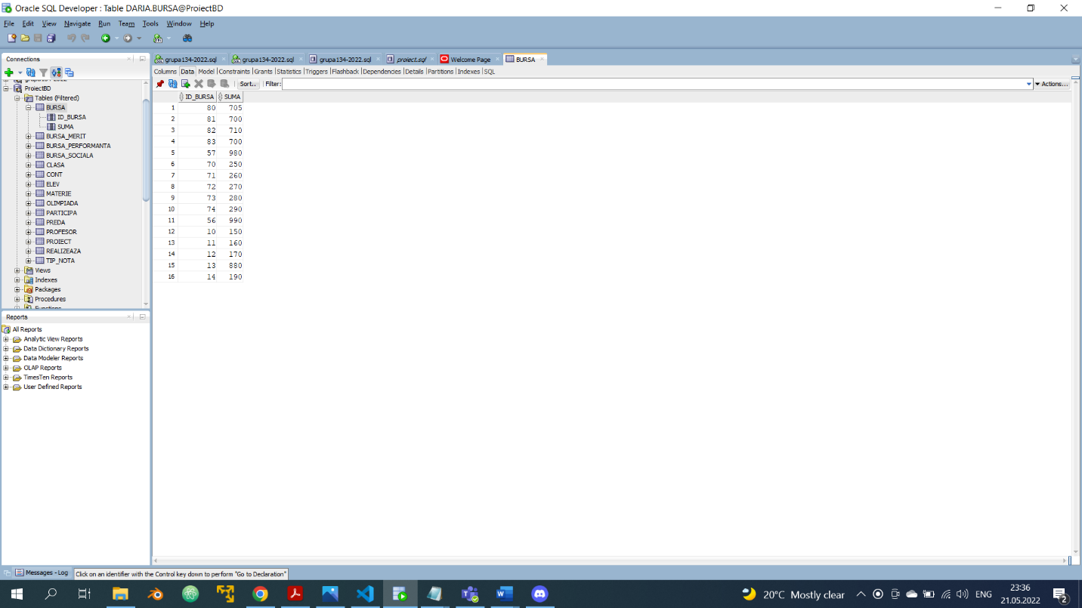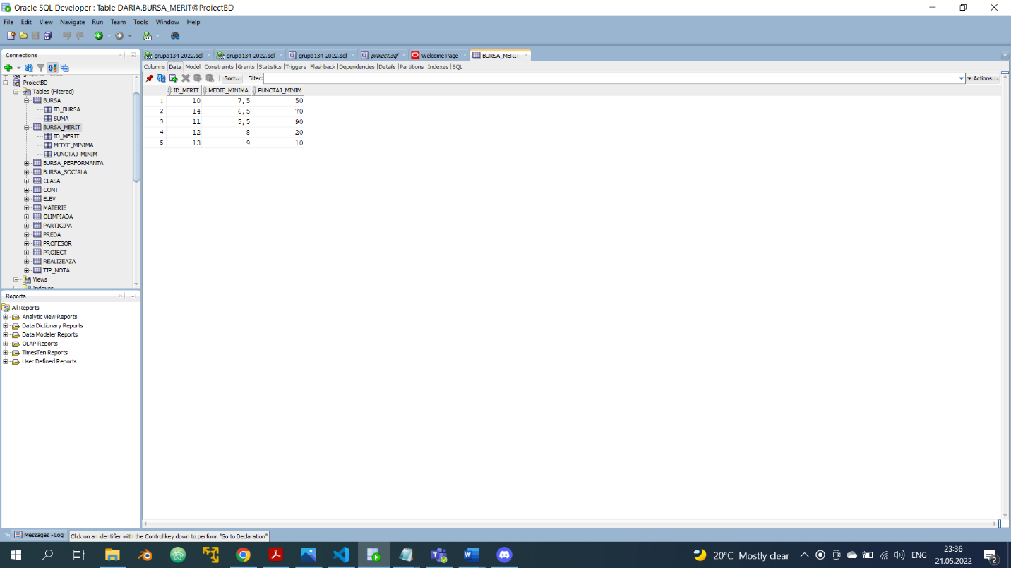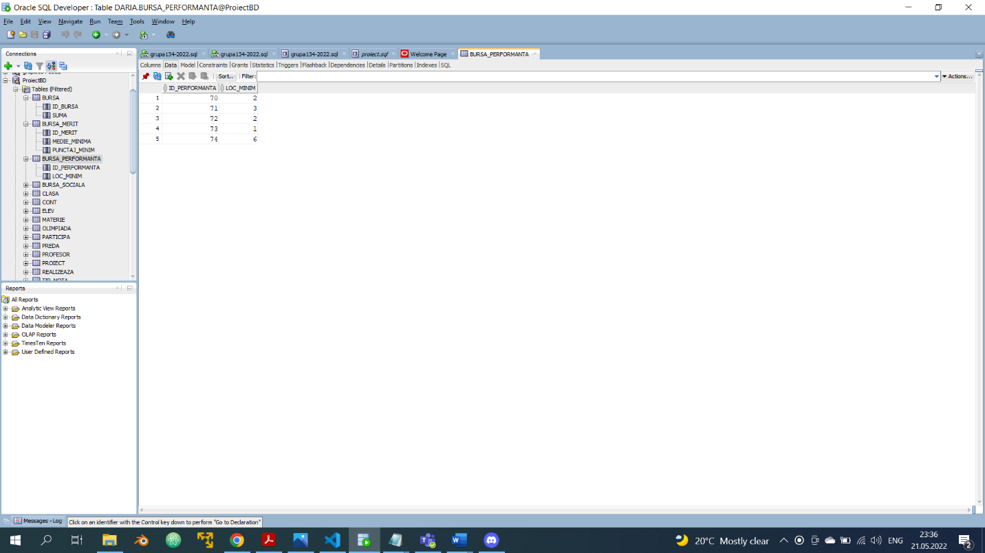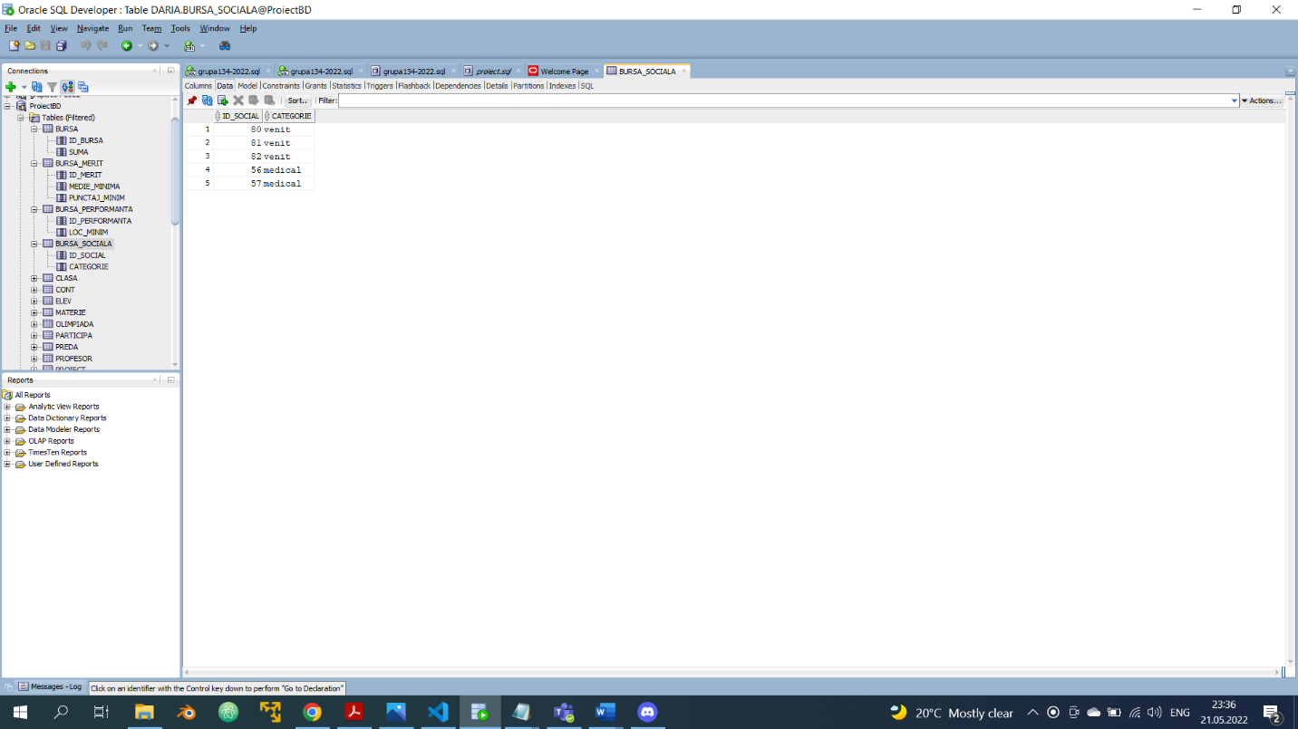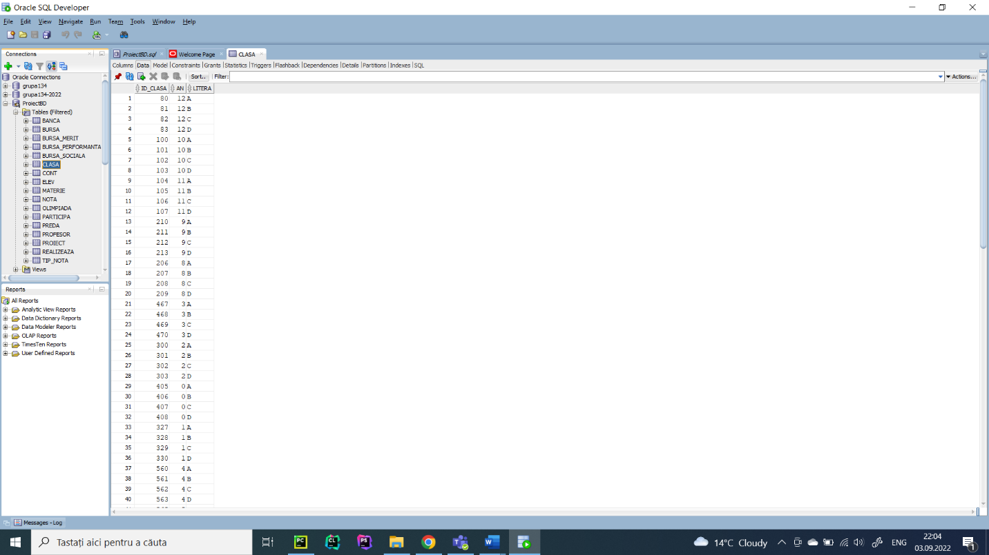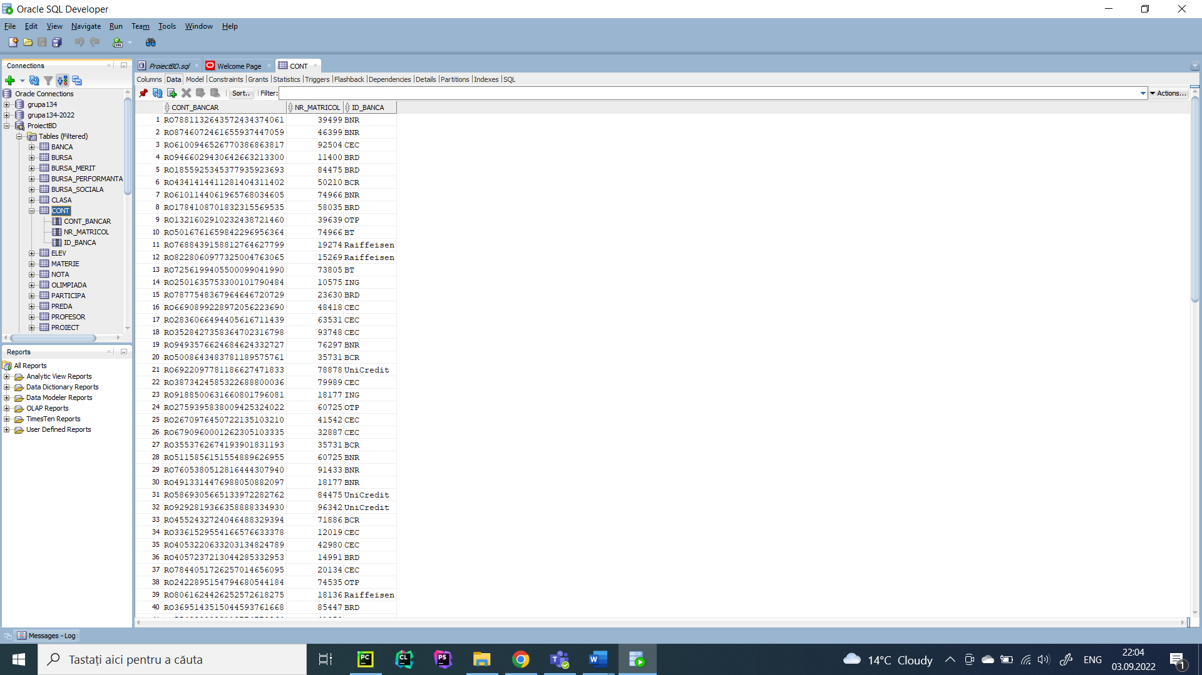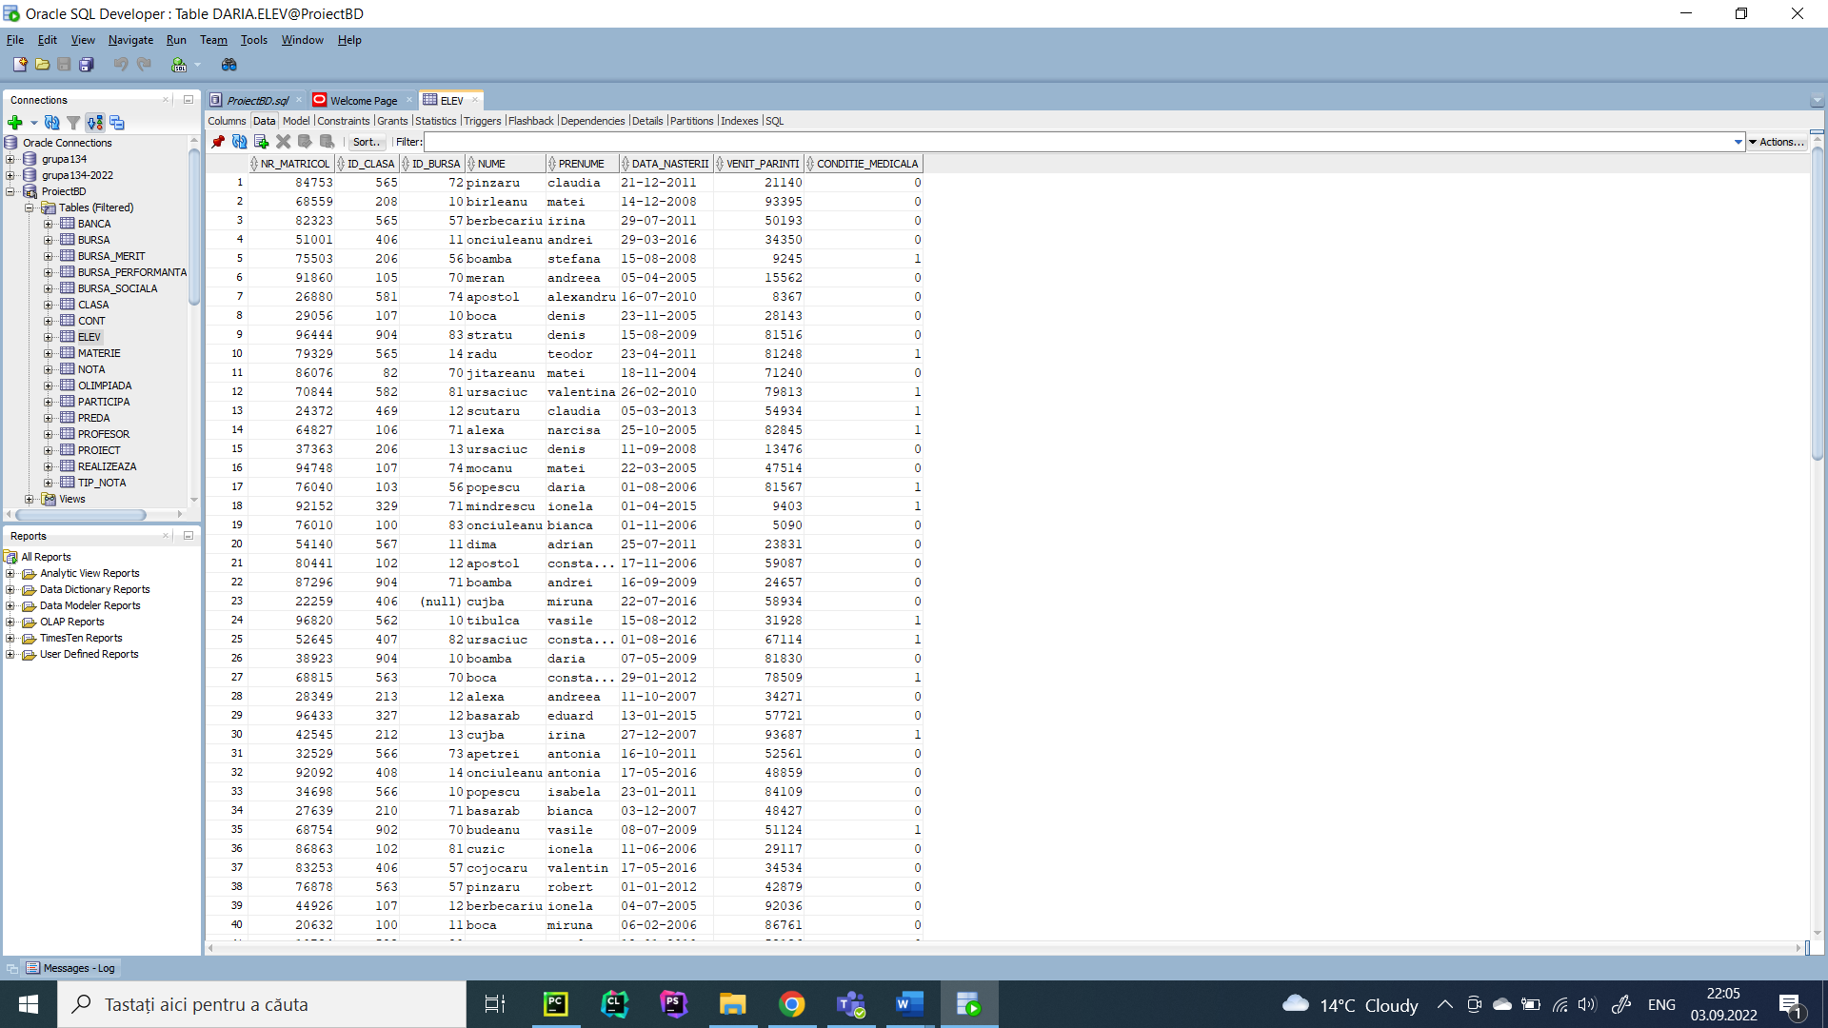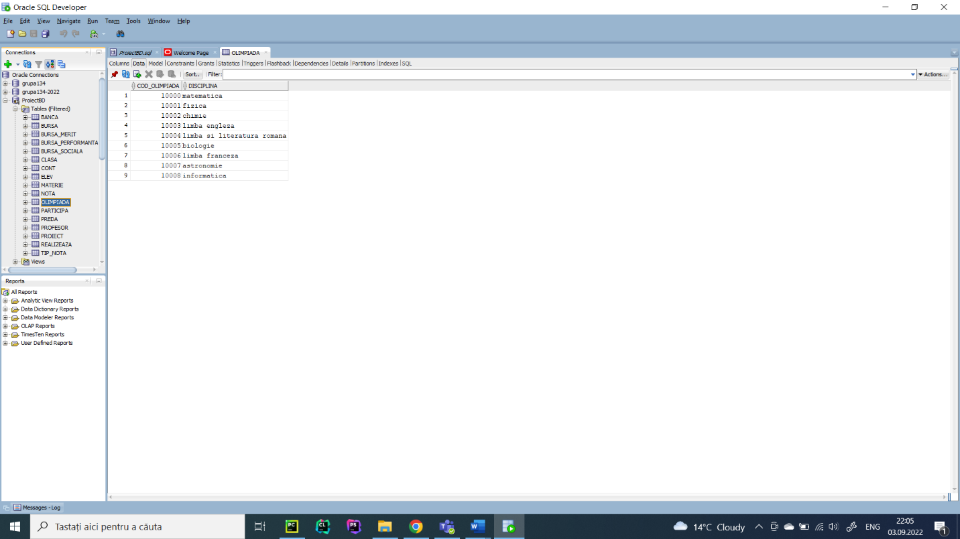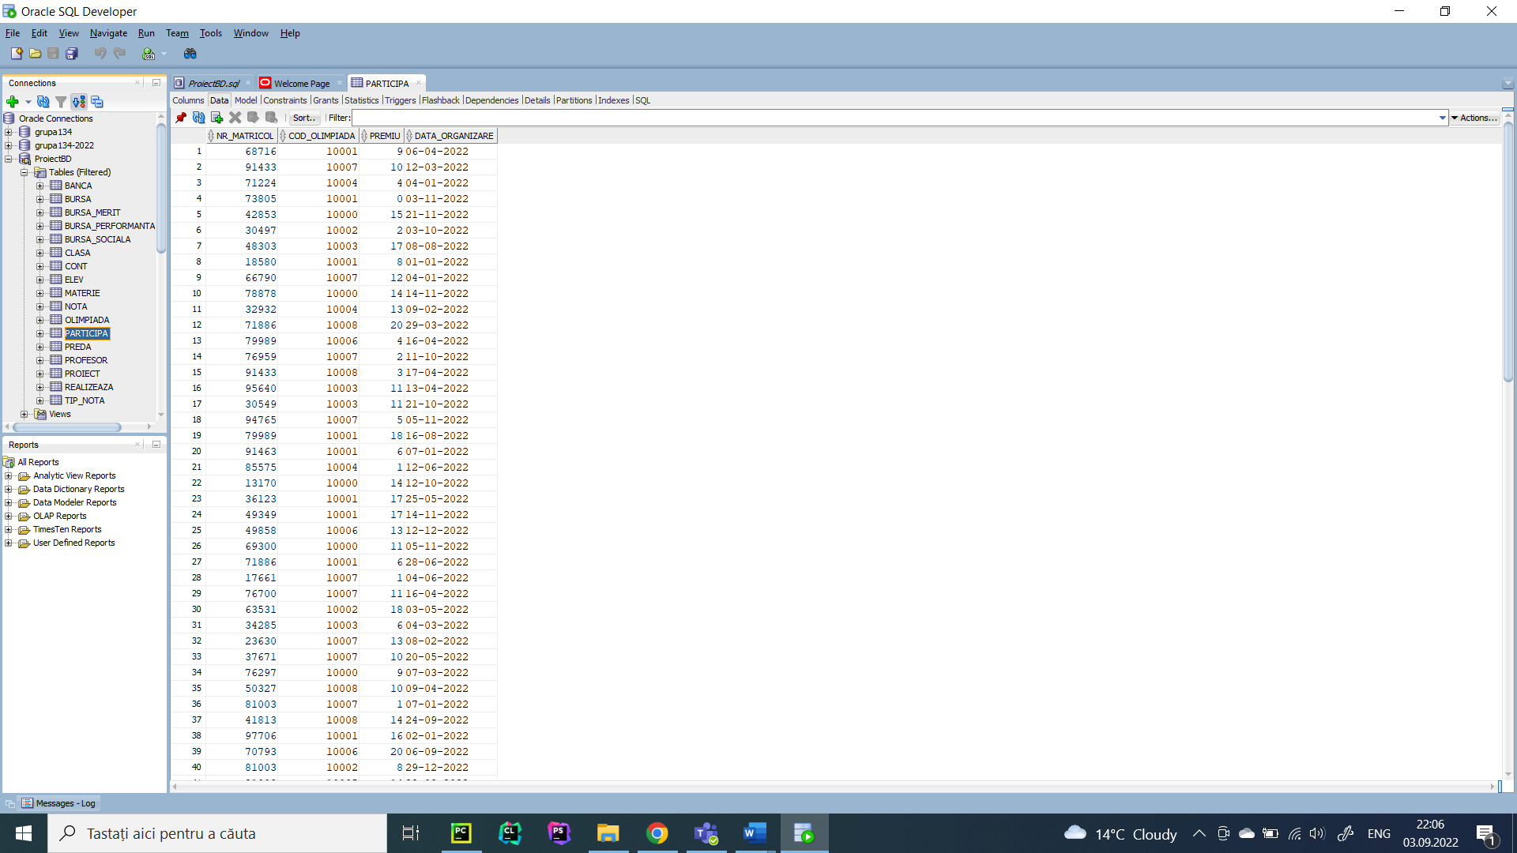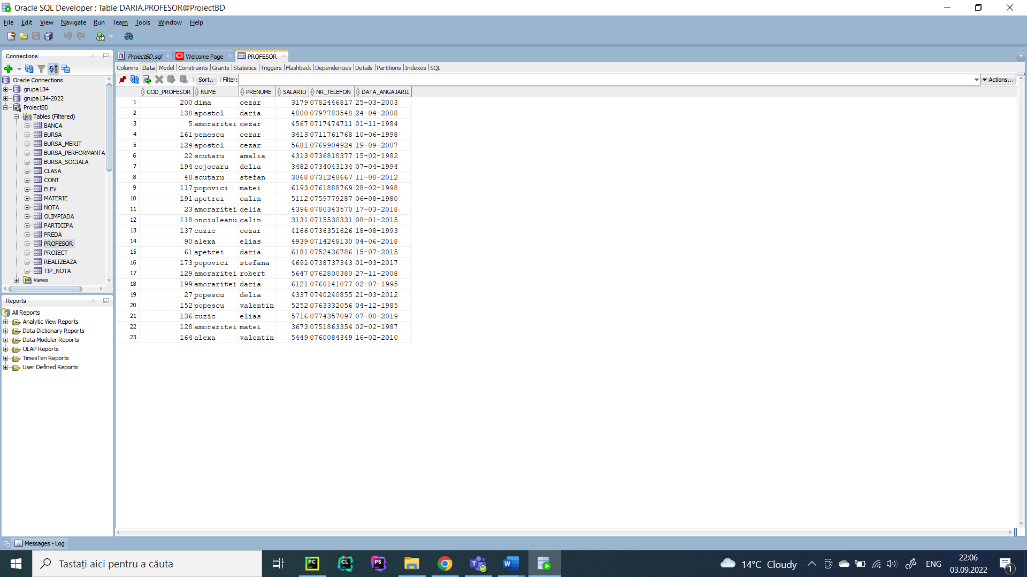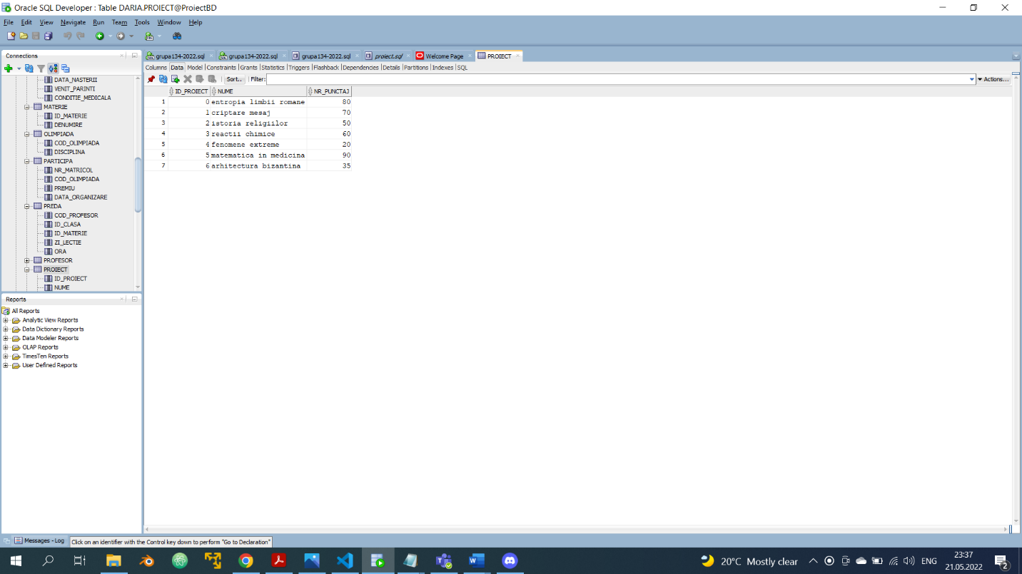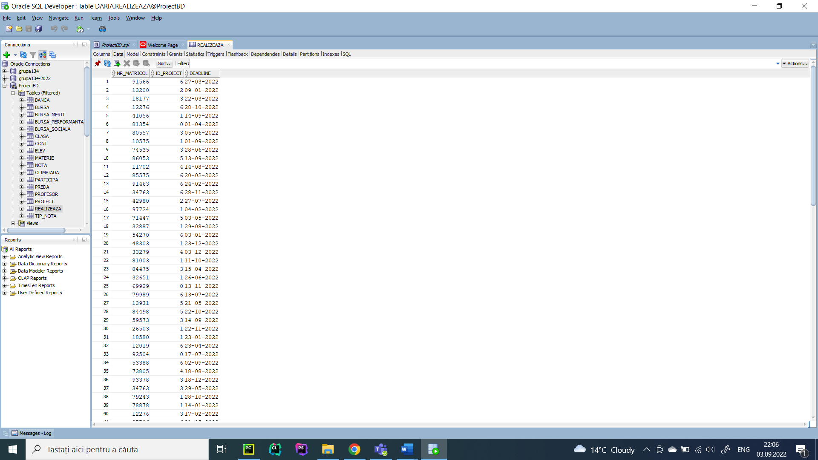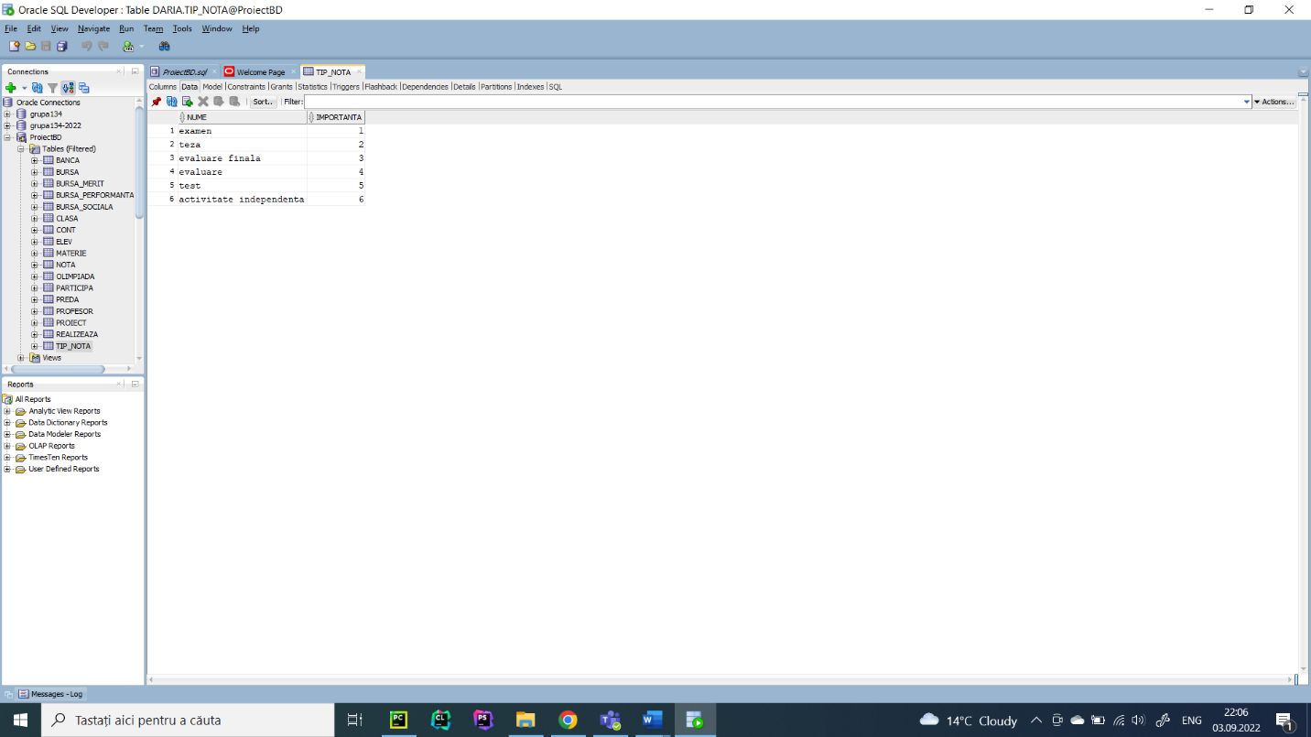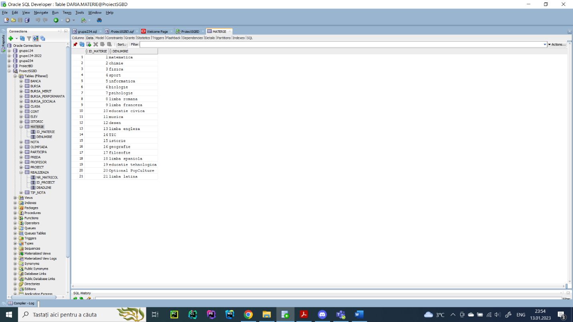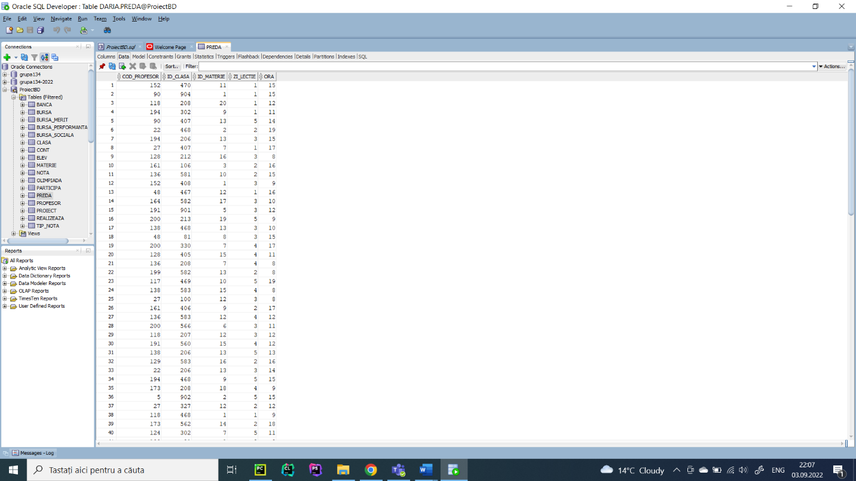

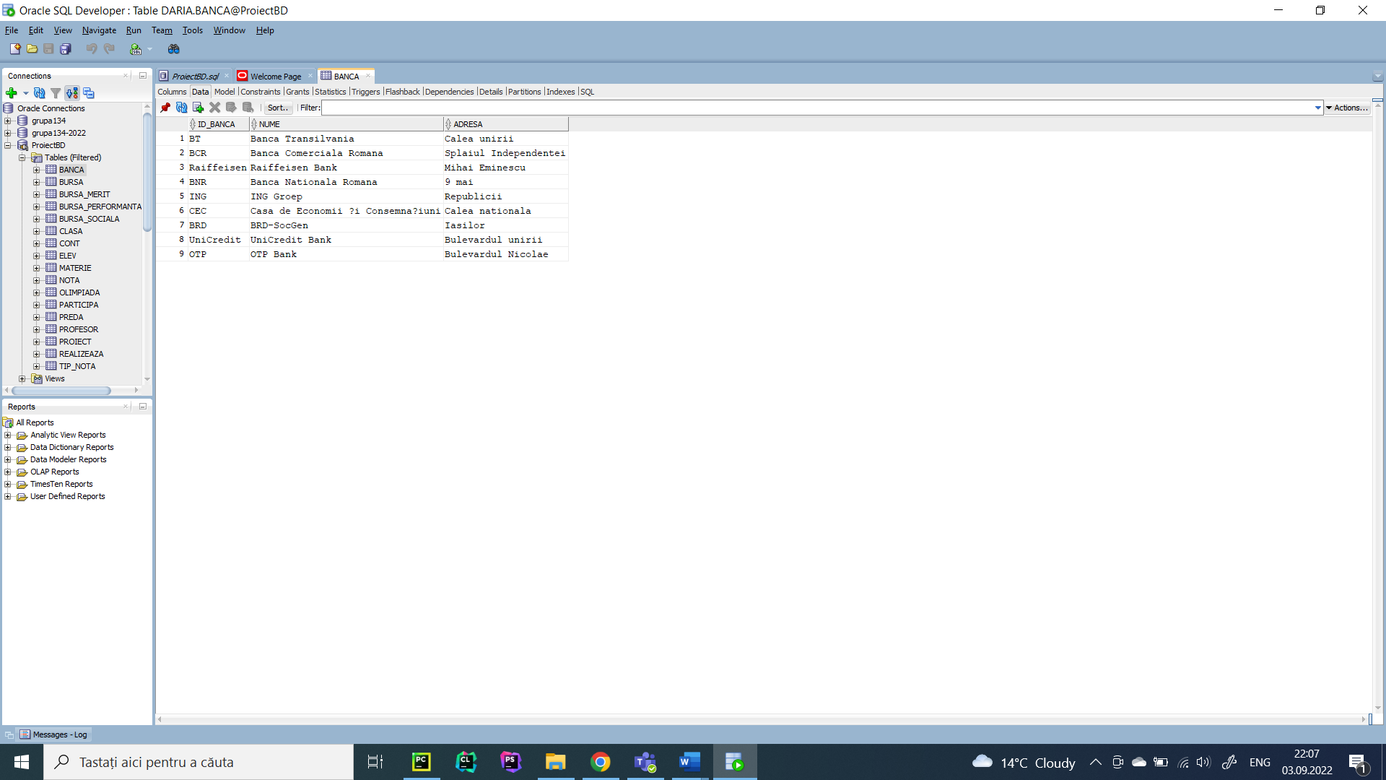

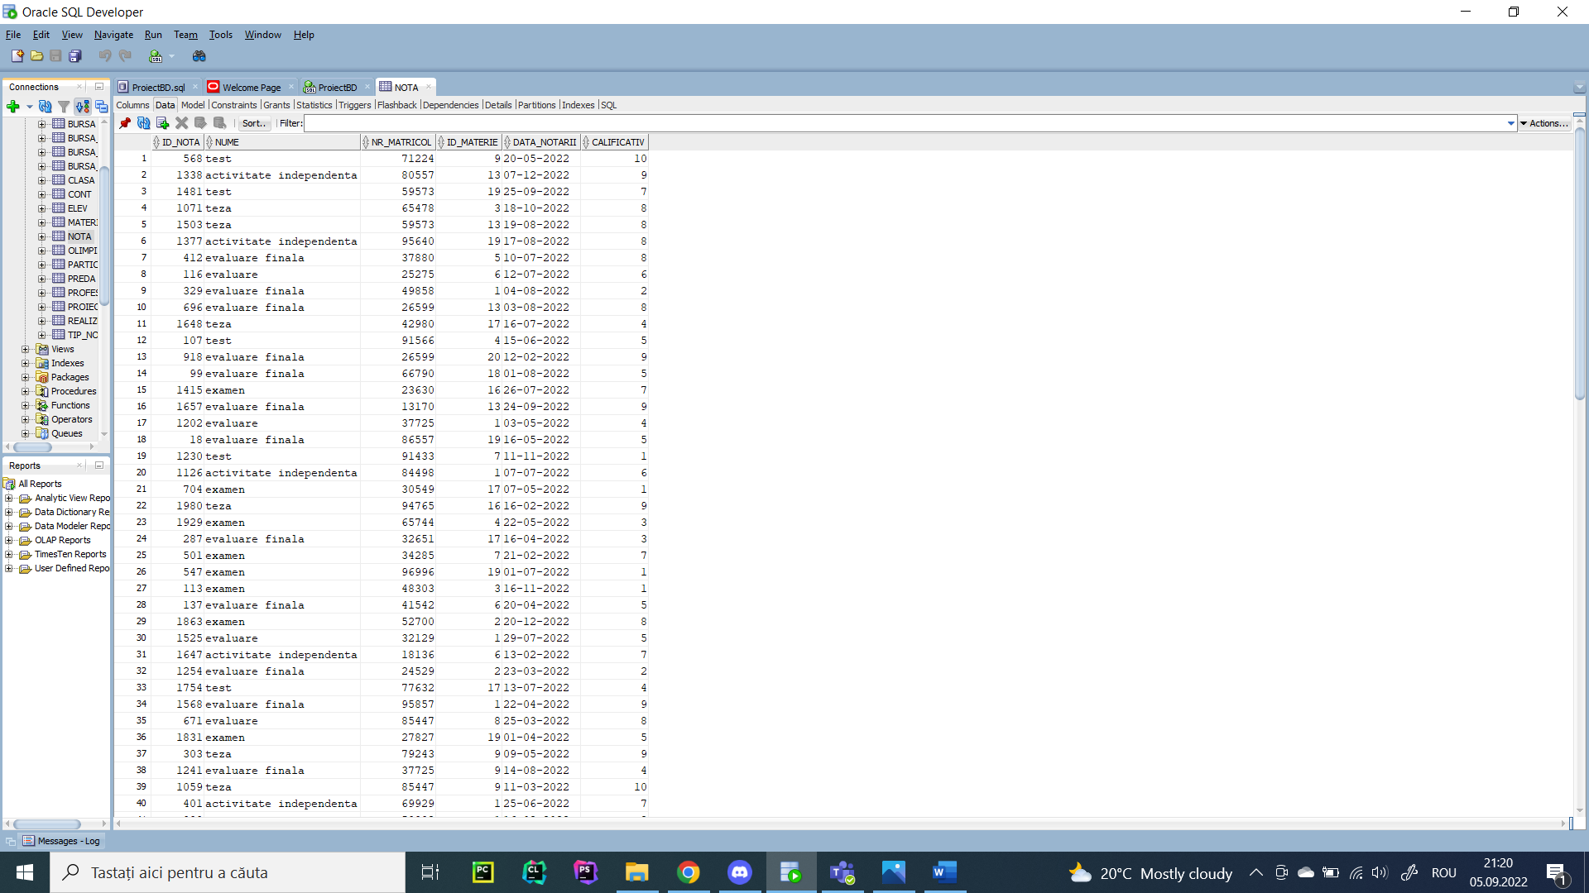

1. Formulați în limbaj natural o problemă pe care să o rezolvați folosind un subprogram stocat independent care să utilizeze două tipuri diferite de colecții studiate. Apelați subprogramul.

-- Sa se selecteze bursele sociale a caror suma este mai mare decat media tuturor burselor sociale. Pentru toti elevii care beneficiaza de o astfel de bursa, daca sufera de o conditie medicala sa li se afiseze numele, prenumele si clasa din care fac parte. Se vor afisa o singura data tipul de bursa si suma corespunzatoare, iar apoi bursierii. Daca nu sunt elevi se va afisa 'nu exista bursieri'.

create or replace procedure f1_burseSociale

is

type t_burse is

table of bursa_sociala % rowtype

index by pls_integer;

v_burse t_burse;

type t_elevi is

varray(1000) of elev % rowtype;

v_elevi t_elevi;

nivel clasa.an % type;

litera clasa.litera % type;

suma number := 0;

numarElevi number := 0;

begin

select bs.*

bulk collect into v_burse

from bursa_sociala bs, bursa b

where b.id_bursa = bs.id_social

and b.suma > (select avg(b2.suma)

from bursa b2, bursa_sociala bs2

where b2.id_bursa = bs2.id_social);

select e.*

bulk collect into v_elevi

from elev e

where e.conditie_medicala = 1;

if v_burse.count > 0 then

if v_elevi.count - 1000 > 0 then

for k in 0..v_elevi.count - 1000 loop

v_elevi.extend;

end loop;

end if;

for i in v_burse.first .. v_burse.last loop

select b.suma

into suma

from bursa b

where b.id_bursa = v_burse(i).id_social;

dbms_output.put_line('Id bursa: ' || v_burse(i).id_social || ', suma: ' || suma);

for j in v_elevi.first .. v_elevi.last loop

if v_elevi(j).id_bursa = v_burse(i).id_social then

numarElevi := numarElevi + 1;

select an, litera

into nivel, litera

from clasa

where v_elevi(j).id_clasa = clasa.id_clasa;

dbms_output.put_line(rpad(v_elevi(j).nume || ' ' || v_elevi(j).prenume, 30) || ' ' || nivel || litera);

end if;

end loop;

if numarElevi = 0 then

dbms_output.put_line('Nu exista bursieri');

end if;

dbms_output.put_line('----------------------------------------------');

end loop;

end if;

end;

/

exec f1_burseSociale;

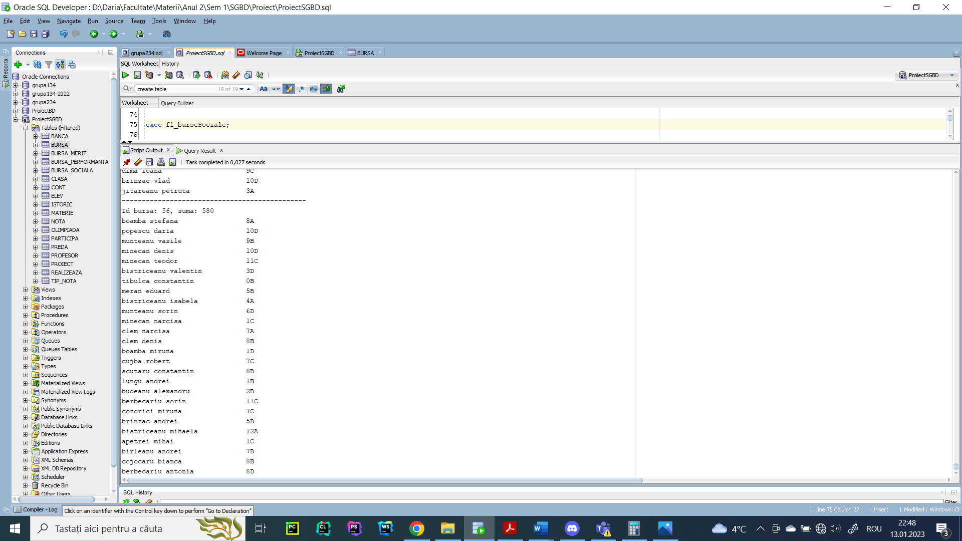

1. Formulați în limbaj natural o problemă pe care să o rezolvați folosind un subprogram stocat independent care să utilizeze 2 tipuri diferite de cursoare studiate, unul dintre acestea fiind cursor parametrizat. Apelați subprogramul.

-- Sa se afiseze pentru un anumit interval de nivele de studiu dat ca parametru profesorul (nume, prenume) care preda la cele mai multe clase. Pentru acesta sa se afiseze in ordine crescatoare dupa clasa elevii (nr matricol, nume, prenume, clasa) care fac parte din clasele la care preda si care au fost pe podium la olimpiadele scolare si numarul de elevi.

create or replace procedure f2_profesorNivel

(an1 clasa.an % type, an2 clasa.an % type)

is

cursor c_profesor (nivel clasa.an % type) is

select nume, prenume, cursor (

select distinct e.nr_matricol, nume, prenume, an, litera

from elev e, clasa c, participa oli

where e.id_clasa = c.id_clasa

and oli.nr_matricol = e.nr_matricol

and c.id_clasa in (select id_clasa

from preda

where cod_profesor = p.cod_profesor)

and oli.premiu < 4

order by an)

from profesor p

where p.cod_profesor in (select cod_profesor

from preda, clasa

where preda.id_clasa = clasa.id_clasa

and clasa.an = nivel

group by cod_profesor

having count(*) = (select max(count(*))

from preda, clasa

where preda.id_clasa = clasa.id_clasa

and clasa.an = nivel

group by cod_profesor));

type rc is ref cursor;

v_rc rc;

numeProfesor profesor.nume % type;

prenumeProfesor profesor.prenume % type;

matricolElev elev.nr_matricol % type;

numeElev elev.nume % type;

prenumeElev elev.prenume % type;

anElev clasa.an % type;

literaElev clasa.litera % type;

v_nrElevi number := 0;

begin

for i in an1 .. an2 loop

dbms_output.put_line('Anul de studiu ' || i || ':');

open c_profesor(i);

loop

fetch c_profesor into numeProfesor, prenumeProfesor, v_rc;

exit when c_profesor % notfound;

dbms_output.put_line('Profesor: ' || initcap(numeProfesor) || ' ' || initcap(prenumeProfesor));

dbms_output.put_line(rpad('Nr.', 5) || ' ' || rpad('Nume', 30) || ' ' || 'Clasa');

v_nrElevi := 0;

loop

fetch v_rc into matricolElev, numeElev, prenumeElev, anElev, literaElev;

exit when v_rc % notfound;

dbms_output.put_line(matricolElev || ' ' || rpad(initcap(numeElev) || ' ' || initcap(prenumeElev), 30) || ' ' || anElev || literaElev);

v_nrElevi := v_nrElevi + 1;

end loop;

if v_nrElevi > 0 then

dbms_output.put_line('Numar elevi: ' || v_nrElevi);

else

dbms_output.put_line('Nu exista elevi premianti pe nivelul de studiu dat cu acest profesor');

end if;

end loop;

close c_profesor;

dbms_output.put_line('---------------------------');

end loop;

end;

/

exec f2_profesorNivel(7, 12);

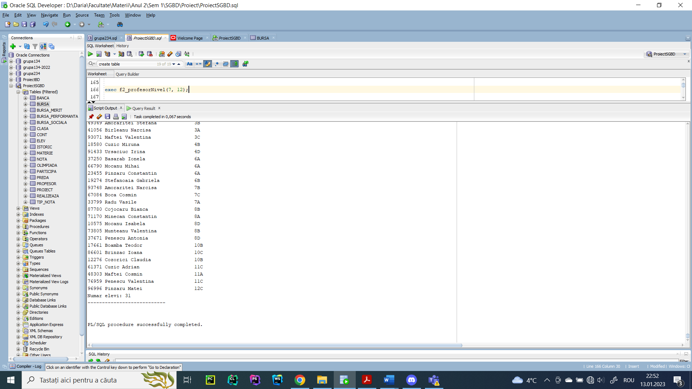

1. Formulați în limbaj natural o problemă pe care să o rezolvați folosind un subprogram stocat independent de tip funcție care să utilizeze într-o singură comandă SQL 3 dintre tabelele definite. Definiți minim 2 excepții. Apelați subprogramul astfel încât să evidențiați toate cazurile tratate.

-- Sa se returneze id-ul profesorulului care ia cel mai mic salariu si care preda o materie data ca parametru.

create or replace function f3_idProfesori

(v_materie materie.denumire % type)

return profesor.cod_profesor % type is

v_id profesor.cod_profesor % type;

v_exista number := 0;

begin

select count(*)

into v_exista

from materie

where upper(denumire) = upper(v_materie);

if v_exista = 0 then

raise_application_error(-20001, 'Nu exista materia data ca parametru.');

end if;

select distinct prof.cod_profesor

into v_id

from profesor prof, preda pr, materie m

where salariu = (select min(salariu)

from profesor prof2, preda pr2, materie mat2

where prof2.cod_profesor = pr2.cod_profesor

and pr2.id_materie = mat2.id_materie

and upper(mat2.denumire) = upper(v_materie)

)

and prof.cod_profesor = pr.cod_profesor

and pr.id_materie = m.id_materie

and upper(m.denumire) = upper(v_materie);

return v_id;

exception

when no_data_found then

raise_application_error(-20001, 'Niciun profesor nu preda materia data.');

when too_many_rows then

raise_application_error(-20002, 'Mai multi profesori care predau ' || v_materie || ' au salariul minim.');

end f3_idProfesori;

/

begin

dbms_output.put_line(f3_idProfesori('limba romana'));

end;

/

begin

dbms_output.put_line(f3_idProfesori('matematica'));

end;

/

begin

dbms_output.put_line(f3_idProfesori('limba germana'));

end;

/

begin

dbms_output.put_line(f3_idProfesori('limba latina'));

end;/

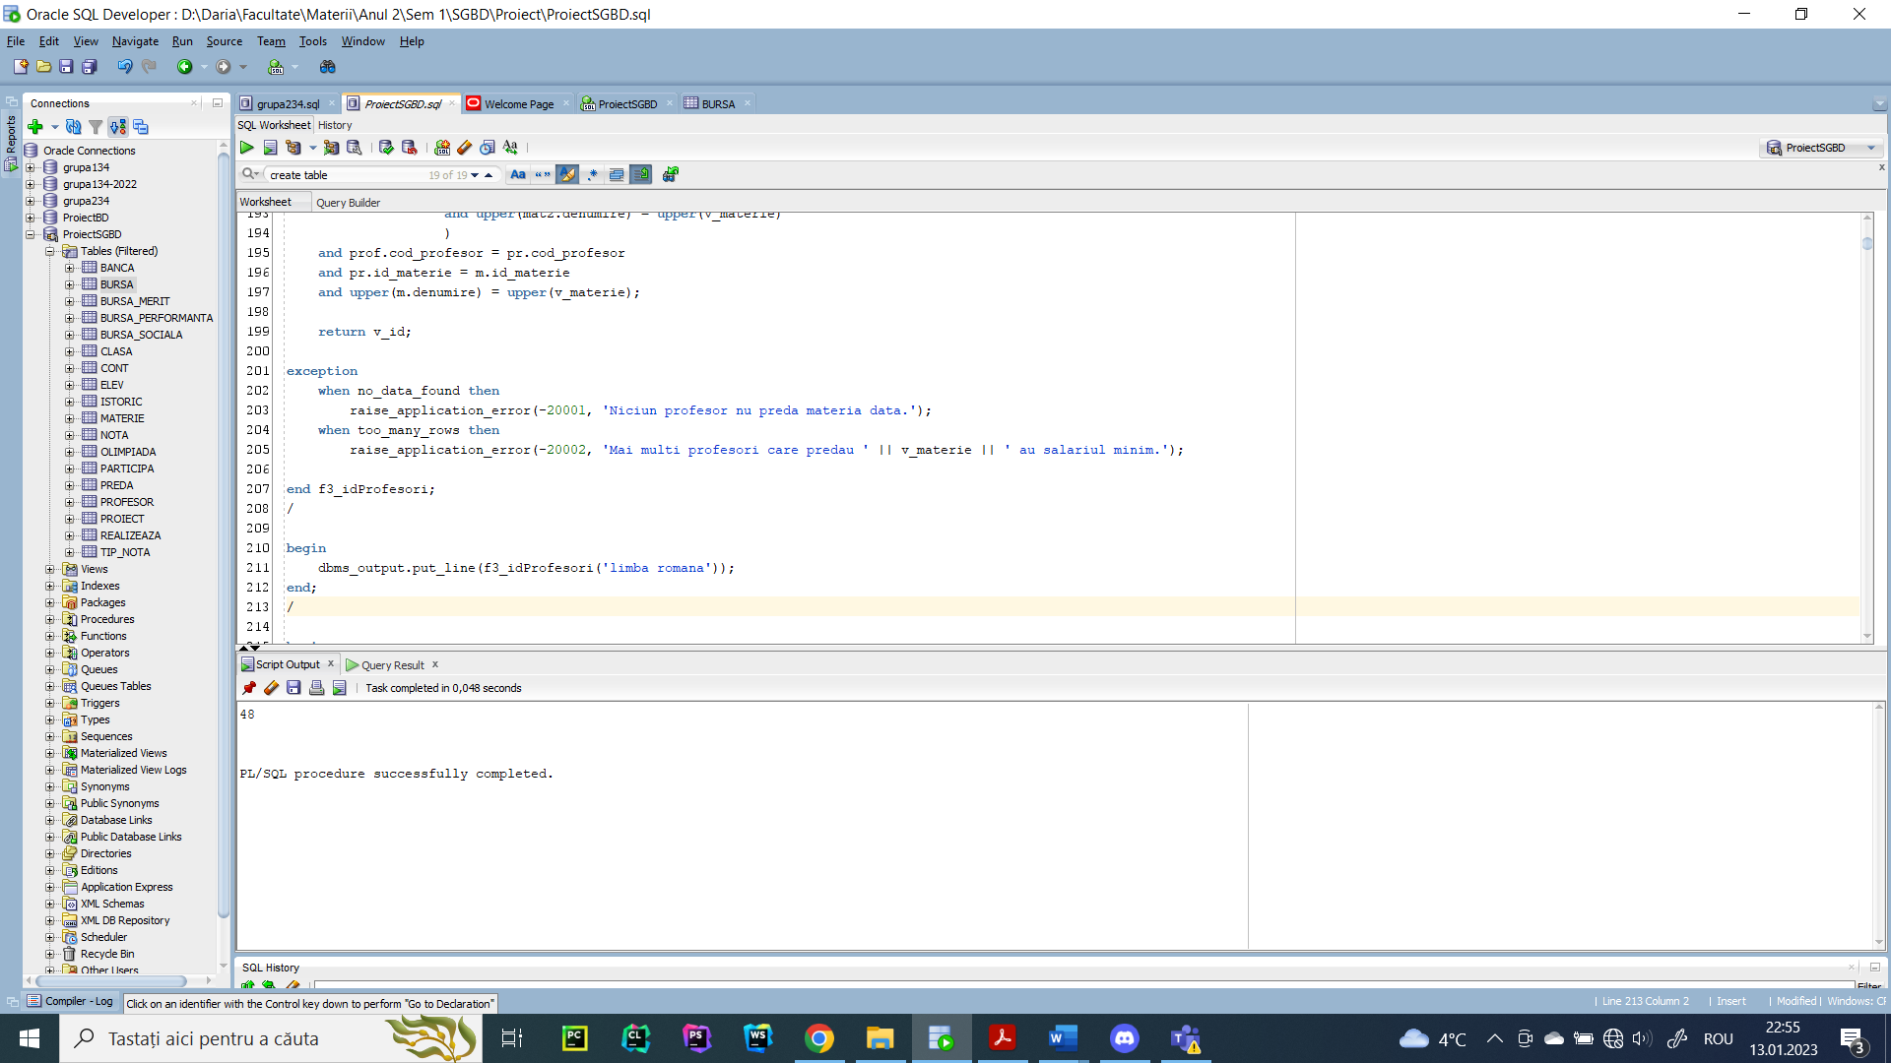

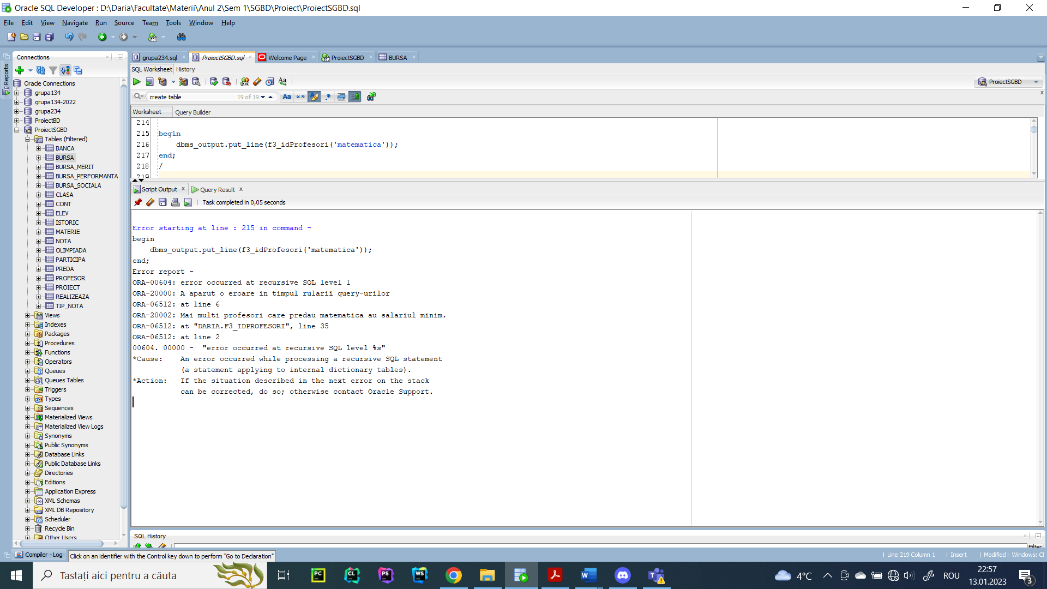

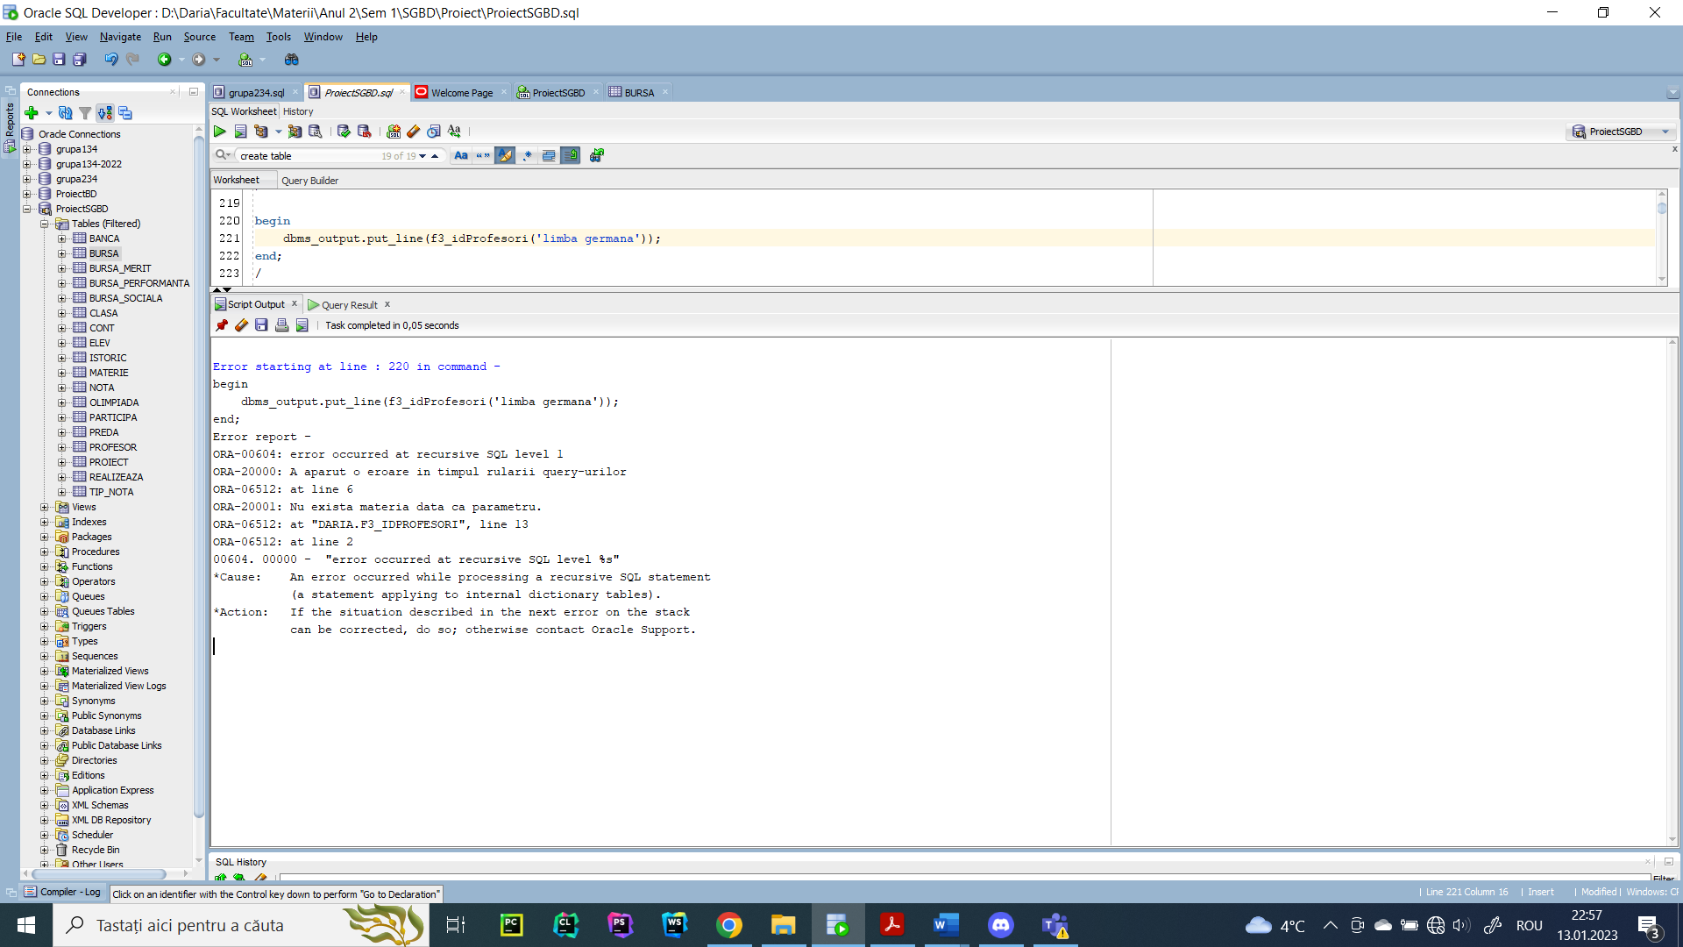

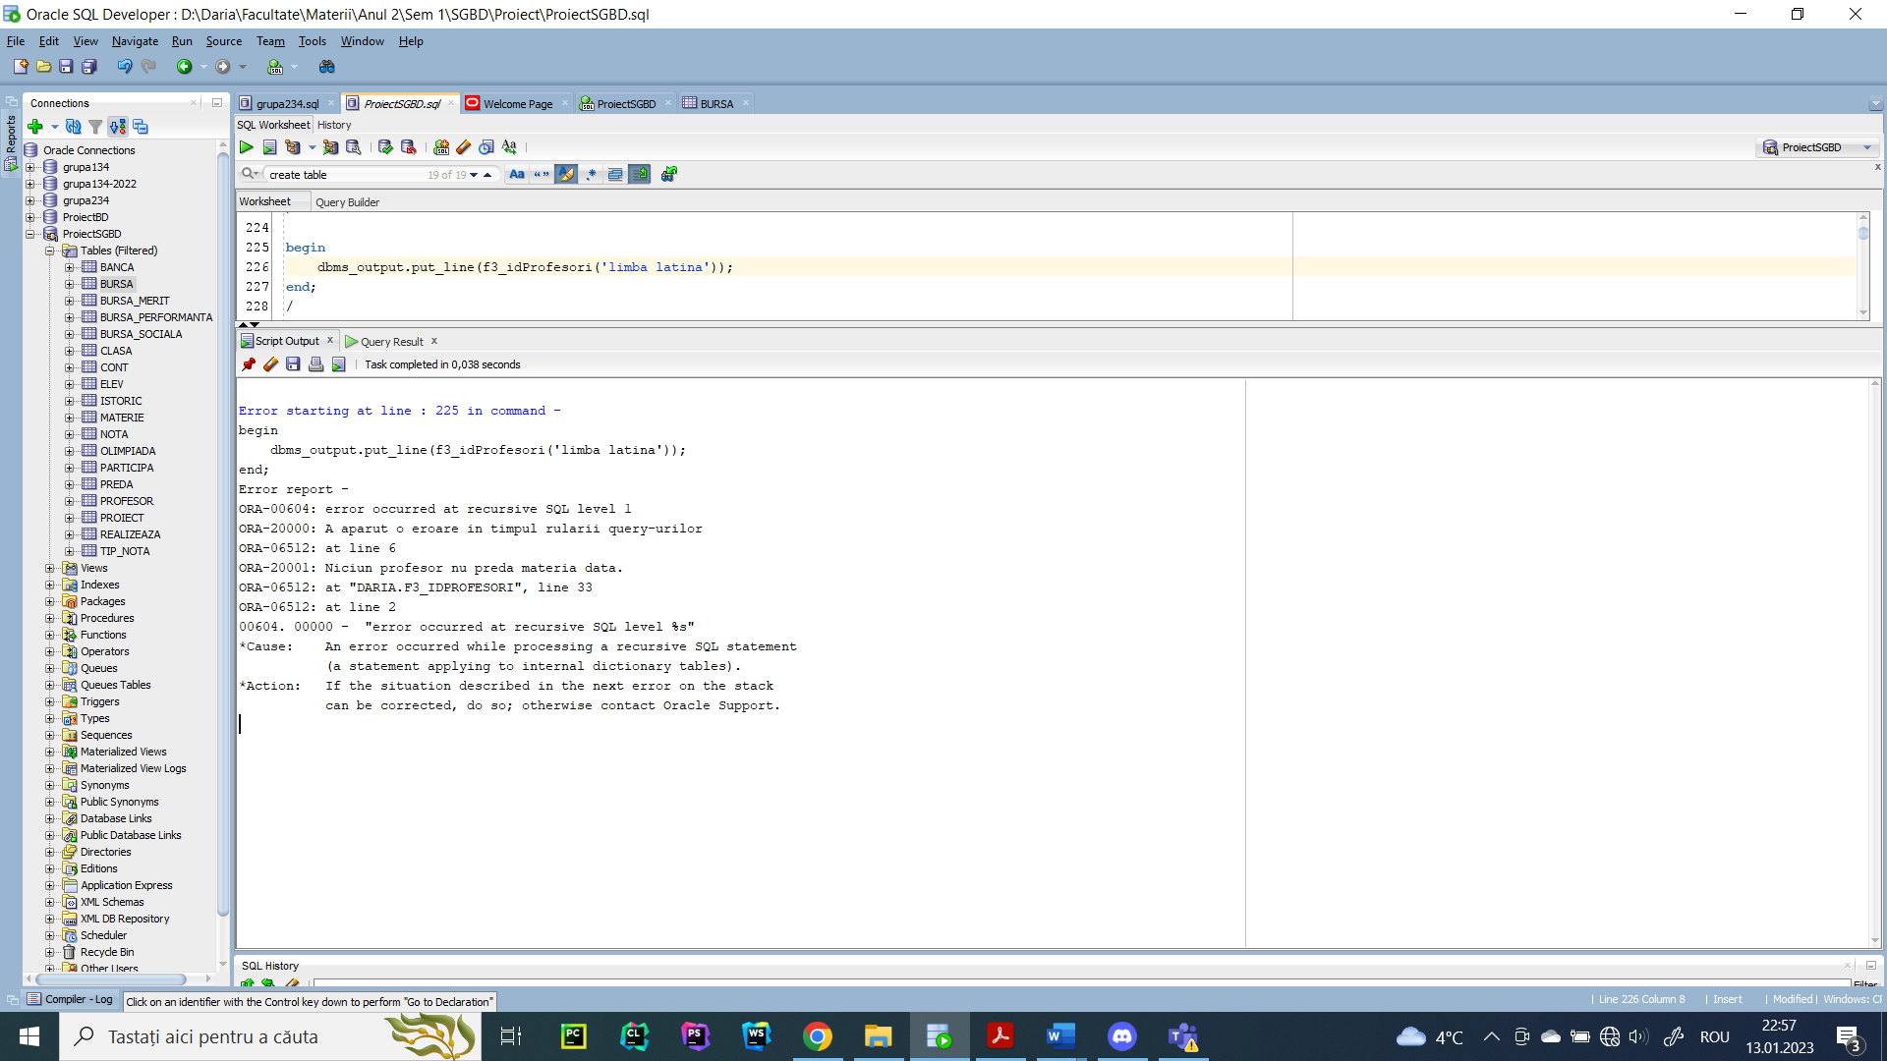

1. Formulați în limbaj natural o problemă pe care să o rezolvați folosind un subprogram stocat independent de tip procedură care să utilizeze într-o singură comandă SQL 5 dintre tabelele definite. Tratați toate excepțiile care pot apărea, incluzând excepțiile NO_DATA_FOUND și TOO_MANY_ROWS. Apelați subprogramul astfel încât să evidențiați toate cazurile tratate.

-- Sa se afiseze banca la care are cont elevul care a realizat cele mai multe proiecte cu deadline-ul dupa o data data ca parametru si care are insumat cel mai mare punctaj. Sa se trateze cazurile in care:

-- 1) Nu exista proiecte cu deadline-ul dupa data data ca parametru

-- 2) Nu exista elevi care sa realizeze numarul maxim de proiecte si cu punctaj maxim (un elev poate sa aiba punctaj maxim, dar cu nr. minim de proiecte sau sa realizeze un punctaj minim, dar cu numar maxim de proiecte)

-- 3) Sunt prea multi elevi care au punctaj maxim si au realizat un numar maxim de proiecte.

-- 4) Elevul are prea multe conturi.

-- 5) Elevul nu are cont la nicio banca.

create or replace procedure f4_contBancar

(v_data realizeaza.deadline % type)

is

v_exista number := 0;

v_bancaNume banca.nume % type;

begin

select count(*)

into v_exista

from realizeaza

where deadline > v_data;

if v_exista = 0 then

raise_application_error(-20001, 'Nu exista niciun proiect cu deadline-ul dupa data data ca parametru');

end if;

v_exista := 0;

select count(*)

into v_exista

from (select r2.nr_matricol

from realizeaza r2, proiect p

where p.id_proiect = r2.id_proiect

and r2.deadline > v_data

group by r2.nr_matricol

having count(*) = (select max(count(*))

from realizeaza r3

where r3.deadline > v_data

group by r3.nr_matricol)

and sum(nr_punctaj) = (select max(sum(nr_punctaj))

from realizeaza r3, proiect p2

where p2.id_proiect = r3.id_proiect

and r3.deadline > v_data

group by r3.nr_matricol));

if v_exista = 0 then

raise_application_error(-20002, 'Nu exista elevi care sa obtina punctaj maxim cu numar maxim de proiecte');

elsif v_exista > 1 then

raise_application_error(-20003, 'Sunt prea multi elevi care au obtinut punctaj maxim cu numar maxim de proiecte');

end if;

select b.nume

into v_bancaNume

from banca b, cont c, elev e

where b.id_banca = c.id_banca

and e.nr_matricol = c.nr_matricol

and e.nr_matricol in (select r2.nr_matricol

from realizeaza r2, proiect p

where p.id_proiect = r2.id_proiect

and r2.deadline > v_data

group by r2.nr_matricol

having count(*) = (select max(count(*))

from realizeaza r3

where r3.deadline > v_data

group by r3.nr_matricol)

and sum(nr_punctaj) = (select max(sum(nr_punctaj))

from realizeaza r3, proiect p2

where p2.id_proiect = r3.id_proiect

and r3.deadline > v_data

group by r3.nr_matricol));

dbms_output.put_line('Banca la care are deschis contul elevul este ' || v_bancaNume);

exception

when no_data_found then

raise_application_error(-20004, 'Elevul nu are cont deschis la nicio banca');

when too_many_rows then

raise_application_error(-20005, 'Elevul are conturi deschise la mai multe banci');

end;

/

begin

f4_contBancar('01-12-2022');

end;

/

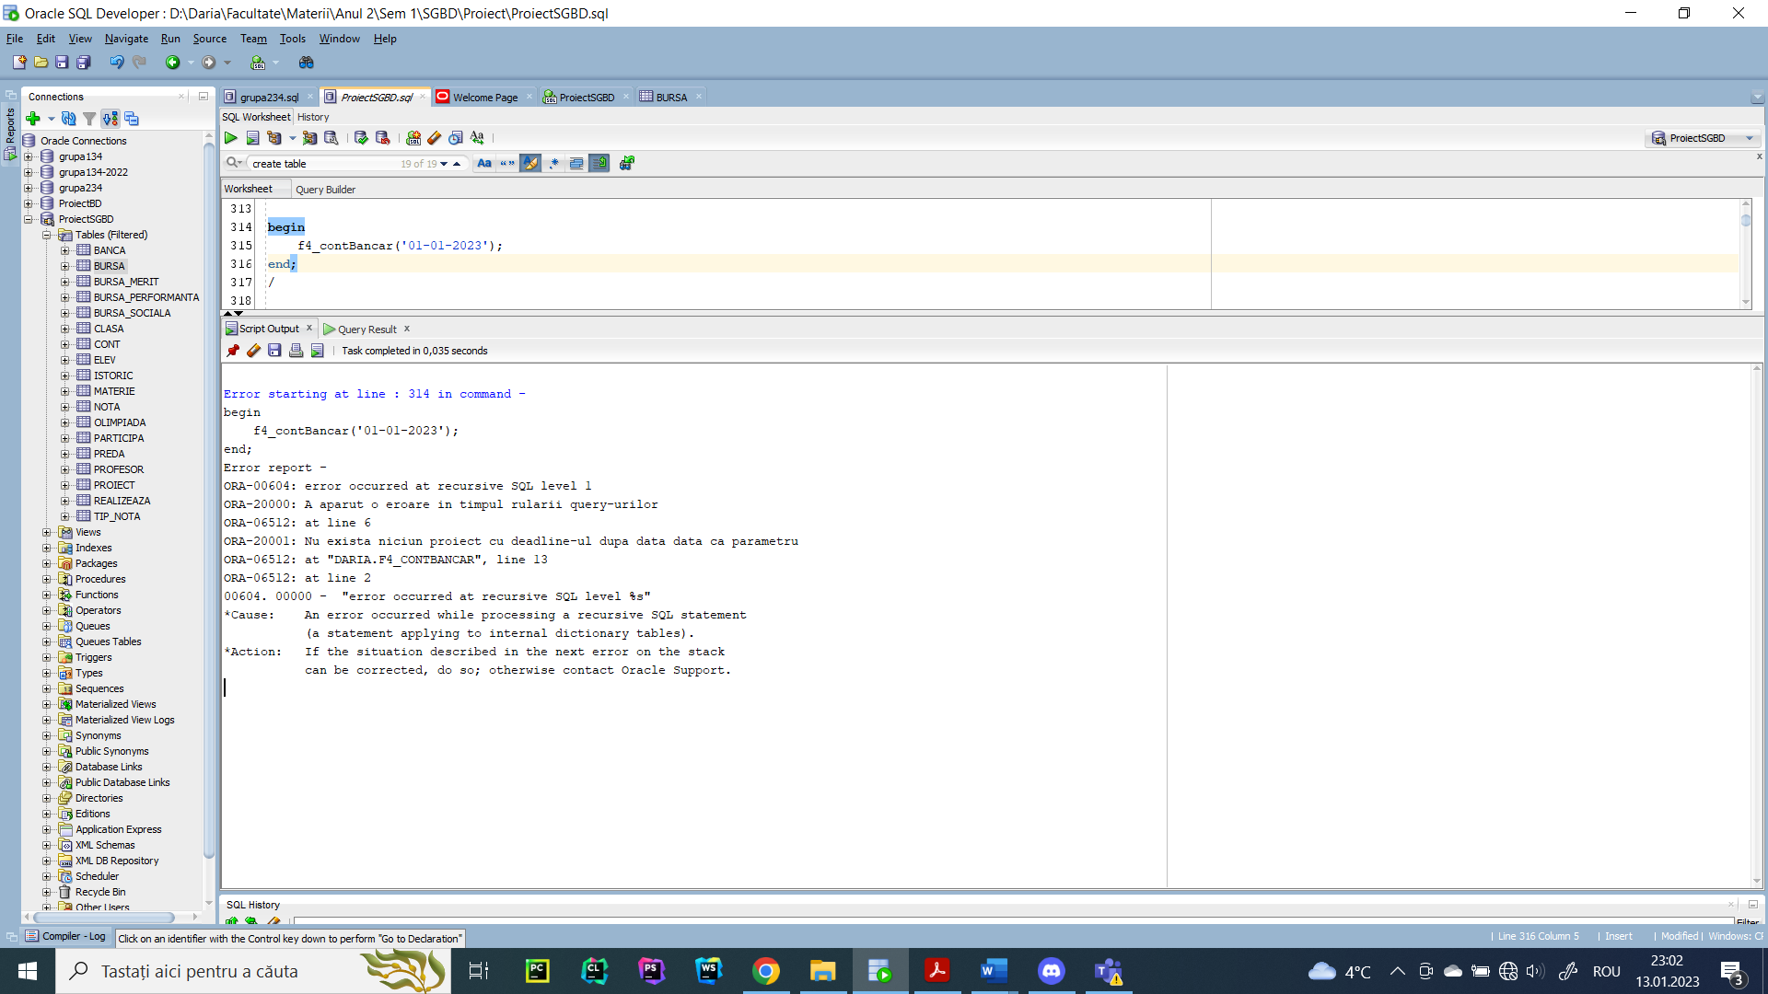

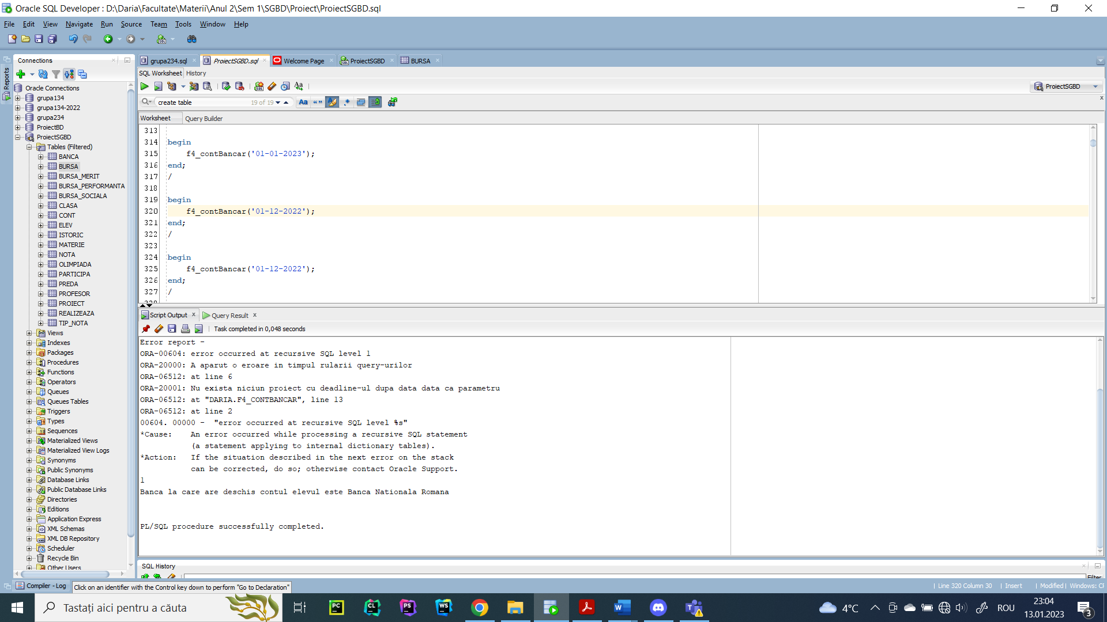

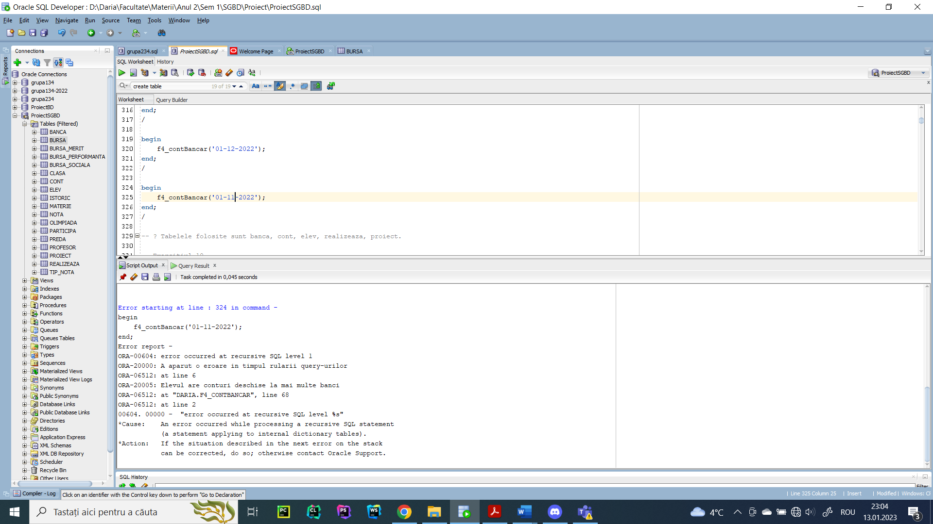

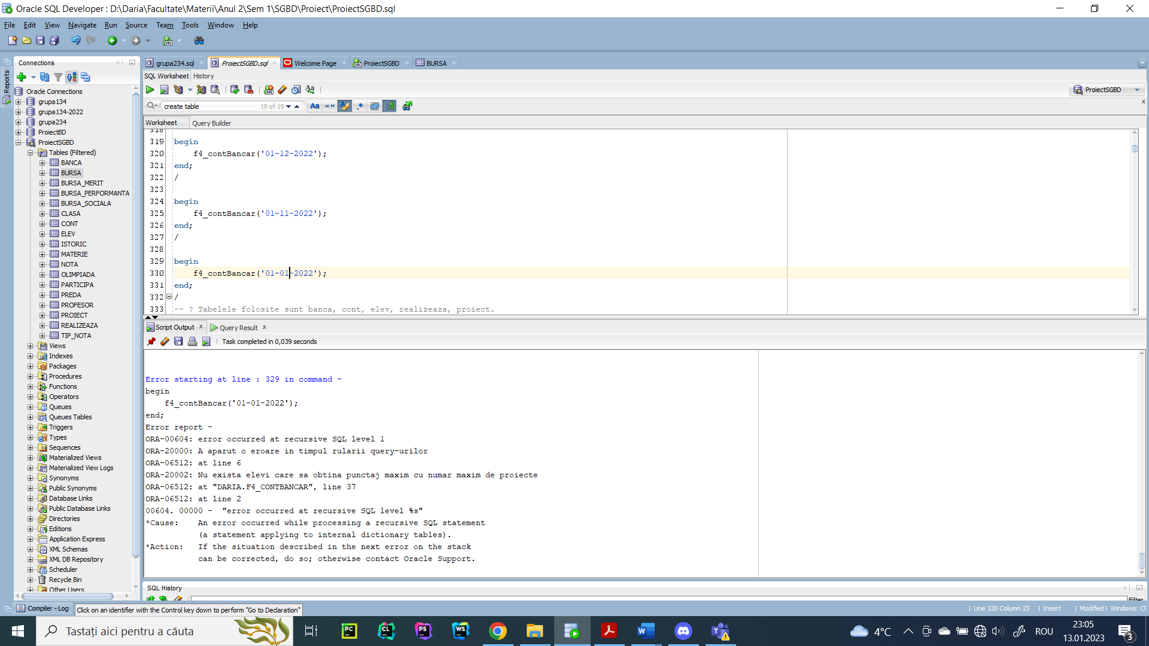

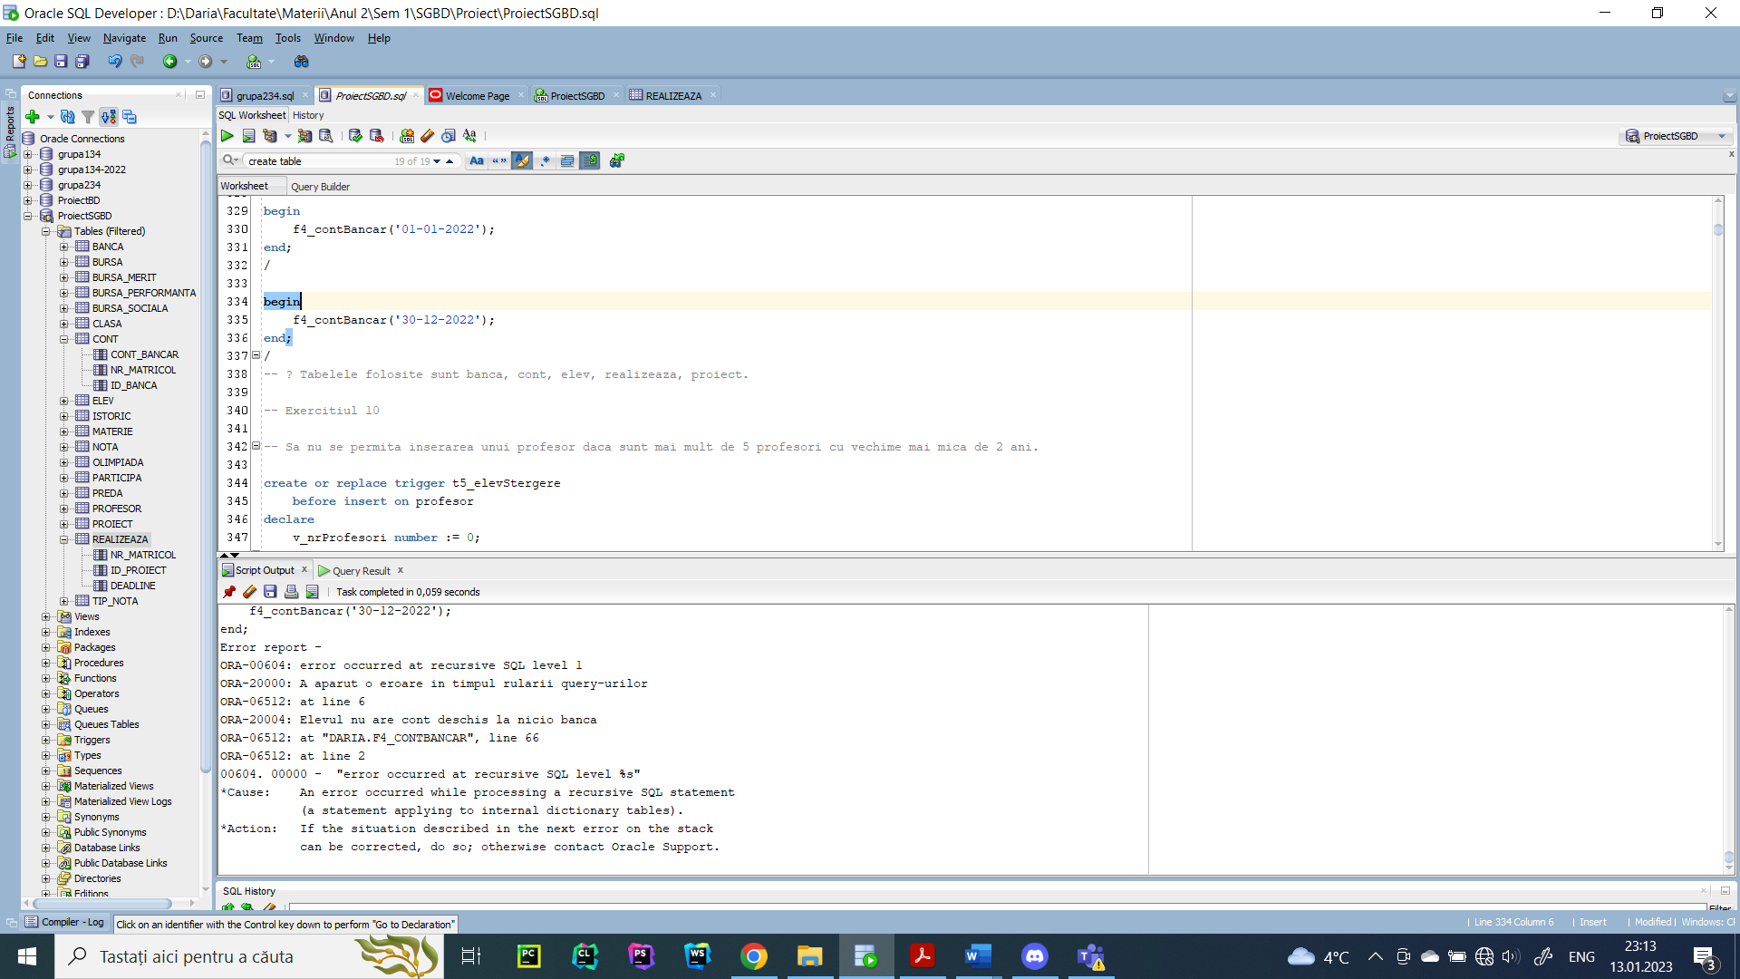

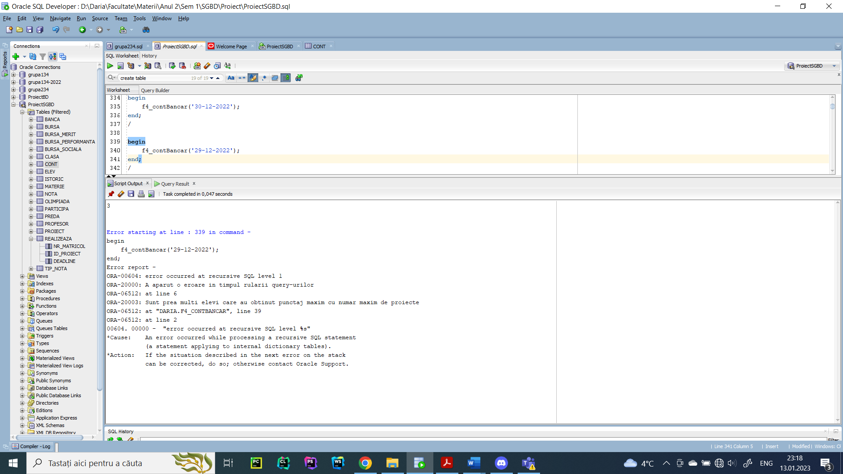

1. Definiți un trigger de tip LMD la nivel de comandă. Declanșați trigger-ul.

-- Sa nu se permita inserarea unui profesor daca sunt mai mult de 5 profesori cu vechime mai mica de 2 ani.

create or replace trigger t5_elevStergere

before insert on profesor

declare

v_nrProfesori number := 0;

v_medie number := 0;

begin

select count(*)

into v_nrProfesori

from profesor

where 2 > (select extract(year from sysdate) - extract(year from to_date(data_angajarii))

from dual);

if v_nrProfesori >= 3 then

raise_application_error(-20000, 'Exista deja 3 profesori cu vechime mai mica de 2 ani');

end if;

end;

/

-- declansare trigger

insert into PROFESOR values (243, 'stejar', 'tiberiu', 3360, '0760586904', sysdate);

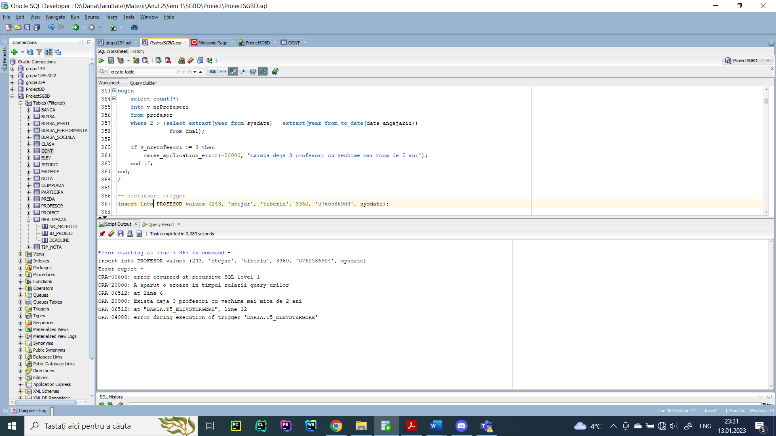

1. Definiți un trigger de tip LMD la nivel de linie. Declanșați trigger-ul.

create or replace trigger t6_profesorSalariu

before update of salariu on profesor

for each row

declare

v_data number;

v_opt number := 0;

begin

if :old.salariu > 5000 then

raise_application_error(-20000, 'Profesorul ' || initcap(:old.nume) || ' ' || initcap(:old.prenume) || ' are un salariu initial mai mare decat 5000 de lei.');

end if;

select (extract(year from sysdate) - extract(year from :old.data_angajarii))

into v_data

from dual;

if v_data < 2 then

raise_application_error(-20001, 'Profesorul ' || initcap(:old.nume) || ' ' || initcap(:old.prenume) || ' are vechime mai mica de 2 ani.');

end if;

select count(*)

into v_opt

from materie m, preda pr

where :old.cod_profesor = pr.cod_profesor

and m.id_materie = pr.id_materie

and lower(m.denumire) like 'optional%';

if v_opt > 0 then

raise_application_error(-20002, 'Profesorul ' || initcap(:old.nume) || ' ' || initcap(:old.prenume) || ' preda un optional.');

end if;

end;

/

update profesor set salariu = salariu + (15 * salariu) / 100;

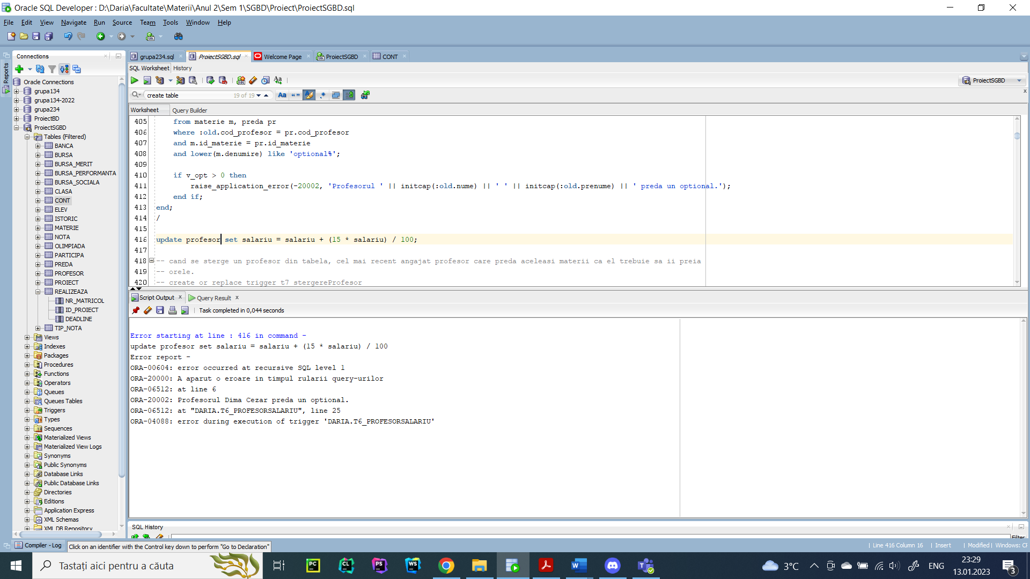

1. Definiți un trigger de tip LDD. Declanșați trigger-ul.

-- Sa se introduca in tabelul istoric doar comenzile care au avut loc fara erori, erorile fiind avertizate printr-un mesaj

create table istoric

(utilizator varchar2(30),

eveniment varchar2(30),

data date);

create or replace trigger t7_erori

after create or alter or drop or servererror on database

begin

if dbms_utility.format_error_stack is null then

insert into istoric

values (sys.login_user, sys.sysevent, sysdate);

else

raise_application_error(-20000, 'A aparut o eroare in timpul rularii query-urilor');

end if;

end;

/

create table test(nr number);

alter table test add(nume varchar2(30));

drop table test;

select * from istoric;

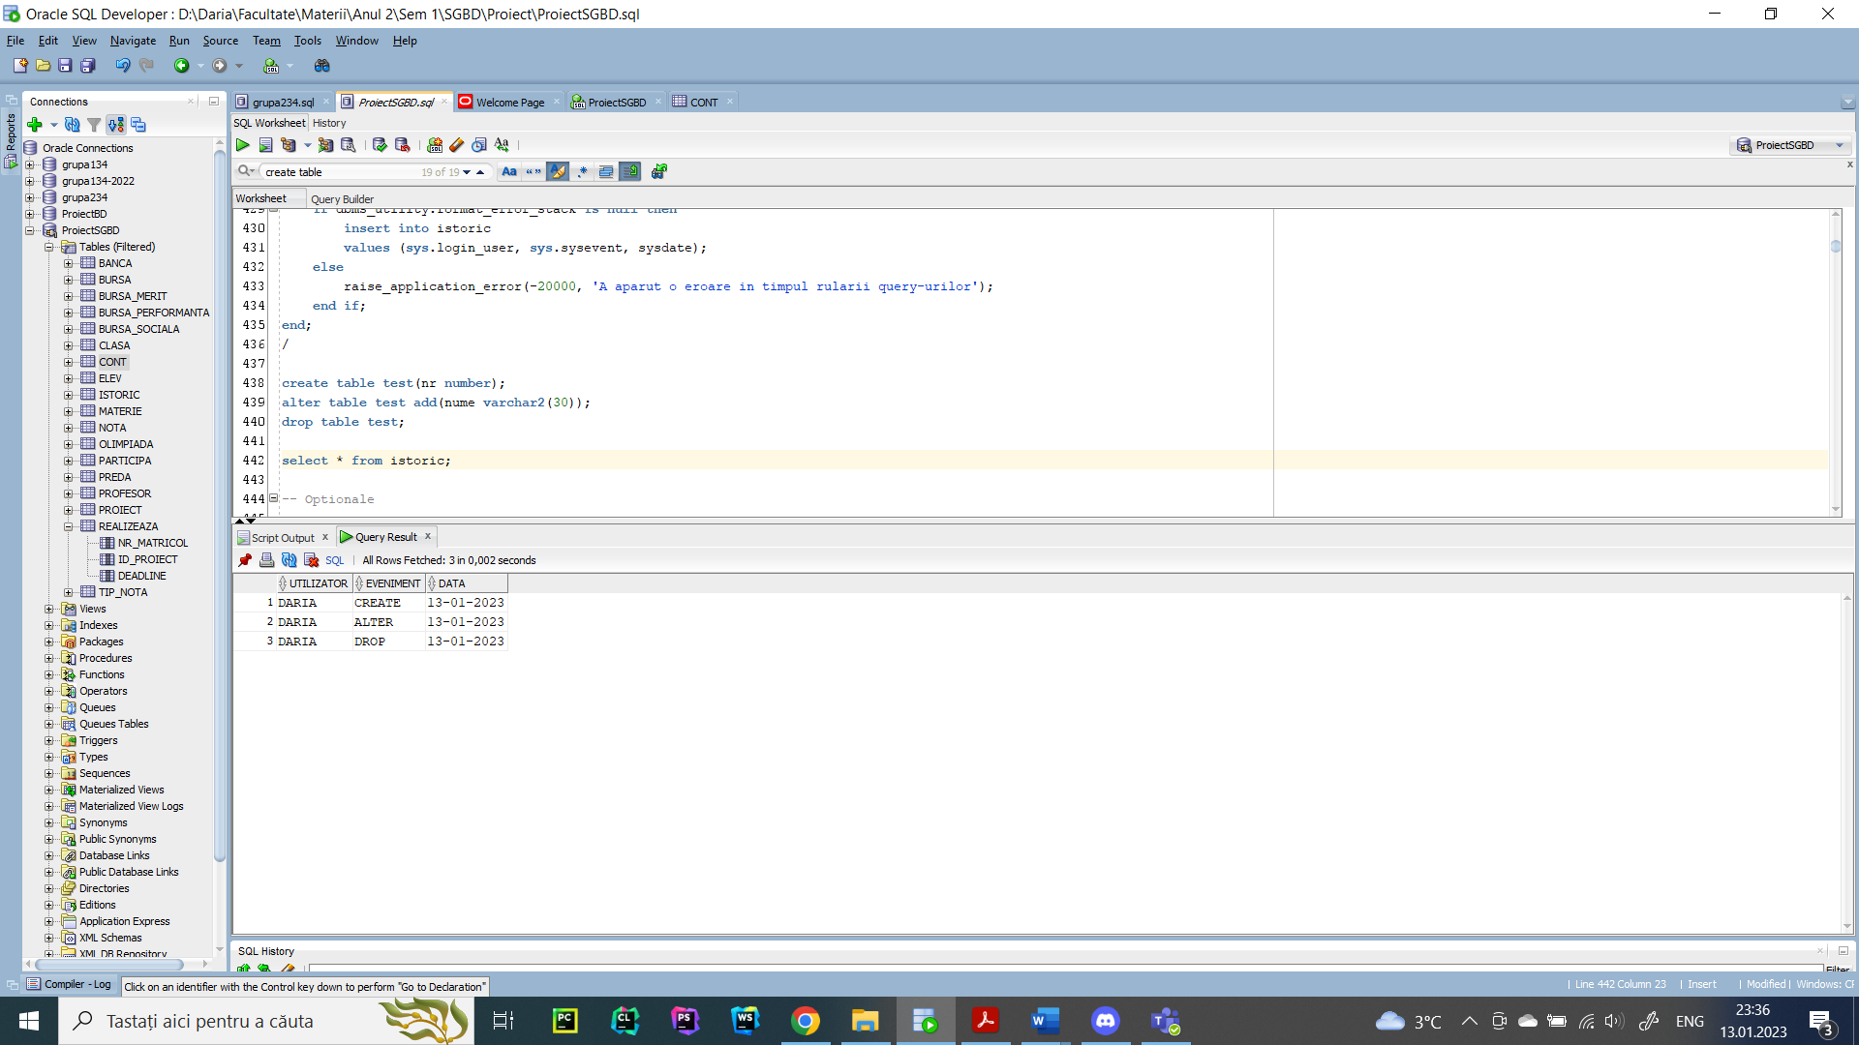

Optionale

1. Definiți un pachet care să conțină toate obiectele definite în cadrul proiectului.

create or replace package pachet_complet as

procedure f1_burseSociale;

procedure f2_profesorNivel (an1 clasa.an % type, an2 clasa.an % type);

function f3_idProfesori (v_materie materie.denumire % type) return profesor.cod_profesor % type;

procedure f4_contBancar (v_data realizeaza.deadline % type);

end;

/

create or replace package body pachet_complet as

-- 6

procedure f1_burseSociale

is

type t_burse is

table of bursa_sociala % rowtype

index by pls_integer;

v_burse t_burse;

type t_elevi is

varray(1000) of elev % rowtype;

v_elevi t_elevi;

nivel clasa.an % type;

litera clasa.litera % type;

suma number := 0;

numarElevi number := 0;

begin

select bs.*

bulk collect into v_burse

from bursa_sociala bs, bursa b

where b.id_bursa = bs.id_social

and b.suma > (select avg(b2.suma)

from bursa b2, bursa_sociala bs2

where b2.id_bursa = bs2.id_social);

select e.*

bulk collect into v_elevi

from elev e

where e.conditie_medicala = 1;

if v_burse.count > 0 then

if v_elevi.count - 1000 > 0 then

for k in 0..v_elevi.count - 1000 loop

v_elevi.extend;

end loop;

end if;

for i in v_burse.first .. v_burse.last loop

select b.suma

into suma

from bursa b

where b.id_bursa = v_burse(i).id_social;

dbms_output.put_line('Id bursa: ' || v_burse(i).id_social || ', suma: ' || suma);

for j in v_elevi.first .. v_elevi.last loop

if v_elevi(j).id_bursa = v_burse(i).id_social then

numarElevi := numarElevi + 1;

select an, litera

into nivel, litera

from clasa

where v_elevi(j).id_clasa = clasa.id_clasa;

dbms_output.put_line(rpad(v_elevi(j).nume || ' ' || v_elevi(j).prenume, 30) || ' ' || nivel || litera);

end if;

end loop;

if numarElevi = 0 then

dbms_output.put_line('Nu exista bursieri');

end if;

dbms_output.put_line('----------------------------------------------');

end loop;

end if;

end;

-- 7

procedure f2_profesorNivel

(an1 clasa.an % type, an2 clasa.an % type)

is

cursor c_profesor (nivel clasa.an % type) is

select nume, prenume, cursor (

select distinct e.nr_matricol, nume, prenume, an, litera

from elev e, clasa c, participa oli

where e.id_clasa = c.id_clasa

and oli.nr_matricol = e.nr_matricol

and c.id_clasa in (select id_clasa

from preda

where cod_profesor = p.cod_profesor)

and oli.premiu < 4

order by an)

from profesor p

where p.cod_profesor in (select cod_profesor

from preda, clasa

where preda.id_clasa = clasa.id_clasa

and clasa.an = nivel

group by cod_profesor

having count(*) = (select max(count(*))

from preda, clasa

where preda.id_clasa = clasa.id_clasa

and clasa.an = nivel

group by cod_profesor));

type rc is ref cursor;

v_rc rc;

numeProfesor profesor.nume % type;

prenumeProfesor profesor.prenume % type;

matricolElev elev.nr_matricol % type;

numeElev elev.nume % type;

prenumeElev elev.prenume % type;

anElev clasa.an % type;

literaElev clasa.litera % type;

v_nrElevi number := 0;

begin

for i in an1 .. an2 loop

dbms_output.put_line('Anul de studiu ' || i || ':');

open c_profesor(i);

loop

fetch c_profesor into numeProfesor, prenumeProfesor, v_rc;

exit when c_profesor % notfound;

dbms_output.put_line('Profesor: ' || initcap(numeProfesor) || ' ' || initcap(prenumeProfesor));

dbms_output.put_line(rpad('Nr.', 5) || ' ' || rpad('Nume', 30) || ' ' || 'Clasa');

v_nrElevi := 0;

loop

fetch v_rc into matricolElev, numeElev, prenumeElev, anElev, literaElev;

exit when v_rc % notfound;

dbms_output.put_line(matricolElev || ' ' || rpad(initcap(numeElev) || ' ' || initcap(prenumeElev), 30) || ' ' || anElev || literaElev);

v_nrElevi := v_nrElevi + 1;

end loop;

if v_nrElevi > 0 then

dbms_output.put_line('Numar elevi: ' || v_nrElevi);

else

dbms_output.put_line('Nu exista elevi premianti pe nivelul de studiu dat cu acest profesor');

end if;

end loop;

close c_profesor;

dbms_output.put_line('---------------------------');

end loop;

end;

-- 8

function f3_idProfesori

(v_materie materie.denumire % type)

return profesor.cod_profesor % type is

v_id profesor.cod_profesor % type;

v_exista number := 0;

begin

select count(*)

into v_exista

from materie

where upper(denumire) = upper(v_materie);

if v_exista = 0 then

raise_application_error(-20001, 'Nu exista materia data ca parametru.');

end if;

select distinct prof.cod_profesor

into v_id

from profesor prof, preda pr, materie m

where salariu = (select min(salariu)

from profesor prof2, preda pr2, materie mat2

where prof2.cod_profesor = pr2.cod_profesor

and pr2.id_materie = mat2.id_materie

and upper(mat2.denumire) = upper(v_materie)

)

and prof.cod_profesor = pr.cod_profesor

and pr.id_materie = m.id_materie

and upper(m.denumire) = upper(v_materie);

return v_id;

exception

when no_data_found then

raise_application_error(-20001, 'Niciun profesor nu preda materia data.');

when too_many_rows then

raise_application_error(-20002, 'Mai multi profesori care predau ' || v_materie || ' au salariul minim.');

end f3_idProfesori;

-- 9

procedure f4_contBancar

(v_data realizeaza.deadline % type)

is

v_exista number := 0;

v_bancaNume banca.nume % type;

begin

select count(*)

into v_exista

from realizeaza

where deadline > v_data;

if v_exista = 0 then

raise_application_error(-20001, 'Nu exista niciun proiect cu deadline-ul dupa data data ca parametru');

end if;

v_exista := 0;

select count(*)

into v_exista

from (select r2.nr_matricol

from realizeaza r2, proiect p

where p.id_proiect = r2.id_proiect

and r2.deadline > v_data

group by r2.nr_matricol

having count(*) = (select max(count(*))

from realizeaza r3

where r3.deadline > v_data

group by r3.nr_matricol)

and sum(nr_punctaj) = (select max(sum(nr_punctaj))

from realizeaza r3, proiect p2

where p2.id_proiect = r3.id_proiect

and r3.deadline > v_data

group by r3.nr_matricol));

if v_exista = 0 then

raise_application_error(-20002, 'Nu exista elevi care sa obtina punctaj maxim cu numar maxim de proiecte');

elsif v_exista > 1 then

raise_application_error(-20003, 'Sunt prea multi elevi care au obtinut punctaj maxim cu numar maxim de proiecte');

end if;

select b.nume

into v_bancaNume

from banca b, cont c, elev e

where b.id_banca = c.id_banca

and e.nr_matricol = c.nr_matricol

and e.nr_matricol in (select r2.nr_matricol

from realizeaza r2, proiect p

where p.id_proiect = r2.id_proiect

and r2.deadline > v_data

group by r2.nr_matricol

having count(*) = (select max(count(*))

from realizeaza r3

where r3.deadline > v_data

group by r3.nr_matricol)

and sum(nr_punctaj) = (select max(sum(nr_punctaj))

from realizeaza r3, proiect p2

where p2.id_proiect = r3.id_proiect

and r3.deadline > v_data

group by r3.nr_matricol));

dbms_output.put_line('Banca la care are deschis contul elevul este ' || v_bancaNume);

exception

when no_data_found then

raise_application_error(-20004, 'Elevul nu are cont deschis la nicio banca');

when too_many_rows then

raise_application_error(-20005, 'Elevul are conturi deschise la mai multe banci');

end;

end;

/

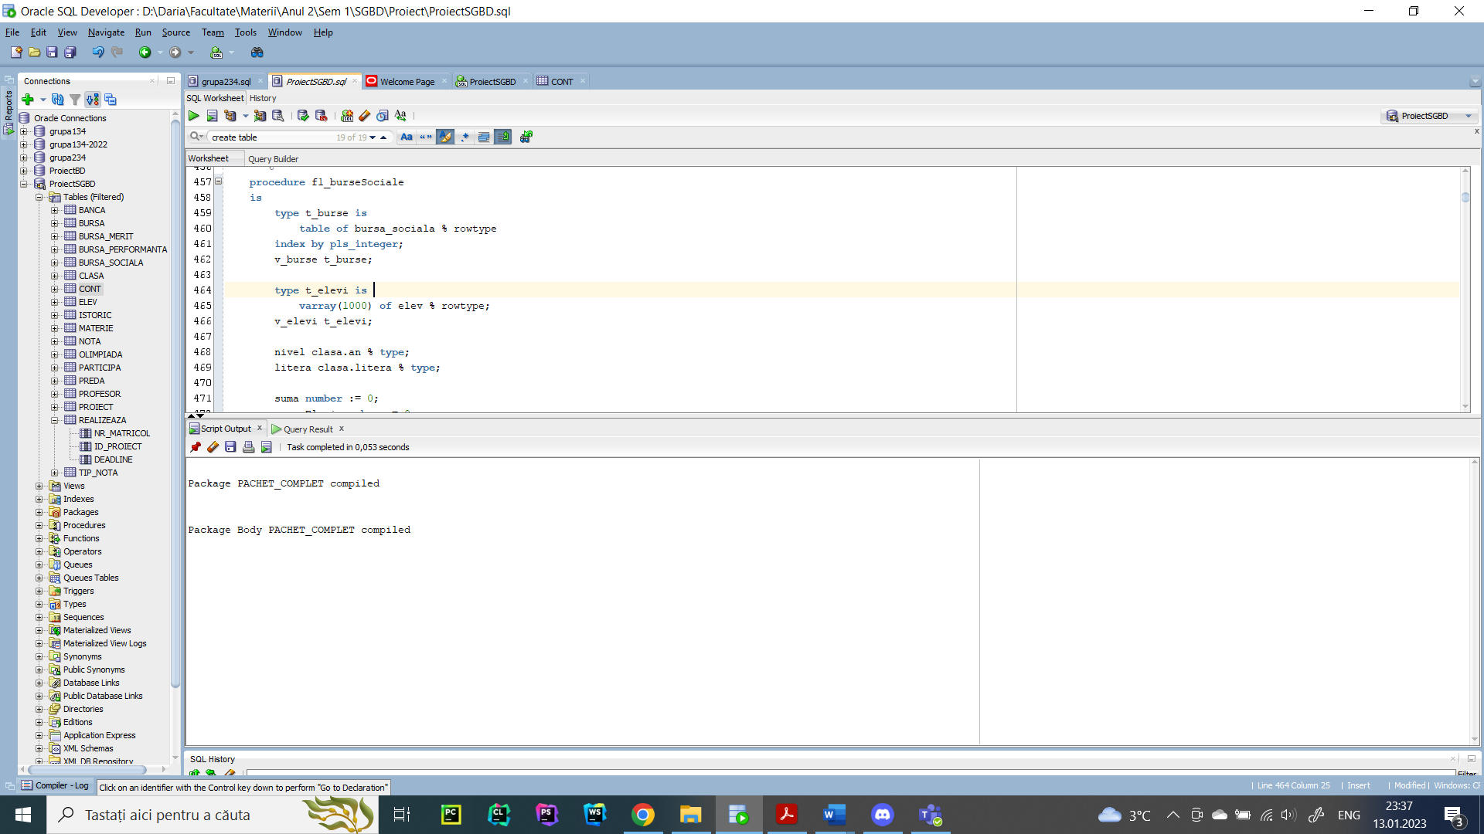

1. Definiți un pachet care să includă tipuri de date complexe și obiecte necesare unui flux de acțiuni integrate, specifice bazei de date definite (minim 2 tipuri de date, minim 2 funcții, minim 2 proceduri).

-- Un pachet care sa vina in intampinarea contabililor care se ocupa de gestiunea burselor. In functie de suma totala pe care o are la dispozitie, contabilul va putea creste sau scade suma oferita elevilor. Daca aceasta este mai mica decat suma minima pentru a plati cel putin circa 50 de lei fiecarui elev care ia bursa, indiferent de tipul ei, se va afisa o eroare. Cand se modifica o bursa se va afisa noua suma.

create or replace package pachet_final as

-- proceduri

procedure cuantumBani(v_bani number);

procedure actualizareBurse;

-- functii

function procent(idBursa number, suma_totala number) return number;

function diferenta(suma_initiala number, suma_modificata number) return number;

-- tipuri de date

type t_burseSociale is

table of bursa_sociala % rowtype

index by pls_integer;

type t_burseMerit is

varray(100) of bursa_merit % rowtype;

type t_bursePerformanta is

table of bursa_performanta % rowtype

index by pls_integer;

-- variabile

v_cuantum number := 0;

v_burseSociale t_burseSociale;

v_burseMerit t_burseMerit;

v_bursePerformanta t_bursePerformanta;

end;

/

create or replace package body pachet_final as

function diferenta

(suma_initiala number, suma_modificata number)

return number

is

v_diferenta number := 0;

begin

if suma_modificata > suma_initiala then

v_diferenta := ((suma_modificata - suma_initiala) / suma_initiala) * 100;

else

v_diferenta := ((suma_initiala - suma_modificata) / suma_initiala) * 100;

end if;

return v_diferenta;

end;

function procent

(idBursa number, suma_totala number)

return number

is

v_procent number := 0;

v_suma number := 0;

begin

select suma

into v_suma

from bursa

where id_bursa = idBursa;

v_procent := round(v_suma * 100) / suma_totala;

return v_procent;

end;

procedure cuantumBani

(v_bani number)

is

v_nrElevi number := 0;

begin

select count(*)

into v_nrElevi

from elev

where id_bursa != null;

if v_nrElevi * 50 > v_bani then

raise_application_error(-20000, 'Cuantumul nu acopera minimul de cheltuieli pentru plata burselor.');

else

v_cuantum := v_bani;

select b.*

bulk collect into v_burseMerit

from bursa_merit b;

select b.*

bulk collect into v_burseSociale

from bursa_sociala b;

select b.*

bulk collect into v_bursePerformanta

from bursa_performanta b;

actualizareBurse;

end if;

end;

procedure actualizareBurse

is

v_procent_social number := 0;

v_suma_social number := 0;

v_procent_merit number := 0;

v_suma_merit number := 0;

v_procent_performanta number := 0;

v_suma_performanta number := 0;

v_diferenta number := 0;

v_suma number := 0;

v_suma_totala number := 0;

begin

select sum(b.suma)

into v_suma_totala

from bursa b, elev e

where b.id_bursa = e.id_bursa (+);

dbms_output.put_line(v_suma_totala);

if v_suma_totala = v_cuantum then

dbms_output.put_line('Cuantumul este suficient pentru a plati bursele elevilor. Nu este cazul de alte modificari.');

else

if v_suma_totala < v_cuantum then

dbms_output.put_line('Cuantumul este mai mare decat necesarul cu '|| diferenta(v_suma_totala, v_cuantum) || ' pentru a plati bursele. Acestea vor fi marite.');

else

dbms_output.put_line('Cuantumul este mai mic decat necesarul cu '|| diferenta(v_suma_totala, v_cuantum) || ' pentru a plati bursele. Acestea vor fi micsorate.');

end if;

for i in v_burseMerit.first .. v_burseMerit.last loop

v_procent_merit := procent(v_burseMerit(i).id_merit, v_suma_totala);

v_suma := round((v_cuantum * v_procent_merit) / 100);

update bursa set suma = v_suma where id_bursa = v_burseMerit(i).id_merit;

dbms_output.put_line('Bursa de merit cu id-ul ' || v_burseMerit(i).id_merit || ' are noua suma ' || v_suma || 'lei');

end loop;

for i in v_bursePerformanta.first .. v_bursePerformanta.last loop

v_procent_performanta := procent(v_bursePerformanta(i).id_performanta, v_suma_totala);

v_suma := round((v_cuantum * v_procent_performanta) / 100);

update bursa set suma = v_suma where id_bursa = v_bursePerformanta(i).id_performanta;

dbms_output.put_line('Bursa de performanta cu id-ul ' || v_bursePerformanta(i).id_performanta || ' are noua suma ' || v_suma || 'lei');

end loop;

for i in v_burseSociale.first .. v_burseSociale.last loop

v_procent_social := procent(v_burseSociale(i).id_social, v_suma_totala);

v_suma := round((v_cuantum * v_procent_social) / 100);

update bursa set suma = v_suma where id_bursa = v_burseSociale(i).id_social;

dbms_output.put_line('Bursa sociala cu id-ul ' || v_burseSociale(i).id_social || ' are noua suma ' || v_suma || 'lei');

end loop;

end if;

end;

end;

/

begin

pachet_final.cuantumBani(250000);

end;

/

